DRAFT



Measuring the Value
of EA Programs

January 2007

DRAFT

Section 5: Measuring the Value of EA Programs

introduction
This section provides guidance to measure the value of enterprise architecture (EA) products and services in assisting agency decision-makers and other stakeholders achieve mission goals and objectives. EA products and services should deliver results-oriented architecture to inform business decisions and increase the efficiency and effectiveness of IT investments. EA value measurement monitors the impact of EA products and services across each phase of the Performance Improvement Lifecycle – architect, invest and implement – collecting valuable information to improve EA products and services.

Information and guidance are provided for the following topic areas:
- EA program value concepts: introduces EA value measurement as an element of the Performance Improvement Lifecycle, and describes candidate EA value measures to demonstrate the impact of EA products and services on IT investment management and program management.
- Measuring EA program value: describes a step-by-step process to define EA value measurement areas, identify measurement sources, and monitor and track value measures during each phase of the Performance Improvement Lifecycle.
- Using EA program value measures: outlines how EA value measures can be analyzed and applied to improve EA products and services to enhance business decisions.

For more information on the Performance Improvement Lifecycle, please refer to Section 1: Overview.

EA Value Measurement: Overview
EA value measures are not intended to be used by the Federal Enterprise Architecture Program Management Office (FEA PMO) to assess the current level of EA program maturity. At present, Federal agencies are not required to achieve specific value measures as part of the annual EA assessment process. However, future versions of the EA Assessment Framework will assess whether the agency has an EA value measurement program in place.

EA value measurement is a continuous, customer-focused process integrated with each phase of the Performance Improvement Lifecycle. The principal goals of EA value measurement are to identify opportunities and actions to improve EA products and services, and provide greater value to agency decision-makers. EA value measurement tracks architecture development and use, and monitors the impact of EA products and services on IT investment, business operations, stakeholder satisfaction, and other measurement areas and indicators.

EA value measurement reflects a best-practice approach to continuously measure and improve the quality and effectiveness of EA products and services. Value measures are defined to monitor progress toward target value outcomes, and establish clear relationships between the development and use of EA work products and target outcomes for IT investment, implementation programs and agency operations. Value measurements demonstrate the impact of EA products and services during each phase of the Performance Improvement Lifecycle, and provide valuable information to EA program staff to improve EA products and services.

EA Value Measurement: Objectives
EA value measures are used by Chief Architects and other agency stakeholders (e.g., Chief Information Officer, Chief Financial Officer) to achieve the following objectives:

- Demonstrate the value of the agency EA program by reporting changes in IT investment, stakeholder collaboration, asset reuse, and other value indicators linked to the use of EA products and services.
- Identify opportunities to improve EA products and services to support business decisions during each phase of the Performance Improvement Lifecycle.
- Justify the allocation of agency resources to the development and use of architectural products using verifiable value measures.
- Update the agency EA program plan to fulfill opportunities to improve EA products and services and enhance customer service.

ea program value concepts

EA Value Measurement as Part of the Performance Improvement Lifecycle
Results-oriented architecture is developed and implemented within the context of the three-phase Performance Improvement Lifecycle – architect, invest and implement (see Figure 5.1).
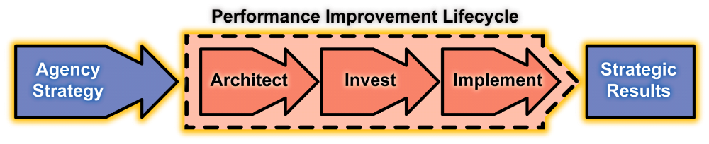
Figure 5.1: Performance Improvement Lifecycle
Each lifecycle phase is comprised of tightly integrated processes to transform the agency’s top-down strategic goals and bottom-up customer needs into a logical series of work products designed to achieve results. The Performance Improvement Lifecycle applies enterprise, segment and solution-level architectures to prioritize IT investments and support program management and execution to optimize the agency operating environment.

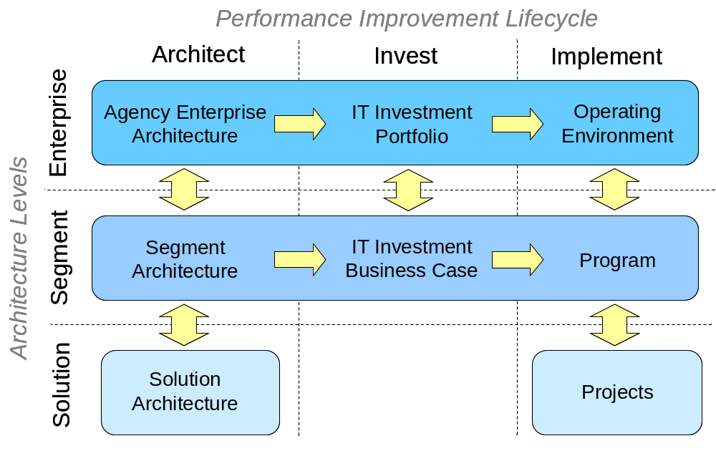
Figure 5.2 EA Value Framework

The EA Value Framework (see Figure 5.2) provides a way to view and measure the impact of the EA across the Performance Improvement Lifecycle. At the Enterprise level, the agency enterprise architecture, principally the EA Transition Strategy, guides and informs the agency IT investment portfolio to achieve agency strategic goals and objectives. At the Segment level, segment architecture for core mission areas, business services, and enterprise services guide and inform the development of individual business cases leading to the formulation of IT programs to implement the agency enterprise architecture and achieve target business outcomes. At the Solution level, solution architecture focuses on an individual project defined by segment architecture supporting tactical implementation objectives.

Architectural work products are used throughout the Performance Improvement Lifecycle. Value measures are defined for each phase and at each level of the Performance Improvement Lifecycle to track progress in architecture development and use, and establish clear relationships to measurable changes in IT investments and program management. EA value measures allow EA program staff to monitor the impact of EA products and services on value measurement areas and indicators (e.g., number of major IT investments, cost savings/cost avoidance, collaboration and reuse, and standards compliance).

EA value measures are collected, analyzed and reported at certain times corresponding to individual phases of the Performance Improvement Lifecycle. Chief Architects and EA program staff must be cognizant of what EA value measures are available and when they can be measured to demonstrate the impact of EA products and services on IT investments, implementation programs and agency operations.

Types of EA Value Indicators
Established measurement concepts for quality control and customer satisfaction can be used to measure the value of the EA.

Subjective and Objective Value Measures
Subjective value measures capture the opinions of EA stakeholders. Stakeholders within the agency evaluate the usefulness of EA products and services based on the value they provide in making business decisions and performing their roles. The advantage of subjective measurement is it provides feedback from stakeholders from a “customer satisfaction” viewpoint. Subjective measures can be collected through surveys and interviews with stakeholders.
The primary challenge of EA value measurement is to demonstrate a cause-and-effect relationship between actions within the EA program and improvements to agency performance. In some cases, there may be many contributing factors resulting in a specific performance improvement, of which the EA program is only one. Moreover, cause and effect may not always be proximate in time. The EA program may identify opportunities to make IT investments influencing agency performance in subsequent fiscal years.

Because subjective measures are dependent on those providing feedback, respondents should be representative of all stakeholders. This can be addressed by contacting multiple stakeholders within a given community to ensure a balanced sample of views is represented. While subjective measures can be used to determine the usefulness of EA products and services, they do not objectively demonstrate the impact of EA products and services on agency mission performance.

Objective value measures do not rely on the opinions of individual EA stakeholders; instead, they represent quantifiable EA value outcomes. These measures may reflect changes in IT investments, IT program performance, or business operations. The advantage of objective value measures is they provide quantitative data often tracked over multiple time intervals to measure trends in agency EA performance.

Common/Shared Measures and Agency-Specific Measures
There are many elements of an enterprise architecture initiative common across all Federal agencies. For example, overall measures of usefulness of the EA for IT investment planning, reuse of IT assets and overall business decision-making value are applicable to any agency. Table 5.1 defines a sample set of common value indicators to measure EA value.

However, there is also a need to define agency-specific EA value measures. These measures would assess the usefulness of the EA for decision-making in the context of specific agency goals, programs, lines of business, or other agency initiatives. The value measurement approach for an agency should include both common and agency-specific elements, and both objective and subjective measures.

Roles and Responsibilities
Value measurement requires the participation of both the producers of EA products and services (e.g., Chief Architect and EA program staff) and the consumers of EA products and services (e.g., EA stakeholders).

Chief Architect/EA Program
The Chief Architect and EA program staff are responsible for establishing the process to measure the value of EA, including defining EA value measures and developing and executing EA value measurement mechanisms. This requires a thorough understanding of how EA products and services can enhance business decisions and increase the efficiency and effectiveness of the agency IT portfolio to achieve agency goals and objectives. Chief Architects need to engage EA stakeholders to educate them on the value of EA and solicit their feedback on how the EA program can be improved.

EA Stakeholders
EA stakeholders provide valuable feedback to improve EA products and services - therefore stakeholder participation is critical to the effectiveness of EA value measurement. Chief Architects and EA program staff can use a number of techniques including customer surveys, stakeholder interviews, and workshops to collect feedback on EA products and services. Appendix A includes sample survey elements to measure EA product use and stakeholder satisfaction.

Measuring EA Program Value

Step 1: Define Value Measurement Areas

Identify Stakeholder Communities
EA stakeholders are not just individuals, but representatives of larger stakeholder communities. The potential scope of enterprise architecture extends across many communities, from senior agency executives to program managers, project leaders, budget analysts, developers, and others.

Identifying stakeholder communities is important because each community will have its own view of the value of the EA. A senior agency executive may be interested in identifying strategic consolidation initiatives to fulfill the mandate of recent legislation, while a programmer may be interested in understanding the technical standards of the agency for server platforms and identifying existing software components available for reuse. Some examples of stakeholder communities could include:

- Senior agency leadership,
- Strategic planning team,
- Budget and capital planning,
- Program managers,
- Chief Information Officer,
- IT infrastructure managers, and
- Software architects and developers.

Identify EA Program Value Goals (Outcomes)
Once stakeholder communities have been identified, they can be engaged to verify what EA outcomes or goals are of greatest value to them. In other words, what information and products could the EA provide to best assist them in making decisions to improve the ability of the agency to carry out its mission? To facilitate these discussions, a “straw man” document with example outcomes can be provided to stakeholders to focus the discussion on the outcomes most relevant to them.

Consensus on the value measurements is important since they should be the primary drivers of the EA program planning activities. These goals also drive the selection of specific value measurements. This document does not attempt to identify what the useful outcomes (or requirements) of an EA program should be across all Federal agencies, but agencies should document their desired EA outcomes as the basis for value measurement.

Common Value Indicators
Listed below are a set of value indicators applicable to any Federal agency with an EA program, and aligned with the value framework illustrated in Figure 5-2. This list should be augmented with agency-specific value measures determined in collaboration with the appropriate stakeholder communities.

Measurement Area | Stakeholder | Type | Common Indicators
Agency Enterprise Architecture | - Senior Leadership  - CIO | Objective | - Total EA Assessment Score (including completion)  - % of baseline and target architectures modeled within EA repository
Agency Enterprise Architecture | - Senior Leadership  - CIO | Subjective | - % of surveyed respondents indicating EA work products are useful to support decisions for strategic planning. IT planning and performance planning
IT Investment Portfolio | - IT Portfolio Managers  - Budget Planners | Objective | - % of IT investments compliant with agency transition strategy
IT Investment Portfolio | - IT Portfolio Managers  - Budget Planners | Subjective | - % of surveyed respondents indicating EA work products are useful to support decisions for IT portfolio selection, control and evaluation
Operating Environment | - CIO  - Architects  - IT Managers | Objective | - Total cost savings/avoidance as a percentage of the total IT budget.  - Number of cross-agency service level agreements (provide and subscribe)  - Number of common/shared business processes, data entities, and service components.  - % of IT systems complaint with agency technical standards profile
Operating Environment | - CIO  - Architects  - IT Managers | Subjective | - % of surveyed respondents indicating EA work products are useful to support decisions for managing agency IT environment, including applications and associated infrastructure
Segment Architecture | - Line of Business Owners  - Senior Leadership  - CIO  - All | Objective | - Number of enterprise segments with an assigned IPT (in accordance with guidance)  - Number of approved segments reconciled with agency EA  - Utilization of cross-agency architecture and e-Gov initiatives
Segment Architecture | - Line of Business Owners  - Senior Leadership  - CIO  - All | Subjective | - % of surveyed respondents indicating EA work products are useful to support decisions for establishing and managing lines of business, executing major transformation initiatives and improving cross-agency collaboration
IT Investment Business Case | - Budget and Capital Planning  - CIO | Objective | - Allocation of investments to segments by type, e.g. core mission areas, business services, enterprise services*  - Consolidation resulting in fewer exhibit 300 submissions
IT Investment Business Case | - Budget and Capital Planning  - CIO | Subjective | - % of surveyed respondents indicating the architecture supports investment decisions.
Programs | - Program Managers  - Architects | Objective | - Changes to average agency program PART score
Programs | - Program Managers  - Architects | Subjective | - % of surveyed respondents indicating the agency architecture enhances program/project management decisions including budgets, resource allocation management, earned value or other measures of program performance
Solution Architecture | - Architects  - Project Managers | Objective | - % of approved software architectures conformant with agency EA standards within data, technical and service component models
Solution Architecture | - Architects  - Project Managers | Subjective | - % of surveyed respondents indicating the architecture supports decisions regarding reuse of existing agency components, services and data
Projects | - Architects  - Developers  - Project Managers | Objective | - % of projects fulfilling opportunities to reuse business processes, data elements and shared services.
Projects | - Architects  - Developers  - Project Managers | Subjective | - % of surveyed respondents indicating the architecture supports development decisions including platform and tool choices, software development lifecycle methodology and other measures of IT implementation performance
Table 5.1: Common Value Indicators

Step 2: Identify Measurement Data Sources
Once the agency has established a set of value indicators, the next step is to identify the appropriate sources for obtaining the value measurements. Objective value measures are typically derived from agency statistics and documentation, such as agency budget exhibits, PART scores, external assessments of agency performance, IT inventories, and other sources. By contrast, subjective value measures are determined through discussion with stakeholders in the form of surveys, interviews, workshops, or other feedback mechanisms. Customer satisfaction surveys can be relatively simple, however, it is important to understand how the questions are worded, the target audience group, and the number of respondents necessary to be statistically valid. Appendix A includes sample survey elements to measure EA product use and stakeholder satisfaction

Wherever possible, agencies should reuse existing data sources for measurement rather than creating new instruments. This will minimize the effort of data collection and the associated burden on agency personnel.

Step 3: Execute Value Measurement
Once a set of indicators has been selected for each measurement area, and sources have been identified to provide the data, the next step is to determine baseline, target, and actual value measures.

Establish Baseline
The first step in executing value measurement is to establish “baseline” measures as a reference for future comparison. If just beginning the EA value measurement process, the baseline measurements will usually capture how the current EA products and services are providing value. If the EA value measurement process is already established, these measures will reflect a specific “starting point” in time.

Establish Target Measures
Next, establish target measures to define the future direction (typically 3-5 years) of how EA products and services can support the agency in achieving its goals and objectives. Define clear relationships between the development and use of EA work products and the target outcomes for IT investment, implementation programs and agency operations. Target measures are usually focused on a specific planning timeframe, typically 3-5 years in the future. Interim value measures take these long-term target values and translate them into more short-term focused (e.g., quarterly, semi-annually, annually) measures. Examples could include an increase in the number of systems deemed EA-compliant or greater levels of EA usage by senior executives.

Measure Actual Value Results
Once the baseline, interim and target measures are established, actual value measurements are taken at specific intervals to monitor progress toward achieving interim and target EA value measures.

using ea program value measures

Approach: Continuous Improvement
EA value measurement is a continuous, customer-focused process relying on feedback from stakeholders and other information sources to increase the quality and effectiveness of EA products and services. Value outcomes, measures and measurement mechanisms are defined and integrated with each phase of the Performance Improvement Lifecycle, and applied to deliver enhanced EA products and services to meet stakeholder requirements and target value outcomes.

EA value measures are collected and applied using the process illustrated in Figure 5.3. This process asks and answers questions related to the value of EA products and services, and determines appropriate actions in response to changes in EA value measures.

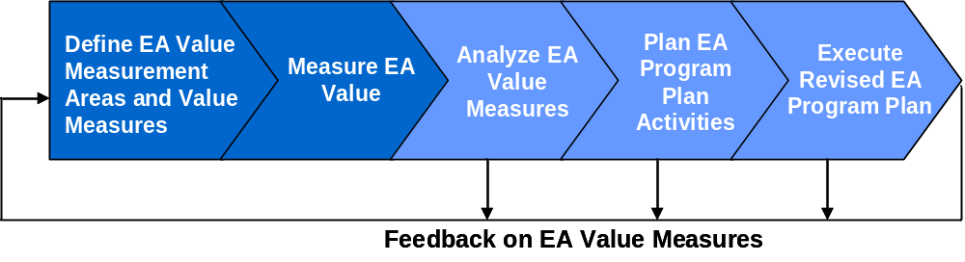
Figure 5.3: EA Value Measurement Process

EA value measures are not static. Feedback and other information resulting from the analysis and use of EA value measures are applied to revise value measures as the agency EA program matures.

Answering EA value questions
The “Analyze” element of the value measurement process applies EA value measures to answer value questions, and determine if EA products and services generate target value outcomes. Sample EA value questions include:

- Are stakeholders satisfied with the content and level of detail of the agency EA to support business decision-making?
- Does collaboration between EA program staff and business owners to develop segment architecture for a core mission area, business service or enterprise service result in increased stakeholder satisfaction in terms of the usefulness of the agency EA?
- Does development of the EA Transition Strategy and integration with the Capital Planning and Investment Control (CPIC) process have a measurable impact on the IT investment portfolio through the consolidation of existing investments?
- Does the development and implementation of the agency EA lead to measurable improvements in the on-time execution of agency performance milestones?
- Is there a clear relationship between EA development and implementation and the implementation of business services and enterprise services using shared services?
- Does the development and implementation of the agency EA and segment architecture result in measurable cost savings or cost avoidance?

If the answer to a value question indicates there is a demonstrated relationship between EA products and services and target outcomes, Chief Architects should consider opportunities to extend the reach of the product or service and other opportunities to increase the impact of the product or service. Alternatively, if the answer to a value question does not indicate there is a demonstrated relationship between EA products and services and target outcomes, Chief Architects should consider why the expected outcomes were not achieved and take appropriate actions to resolve the value or performance gap.

Specific actions to resolve value or performance gaps are dependent upon actual EA value measures and trends in the data, and will vary from agency to agency. The following list describes common actions to improve the quality and effectiveness of EA products and services:
- Manage business stakeholders’ expectations of value outcomes from the agency EA program.
- Verify interactions between EA program staff and stakeholders during each phase of the Performance Improvement Lifecycle to fulfill stakeholder requirements.
- Modify the content and level of detail of architectural work products to meet stakeholder requirements and support decision-making processes.
- Enhance architecture development and implementation processes such as segment architecture development, CPIC integration, and EA governance processes to resolve EA value and performance gaps.
- Change the timing, frequency, and/or nature of interactions between EA program staff and business stakeholders to meet stakeholder requirements and support decision-making processes.
- Increase stakeholder awareness and understanding of target EA value outcomes, products and services through regular stakeholder communications and outreach.
- Allocate additional EA program resources and/or business resources to resolve priority value or performance gaps.

Each action identified to resolve an EA performance gap should be incorporated into the EA program plan. EA value outcomes can be linked to completion and use milestones to show the planned progression toward target value outcomes. For more information on the definition of EA progress milestones please refer to Guidance for Quarterly Reporting Requirements.

Appendix A: Sample Survey Elements
This appendix provides sample EA survey elements to measure subjective value indicators such as overall stakeholder satisfaction and the perceived value of EA products and services to support parts of Performance Improvement Lifecycle, i.e., segment architecture development, IT investment management, program/project management and solutions delivery. Sample survey elements are provided as guidance – they are not intended to prescribe the nature and content of agency surveys. Agency surveys should be developed to reflect specific agency requirements and value indicators.

Sample survey elements are provided in a simple table format and organized into three sections:
- About the Respondent: Collects information on stakeholder responsibility and how they use EA products and services
- Overall Satisfaction: Measures overall satisfaction with EA products and services including accuracy, accessibility, and relevance to business decisions
- Performance Improvement: Measures value of EA products and services to support specific parts of the Performance Improvement Lifecycle.

Actual stakeholder survey instruments can use different formats and techniques to solicit stakeholder responses, e.g., on-line or e-mail survey forms.

About the Respondent
What is your level of supervisory responsibility? (choose one)
None
Team Leader
Supervisor
Manager
Executive

How often do you use EA products and services? (choose one)
Once a week or more
2 to 3 times per month
Once per month
Quarterly
2-3 times per year or less

The EA program provides products and services to support decision-making in the following areas. Which of the following areas contributes most to your success? (choose one)
Business Planning (Architecture)
IT Investment Management (Investment)
Program/Project Management (Implementation)
Solutions Development (Implementation)

Overall Satisfaction
Please rate the following: | Excellent | Good | Neutral | Poor | Don’t Know
The value provided by EA products and services to support business decisions relative to your costs, e.g. time dedicated to meetings, training sessions, presentations, and other EA-related activities
Your overall satisfaction with EA products and services
The likelihood you would recommend using EA products and services to a colleague to support business decisions

Please respond to each statement | Strongly Agree | Agree | Disagree | Strongly Disagree | Don’t Know
I am satisfied with the overall accuracy of EA products
I am satisfied with the overall relevance of EA products and services
I am satisfied with the availability and accessibility of EA products and services
The EA program team communicates well with my program area
The EA program team collaborates well with my program area
EA products and services enhance the efficiency and effectiveness of our business environment and operations

Performance Improvement
Please respond to each statement: | Strongly Agree | Agree | Disagree | Strongly Disagree | Don’t Know
Segment architecture development provides valuable information to support business planning and decision-making
Program areas and the EA team work together to plan IT investments
Program areas and the EA team collaborate to improve the quality and management of IT investments and programs
Program areas and the EA team collaborate to improve the quality of business solutions
The agency enterprise architecture describes reusable business processes, data elements and/or services (applications) to support business solution delivery

Please provide additional information on how EA products and services can be improved to support business decisions, management, and operations.

OMB Circular A-11, Section 26 and the Government Performance and Results Act (1993)

