10/23/2007
A New Enterprise Data Management Strategy for the US EPA
Part 6: Support for E-Discovery
Brand L. Niemann, Senior Enterprise Architect,
US EPA Enterprise Architecture Team, and
Co-Chair, Federal Semantic Interoperability Community of Practice (SICoP)

Summary
The previous five parts of “A New Enterprise Data Management Strategy for the US EPA” addressed an EPA Data Architecture for DRM 3.0 and Web 3.0 (1), the Inventory of Data Assets (2), and the Integration of Data Tables (3) all using the EPA’s 2007 Report on the Environment: Science Report as the example (4). Since the later included some maps, the fourth part (5) addressed spatial data using LandView (6) and the work of the Spatial Ontology Community of Practice (SOCoP) (7) as examples. Part five addressed data management for the Land Quality and Water Quality Management Segments (8) of EPA Enterprise Architecture.

This part also supports the premise of reusing the data and information, rather than changing the data systems themselves, by putting the business and technical rules, logic, etc. into the data itself using markup languages; and the concepts and standards of the Semantic Web (also called the Data Web or Web 3.0) where the most important tenets of the reuse are:
Bring the data and the metadata back together.
Bring the structured and unstructured data and information back together.
Bring the data and information description and context back together.

E-Discovery data management includes information and data from many activities and shows how the use of high-quality content based on considerable multi-disciplinary subject matter expertise can be reused to build multiple knowledgebases that contain data and information assets with standardized metadata that supports the four functionalities of DRM 3.0 and Web 3.0, namely, Integration of Data and Metadata, Harmonization, Enhanced Search, and Mashups. It is recommended that agencies and government employees do likewise to become more E-Discoverable.

Table of Contents
1. Introduction
2. E-Discovery
3. Examples
4. Recommendations
5. References

1. Introduction

E-Discovery: Records Management and Email Retention was the subject of a recent CIO Council IT Quarterly Forum (9) by the National Archives and Records Administration (NARA), who leads agency federal records management (RM) guidance and implementation oversight (44 USC chapter 29), and the General Services Administration (GSA) that provides support to NARA for Records Management (RM). The presentation at this Forum (10) defined Common Forms of Electronically Stored Information (ESI) as: Email with attachments (all kinds), text files, PowerPoint, spreadsheets, voice mail, instant and text messaging, databases, proprietary applications, Internet, intranet, wikis, blogs, RSS feeds (plus cache files, slack space data, cookies), data on PDAs, cell phones,
video-conferencing & webcasting, and metadata. The presentation at this Forum (10) defined Common Sources of ESI as: mainframes, network servers, local drives (including network activity logs), DVDs, CD-ROMs, floppy disks, laptops, backup tapes, external hard drives (e.g., flash, Zip, Jazz, Ipods), and third-party storage. The Forum experts advise that “Agencies must anticipate demands for preservation of evidence in litigation and compliance/oversight settings that go beyond baseline record retention requirements.”

NARA provides a comprehensive records management website (11), with toolkit of best practice white papers, including on transitioning to enterprise electronic recordkeeping, also Frequently Asked Questions (FAQ) on many subjects, including scanning documents, instant messaging, wikis, etc. (11). In addition, Jason R. Baron, Director of Litigation, NARA, and Co-Chair of the Sedona Conference Search and Retrieval Sciences Team and Editor-in-Chief of the Sedona Best Practices Commentary On the Use of Search and Information Retrieval Methods in E-Discovery (12), provided The Sedona Principles (2007) (e.g., 8. The primary source of electronically stored information for production should be active data and information.), and The Sedona Guidelines (2007) (e.g., 4. An organization adopting an information and records management policy should consider including procedures that address the creation, identification, retention, retrieval and ultimate disposition or destruction of information and records.)

The purpose of this paper is to apply this develop a new enterprise data management strategy for the US EPA that supports E-Discovery.

2. E-Discovery

The US EPA CIO and Chief Architect have recently provided a description of the scope of the E-Discovery problem (13) and the Environmental Management Line of Business (14), respectively. Our CIO said: “Many of us, and the people we support are working on the front line of environmental issues. Most people don't care ‘what's under the hood,’ they care about getting the specific, accurate information they need quickly and easily. EPA has a variety of systems and mechanisms for storing, finding and accessing information that are challenging for our staff and stakeholders to navigate. For those of you that are visual learners, like me, our current situation looks something like this diagram.”
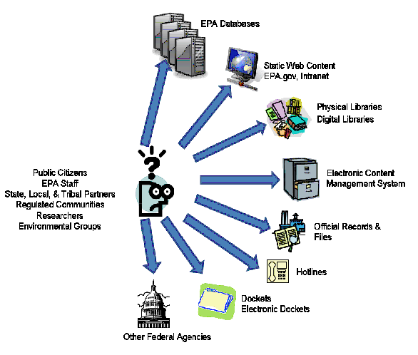

Our EPA Chief Architect said that the Potential Goals of an Environmental Management Line of Business (LoB) are to share services, provide SOA services, federated business component systems, and share data by converging data standards, and ultimately, shared ontologies, which is consistent with the central theme of this new enterprise data management strategy (1-3, 5, and 8).

There are three topics the author has worked on that will be illustrated with specific examples in the next section as follows:
(1) From Web Site Search to Federated Enterprise Search;
(2) From Exchange Network to Service Oriented Architecture (or to Web 2.0 and SOA - the Killer App!);
(3) From Conventional Conference to Collaborative Conference;
and these also illustrate how to deal with both legacy information systems and new collaborative activities going forward.

3. Examples
The three specific examples that deal with both legacy information systems and new collaborative activities going forward are:

(1) From Web Site Search to Federated Enterprise Search
Examples of this are the US EPA Region 4 Semantic Technologies Pilot: Update (15) requested by former CIO Kim Nelson, et al.; Enterprise Search of Distributed Content Managed with Taxonomies and Ontologies (16) as part of the Data Reference Model Public Forum, June 13, 2005 (see next page), and Semantic Indexing & Search Collaborator for the EPA CIO's Grand Challenge (Is my child safe from environmental toxins?) (17) at the Fourth Semantic Interoperability for E-Government Conference, February 9-10, 2006 (see next page) . Now we are working on this using the Sitemaps Protocol and newest Google Universal Search Appliance (18).
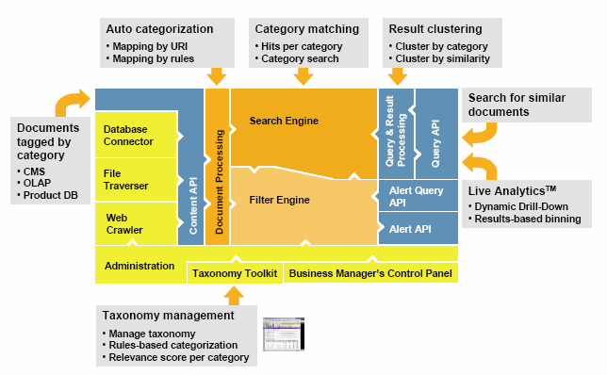
FAST Data Search: Categorization and Taxonomy Support (16)

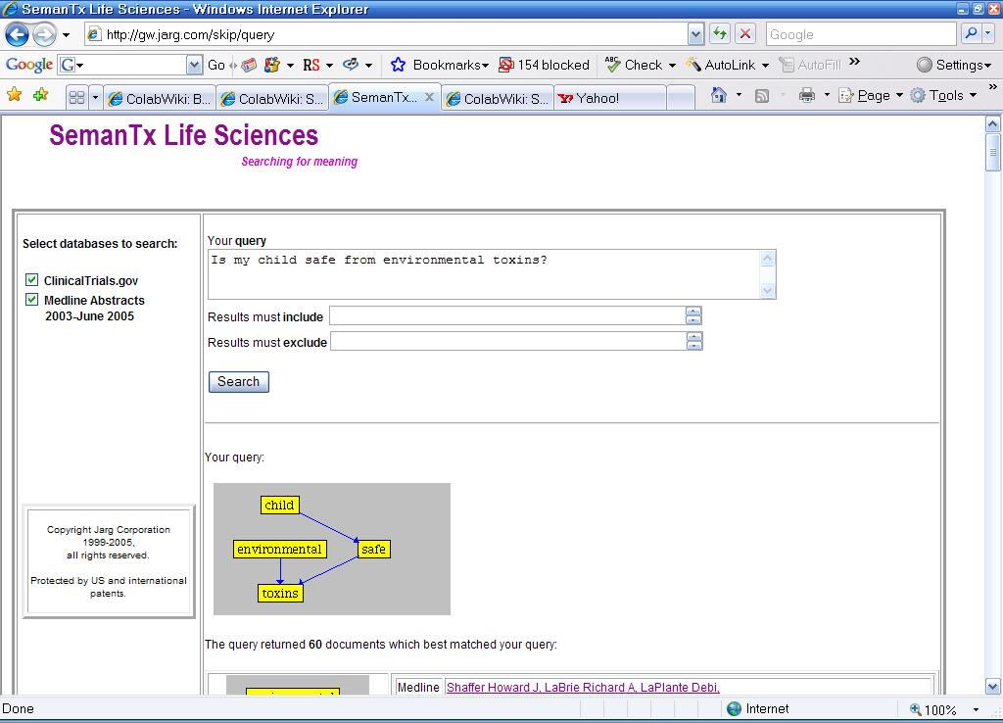
SemanTx Life Sciences: Searching for meaning at http://gw.jarg.com/skip/query (17)

(2) From Exchange Network to Service Oriented Architecture (or Web 2.0 and SOA - the Killer App!)
An example of this is the Integration of Environmental Information and Indicators (19) for the Council on Environmental Quality to create "a federated directory of many efforts at the national, regional, and local levels to foster communications and networking among those efforts". This LivePublish (19) platform used for this supports XML markup of the data and information within the individual nodes, XML-based messaging for communication between nodes, and XML-based queries across any and all nodes. In essence this is an early example of a Web 2.0 front-end on a SOA back-end! (see screen capture below)

(3) From Conventional Conference to Collaborative Conference
An example of this is the SOA Community of Practice with their recent collaborations over a six month period to develop another major collaborative conference (20). They now have a considerable body of e-discoverable content in their Wiki pages, file repositories and formal knowledgebases (see screen captures on next page). MITRE, which hosts these SOA CoP Conference and others, usually does streaming video to their facilities to support this very successful pattern for E-Discovery. Another example is of the “Locate, Collaborate, and Integrate” paradigm of enterprise database management in support of E-Discovery was the recent Shenandoah Valley Science Symposium (21) which used a combination of Web 2.0 technologies, namely the Collaborative Work Environment and the Videocasting by KZO Networks and Software as a Service WebCasting (21) (see screen captures below and on page 7).

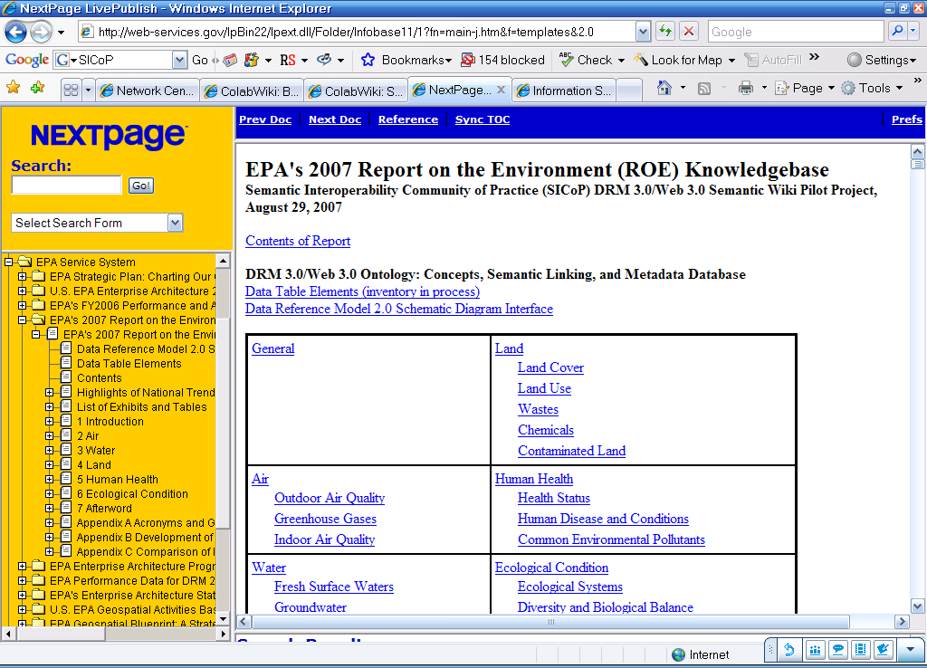
EPA’s 2007 Report on the Environment Knowledgebase as Part of the EPA Service System Network of Nodes at http://web-services.gov/lpBin22/lpext.dll/Folder/Infobase11/1?fn=main-j.htm&f=templates&2.0
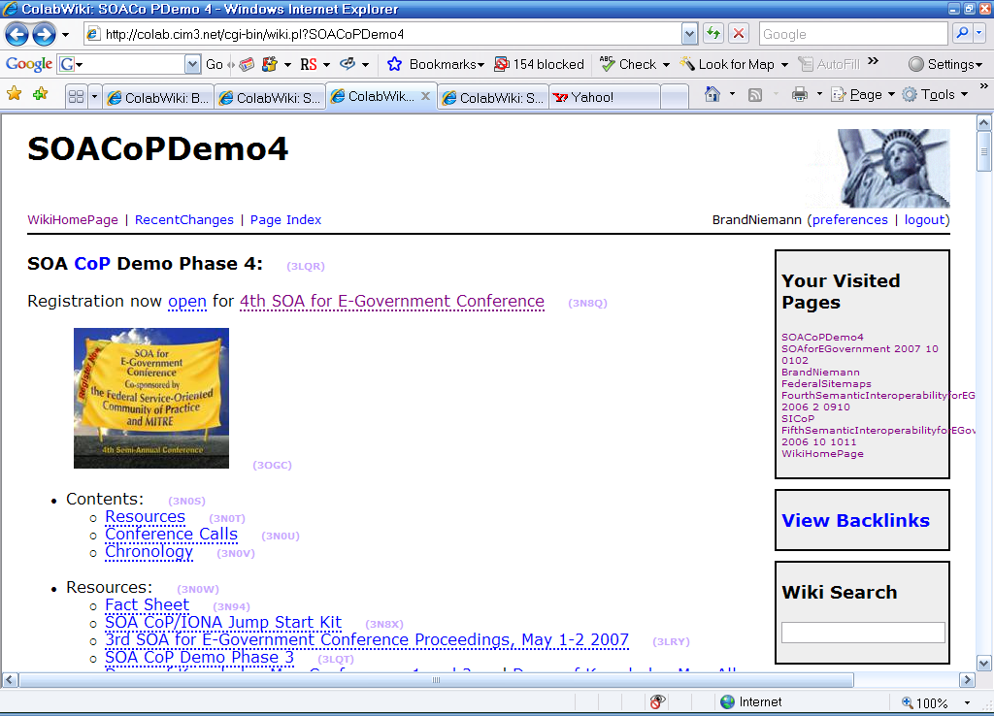
SOA CoP Demo Phase 4 Collaboration at http://colab.cim3.net/cgi-bin/wiki.pl?SOACoPDemo4

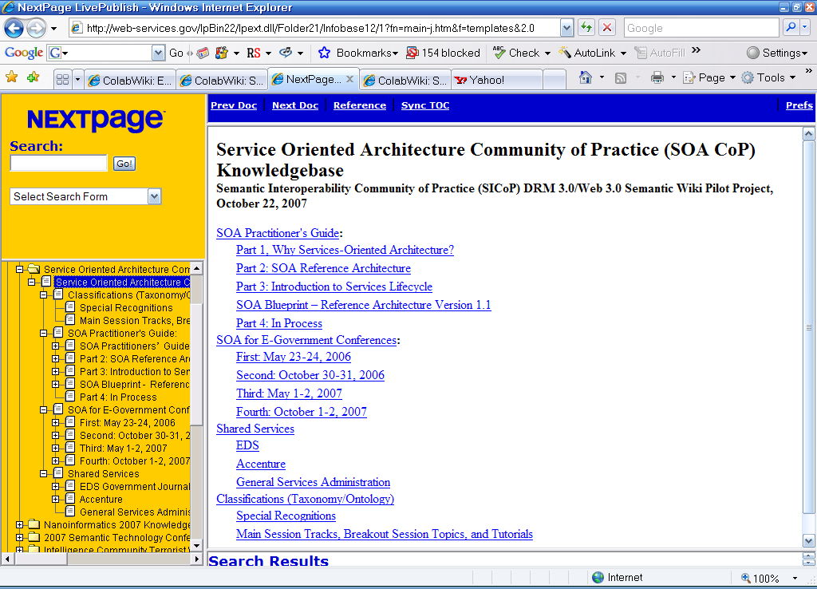
SOA CoP Knowledgebase at http://web-services.gov/lpBin22/lpext.dll/Folder21/Infobase12/1?fn=main-j.htm&f=templates&2.0
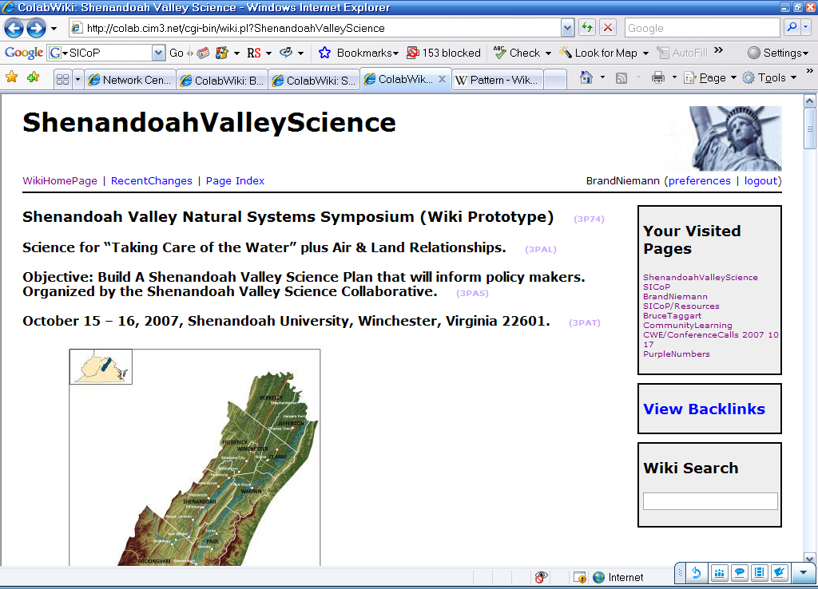
Google: Shenandoah Valley Science (21)

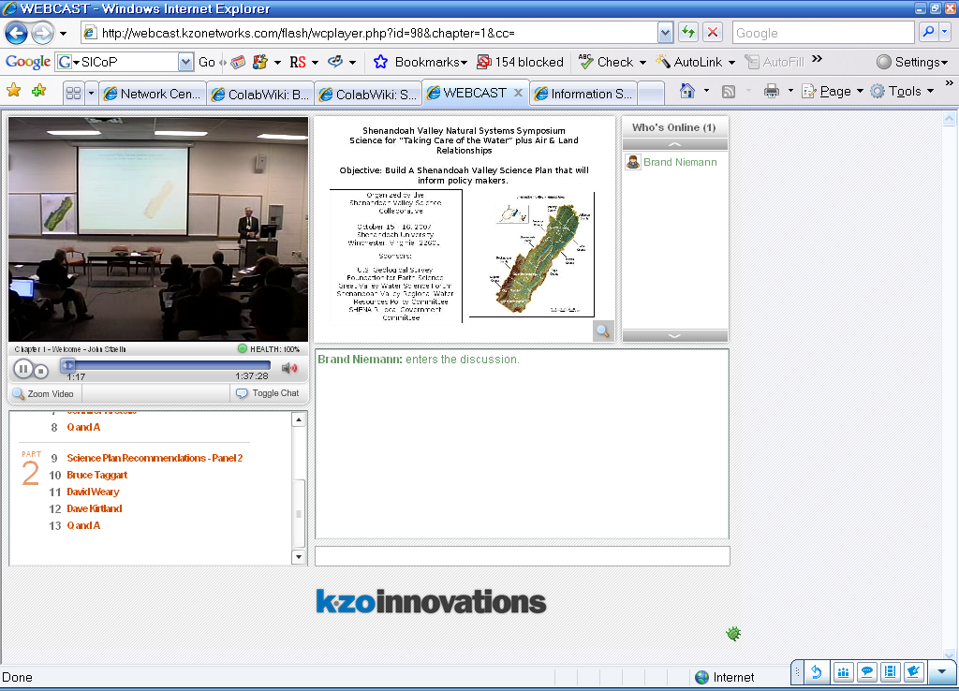
Videocasting by KZO Networks and Software as a Service WebCasting (21)
4. Recommendations

The previous five parts of “A New Enterprise Data Management Strategy for the US EPA” addressed an EPA Data Architecture for DRM 3.0 and Web 3.0 (1-3, 5, and 8) that supported E-Discovery as this paper illustrates. The real business potential for Web 2.0 to be developed in the government context, is E-Discovery and Records Management. One of the real benefits of Web 2.0 is that it enables individual government employees to become an “E-Discoverable Government Employee”: For example - Google my name and get my Wiki Page at the top of their hit list! My Wiki page shows that I practice CAT*: Clarity (about what I do); Accountability (for what I do); and Transparency (in how I do it) as requested by Mr. Clay Johnson, III, Deputy Director for Management, OMB, Executive Chair of the Federal CIO Council, at the Federal IT Summit 2006, October 4th (22). It is recommended that agencies and government employees do likewise.

References

(1) A New Enterprise Data Management Strategy for the US EPA, August 15, 2007.
Word: http://colab.cim3.net/file/work/SICoP/EPADRM3.0/BNiemann08152007.doc

(2) A New Enterprise Data Management Strategy for the US EPA - Part 2: Inventory of Data Assets, August 29, 2007.
Word: http://colab.cim3.net/file/work/SICoP/EPADRM3.0/BNiemann08292007.doc

(3) A New Enterprise Data Management Strategy for the US EPA - Part 3: Integration of Data Tables, September 5, 2007.
Word: http://colab.cim3.net/file/work/SICoP/EPADRM3.0/BNiemann09052007.doc

(4) EPA’s 2007 Report on the Environment: Science Report
http://cfpub.epa.gov/eroe/index.cfm

(5) A New Enterprise Data Management Strategy for the US EPA - Part 4: Spatial Data, September 24, 2007.
Word: http://colab.cim3.net/file/work/SICoP/EPADRM3.0/BNiemann09242007.doc

(6) Interagency LandView (hosted by the Census Bureau): LandView 6.
Web Site: http://landview.census.gov/

(7) Spatial Ontology Community of Practice (SOCoP)
Visual Knowledge Semantic Wiki: http://www.visualknowledge.com/wiki/socop

(8) A New Enterprise Data Management Strategy for the US EPA - Part 5: Land Quality and Water Quality Management Segments, September 25, 2007.
Word: http://colab.cim3.net/file/work/SICoP/EPADRM3.0/BNiemann09252007.doc
(9) Who is Afraid of E-Discovery? Cautionary Tales Every CIO and Every IT Person Needs to Know to Survive into FY2008, and Beyond.
Abstract: This presentation was made by Jason R. Baron, Director of Litigation at the National Archives and Records Administration, Jonathan M. Redgrave, founding partner of the law firm Redgrave Daley Ragan & Wagner, and Rachel Spector, senior attorney at the General Law Division of the Department of the Interior. The session focused on how CIOs and those who work in IT shops can best interact with lawyers and senior agency managers, based on lessons learned from some of the “worst case” disasters that have happened in recently reported cases, including involving email and backup tapes. This is one of two presentations made during a Quarterly IT Forum co-hosted by the IT Workforce Committee of the CIO Council and GSA's Office of Technology Strategy on August 14, 2007 at GSA. http://cio.gov/documents/ITQF_ediscovery_presentation.ppt

(10) Email and Records Management Overview
Abstract: This brief presentation was made by Michael Kurtz, Assistant Archivist for Records Services for the National Archives and Records Administration and Keith Thurston, Assistant Deputy Associate Administrator for the Office of Technology Strategy at the General Services Administration. It discusses the current environment and increased attention being given to E-mail Retention and Records Management and offers links to helpful resources. This is one of two presentations made during a Quarterly IT Forum co-hosted by the IT Workforce Committee of the CIO Council and GSA's Office of Technology Strategy on August 14, 2007 at GSA.
http://cio.gov/documents/ediscoveryoverview.ppt

(11) National Archives and Records Administration (NARA) Records Management
Web site: http://www.archives.gov/records-mgmt/

(12) The Sedona Conference
Web site: http://www.thesedonaconference.org

(13) “Getting It Right: Access to Environmental Information”: National Environmental Information Symposium in St. Louis, MO.
Email to the Office of Environmental Information from the CIO, Mollie O’Neill, October 4, 2007.
Web site: http://www.epa.gov/oei/proceedings/2007/proceedings07.htm

(14) Environmental Management Line of Business – Mr . John Sullivan, Chief Architect, EPA and Mr. Kevin Kirby, Data Architect, EPA. Chief Architects Forum Quarterly Meeting, Monday, October 15, 2007.
http://colab.cim3.net/cgi-bin/wiki.pl?ChiefArchitectsForum/Meeting_2007_10_15
http://colab.cim3.net/file/work/caf/meetings/2007-10-15/JSullivan10152007.ppt

(15) The US EPA Region 4 Semantic Technologies Pilot: Update, June 9, 2005 (Updated June 20, 2005).
Web site: http://web-services.gov/scoper406092005.ppt

(16) Enterprise Search of Distributed Content Managed with Taxonomies and Ontologies
Web site: http://web-services.gov/DRMFAST06132005.ppt
as part of the Data Reference Model Public Forum, June 13, 2005, at http://colab.cim3.net/cgi-bin/wiki.pl?DataReferenceModelPublicForum_2005_06_13

(17) Semantic Indexing & Search Collaborator for the EPA CIO's Grand Challenge (Is my child safe from environmental toxins?) at the Fourth Semantic Interoperability for E-Government Conference, February 9-10. 2006
http://colab.cim3.net/cgi-bin/wiki.pl?FourthSemanticInteroperabilityforEGovernmentConference_2006_2_0910#nid31SJ

(18) Federal Sitemaps Initiative and Google Website search and Universal search
http://colab.cim3.net/cgi-bin/wiki.pl?FederalSitemaps
http://www.google.com/enterprise/search.html

(19) Integration of Environmental Information and Indicators for the Council on Environmental Quality and Sustainable Water Resources Roundtable
http://colab.cim3.net/file/work/SICoP/2007-01-25/SICoPSWRR01252007.ppt
http://www.sdi.gov/

(20) SOA CoP and 4th SOA for E-Government Conference, October 1-2, 2007
http://colab.cim3.net/cgi-bin/wiki.pl?SOACoPDemo4
http://colab.cim3.net/cgi-bin/wiki.pl?SOAforEGovernment_2007_10_0102

(21) Shenandoah Valley Science Symposium
Wiki Page: http://colab.cim3.net/cgi-bin/wiki.pl?ShenandoahValleyScience
Collaborative Work Environment: http://colab.cim3.net/cgi-bin/wiki.pl?WikiHomePage
Videocasting by KZO Networks: http://webcast.kzonetworks.com/plugins/webcast/regform.php?id=98
KZO Software as a Service WebCasting: http://colab.cim3.net/file/work/SICoP/SHEN/2007-10-1516/General/KZOWEBCASTSaaS.pdf

(22) October 18, 2007, Web 2.0 Conference Roundtable. Answers to Questions
http://colab.cim3.net/file/work/SICoP/2007-10-18/BNiemann10182007.doc
November 1, 2007, Web 2.0 for Business Featuring a Special Government Track. Invited Presentation on Web 2.0 and Government: Current Web 2.0 Initiatives within Government Agencies.
http://www.tnni07.thenewnewinternet.com/
http://colab.cim3.net/file/work/SICoP/2007-11-01/BNiemann10021007.doc
http://colab.cim3.net/file/work/SICoP/2007-11-01/BNiemann11012007.ppt
Executive Spotlight for Conference
http://www.executivebiz.com/newsletter-executives-detail.php?who=bniemann

