The Federal Enterprise Architecture
Data Reference Model: A Synopsis

What is the purpose and scope of the DRM?
Every Chief Information Officer (CIO) faces the challenge of ensuring that information required for a strategic goal or business objective is quickly and easily located, accessed, and understood by those who need it. The Federal Enterprise Architecture (FEA) Data Reference Model (DRM) helps meet this challenge. It serves as guidance for federal CIOs constructing their respective enterprise information architectures and provides a critical link between the business needs of an agency and its services and technologies. The DRM is written to unify the federal-wide approach towards expressing information assets in enterprise architectures. It serves both department and agency business needs as well as emerging business driven cross-agency collaborations.

What will the DRM require?
The DRM provides a standardized model or template for building an information architecture. The model, which is reusable across government, requires answers to three key questions a business owner really cares about: How can I find the right data? How can I share that data? How do I understand what the data means?

Recognizing the highly decentralized nature of data management in the federal government, the varied existing statues, policies and directives, the DRM only requires that agencies implement a standard template for building their information architecture. Use of the DRM, in and of itself, does not mandate or create information sharing. Departments and Agencies will still decide what data to share based on common business needs.

As depicted in the table below, information captured in the DRM template is analogous to that captured in a reference (e.g., Title, Author, Publisher) on an index card for a book.

Reference Element  (required for a Book) | Element Value
Title | “Incrementalism and Public Policy”
Author | “Michael T. Hayes”
Publisher  Location | “Longman  “ New York , London”

In a similar way that everyone understands what Title, Author, and Publisher mean to capturing information about a book, the DRM describes a required template to capture enterprise information assets which departments and agencies will populate with their own content. The following table provides a simplified example of the template with DRM elements organized by its’ three major standardization areas for data context, sharing, and description.

DRM Element  (required for Information Architecture) | Element Value
Data Context:
Data Subject | “Terrorist Watchlist”
Data Sharing
Information Exchange Template | ” Identity Check Message”
Data Description
Data Object  Attribute | “Person”  “American Citizen”

More specific descriptions of agency data will occur only when and if an agency has a business need and desire to share the information on an intra-agency or inter-agency basis.

How can the DRM add value?

The DRM can play an important role in defining the security and privacy attributes associated with data. While information sharing is an important goal in improving our ability to achieve the President’s goal of a citizen centered government and reducing duplication, we must not lose sight of the increasing importance of security and privacy issues. The DRM, through creating a way to tag data assets with security and privacy attributes, will help us ensure appropriate use of data in accordance with existing legislation, directives and policies.

In fact, the DRM is informed by the federal subject matter experts who have designed the three cross cutting FEA profiles: security and privacy, records management and geospatial.

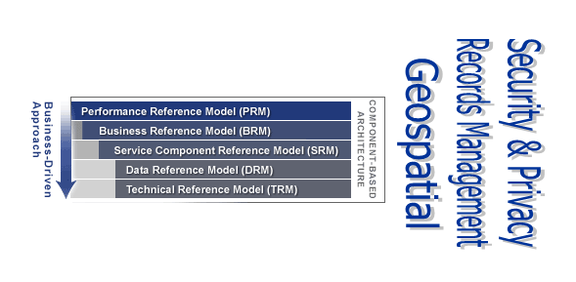
The DRM real value comes into focus when a strategic goal or business objective drives an interagency collaboration. Today, it is not uncommon for the members of the team to arrive at the table with disparate ways to characterize their data assets (including data models, links to data dictionaries and Metadata registries, or data source descriptions). Wouldn’t our performance in transforming government be greatly accelerated if interagency teams had a more structured way to quickly analyze their collective data assets including the ways they are located, accessed and understood?

The DRM provides a reusable framework or template for agencies to talk the same language about the information needed for a business objective. A department’s or agency’s DRM can be translated into an XML schema, which allows interagency teams to quickly query, compare and understand their collective data assets and their current disposition. This interagency team then has a firmer foundation to define what data is needed to achieve the business objective, and create the common agreements regarding security and privacy, data standardization, access in their future solutions architecture.

A testing of the DRM XML schema method for a real interagency business objective would take the information sharing challenge from a conceptual solution to a concrete approach. It would demonstrate the value of enterprise architecture and the FEA through putting the blueprint for data into the hands of business owners.

