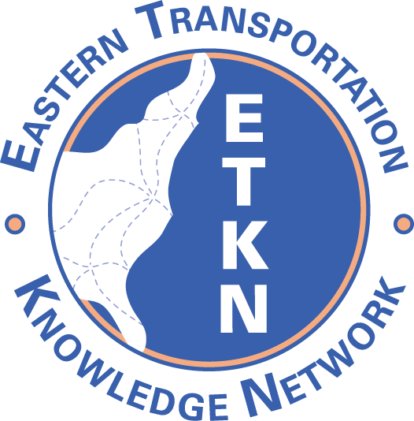

ETKN Meeting Minutes
September 23, 2010
10:30 – 11:30 a.m. EST

PARTICIPANTS
Jane Minotti, New York State DOT
Lynn Matis, Massachusetts DOT
Betty Ambler, Connecticut DOT
Sandy Brady, Louisiana Transportation Research Center
Carol Paszamant, New Jersey DOT
Bonnie Fields, Pennsylvania DOT
Mary Ellen Tucker, UNC Highway Safety Research Center
Gail Kostinko, GRA Research Library
Lamara Williams, NCDOT
Deena Adelman, FHWA
Rosalyn Alleman, RITA-NTL
Bob Cullen, AASHTO
David Jared, GDOT

Approval of Previous Minutes
Corrections re: the NTL projects: the notes under the Cooperative Collection Development (CCD) project were actually for the Web 2.0 project. Jane will make the correction and distribute the revised minutes.
Ken Winter subsequently clarified (e-mail) that VDOT is paying for Year 2 of the Lunar Pages site-hosting contract, from June 2011-2012. A new sponsor will be needed in June 2012.

NTKN Report
The Chairs of the regional TKN’s met on August 3. Amanda Wilson is putting together a strategic plan for the National TKN. Sandi Hoff (TDOT) will develop a presentation on long-range planning for NTKN. Regional chairs, Amanda, and Leni Oman (WSDOT), who is also involved with this effort, will meet again the first week of October.

Project Updates
The NTKN project discussion boards can be found at the following link: http://www.transportationresearch.gov/NTL/NTKN/default.aspx.
National Cooperative Highway Research Program (NCHRP) Projects with Library Relevance

Project 20-90, “Improving Management of Transportation Information”
- New RFP has been issued. Proposals due November 2, 2010.
- Funding is $350,000, and project is expected to begin in March, 2011.
- Panel members include Jane, Karen Perrin (Illinois DOT), Rita Evans (UC-Berkeley), and Amanda Wilson and Lisa Loyo as advisory members. NCHRP program officer for the study is Andrew Lemer.
- Project scope is broad and includes developing guidance document identifying current practices and recommending best practices of information management used by DOTs.

Project 20-89, “Intellectual Property Stewardship Guide for Transportation Departments”
- Lynn is a panel member.
- Scope: develop a guide on effective stewardship of intellectual property for public transportation agencies--how to handle IP issues “smarter” (Dave Huft, panel chair)

New Membership

Membership Letter
- The new ETKN membership letter (revised by Alison Kemp) was discussed, and it includes the three tiers of membership. It was agreed that the letter could be distributed with this change: “patrons” in the second paragraph of the letter should be changed to “customers.”
- The Midwestern TKN adopted ETKN’s membership structure, but Western TKN has a different structure.
- Carol is serving currently as ETKN membership chair, and a new chair will be appointed each calendar year.
- Membership letter should be sent to Kay Geary (Northwestern University Library) Chair of MTKN.

New Member Solicitation
- David mentioned inviting other DOT’s in AASHTO Region 2 that are not yet involved in ETKN. His supervisor will do a presentation in Baton Rouge October 6 re: TKN’s for research managers of several Region 2 states.
- Carol will develop spreadsheet of potential ETKN members.

Pooled-Fund Study: Transportation Library Connectivity
- Final meeting of five-year project held in Madison, WI on September 15, 2010.
- Project findings reviewed at meeting.
  - Missouri DOT will lead next TPF (Solicitation #1271 on www.pooledfund.org).
  - Commitments are being received, and a request for proposal will be issued after enough commitments are made.
  - New study will have three levels of membership; commitments can be made one year at a time.
  - All members will have the same voting rights, but fiscal contributions, and corresponding benefits, will differ (see page 9 of solicitation document).
  - David suggested that an agenda item for the next ETKN teleconference be a discussion of the benefits from the previous pooled-fund study.

Midwestern TKN Meeting News
- Midwestern TKN met on September 16, 2010 in Madison, WI, at Annual Pooled Fund meeting.
- John Cherney and Hank Zaletel did a presentation on the history of the TKN’s and their value. Jane will look into having John and Hank present online for ETKN.
- Carol reported that MTKN also discussed the following:
  - Performance measures re: library output, with no agreement on best approach for that.
  - Brochure by Ron Curb (Oklahoma DOT) on value of transportation knowledge management. Lynn is to send everyone a scanned version.

Special Libraries Association (SLA) News
- SLA Transportation Division asked Carol, Jane, and Kay Geary to be on its Awards Committee (Achievement Award for Technical Innovation and SLA Division Achievement Award)

Transportation Librarians Roundtable News
- Next meeting is October 14 at 2 p.m.
- Speaker: Diane Brenes, Librarian, Boeing Library & Learning Center Services
- Boeing Library was recognized by SLA (Innovation Award).

Miscellaneous
- Deena advised that the Transportation Research Board (TRB) Committee on Library and Information Science for Transportation (LIST) is sponsoring a poster session at the upcoming TRB Annual Meeting in Washington, D.C. (January 23-27, 2011)

Next ETKN Teleconference
- November 18, 10:30 – 11:30 a.m. EST

