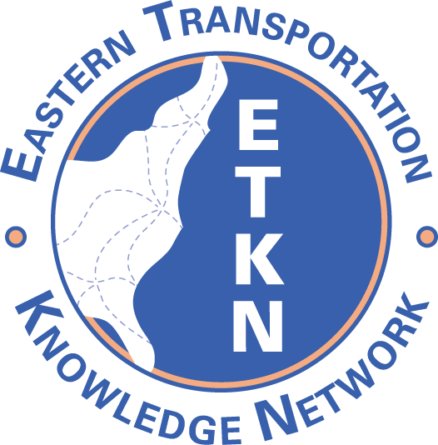

ETKN Meeting Agenda
May 27, 2010 10:30-11:30 AM EST

Conference Call- Dial-in number: 888-677-1306; Participant code: 8560699

- ETKN web site (www.etkn.org)
domain (expires 6/19/2010)
Price quotes – includes domain registration and page hosting:
Lunarpages and GoDaddy
12 months $107.40 (not available)
24 months $166.80 $151.36
36 months $214.20 $205.24

- Report on TKN chairs meetings

- Annual TKN Meeting in New Orleans,
Thursday June 17 @Milton H. Latter Memorial Library, 5120 St. Charles Ave., 9AM- 2 PM
  - Web conferencing capability will be available
  - Develop a strategic plan with NCHRP Report 643 as guide

- Report from NTL- Roger Garren , NTL Reference Librarian and Coordinator of the
Climate Change Clearinghouse http://climate.dot.gov/

- ETKN Projects -Thanks to all who participated in the resource sharing project and updated their statistics on the NTL page.

- ETKN Annual Meeting- Results of Doodle poll; Plan a web conference or meet at TRB in 2011

- Member news

- Next meeting: July 29 10:30-11:30 AM

