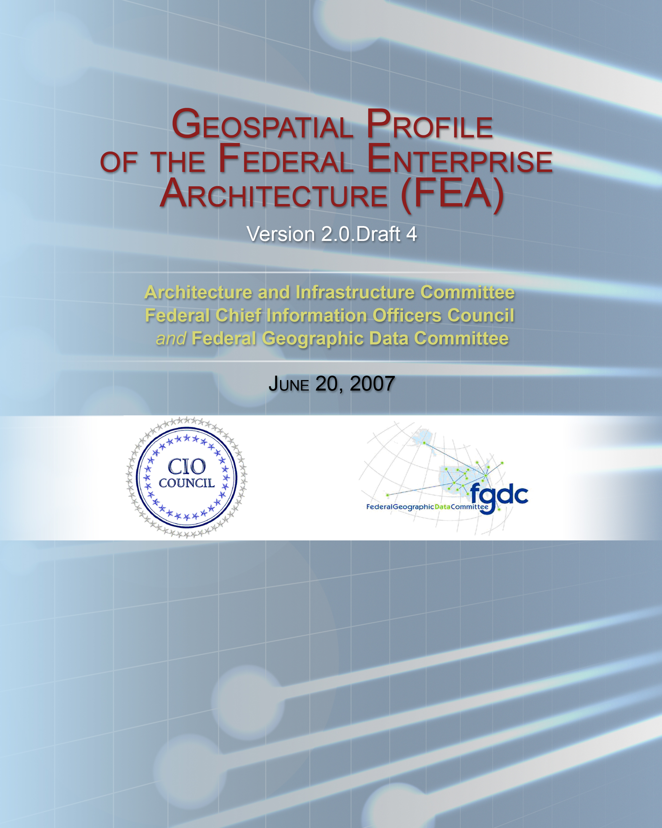
Table of Contents
Table of Contents ii
Executive Summary iIi
1 Introduction 6
1.1 Overview 7
1.2 Intent 8
1.3 Objectives 8
1.4 Intended Audience 8
1.5 Structure of the Document 10
2 Context and Background 11
2.1 Geospatial Data Are Everywhere 11
2.2 Advances in Geospatial Technology 13
2.3 Remote Sensing and Image Processing 14
3 Managing and Improving Geospatial Capabilities 24
3.1 Application of Geospatial Business Reference Model (BRM) to Geospatial Functions and Activities 24
3.2 Geospatial Service Reference Model (SRM) 30
3.3 Geospatial Data Reference Model (DRM) 37
3.4 Geospatial Technology Reference Model 47
3.5 Geospatial Performance Reference Model (PRM) and Program Maturity 50
APPENDIX A: References 57
APPENDIX B: Glossary of Terms 59
Appendix C: Methodology for Geo-enabling Business Processes 62
APPENDIX D: EXAMPLE Of GEo-Enabling Business Activities 70
APPENDIX E: Lines of Business and Geospatial APPROACHES 76
APPENDIX F: GEOSPATIAL SERVICE COMPONENTS 83
APPENDIX G: Geospatial Standards and Extended TRM 111
Service Platform and Infrastructure 111
Component Framework 111
Service Interface and Integration 115
APPENDIX H: GEA COP SUGGESTIONS FOR FEA CHANGES 123

Executive Summary
Knowledge of geographic space, places, and locations are integral to virtually all Federal, State, local, and tribal government decisions. Meanwhile, many government organizations do not effectively use place-based approaches to data, technologies, and services in support of their businesses. The Geospatial Profile of the Federal Enterprise Architecture (FEA) is a tool for chief architects to determine how and where place-based approaches and associated geospatial resources fit into their enterprise architectures as they implement the FEA reference models. It is also intended to facilitate discussions with government executives, program managers, and technical staff on how to enhance business operations and intelligence through geospatially enhanced enterprise architecture. This is accomplished by illustrating how to
- enhance the business processes that are essential for fulfilling agency missions with geospatial data, services and technologies;
- optimally collect, manage, and utilize geospatial data in efficient and effective ways within an enterprise architecture; and
- leverage geospatial standards and coordination efforts to enable the sharing of geospatial resources across an organization and with partners.
The Executive Office of the President, Office of Management and Budget (OMB), supports the development of the Geospatial Profile for the Federal Enterprise Architecture. The goal is to ensure that organizations have the means to architect, invest in, and implement geospatial capabilities in a coordinated way that supports Federal agencies and their data sharing partners. Chapter 1 outlines the vision, purpose, and intended audience for the Profile. Chapter 2 contains an overview of Federal geospatial data activities, coordination, and policies. Chapter 3 describes how geospatial perspectives, approaches, data, and technologies apply to each of the five FEA reference models. The appendices provide more detailed information on various geospatial topics.
The FEA “reference models” collectively comprise a common and consistent framework for describing important elements of the FEA. This Geospatial Profile brings a geospatial perspective to each of the five FEA reference models to facilitate consistent incorporation of geospatial resources into relevant activities of an agency and its collaborating institutions. Through the use of this common framework and vocabulary, information technology portfolios can be better managed and leveraged across the Federal government.
The information included in this Profile is intended to promote dialogue between those responsible for the parts of the enterprise architecture described in each of the FEA reference models and those responsible for geospatial resources within the organization. The intent is to incorporate, to the extent appropriate, geospatial approaches and resources into the overall enterprise architecture of an organization in support of the implementation of the organization’s mission goals and operations.

The FEA reference models are described from a geospatial perspective as follows:
The Business Reference Model (BRM)
The BRM provides a descriptive framework for business activities. The role of place or location is not often considered when modeling business processes because enterprise architects and program managers are often not aware of benefits that could be derived from place-based approaches. The Geospatial Profile provides program managers and enterprise architects with approaches for identifying when place and spatial distance are important to a business process and then how to incorporate geospatial data, services, and technology into those business processes.
The Service Component Reference Model (SRM)
The Geospatial Profile builds on and extends the FEA SRM by defining, classifying, categorizing, and recommending common, reusable geospatial “building blocks”—geospatial service components—for government computing environments. The section provides guidance to agencies on the Geospatial SRM implementation and use and how to align with and leverage other significant Federal interoperability and resource sharing initiatives.
The Data Reference Model (DRM)
This chapter provides a geospatial view of the elements of the FEA DRM. It addresses the components, interfaces and processes for implementing and managing an integrated, cohesive geospatial data policy. This includes data development, documentation, adoption of data sharing standards and protocols, and conceptual and logical design and modeling of the geospatial aspects of business data. The Geospatial DRM provides guidance to enterprise architects on approaches to describe geospatial data and metadata and align geospatial investments with the FEA DRM.
The Technical Reference Model (TRM)
This section of the Geospatial Profile extends the TRM to include geospatial capabilities. This is provided to encourage the standards-based integration of capabilities, particularly in a multi-agency information sharing and processing environment. Specifically, this chapter of the Geospatial Profile describes elements of proposed solutions using a standard geospatial vocabulary and categorization scheme. This facilitates the identification of overlaps and gaps (lack of standardization) and opportunities for sharing technical solutions and standards.
The Performance Reference Model (PRM)
The PRM provides a structure for analyzing inputs and outcomes and focuses on setting targets for action and measuring the degree of transformation achieved. The Geospatial Profile chapter on the PRM provides a tool for focusing scarce geospatial resources more effectively and for communicating the benefits of geospatial programs.

Introduction
Government agencies provide many services. The majority of these services can be tied to a location, such as an address, regulated or managed site, delivery route, or incident. Coupling business data with information about location provides an important context for organizational processes and can improve the delivery of governmental services. Location information is commonly referred to as “geospatial data or information.”
Why Geospatial?
The ability to store and analyze information in its geographic or geospatial context opens up areas for new and innovative applications. The technology is complex and yet has to fit within the context of a general enterprise architecture.
This Profile explains how this can happen.

Despite the potential benefits of incorporating geospatial capabilities into an agency’s business, many organizations have neither developed an effective means to manage geospatial information nor incorporated geospatial technologies and services to enable the implementation of their business processes. Use of this document is intended to increase awareness of:
- the dependency of government business on location and how geospatial technologies can enhance the ability to conduct their business;
- how to collect, manage, and utilize geospatial data in efficient and effective ways within their enterprise architecture; and
- means to leverage the geospatial standards and coordination efforts that promote the ability to share geospatial resources across organizations;
This document, the Geospatial Profile of the Federal Enterprise Architecture (FEA), provides approaches to address these issues. Additionally, the Geospatial Profile outlines approaches for developing a “geospatial architecture” that is nested and managed within the overall enterprise architecture of an organization. This will allow geospatial resources to be fully leveraged, as appropriate, by all aspects of the organization to support the agency mission. The approaches described within the Profile are provided within the context of the FEA reference models—the framework for the FEA—and can be adopted in the deployment of an agency enterprise architecture.
The Geospatial Profile, like the Security and Privacy and Records Management Profiles of the FEA, is defined by a horizontal segment that supports the traditional vertical lines of business. Rarely are geospatial activities conducted as a primary outcome; they are typically deployed in support of primary agency business processes that provide access to information in support of mission requirements. Although the isolation of geospatial capabilities in most organizations will be difficult, the identification of common geospatial capabilities that can be applied to meet a variety of needs is of benefit to the enterprise.
The applicability of the Geospatial Profile is not restricted to Federal EA; its scope and relevance are applicable to any organization interested in incorporating geospatial capabilities in their business activities. The activities of government agencies and other organizations, public and private, are often related to common geographic areas, creating opportunities to leverage interests in specific, common locations. Recognizing the common needs of multiple organizations, the Geospatial Profile promotes broad use of geospatial standards, data, and services among public and private sector entities.

Overview
The purpose of the Geospatial Profile is to provide chief architects a means to examine roles that location and geospatial resources play in agency business activities (enterprise architecture) and to ascertain how to best incorporate geospatial resources into the mainstream business and IT operations of an agency (“geo-enablement”). Ultimately, the Geospatial Profile is intended to help chief architects consider collaborative approaches for creating, using, and managing those geospatial resources within their organizations and between organizations.
The Geospatial Profile uses the five FEA reference models as a framework for the approaches outlined as they are the overarching structure by which Federal agency designs its enterprise architecture and formulates information technology (IT) investment strategies. This Profile, like other FEA Profiles, provides guidance on how to incorporate this cross-cutting discipline in the context of the FEA reference models and the many FEA Lines of Business where it may apply. The development of this profile is sponsored by the Architecture and Infrastructure Committee (AIC) of the Federal Chief Information Officers Council in partnership with the Federal Geographic Data Committee (FGDC).
The Geospatial Profile facilitates the ability to “geo-enable” business and enterprise architecture of agencies. The phrase “geo-enable” includes three constructs in this Geospatial Profile. The first is to develop an infrastructure of staff and services that work together to provide geospatial resources in support of the organization’s business. The second is to identify the business activities that depend on location and to support them with appropriate geospatial data and services to improve services. The third includes the incorporation of geospatial functionality into traditional databases not previously optimized to support geospatial information and services. A “geo-enabled process,” whether from a business or technology perspective, is one that generates, uses, or displays digital geospatial data. A “geo-enabled” organization optimizes the ability for the agency to use geospatial resources.

Intent
The Geospatial Profile will provide chief architects and program managers with the tools to incorporate geospatial approaches, data, and associated technologies into the agency enterprise architecture to improve business in ways not previously imagined. This will allow architects and program managers to leverage and reuse geospatial resources in standard, cost-effective, and efficient ways within the overall agency EA.

Objectives
The overall objectives of the FEA Geospatial Profile include the following:
- Provide guidance to chief architects and program managers on ways to take advantage of geospatial capabilities consistent with the requirements of the FEA and emerging OMB guidelines.
- Provide guidance to architects on how to develop, represent, and evaluate geospatial architecture and incorporate it into mainstream IT infrastructure and operations
- Provide a framework for improving the interoperability of geospatial architectures across all levels of government.

Intended Audience
The Geospatial Profile is intended for many audiences; however, the primary audience includes enterprise architects, Geospatial Information Officers, and those managing enterprise architecture programs. The document has been organized to target specific stakeholders involved in developing aspects of the enterprise architecture. Additional audience types that may be considered in consultation include the following:
- agency executives, business owners, and program managers who support activities where location matters;
- information technology planners and implementers, including Chief Information Officers (CIO) and Geospatial Information Officers (GIO); and
- geospatial resources experts, including discipline practitioners, data stewards, portfolio managers, capital planners, solutions providers, and geospatial vendors and consultants.
Participants and their roles in the development and execution of a broad-based geospatial enterprise architecture are described in Exhibit 1–1.

Exhibit 1–1: Potential FEA Geospatial Profile Audiences and their Roles and Responsibilities

Role | Responsibility and Use of the FEA Geospatial Profile
Agency Executive | Provides general oversight, direction, leadership for an agency or a major program in an agency. Will use the Geospatial Profile to better understand how geospatial resources and activities can support the agency mission.
Chief Enterprise Architect | Develops and promotes implementation of the enterprise architecture within an agency. Will use the Geospatial Profile to incorporate geospatial activities with the FEA of the organization. Will likely interact with the Geographic Information Officer (GIO) and the Senior Agency Official for Geospatial Information (SAOGI), and Program Business Managers.
Chief Information Office (CIO) | Manages agency information resources. Will use the Geospatial Profile to better understand and manage geospatial resources as a component of information resources. (Note: CIO, GIO, and/or SAOGI may be the same individual in some agencies.)
Geospatial Information Officer (GIO) | Oversees development and use of geospatial resources within an agency. May serve as the primary technical officer and developer of geospatial architecture. May serve as the SAOGI to oversee investments. Will use the Geospatial Profile as a framework to design and build the geospatial architecture, to integrate geospatial aspects into the overall enterprise architecture , to ensure compliance with standards, and to promote intra- and inter-agency interoperability.
Senior Agency Official for Geospatial Information (SAOGI) | Accountable for fiduciary aspects of geospatial resources and acts as the agency representative to the Federal Geographic Data Committee Steering Committee. May be the GIO and/or CIO. Will likely serve as the champion for the geospatial architecture, especially if there is no GIO. Will use the Geospatial Profile to work with business managers to geo-enable business processes. Specified by OMB as a required position in Federal agencies.
Program Business Managers | Administers the business of an agency, drives decisions about investments, and plans and budgets program-specific applications of geospatial approaches and technologies. Will examine business needs from a location or place-based perspective and determine georeferencing, geospatial data, and application requirements needed to achieve program goals and objectives. Will use the Geospatial Profile as a road-map for analyzing business needs and select appropriate approaches for data, services, and technologies.
Geospatial Resource Experts | Develops and supports the use of geospatial data, services, and associated technologies within the overall enterprise architecture of the agency. Works with Program Business Managers to ensure that the geospatial services needed to support their business are operational. Specific technological expertise is often useful in identifying opportunities for location-based business approaches. It is essential to include Geospatial Resource Experts as part of an overall target architecture design effort to ensure that opportunities to incorporate place-based approaches are realized.

Structure of the Document
The Geospatial Profile is organized to provide an understanding of the importance of geospatial resources and approaches to appropriately using those resources in support of an organization’s business. The structure builds on the FEA reference models and provides a clear means to link these models through a methodology for a geospatial architecture fully integrated with agency enterprise architectures. Examples, terminology, and standards are provided as appendices. The document is structured as follows:
- Chapter 1 provides an introduction, overview, discussion of audience, and vision for the Geospatial Profile.
- Chapter 2 provides contextual and background information, describing why a profile is needed. The chapter describes the nature of geospatial data and location, the policy objectives and approaches taken by OMB to coordinate geospatial data, current coordination activities, recent technical advances in geospatial technology, and the component models of the FEA. The chapter will be of interest to chief enterprise architects and others who do not have an extensive background in geospatial resources.
- Chapter 3 provides a summary of each of the FEA Reference Models, how they link together, and how geospatial resources relate to each. The concepts in this chapter provide the basis for developing the geospatial architecture segment of the overall agency enterprise architecture. Agency enterprise architects will find this chapter of interest, as well as business managers and geospatial staff who want to better understand how the FEA can support their activities.

Context and Background
This chapter provides context and background for development of the FEA Geospatial Profile. Included are an introduction to geospatial capabilities, policy origins and implications, and institutional support for geospatial coordination. Geospatial standards, policies, capabilities, and services have been established within the government over the years. These are described so that they may be incorporated into the business architecture of government. Existing geospatial initiatives are described to increase awareness of and access to available data and services.

Geospatial Data Are Everywhere
Location is inherent in many endeavors. People frequently put information in a geospatial context: where they live, where they work, how far they commute, where they vacation, distance to relatives, or tracks of storms. In addition, they think in terms of spatial boundaries (What is the population of the county or school district? What is the average home price in this neighborhood? What is the range of their wireless router?). Geospatial data come in many forms, including street addresses, highway names and markers, latitude-longitude coordinates, and maps of facilities or resources of interest. Geospatial data, when processed, often with other data (such as the name of an individual, a particular building, the name of a hurricane, or the victims of an accident), becomes geospatial information. Locational data occurs almost everywhere, but not necessarily in the form of maps. What has changed is that all these forms of data can now be reduced to interoperable digital forms and used to answer many questions.
Geospatial information is also used in a variety of organizational settings. Examples of information and use include property records, building addresses, routing vehicles, species ranges, crime patterns, electronic health records, traffic congestion, utility networks, hazardous waste management, airspaces, watersheds, election results, satellite and airborne imagery, etc. Organizations that may benefit from the incorporation of geospatial information and capabilities include asset and personnel management; natural resource, environmental, health, and transportation agencies; and homeland security, intelligence, and defense.
A common use of geospatial information is in emergency planning and response. For example, a forecast of the progression of the track and intensity of a hurricane is based on geospatial information and is shown in Exhibit 2–1.
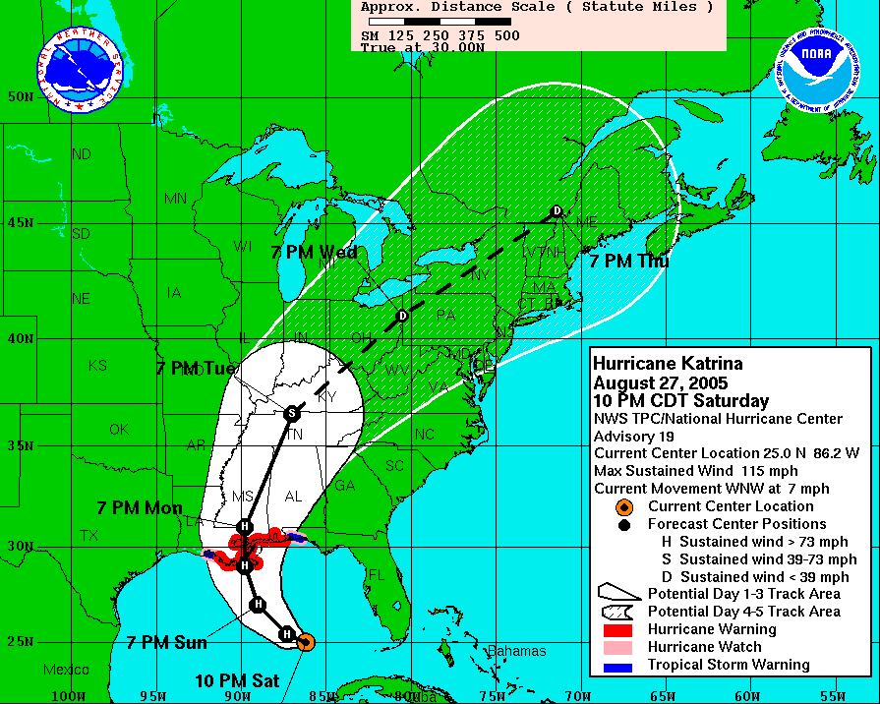
Exhibit 2–1: Predicted Path and Intensity of Hurricane Katrina over the Gulf Coast and Inland States

Geospatial information includes not only information that is obvious to most people such as driving routes and maps, but also other types of data, including elevations, satellite imagery, and location information acquired from a global positioning system (GPS). Additionally, location is often an important feature of other types of information that many people may not think of as geospatial:
- Human resources systems capture the location of office buildings and rooms as well as home addresses for each employee.
- Inventory and asset management systems generally identify where a piece of equipment is stored or used.
- Business performance reports often itemize results according to an organization’s regions or jurisdictions.
- Grants and funds to cleanup or address specific community concerns are often distributed based on proximity to population centers or other relevant factors.
Other situations may require that a moving asset or phenomenon may be tracked according to its geographic location. Examples of a moving asset can include aircraft, trucks, vessels, or even individuals on a watch list. Commercial companies such as Federal Express track every truck and package.
Business operations based on the use of location, as well as collaborations in effective use of geospatial information, can provide government and private sector organizations with many benefits, such as
- geographically referenced, or geospatial, information that provides a means for organizations to collaborate with other government agencies or organizations, particularly in times of emergencies or where rapid decisions are needed for business purposes;
- common semantics and functional capabilities as components of shared geospatial partnerships that contribute to inter-agency and inter-governmental interoperability;
- spatial data infrastructure services and networks in the Web environment that describe the availability of geospatial data and services to facilitate development and use of geospatial information and functionality within organizations;
- geospatial information resources created and documented using standards (e.g., metadata) by many organizations, making the resources potentially accessible and usable to many others; and
- coordination mechanisms and examples of partnerships for shared data acquisition within the geospatial community to serve as models for those new to the use of geospatial resources.
The geographic tagging of business data can be a key element in business process re-engineering, and can result in large returns on investment in terms of improved workflow and resulting resource savings.

Advances in Geospatial Technology
Several advances over the last 30 years have contributed significantly to the ability to productively use geospatial data within business processes. Although these represent general advances in the world of computing and networking, geospatial applications and processing would not have evolved as quickly without them. For example, the advances in both computer processing power and telecommunications capacity ensure that large and complex geospatial data files can be processed more efficiently and in a timely manner. Several of these advances critical to geospatial architecture are described in this section.
Technologies and data that were either completely unavailable, or highly costly and restricted to skilled and uniquely trained staff, are now available widely at reasonable or even no cost to millions of individuals. Non-expert professionals are now able to take advantage of geospatial information on the desktop, owing to popular applications that run through a Web browser or a downloadable general-purpose client.

Geographic Information Systems (GIS)
A geographic information system, or GIS, is often defined as the hardware, software, data, and skilled staff needed to capture, manage, analyze, and display geospatial information. GIS, originally known as “computer mapping,” originated in the early 1960s. For many years agencies that bought and attempted to use GIS software were faced with a significant level of effort to digitize or geo-code their data in a way that allowed the hardware and software to manipulate those data. Increasing availability of data based on significant investments and thousands of organizations using GIS and the proliferation of means to share those data (e.g., via the Web) have made it far easier to access and use GIS software to address real issues.
Initially GIS were thought of only as a mapping tool that served as a barrier to integrating geospatial analysis into operational business process. Over the last decade, software companies have increasingly added functionality to GIS and these tools now support complex data management and analytical functions. This includes the means to link thousands of attributes to location and model relationships within those data.
Over the last decade, the cost of GIS hardware and software has also decreased significantly. This allows a variety of tools to be accessible to nearly any organization with the interest in managing data based on location.

Global Positioning System (GPS)
The Global Positioning System (GPS) is a satellite system that provides the means to capture highly accurate location information via GPS receivers. GPS devices allow staff to locate facilities or sites with significant accuracy often using hand-held devices with basic mapping capabilities to collect location data and either uload the position data via wireless networks or through office networks. A number of vendors have Differential GPS services that provide better accuracy than the nominal 15 meters offered by GPS. This supports the collection of more precise positions required by some business practices (e.g. facility management, emergency response). These capabilities allow agencies to affordably collect and then use or share locational information where such positions are linked into the mission databases and systems.

Remote Sensing and Image Processing
Satellites and aircraft have collected increasing volumes of digital data in multiple spectra and formats that provide almost limitless means to measure and examine features and phenomena on the Earth’s surface. Additionally, GIS and image processing software have evolved to provide the means to integrate a multitude of data formats and resolutions to support the means to fully utilize remotely sensed raster data with traditional map (vector) information. Continuously increasing quantities of accessible and usable remotely sensed data offer rich opportunities to monitor trends, changes, and characterize locations. Many commercial organizations have begun to use remotely sensed data in the services they are providing on the Internet (e.g., Google Earth and Microsoft Live Local) that are popularizing the visualization of place-based information.

Geospatial Simulation Models
Advances in computer technology—processing speeds and storage, in particular—have made it possible to run complex models that rely on massive volumes of data, as geospatial data activities frequently do. Many types of modeling applications are increasingly available (many at no cost) for different business purposes, including contaminant plume modeling, agricultural crop models, epidemiology, urban development, and scenario simulation. Simulation models become a realization of business processes that are driven by mission requirements that address phenomena in a geospatial context.

Geospatial Web Services
Web services provide a means to support sharing and application of geospatial data. Information that has an associated location can be used in geospatial queries, analyses, intelligence, and visualization over the Web. Combinations of data from different sources may be needed to provide an integrated view over time of events, tracked entities, and their locations to support decision-making during operational planning, preparedness, prevention, response, and remediation. An example of such a service is Fire Weather Forecasting as shown in Exhibit 2–3.
Geospatial Web services process data and information to support and address specific user requirements. Geospatial Web services can cut across all lines of business in a multitude of applications. Systems that process geospatial information have tremendous potential to integrate information from seemingly disconnected activities and a variety of sources. Geospatial services can be used to transform, manage, or present geospatial information to users. Examples of geospatial services of potential use by many business applications include:
- displays of agency information using map backgrounds to visualize situations or events and include other relevant geographic features and entities of interest,
- determinations of the geographic coordinates corresponding to an address (geo-coding),
- identification of routes and directions for navigating from one location to another,
- queries to retrieve geospatial information based on geographic regions and/or political boundaries, and
- conversion of geographic data from one coordinate system to another.
Geospatial services may be made accessible to users through Web browsers, Web-based applications, or desktop client applications.

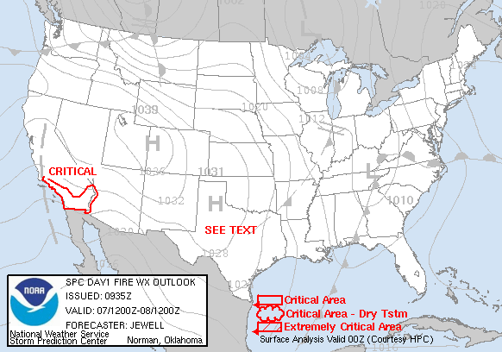
Exhibit 2–3: Fire Weather Forecasting - Example of a Geospatial Web Service

Policy Context for Geospatial Resource Sharing
OMB Circulars, Presidential Executive Orders, and other strategic initiatives have provided guidance specific to geospatial data and generally to the management of information resources for approximately 50 years. The requirement has been for a more effective creation, use, and dissemination of geospatial resources across the federal government promoted through various coordination activities. This Geospatial Profile builds on and supports the policies and initiatives described in the following sections. These are important factors in the design of agency enterprise architecture as your organization can leverage government-wide investment in a national geospatial infrastructure.

Office of Management Budget (OMB) Activities
OMB policies and directives are pivotal to coordinated development of national geospatial data resources because they provide the policy framework for the development of common government investments in business and IT. Here are some of the key activities:
- OMB Circular A–16 was originally issued in 1953, revised in 1967, 1990, and 2002. The purpose of the 1953 circular was “to insure (sic) that surveying and mapping activities may be directed toward meeting the needs of federal and state agencies and the general public, and will be performed expeditiously, without duplication of effort.” Circular A–16 describes the management and reporting requirements in the acquisition, maintenance, distribution, use, and preservation of geospatial data, including specifically the development of various common themes of data and metadata most prevalently used to support government business processes. Additionally, the Circular establishes and clarifies the responsibilities of the Federal Geographic Data Committee and development of the National Spatial Data Infrastructure (NSDI).
- OMB Circular A–119 specifies that Federal agencies will develop their geospatial data and technologies in compliance with international voluntary consensus standards, as defined by the circular. Use of these standards enables consistency and increases the ability to share data and reproduce various analytical operations. across organizations
- OMB Circular A–130 directs that Federal agencies manage and make accessible all public information (including geospatial resources) at no or low cost through established policies for the management of Federal information resources.
- The E-Government Act of 2002 addresses geographic information in Section 216 (“Common Protocols for Geographic Information Systems”). The purpose is to reduce redundant data collection and information and to promote collaboration and use of standards for government geographic information. Section 216 assigns responsibilities for common protocols for ensuring the compatibility, accessibility, and interoperability of geographic information.
- The OMB FEA Program Management Office’s (PMO) 2005–2006 Federal Enterprise Architecture Action Plan (March 2005) includes a strategic initiative, “Create a Geospatial Profile,” which is described as follows: “The FEA PMO is supporting geospatial efforts through its FEA reference models and contribution towards establishing a Geospatial Profile. The FEA models will help define information in terms of a common service component that will assist in leveraging geospatial services across Federal, State, local and tribal agencies ... The purpose of this profile is to provide a consistent framework that can be applied within and across agencies to identify the geospatial implications across lines of business.
- OMB Memorandum M–06–07: Designation of a Senior Agency Official for Geospatial Information. OMB asked 27 executive departments and agencies to designate a senior agency official who has agency-wide responsibility, accountability, and authority for geospatial information issues to assist agencies and ensure consistency across the government. Among other responsibilities these individuals oversee, coordinate, and facilitate an agency’s implementation of geospatially related requirements and represent their agency on the Federal Geographic Data Committee.
- OMB has directed 25 agencies to participate in the Geospatial Line of Business in February 2007. The purpose of the Line of Business is to develop a common solution to ensure effective and efficient development of
- productive intergovernmental collaboration for geospatial-related activities and investments across all sectors and levels of government;
- optimized and standardized common geospatial functions, services, and processes that are responsive to customers; and
- cost efficient acquisition, processing, and access to geospatial data and information.

The National Spatial Data Infrastructure
The National Spatial Data Infrastructure (NSDI) was initiated by OMB in the early 1990s to develop the technology, policies, standards, human resources, and related activities necessary to acquire, process, distribute, use, maintain, and preserve geospatial data. Its goal is to enable geospatial data from many sources (including Federal, State, local, and tribal governments, academia, and the private sector) to be used together to enhance users’ understanding of the physical and cultural world. Executive Order 12906 issued in April 1994 outlined the major components of the NSDI, including a clearinghouse, framework data, and metadata. Are all considered part of the NSDI and need to be taken into consideration when developing an agency enterprise architecture. Where they align with your business process requirements, determine if existing external capabilities can be re-used instead of creating this capability internally.
The Federal Geographic Data Committee (FGDC), Geospatial One-Stop (GOS), and The National Map are three national geospatial initiatives that share the goal of building the NSDI. FGDC focuses on policy, standards, and advocacy; GOS focuses on discovery and access; and The National Map focuses on integrated, certified base mapping content. The National Geospatial Programs Office (NGPO) of the USGS is the organizational host for these complementary activities.

The Federal Geographic Data Committee (FGDC)
For the past 16 years, the FGDC has provided coordination for geospatial data activities at a national level. The FGDC has membership from Federal departments and independent agencies and maintains liaison with non-Federal governmental and professional organizations. The committee structure is composed of agency-led subcommittees and Working Groups. Subcommittees are organized by data themes such as transportation, cadastral, and hydrography. Working groups play a crosscutting role, dealing with issues that span many of the subcommittees.
The FGDC facilitates the establishment and implementation of strategic guidance and specific actions that support improved collection, sharing, dissemination and use of geospatial data, as well as standards development. For example, the FGDC Standards Working Group (SWG) actively promotes, coordinates, and provides guidance on geospatial standards policy and procedures. It facilitates coordination among the FGDC subcommittees, and reviews and makes recommendations on the approval of standards proposals, draft standards for public review, and draft standards for FGDC Steering Committee endorsement.

Geospatial One-Stop (GOS)
The President's E-Government Strategy identifies Geospatial One-Stop (GOS) as the component of the NSDI that provides a single-point of access to map-related data. It also provides the primary user interface to the NSDI Clearinghouse and serves as the register of datasets. A registry for planned dataset acquisitions via a “marketplace” functionality, is another component of GOS that enables users to coordinate and potentially share geospatial data acquisition costs. The GOS portal system has a registry/catalog that contains the metadata records for current datasets and planned data acquisitions. The portal also provides access to “geospatial services,” such as Web-based mapping.
Most data cataloged in GOS are not Federal data. The most accurate and up-to-date are data that are collected, maintained, and used locally.

Conceptual Architecture of the NSDI

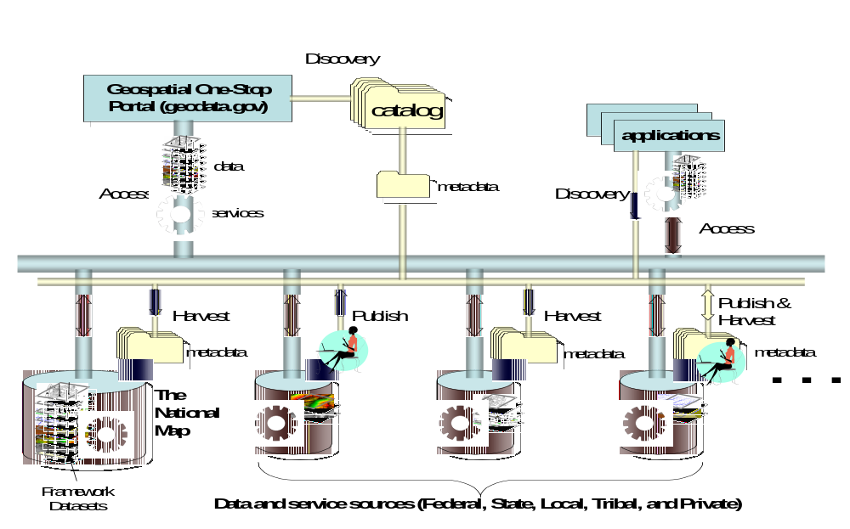
Exhibit 2–2: Key Technology Components of the National Spatial Data
Infrastructure (NSDI)

The “thin network” corresponds to the ability to discover, harvest, and publish metadata, and can be thought of as the Clearinghouse network. Metadata can be published to the Geospatial One Stop (GOS) catalog or a local metadata collection. Local metadata can be harvested to populate another catalog, such as the GOS catalog. Local metadata collections or GOS can be searched via distributed search protocols to perform discovery on behalf of an application. Metadata can be published into any of the catalogs that allow this capability, and in this way, participants in the NSDI do not necessarily have to host a Clearinghouse node to participate as publishers of metadata.
The “thick network” corresponds to the ability to access data and services made available via “common geographic protocols.” Once an application (or the GOS portal) knows that a dataset and/or that a service exists, then the application can access the service and make use of it.
The National Spatial Data Clearinghouse is an electronic service providing access to documented geospatial data and metadata from distributed data sources nationwide, each with a catalog, describing their data and/or services. Under the various OMB and Executive Office initiatives, Federal agencies are required to use FGDC data content standards and the FGDC Content Standard for Digital Geospatial Metadata, and to make metadata available online through an NSDI-registered catalog.

The National Map
The National Map is another key component of the NSDI. It contains much of the “framework” and other key content described in OMB Circular A–16 generated by Federal agencies. Data sets currently in the National Map include
- high-resolution digital orthorectified imagery from aerial photographs or satellite imagery that will provide some of the feature information now symbolized on topographic maps;
- medium-resolution surface elevation (land) data;
- vector data for hydrography (rivers and water bodies), transportation (roads, railways, and waterways), structures, government unit boundaries, and publicly owned land boundaries;
- geographic names for physical and cultural features to support the U.S. Board on Geographic Names and other names such as for highways and streets; and
- additional earth science data (geology, land cover, land use).

In summary, the NSDI is intended to support the business of agencies and organizations across and beyond the Federal government as follows:
- provide access to geospatial data and services by Federal, State, local and tribal agencies, private businesses, academic organizations, and the general public via implementation of the Clearinghouse network and Geospatial One-Stop;
- enable the widest possible use of geospatial data and services by ensuring that providers and users have knowledge of lineage and quality and have security level of data and services via metadata publishing;
- facilitate sharing of data and services through standards and specifications for interoperability via the standards adopted by the FGDC;
- provide a user-oriented delivery system enabling multiple means of delivery; and
- ensure that redundancy and waste are minimized via the sharing of data and services.

Geospatial Standardization Organizations
There are several other organizations that contribute to the effective use and sharing of geospatial data and services through standards and specification development. These are adopted by the National Spatial Data Infrastructure and provide key resources for reference by the FEA Technology Reference Model. Two of the major standards organizations are described below.
International Organization for Standardization Technical Committee 211 (ISO/TC 211)
ISO is the world's largest developer of standards. Within ISO, the Technical Committee 211 (ISO/TC 211) Geographic information/Geomatics is responsible for the geographic information series of ISO standards. It is the internationally recognized standards body for the geospatial community with representatives from 29 different countries. ISI/TC211 has published 32 standards related to digital geographic information.
The International Committee on Information Technology Standards, Committee L1 (INCITS L1) is the U.S. Technical Advisory Group to ISO/TC 211. The work of L1, Geographic Information Systems (GIS) consists of adopting or adapting information technology standards and developing digital geographic data standards. Digital geographic data standards are concerned with creating, defining, describing, and processing such data.
Open Geospatial Consortium (OGC®)
The Open Geospatial Consortium (OGC) is a non-profit, international, voluntary consensus standards organization that is leading the development of standards for geospatial and location based services. The OGC represents an industry consortium of over 300 companies, government agencies, and universities participating in a consensus process to develop publicly available interface specifications. OpenGIS® Specifications support interoperable solutions that “geo-enable” the Web, wireless and location-based services, and mainstream IT. The specifications empower technology developers to make complex spatial information and services accessible and useful within a wide variety of applications. OGC maintains a close working relationship with ISO/TC211 and the two organizations engage in a joint standards development process. This results in standards that are “double-branded” as ISO and OpenGIS® standards.

Managing and Improving Geospatial Capabilities
This chapter is intended to assist architects in examining, defining, and improving various agency activities by designing an enterprise architecture that contains a geospatial component as part of the whole. The process for achieving this is outlined through examining how geospatial capabilities fit into the five FEA reference models: business, services, data, technology, and performance. To aid in the development of the geospatial component of an enterprise architecture, a vocabulary has been established to clarify geospatial terminology. The Geospatial Business Language can be found in Appendix B. These terms serve as a starting place for agencies to use in defining the geospatial aspects of their enterprise architectures and business functions.
Although the FEA Reference Models provide a convenient framework for the appraisal and execution of Federal enterprise activities, other resources may be worth considering in the discovery and declaration of geospatial capabilities:
- Agency Strategic Plans may be useful in identifying the geographic context or functionality required to meet strategic goals.
- Exhibit 300 and PART documentation for Federal activities may contain reference to requirements and plans that may include geospatial capabilities.

Application of Geospatial Business Reference Model (BRM) to Geospatial Functions and Activities
Supporting and adding value to an agency’s business processes is the motivation for all architecture efforts. This chapter illustrates how coupling geospatial data, services, and technologies with conventional data, services and technologies can be a significant enabler of better business decision-making and improved mission performance. This section discusses how these approaches and subsequent improvements can be accurately documented in an agency’s business architecture. It provides managers with a clear reference on where geospatial approaches are, or could be, applied throughout the enterprise. It also summarizes the purpose of the FEA Business Reference Model (BRM) and how architects can use the BRM to describe geospatial support activities within an agency.
Appendix D contains a structured process that an architect can provide to a business manager to facilitate Geoenabling an individual business function to improve the workflow of that process for end-user benefits to citizens. If utilized consistently throughout the organization the geospatial architecture will evolve to produce the best combination of infrastructure services necessary to support the wide array of geospatially-enabled services to citizens. With today’s technology, the use of geospatial information within a business process can and should be entirely transparent to the user. Geospatial services no longer require users to be experts in the technology and mathematics that make such services possible.

Introduction to the FEA BRM
The FEA BRM is a function-driven framework for describing the business operations of the Federal government as “lines of business” (LoBs) independent of the agencies that perform them. The BRM categorizes the LoBs into four business areas: Services for Citizens, Mode of Delivery, Support Delivery of Services, and Management of Government Resources (Exhibit 4–1).

Services for Citizens

Services for Citizens are the ultimate purpose and mission of government, essentially the functions that the executive branch delivers and for which it is accountable. All other business areas within the BRM are a means to achieving Services for Citizens. Enterprise 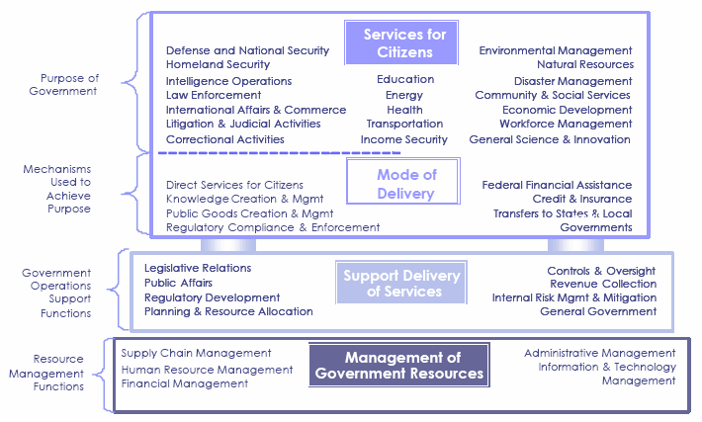
Exhibit 3–1: FEA BRM Overview

Enterprise architecture’s ultimate purpose is to improve the quality and efficiency of these top-level citizen services. All of the high-level LoBs delineated within the FEA BRM are associated with a location that can be supported and improved by geospatial capabilities (See Appendix D and Exhibit 4–2).

Exhibit 3–2: Example of “Services for Citizens” Natural Resources Line of Business
(See Appendix D for additional LoB examples)
Business Area | Line of Business | Primary or Secondary Element—Line of Business Description | Geospatial Aspects of the Activities
Services for Citizens | Natural Resources | Primary—all activities involved in conservation planning, land management, and national park/monument tourism that affect the Nation's natural and recreational resources, both private and Federal. | Establishing and managing outdoor recreational areas  Planning and managing timber production and economic effects on nearby communities.  Assessing biological health of wildlife populations and planning for species which may be at risk  Collecting and maintaining basic mapping data for use in all government and services programs  Conducting seeding, replanting or other rehabilitation actions after wildland fires  Analyzing and defining areas suitable for conservation

Mode of Delivery
The Mode of Delivery layer of the BRM represents the mechanisms used to achieve Services to Citizens, not the services themselves. It identifies how the government delivers a high-level of service. For example, the Federal government can deliver health care to a citizen directly as a “civilian operation,” providing emergency responders at the scene of a disaster; indirectly as “research and development,” through a researcher discovering a cure for a disease; or by proxy, through “Federal financial assistance” that supports a State employee working under a Federal grant. Many of the modes of delivery can be geo-enabled, and as a result improve the outputs and outcomes for a particular Service to the Citizen. For example, the use of a route-finding application within a GIS (Geographic Information System), with an aerial photograph backdrop in the GIS will make it easier for crews to find their way and help in preplanning responses by identifying better routes for emergency responders. Mode of Delivery does not define any form of “geospatial services” as such a mechanism.

Support Delivery of Services
Support Delivery of Services represents government functions that provide the means to the support top-level citizen services. These functions are cross-cutting—able to support a range of Services to Citizens—but they link closely to the specifics of those services. For example, all agencies enact controls and oversight to monitor their programs, but each agency tailors its controls and oversight to its own set of services. Overseeing a securities audit is entirely different from overseeing a soldier in the field. Many of these functions can benefit from a geospatial approach. However, most of these functions can be greatly enhanced by taking a place-based approach. For example, public affairs might conduct outreach to potential applicants by identifying areas of under-served populations, or advocates for specific communities might examine issues of environmental justice based on where people live, the demographics of the affected population, and the types of pollutants present in their neighborhoods.
If an agency has a program whose specific purpose is to design improved ways to deliver and coordinate geospatial services, that program’s function is appropriately placed at the Support Delivery of Services layer of the BRM. This is discussed further below.

Management of Government Resources
Management of Government Resources is the other set of BRM support functions, but unlike those listed under Support Delivery of Services they are only loosely tied to an agency’s mission. They include functions such as financial management, human resources management, and information technology management—functions that are mostly the same at every agency, needing little tailoring to mission specifics. For instance, the government manages timecards and delivers paychecks to every government employee, regardless of the agency of employment. Geospatial approaches to these functions might include better understanding the allocation of grant dollars based on location or tracking employees and their commutes at specific facilities. If any agency specifically separates out its management of geospatial data and technology, these geospatially specific “back office” aspects of information technology and information management, can be appropriately classed as an additional sub-function of Management of Government Resources. Understanding how these services can optimally be supported is an important component of a geospatially-aware architecture and is required for geo-enabling an organization.

A critically important architectural endeavor is identifying and incorporating geospatial technologies into the mainstream IT architectures and portfolio management processes to obtain this optimization. As an example, determining how to use the existing communications backbone and net-centric technologies to convey necessary mapping data and capabilities to the appropriate offices across an organization or the Federal government is critical. Also key is identifying the extent to which many missions within an organization have duplicated acquisition of Geospatial capabilities through project/ program specific initiatives. Completing this exercise enables enterprise perspective and enables an organization to gain economies of scale from the shared services, data and infrastructure across mission and functional areas.

Geo-enabled Organizations
A geo-enabled organization is one that deploys the staff and technological infrastructure necessary to provide enterprise geospatial data, services, and technological support to business processes across an organization, while also promoting economies of scale and reuse. This includes supporting agency-wide access to geospatial data and services for multiple business processes and deploying mechanisms for external partners to access the agency geospatial assets. A successful team will engage in effective outreach and communications appropriate to different audiences within the enterprise to identify business processes that may benefit from place-based approaches. Once these are identified, they will work closely with business process and program managers to aid in geo-enabling these processes.
Successfully geo-enabled organizations recognize that senior management must be engaged to support ongoing integration of geospatial practices in the business architecture. At the implementation level, the organization must also promote the adoption of standards and geospatial policies among all current and potential users. A geo-enabled organization will support mission programs in the development of their own geospatial architectures consistent with the larger enterprise geospatial infrastructure to
- identify program geospatial data needs;
- procure, maintain, store, and share program-specific data;
- identify program geospatial service component needs; and
- procure, maintain, and share geospatial service components at an agency level or through www.core.gov.
This chapter offers insight on how organizations can take advantage of geospatial information and associated software and technology to increase support to business processes. Achieving benefits from geo enabling an organization depends on clearly understanding the role that geospatial data and services play (or can play) in the business of an organization. It also depends on developing an awareness of the geospatial infrastructure that exists (or should exist) within an agency to support integrating geospatial resources and architecture into the mainstream business and IT operations. Geo-enabling business processes results in the “payoff” for a geospatial architecture—where productivity is enhanced and services are delivered better, faster, or cheaper.

Applying a Geospatial Lens to the FEA BRM
The primary function of the BRM is to map an agency’s functions—existing or planned—to the consistent LoBs that the BRM defines. As noted above, virtually all high-level mission functions (Services to Citizens)—from administering justice to providing national defense—can make use of geospatial capabilities. Similarly, almost all support services, whether they are closely tied to the mission (Support Delivery of Services) or are more generic back office functions that change little from agency to agency (Management of Government Resources) can also benefit from geospatial technology.
One use of the BRM, therefore, is to use it as a map of potential sub-functions that might be geo-enabled by the approach suggested in Appendix C.
A second and essential use of the BRM, however, is to document common geospatial support functions that an agency uses to deliver planning, governance, data, and IT support to its growing catalog of geo-enabled business processes. These are separate from the geo-enabled business functions. An analogy is that all functions of an agency are subject to its budgetary process, but the agency budget process itself is separate and identified as such within Management of Government Resources.
Various geospatial support functions operate as the budget process does, providing management and coordination across other functions—finding opportunities for reuse. For example, data sets that are common for one agency or application may also be important for a very different mission or LoB. For example, transportation (map of road infrastructure) and address information can support emergency responders, evacuations, environmental assessments, or address matching. Geo-enabled processes geospatial support services can draw on a common library of geospatial data sets and technical services. Management of this common library should be recognized as a separate business sub-function and specifically mapped within an agency’s BRM. To increase economy of scale and reusability, architects will also want to examine existing and emerging geospatial services arising from FGDC and Geospatial LoB activities and determine whether they can be utilized as opposed to developing these capabilities internally.
A Geospatial Line of Business was proposed by OMB in 2006. This will be supported as a cross-cutting LoB for reference by agencies that conduct geospatial functions and deliver geospatial data as a primary agency mission. Until the FEA BRM is amended in future budget cycles to recognize the new Geospatial LoB, and for BRM categorization of mission-supportive geospatial capability, agencies can adopt the proposed sub-functions as third-level lines of business (e.g., functional breakouts under existing FEA sub-functions):
- Geospatial Policy, Governance, and Planning can be placed as a sub-function of Enterprise Architecture;
- Geospatial Services can be placed as a sub-function of IT Infrastructure Maintenance; and
- Geospatial Information and Services Dissemination can be placed as a sub-function of Information Management.
The BRM sub-functions discussed above answer the first set of questions asked above. But not the follow-up question: “if a business function becomes “geo-enabled,” as discussed in Chapter 3, how is that reflected in the BRM?” The answer is that it is not reflected, as such, in the BRM. The geo-enabled process would map to the geospatial data sets that it uses, or to the geospatial applications or technologies that it uses. But the business process itself remains mapped to its core mission/business function. A grant review function, even if geo-enabled, is still a grant review function. A geo-enabled emergency response function is still an emergency response function. They happen to make use of geospatial data and technology to perform “better, faster, or cheaper.” The architecture documents their links to geospatial data, applications, and technology, but the function remains as before. Where the delivery of geospatial data or services is a mission-critical capability in its own right, the future categorization of those business functions under the Geospatial LoB is anticipated. Tracing the existence of this geospatial functionality, like other enterprise architecture artifacts, will support potential savings and reuse.
The essence of geospatial architecture is similar to other cross-cutting, multi-level architectures (e.g., Security and Privacy or Records Management). A geospatial architecture is, in most agencies, subordinate to broader mission functions and lines of business. Each function exists to serve the agency’s purposes and can be supported by geospatial data, or applications, or technology, as the need arises.

Geospatial Service Reference Model (SRM)
The growing importance of Service Oriented Architecture (SOA) to the support of business processes gives the FEA Service Component Reference Model (SRM) particular importance in the development of geospatial architectures. SOA is an approach to capture, define, and expose a collection of services and service components throughout an organization. In simple terms, a “service” is a unit of work done by a service provider to achieve desired results for a consumer. Service components refer to individual processes, data, applications, and technology that an organization can bundle as a service to deliver. SOA strives to achieve economies of scale in the development and implementation of business solutions via the reuse of services and service components.
The SRM supports the reuse of applications as modules. It enables agencies to document how and where they are employing a service-based approach to streamline their business, as well as how services relate to each other and to underlying data and technology components. Resources in the form of services on a network in an SOA environment are made available without need to know underlying platform implementation. The SRM serves as a bridge between the BRM and TRM layers of the FEA. This section describes the concept of service components to help geospatial architects better meld IT with business processes in support of an agency’s mission.

Introduction to the FEA SRM
The SRM defines a service component as “a self-contained business process or service with predetermined functionality that may be exposed through a business or technology interface” (emphasis added). In the Federal architecture context, services can be provided by either a business or technology component of the architecture, or a combination of both. Exhibit 4–3 following, from Version 1.0 of the SRM, presents the degrees of service component granularity recognized by the FEA.
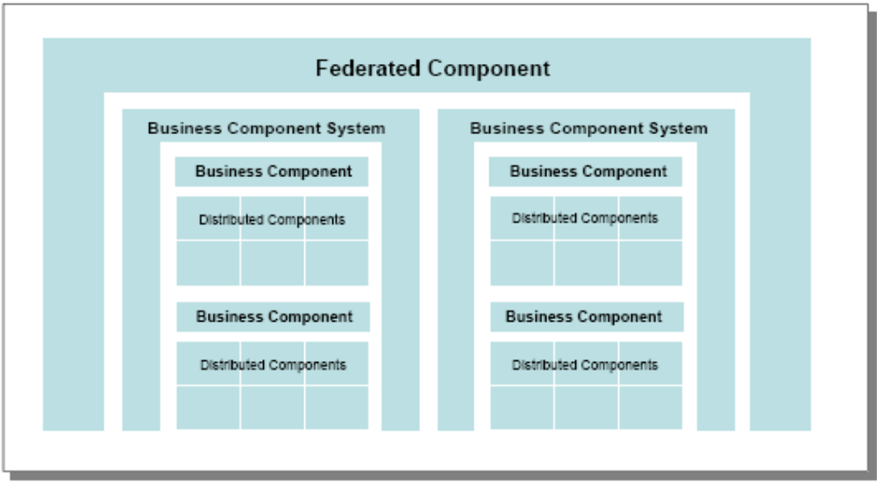
Exhibit 3–3: Hierarchy of SRM Service Components

Degrees of Service Component “Granularity”
The levels in this hierarchy can be useful to architects to catalog an agency’s service components and develop a baseline of geospatial capabilities. They are described below.
- Distributed Component (DC): A distributed component is the lowest level of a service. This often represents a single-function technology service that may be provided by a Commercial Off-the-Shelf (COTS) or Government Off-the-Shelf (GOTS) package. DCs are the building blocks of complex services. An accurate baseline inventory of DCs can help identify redundancy and situations where DCs can be more widely exposed for reuse. Such a baseline may suggest an e-Gov SMARTBUY group purchase opportunity. A DC provides a component function of a larger business component and may include:
  - Single function data assets
  - Single function technology application modules (often COTS or GOTS)
  - Single-function hardware or software platforms
  - Example Geospatial DC: A coordinate transformation service—a low-level function that transforms geospatial data between different coordinate reference systems, datum, and units.
- Business Component (BC): A business component provides a multi-function service; it includes one or more distributed components. BCs, like DCs, are relatively low-level acquisitions. As for DCs, an accurate baseline inventory of BCs can identify redundancy, helps identify situations in which BCs can be more widely exposed for reuse, and may suggest e-Gov SMARTBUY group purchase opportunities. In addition, BCs may sometimes be significant components of major investments under the Capital Planning and Investment Control (CPIC) process. BCs may include
  - multi-function business processes, or single function business processes that operate with the support of DCs;
  - multi-function data assets such as warehouses; and
  - multi-function applications, including multi-module COTS or GOTS packages.
  - Example Geospatial BC: A Geographic Information System (GIS) is the premier example of a geospatial business component. Its operation includes such distributed components as a coordinate transformation service, Web mapping, and other spatial analytical tools.
- Business Component System (BCS): A business component system includes more than one BC, or includes a human activity in addition to a technology BC. BCSs are relatively high-level service components. They are generally large enough to be included in CPIC business cases. In addition, some BCSs may offer potential to become federated components. BCSs may include:
  - Information technology systems that are hierarchies or networks of technology BCs
  - Business processes supported by one or more technological BCs
  - Example Geospatial BCS: (1) A GIS-enabled facilities management system provides a facility management service (BC) on top of a GIS (BC); (2) the Federal Emergency Management Agency (FEMA) operates FEMA MAC (Mapping Analysis Center) that produces Emergency Declarations Maps for a variety of clients, including State governors; it combines a staff-based service operation with GIS mapping capabilities.
- Federated Component (FC): A federated component includes numerous business component Systems exposed as an integrated service across the government to multiple end-users in different organizations. No geospatial services listed in Appendix E reach this level of aggregation at present. The Geospatial LoB initiative seeks to identify common services as FCs in the future.

  - Example Geospatial FC: A payroll service provided by one agency to other non-mission-related agencies (e.g., U.S. Department of Agriculture). If FEMA MAC type services were offered as a service shop for generating mission-specific maps for other agencies, then the service would be an FC.
Recognizing differences in component granularity has another, more general, benefit—it improves communication between investment managers and technology developers. Investment managers tend to deal with services at an aggregated level, where they may involve combinations of manual and technological functions. Developers tend to deal with services at the disaggregated level—as DCs and BCs. Recognizing that service components interact with each other and often form complex hierarchies helps avoid confusion.

Definition of Geospatial Service Domains, Types, and Components
The FEA SRM is a business-driven, functional framework that classifies service components with respect to how they support business and performance objectives. It serves to identify and classify service components that support Federal agencies and their information technology investments and assets. The model aids in recommending service capabilities to support the sharing of business components and services across the Federal government.
The FEA SRM is structured across horizontal service areas that, independent of the business functions, can provide a leverage-able foundation for sharing applications, application capabilities, components, and business services. The SRM structure is based on service domains, types, and service components.
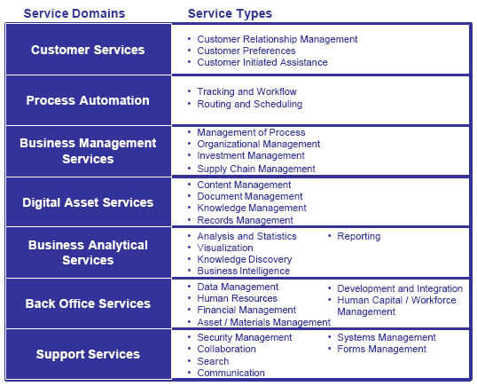
Exhibit 3–4: FEA SRM Overview
Exhibit 4–4 depicts the seven service domains and their corresponding service types as outlined in the FEA SRM. The seven FEA SRM service domains are differentiated by their business-oriented capability and provide a high-level view of the services and capabilities that support enterprise and organizational processes and applications.
These service domains are composed of service types that further categorize and define similar capabilities in each Domain. Service types provide an additional layer of categorization that defines the business context of a specific component within a given Domain. Finally, each Service Type includes one or more service components that provide the “building blocks” to deliver the component capability to the business.
Version 1.0 of the FEA SRM contained only one reference to geospatial services, aggregating all geospatial-related components under the Business Analytical Services Domain, Visualization Service Type, and a component identified as “mapping, geospatial (GIS), elevation, GPS.” This does not adequately represent all geospatial-related capabilities, and not all geospatial activities produce visualizations. The role of geospatial service components is much broader than described in the current FEA SRM. Accordingly, future versions of the SRM will likely expand to include two new service components under the Analysis and Statistics service type as follows:
Geographic Analysis – A general purpose set of capabilities for analyzing and processing geospatial data. This service includes general Geographic Information Systems (GIS) services as well as general analytical capabilities such as geocoding, geolocation, navigation, routing, monitoring and tracking, and specific decision applications.
Image Analysis – A general purpose set of capabilities for analyzing and processing geospatial imagery and related metadata. Capabilities in this service area include image manipulation and processing, feature identification and extraction, and image merging (compositing).
As in the case of the FEA BRM, it is possible to create a geospatially-extended SRM to include a broader array of geospatial service components, largely decompositions of existing service components. The goal of this section is to categorize the new and/or extended service components into the framework of the existing SRM. The primary existing source lists for geospatial service components include the list compiled by FGDC for the General Services Administration and the Department of Homeland Security’s Geospatial Enterprise Architecture.
Appendix E presents a consolidation of these two sources as mapped to the FEA SRM. The list will expand as architects identify and catalog more geospatial service components. New service domains and/or service types may be identified, in addition to the two proposed above, but where possible, geospatial services will be grouped within the existing service domains and service types as “special methods” under existing FEA SRM components. The benefits of this approach are two-fold:
- It permits agencies to express geospatial investments more accurately as elements of a business-focused service implementation rather than as a separate geospatial service component outside of the business context, and to cluster those services into a capability appropriate for their application.
- The de-emphasis of geospatial context means that the technology target architecture will focus the implementation stack of standards in the right order (i.e., geospatial standards will have to be supported within the framework of the more general information technology standards framework such as SOAP. This will encourage the integration of geospatial services into business process, and provide ready adoption as new applications are identified.
The distinction between component levels may be somewhat grey until the geospatially-extended SRM is applied and tested. For example, one agency’s idea of an appropriate bundling of services as a business component may not exactly mesh with another agency. Greater consensus is likely to occur at the lower level (distributed components) than at the higher levels, where business needs are more subtle and specialized. The exception will likely be in more broadly appealing, general-purpose systems, such as a robust Geographic Information System (GIS), as an enterprise-wide business component system. Finally, a geospatially-extended SRM will likely require a geospatially-extended Technology Reference Model (TRM), as is discussed in section 4.4 below.

Desired Features of Geospatial Service Components
The Federal CIO Council, in cooperation with the FEA Program Management Office, developed the following list of desired features to assist agencies in successfully defining service components (these definitions have been slightly altered for geospatial audiences). Stakeholder engagement in the process of identifying service components is critical. A successful service component-based architecture requires the application of sound architectural principles to the definition and composition of components. The components in the architecture should exhibit the following basic features:
- Encapsulation – A component should clearly separate the definition of the services that it provides from the implementation of those services. This implies that how a service component works is hidden behind an agreed-upon application interface. For example, a service component with a Web-mapping interface can be made available by a business component system (like a GIS) or as a stand-alone distributed component attached to another business component system (like a geospatially-enabled database management system).
- Consumability or Usability – A component that is designated as the provider of certain services should be able to provide those services in a coherent and consistent manner to another software or business process. To the extent possible, components should provide services without restricting the operations of users. A component should not impose complex interdependencies on other external components (i.e., keep interfaces functionally simple). For example, a Web-mapping service component’s output is a standard, common graphic format used by many existing applications (such as a Web browser or any graphics processing application). Therefore, a Web map service can easily be integrated into any number of Web or graphics workflows without building specialized software.
- Extensibility – A well-constructed service component should be extensible to both the services it provides and the way those services are provided within the component itself. A well-behaved component should be extensible to adapt to changes in the business and data while at the same time preserving services provided to existing consumers.
- Standards-Based – The value of a component increases in proportion to the number of places it can be used. Standards, both technical and domain, affect this applicability in a number of ways. First, component interface based on industry standard practices and technologies is most likely to be shared. As an example, if a component is built using Cobol, sharing that component in a .NET environment is difficult and unlikely to occur. On the other hand, if a technology standard, such as Web Services Definition Language (WSDL), is used to create an interface for the component, it can be used with Java or .NET with equal ease. Further, if the interface is based on a domain industry standard such as GML (Geography Markup Language) or NIEM (National Information Exchange Model), even greater reuse is likely, as many organizations have agreed to use those standards. Common standards also help ensure a compatible execution environment, which in turn benefit implementation. For example, if a component is written to Web Services Interface Standards, such as many OGC specifications, it can be deployed in a broad set of execution environments.
- Industry Best Practices and Patterns – A component should embody industry “best practices” and patterns. Patterns are simply common solutions to recurring problems or issues faced in the software life cycle. Patterns typically reflect industry best practices—the convergence of approaches to solving problems. The use of technology patterns and e-business patterns in components facilitates the understanding and use of the components.
- Well Documented – A component should be well documented to promote understanding of its capabilities and encourage use. The documentation should permit architects, designers, and integrators to evaluate and use the component. The documentation should include models (preferably in UML) depicting the process and data capabilities of the component, user guides, functional over-views, and installation guides, as well as API documentation. Consumers should have the means to test each of the services or methods offered. If appropriate, the component should include the source code. Finally, a component should be delivered with samples of use to show how the component operates within an application environment.
- Cohesive Set of Services – Components should be selected in such a way that they provide a cohesive set of services. Proper packaging makes the services easier to find and use. Using components that offer too broad an array of services leads to bloated software and can result in bugs due to inadvertent use of features that are not appropriate. As an example, if an image processing component included a complex array of image processing and data management functions for a certain type of imagery, a specialized community of imagery analysts might benefit, but further sharing would likely be limited. Creating appropriately selected service offerings will significantly increase the breadth of opportunities for component sharing.
- Well-Defined and Broadly Available Licensing – A component should be accompanied by a well-defined license or service-level agreement (SLA). The license or SLA defines a user's rights and responsibilities with respect to the component. In particular, the license or SLA should clearly articulate the intellectual property ownership for the component, the scope of usage permitted, the extent of any rights granted to modify the component or produce derived works, and the extent of any rights granted to redistribute the component. To promote sharing the component, the license or SLA terms should be sufficiently broad to allow the component to be shared.

Geospatial Data Reference Model (DRM)
The Federal Enterprise Architecture Data Reference Model (FEA DRM) is a framework whose primary purpose is to enable information sharing and reuse across the Federal government via the standard description and discovery of common data and the promotion of uniform data management practices. The DRM describes artifacts that can be generated from the data architectures of Federal government agencies. The DRM provides a flexible and standards-based approach to accomplish its purpose. The scope of the DRM is broad, as it may be applied within a single agency, within a Community of Interest (COI), or across COIs. Appendix F provides a listing of various data standards in use in the geospatial community.
The DRM Implementation Framework provides a roadmap to be used by enterprise architects and data architects to guide their efforts in supporting data sharing within the COIs that they support. The roadmap is based upon the following basic assertions:
- Data Description is a standardization area within the DRM. A COI should agree on meaning and the structure of the data that it needs to effectively use the data.
- Data Context is a standardization area within the DRM. A COI should agree on the context of the data needed to meet its shared mission business needs. A COI should be able to answer basic questions about the data assets that it manages. “What are the data (subject areas) that the COI needs? What organization(s) is responsible for maintaining the data? What is the linkage to the FEA Business Reference Model (BRM)? What services are available to access the data? What database(s) is used to store the data?” Data Context provides the basis for data governance with the COI.
- Data Sharing is a standardization area within the DRM. A COI should have common capabilities to enable information to be accessed and exchanged. Hence, the DRM provides guidance for the types of services that should be provisioned within a COI to enable this information sharing.

Geospatial Line of Business Conceptual Target Data Architecture (TDA)
This section presents a conceptual Target Data Architecture (TDA). The TDA augments the FEA DRM and provides additional guidance for agency architects with respect to geospatial data. The TDA is intended to enable the widespread adoption of shared and reusable geospatial and geo-enabled business data and services. The TDA sets forth principles for data set stewardship to improve national use. As set forth in the FEA DRM, the TDA states that geospatial data shall be defined, structured, and documented to facilitate efficient discovery, sharing, and reuse. It further recommends that specific data schemas shall be documented by lead Federal agencies responsible for nationally significant framework data themes and by COIs responsible for thematically or regionally specific data.
Several challenges have been identified that limit the Nation’s ability to discover, share, and reuse geospatial data. Nationally significant geospatial data (as defined in OMB Circular A–16) are incomplete and are not shared effectively. Existing geospatial data assets are not formally aligned with business functions and the taxonomies and data schemas are not documented to enable efficient discovery, sharing, and reuse. The findings of the Geospatial LoB Request for Information issued in 2006 show that citizens and organizations would benefit from interoperability, and that common data standards could help enable that interoperability. Exhibit 4–5 depicts the TDA.
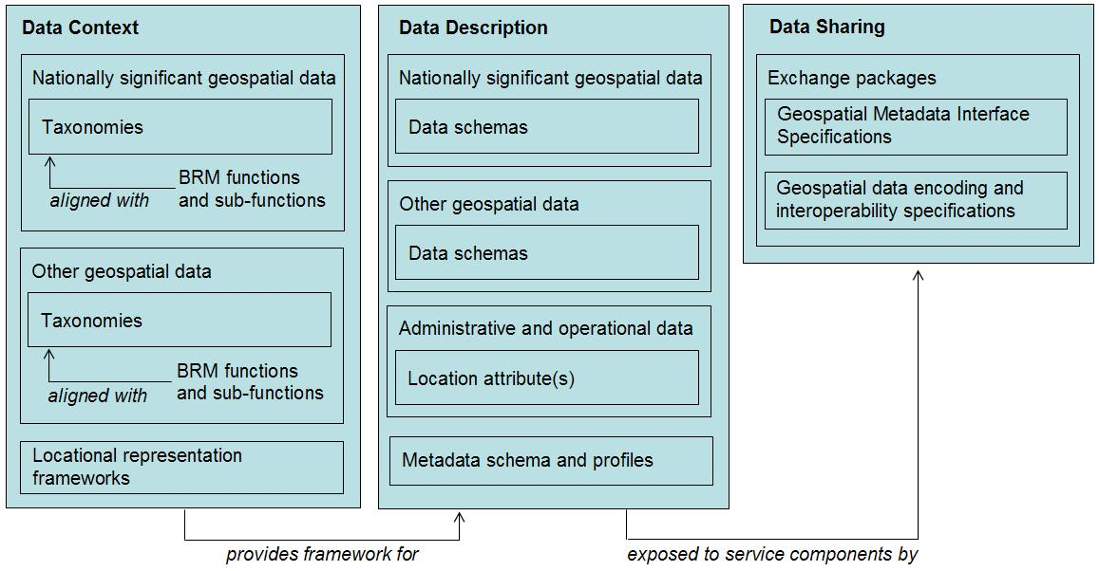
Exhibit 3–5: Target Data Architecture (TDA) Framework
Exhibit 4–6 provides an illustrative overview of the Target Data Architecture Framework. The TDA follows the standardization scheme set forth in the FEA DRM as follows:
- Nationally Significant Geospatial Data—Geospatial data themes of national significance and coverage providing the core, most commonly used set of base data, referred to as “National Spatial Data Infrastructure (NSDI) framework themes” in OMB Circular A–16. These nationally significant geospatial data serve as the foundation of national and regional use and the foundation into which other geospatial data (locally oriented, thematically specialized, more detailed) may be “nested.” Nationally significant data are stewarded by lead Federal agencies identified in OMB Circular A–16. Lead Federal agencies must establish and maintain data taxonomies and data content schemas for nationally significant geospatial data as described in FEA DRM.
- Other Geospatial Data—Other geospatial data include those geospatial data with national or regional coverage that do not fit into the context of the NSDI framework themes set forth in OMB Circular A–16 and State, local, or tribal data that can be “nested” into the nationally significant geospatial data framework themes. Some other geospatial data might be stewarded by COIs with participation by key stakeholders. These COIs may be internal to Federal departments and agencies or can be intra-agency where particular business functions or requirements warrant. COIs include State, local, and tribal participation as appropriate. Other geospatial data must have their context, taxonomies, and data content schemas formally defined. FEA DRM defines the role of COIs in establishing and documenting geospatial data context and data schemas for these data.
- Administrative and Operational Data—Administrative and operational data are those business data maintained and used by Federal departments and agencies that are specialized or more dynamic in nature and used for specific events or analytic purposes. These data are typically non-spatial in nature but include one or more locational attributes (address, etc.) that enable geo-referencing to facilitate fusion with nationally significant and other geospatial data to support specific visualization or analysis needs. COIs may identify the business need (context) warranting the geo-referencing of administrative and operational data.
The following sections discuss in more detail the three standardization areas of the FEA DRM just described.

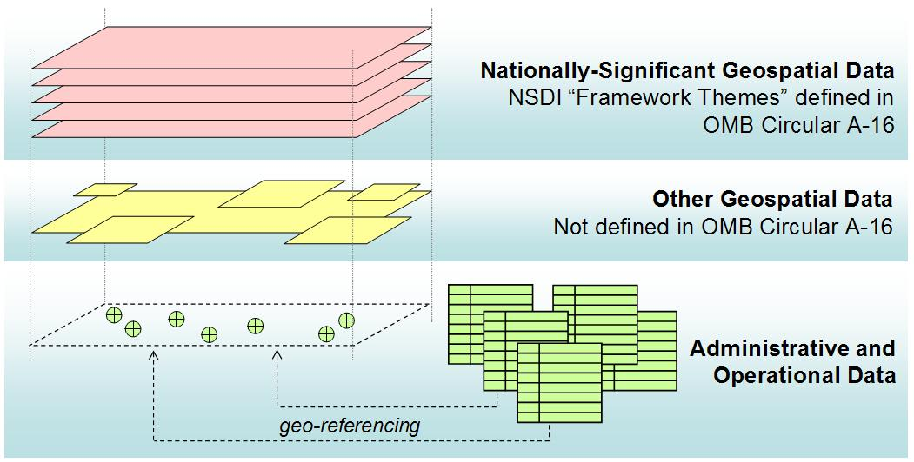
Exhibit 3–6: Geospatial Data Asset Categories

Data Context
The FEA DRM Data Context area provides a standard approach for representing taxonomies that data stewards use to categorize data. Taxonomies are important for all data—including geospatial data—to ensure a consistent understanding of how data are organized and how data model the real world. The FEA DRM Data Context also enables the business context of data to be well understood, which enables the ability to track and align geospatial investments by Line of Business and the ability to establish business- and mission-oriented taxonomies for geospatial data.

Defining Taxonomies and Business Context for Geospatial Data
FEA DRM States that the Data Context for data assets should answer the question “What is the linkage to the FEA BRM?” Agencies typically further define business functions in their agency BRM. The entire set of agency BRM business functions should map directly to the (sub-functions in) FEA BRM. Thus, the data context for data assets should provide a linkage to either agency BRM or the FEA BRM with the same effect. There can be more than one context for a Data Asset. Context can be considered a “lens” and one may view something through a number of different “lenses,” one for each of the different contexts in which a Data Asset is of interest. Data Context artifacts should be developed to reflect the understanding of the relevant data assets from the perspective of a COI.
The TDA requires that nationally significant and other Federally stewarded geospatial data be explicitly associated with one or more FEA BRM business functions or sub-functions. The BRM functions and sub-functions that have associated geospatial data shall be recorded in the metadata describing each data object and in Exhibit 300 submittals.
As previously stated, Data Context facilitates the discovery of data through an approach to the categorization of data (assets) according to taxonomies. Taxonomies contain a hierarchy of topics and relationships between topics, which in turn are used to define specific data assets. Data assets provide the management context for structured data resources. Once data assets are identified for a given taxonomy, logical data models can be developed to guide physical instantiation and implementation of specific data objects. This framework, described in the FEA DRM, should apply to all nationally significant and other Federally stewarded geospatial data.
Taxonomies describing nationally significant and other Federally stewarded geospatial data should be documented using eXtensible Markup Language (XML) Topic Maps, Web Ontology Language (OWL), Resource Definition Format (RDF) hierarchies, or ISO 11179 classification schemes. Taxonomies describing geospatial data can then be made accessible via services to facilitate efficient search, discovery, and data translation capabilities and to facilitate development of more detailed data schemas and logical data models.
Geospatial data schema should be associated with existing business-oriented taxonomies (i.e., those taxonomies defined by and/or aligned with the FEA BRM) where possible. This will enable synchronization of geospatial data schemas with business language and processes and facilitate the integration of geospatial data with departmental and agency-specific enterprise architectures.
In some cases, taxonomies have been developed describing specific FEA BRM LoBs, functions, and sub-functions, but no explicit reference is made to geospatial representation of data assets. These taxonomies typically describe non-spatial operational and administrative data as described above. To facilitate geo-referencing of operational and administrative data, COI’s may choose to identify those data assets resulting from the taxonomy that should or could have a geospatial representation and then develop geospatially oriented data schemas to organize geospatial representations of those data.
Nationally significant and other geospatial data are inherently geospatial in nature—they are represented using spatial geometries. Other operational and administrative data are typically non-spatial in nature but can be geo-referenced by rendering spatial objects (points, lines, areas) using locational attributes associated with operational and administrative data objects.
Various frameworks exist for representing location, several are summarized here. Appendix F provides more information on the international (ISO) and national (ANSI/NISO) standards that govern the representation of location using these frameworks:
- Spatial Referencing by Coordinates (“Absolute Location”)—Geographic objects (points, lines, areas) can be represented by one-, two-, or three-dimensional coordinates and coordinate reference systems. Nationally significant geospatial data and other Federally stewarded geospatial data should be referenced using absolute location.
Any number of coordinate systems, horizontal and vertical datums, and projections may be applied to different geospatial data. The Geospatial LoB Target Data Architecture does not dictate use of a single, common coordinate reference system, horizontal or vertical datum, or projection. Rather, the metadata describing geospatial data objects shall comprehensively and accurately describe these parameters to enable real-time fusion with other disparate geospatial data and to enable extract, transform, and load (ETL) operations.
- Spatial Referencing by Geographic Identifiers (“Relative Location”)—Geospatial data can also be referenced using relative location. Relative location is established by use of geographic identifiers that do not provide precise, explicit coordinate locations for a given data asset. Relative location is typically appropriate when geo-referencing non-spatial administrative and operational data, but can also be associated with geographic objects (points, lines, areas) as attributes. Methods for representing relative location include the following:
  - Addressing—Addresses specify location by reference to a thoroughfare, landmark, or a point of postal delivery. The FGDC is currently coordinating a national addressing standard, to be stewarded by the U.S. Census Bureau upon publication.
  - Linear Referencing—Specifies location along a linear feature using a measurement from a known point, such as highway mile-markers.
  - Place Name and Identifier—The U.S. Board of Geographic Names approves the official names of over 20 different types of named locations in the United States, its Territories, and Possessions. The USGS manages the authoritative place names, identifiers, and their geographic location in the Geographic Names Information System. The use of system identifiers is recommended as a key to unique, officially recognized locations in the United States.
  - Federal Information Processing (FIPS) Codes—ANSI/NISO standard codes ensuring uniform identification of geographic entities in the United States and territories. Relevant FIPS codes include the following:
    - FIPS Pub 5–2, Codes for the identification of U.S. States
    - FIPS Pub 6–4, Counties and equivalent entities
    - FIPS Pub 8–6, Metropolitan areas (MSAs, CMSAs, PMSAs, and NECMAs)
    - FIPS Pub 9–1, Congressional districts
    - FIPS Pub 55–3, Named populated places, primary county divisions, etc.
  - United Nations Code for Trade and Transport Locations (UN/LOCODE)—Initiated within the United Nations Economic Commission for Europe Working Party on Trade Facilitation, UN/LOCODE is based on a code structure developed in United Nations Conference on Trade and Development in cooperation with transport organizations like the International Air Transport Association and with active contributions from national governments and commercial bodies. Its first issue in 1981 provided codes to represent the names of some 8000 locations in the world. UN/LOCODE 2006–1 includes over 48,300 locations in 236 countries and installations in international waters. It is used by most major shipping companies, by freight forwarders, and in the manufacturing industry around the world. It is also applied by national governments and in trade related activities, such as statistics where it is used by the European Union, by the UPU for certain postal services, etc.
  - U.S. Public Land Survey System—Location reference system for western States that reference meridian, township, range, section, and partitioning for land and resource management
  - U.S. National Grid (USNG)—A hierarchical spatial reference system presenting Universal Transverse Mercator (UTM) coordinates via a scalable grid reference system at various levels of precision.

Data Description
The FEA DRM Data Description guides the uniform description of data to enable data discovery, reuse, harmonization, sharing, and exchange. Data Description is based on taxonomies developed under the FEA DRM Data Context area and result in the development of data schemas that define entities, attributes, associated data types, and the formal relationships between entities. When properly documented, data schemas can be exposed to the broad user community to enable discovery and understanding of the structure of data assets and to implement physical (operational) data models. The TDA establishes guidelines for developing and documenting geospatial data schemas and documenting geospatial data resources using metadata.

Geospatial Data Schemas
Data schemas define how geospatial data are organized and how geospatial objects relate to each other and to the attributes associated with each object. For maximum interoperability, these schemas must be based on standards identified by lead Federal agencies or COIs for logical (abstract/database design) and physical (encoding/exchange) applications. For data that have not been standardized, data schemas should be documented using logical data models with sufficient detail to enable physical data models and development of geospatial data objects. Logical data models are vendor-neutral and are independent of physical data storage devices, but may be used to define data transfer encodings. Logical data models should be documented using international (ISO) and national (ANSI/NISO) standards including

- Unified Modeling Language (UML)
- Entity-Relational (E–R) diagrams
- XML schema
All nationally significant geospatial data (NSDI framework themes) and other Federally stewarded geospatial data should have established logical data models. These logical data models then govern physical implementation of geospatial data. Logical data models will be developed by lead Federal agencies responsible for NSDI framework themes—as per OMB Circular A–16—and by COIs for other Federally stewarded geospatial data.
Taxonomies and logical data models for non-spatial administrative and operational data are expected to be developed by appropriate COIs. Once a decision is made to geo-reference a specific non-spatial data resource, collaboration with the authoritative data steward (or COI) is required to extend the data models to facilitate consistent geospatial representation of the data resources.

Geospatial Metadata
The TDA states that all nationally significant and other Federally stewarded geospatial data shall be documented with descriptive metadata to enable discovery, assessment of fitness-of-use, and sharing of geospatial data resources. Geospatial metadata should be organized by a common schema to be applied across the Federal sector that
- Is organized in accordance with ISO metadata specifications (ISO 19115 and ISO 19139), documenting key properties of geospatial data resources including but not limited to the following:
  - Identification information (e.g., context/topic, search keywords, data set title)
  - Data quality information (e.g., positional accuracy and precision, adherence to data accuracy standards, completeness)
  - Spatial representation and reference system information (e.g., geometric properties, coordinate systems, projections, datum)
  - Other relevant information [e.g., maintenance frequency, data steward (POC) information, content description, distribution protocol and constraints]
- Contains, to the maximum extent possible, normalized and well-defined metadata descriptive attributes (“pick-lists”) to enable efficient discovery. “Free-text” metadata tags should be kept to a minimum
- Utilizes ISO 19115 topic categories to categorize data to facilitate keyword searches and structured queries. ISO 19115 topic categories should be mapped to FEA BRM functions and sub-functions to enable linking between geospatial data resources and the FEA BRM (as previously described in the Data Context section)
- Explicitly defines distribution rights and restrictions to enable role-based access implemented through Federal e-authentication initiatives and strategy
The common metadata schema should be documented using international (ISO) and national (ANSI/NISO) standards including the following:
- Unified Modeling Language (UML)
- Entity-Relationship (E-R) diagrams
- XML schemas
Lead Federal agencies and COIs stewarding specific data resources may establish targeted profiles that extend the common metadata schema to accommodate descriptive requirements for a particular mission or problem set.
The FGDC is currently developing the North American Profile of ISO 19115/19139 metadata standards. This profile will act as the next generation of a government-wide geospatial metadata schema and, when finalized, will provide the discovery capabilities and meet the objectives of the FEA DRM and DRM XML schema. ISO metadata supports the collection and management of feature-level, dataset-level (as does current FGDC metadata standard), and collection-level metadata. Until this profile has been completed and properly vetted, Federal departments and agencies should continue to document all existing geospatial data resources using the Content Standards for Digital Geospatial Metadata (CSDGM) v2.0, 1998, as maintained by the FGDC.

Data Sharing
The FEA DRM Data Sharing area provides an architectural pattern for sharing and exchanging data through a services-oriented strategy. Geospatial data should be encoded using appropriate interface standards and specifications to enable data exchange (fixed recurring transactions between data suppliers and consumers) and less structured requests for data access. This section identifies the key interface standards and specifications to enable geospatial data sharing.

Supplier-to-Consumer Matrix
The FEA DRM recommends development of a supplier-to-consumer matrix to identify organizational (or COI-oriented) information exchange requirements to guide development of service components and information exchange packages. The number of potential consumers of Federal geospatial data assets is too large to warrant an explicit data supplier-to-consumer matrix as recommended by the DRM. Implementation of metadata catalogs will enable consumers to discover availability and fitness-of-use of relevant geospatial data and provide an effective means to connect consumers with authoritative geospatial data through service-oriented discovery, brokering, and access. Service components defined in Appendix E will provide broad, cross-cutting capabilities that can be exploited by the full range of potential consumers of Federal geospatial data resources.

Geospatial Data Interoperability Standards
After consumers search for and discover geospatial data resources of interest, the data must be encoded in a fashion such that interoperable service components can access and deliver the data. Geospatial data encoding standards should
- Be open and vendor-neutral to enable exploitation by a broad range of technology solutions
- Be based on ISO and ANSI/NISO standards
National Information Exchange Model (NIEM)
The Open Geospatial Consortium (OGC) family of specifications should be used as they are based on and adhere to the two fundamental requirements listed above. Geospatial data should be encoded and exposed to services using OGC encoding standards including but not limited to the following:
- Web Map Service
- Web Feature Service
- Web Coverage Service

FEA Geospatial DRM and the NSDI
The concept and vision of the NSDI can help guide architects in establishing and making use of a geospatial DRM. The following guidelines represent the underpinnings of the NSDI and will facilitate use of the TDA just described:
- Formally chartered communities of interest (COI) will act as stewards for geospatial data sets.
- Geospatial data will be aligned with business functions and sub-functions defined in the FEA BRM and departmental/agency enterprise architectures.
- Geospatial data will be collected, maintained, and disseminated in ways to promote sharing and integration of those data. This will be done through the use of relevant standards (see Appendix F), metadata, and defined and documented taxonomies and data structures.
- Geospatial metadata and data will be made accessible using open, vendor-neutral interoperability standards and networks, including the Geospatial One-Stop Portal network of registered NSDI Clearinghouse nodes.
- Geospatial data will be exposed through services documented in the service component Target Architecture.
Achieving the above for geospatial data will help
- Facilitate the translation and exchange between national and local data resources organized by disparate standards and schemas
- Improve the ability to fuse disparate data and provide a more comprehensive and holistic view of a particular problem set
- Improve the ability to make connections and relationships based on location and spatial relationships
- Increase interoperability, communication, and collaboration
- Reduce redundancy by making existing data discoverable and accessible—and improving access to government information resources—via query and catalog services as described in the service component target architecture.

Geospatial Technology Reference Model
The technological element of a particular solution architecture typically includes a listing of the products and standards required to meet needs of the architecture being described. This section establishes the basic guidance necessary to help ensure that proposed information technology solutions that include or should include a geospatial component (or components) are in compliance with industry standards and are, therefore, likely to integrate efficiently into a multi-agency information sharing and processing environment. Specifically, this section supports technological solutions by supplying a standard vocabulary and categorization scheme that is an extension to the FEA TRM. This geospatially-extended TRM and a list of specific geospatial standards are contained in Appendix F.
Neither this section nor the appendix enumerates technological products. The reader is directed to other sources, such as the annual Geospatial Industry Technology Association (GITA) Geospatial Technology Report, for a list of technological products.

A Geospatially-Extended TRM
Establishing and institutionalizing the geospatially-extended TRM will provide the guidance and direction for an organization to function as an integrated enterprise, improving the ability to accomplish its mission(s). The geospatially-extended TRM has the following goals:
- improve interoperability and information and service sharing across operational entities;
- improve operational effectiveness and efficiency through the use of common concepts and tools;
- improve security through the identification of common security services and standards;
- improve development and integration efficiency and responsiveness through the identification of a common infrastructure for applications; and
- promote vendor neutrality through the use of standards-based products and interchangeable services and components.
The geospatially-extended TRM is intended to support three principal uses in conjunction with standards profiles:
- ensuring interoperability among internal and external systems and users,
- guiding the design of system and technical architectures, and
- providing the basis for assessing architectural compliance for technical solutions.
Interoperability is the primary goal. The geospatially-extended TRM uses the same structure as the Federal Enterprise Architecture (FEA) TRM to ensure interoperability with service components outside the geospatial domain.
The geospatially-extended TRM provides a technology-focused, vendor-independent view of the hardware and software services that will support the enterprise. It is intended to be used by system architects, engineers, developers, vendors, service providers, and others involved in defining and creating new systems and modifying existing systems. This section identifies the technical services and capabilities provided by a common IT infrastructure that system and application architects and engineers must consider when defining new systems or modifying existing systems.

Relationship to the Service Component Reference Model
The geospatially-extended TRM must be viewed within the context of a geospatially-extended SRM. The functionally-oriented capabilities described in the geospatially-extended SRM are enabled by the technical services described below. As the geospatially-extended SRM matures, the geospatially-extended TRM will change in response.

Overview of the FEA TRM
The FEA TRM provides a view of technical services, protocols, and interfaces (Exhibit 4–7) that are primarily concerned with supporting the implementation of service components, as defined in the FEA SRM. Geospatial technology is in many ways a special case of database technology, and therefore, the architectural concerns of database technologies usually address the geospatial as well. For example, there is no need to account separately for the geospatial in the high-level TRM category of Service Access and Delivery. However, geospatial technology transcends the database and can be considered visualization and analysis technology. For example, a Web browser may need a geospatial plug-in to support display of geospatial information, or it may deliver images from a server through Dynamic Server-Side Display and Content Rendering.
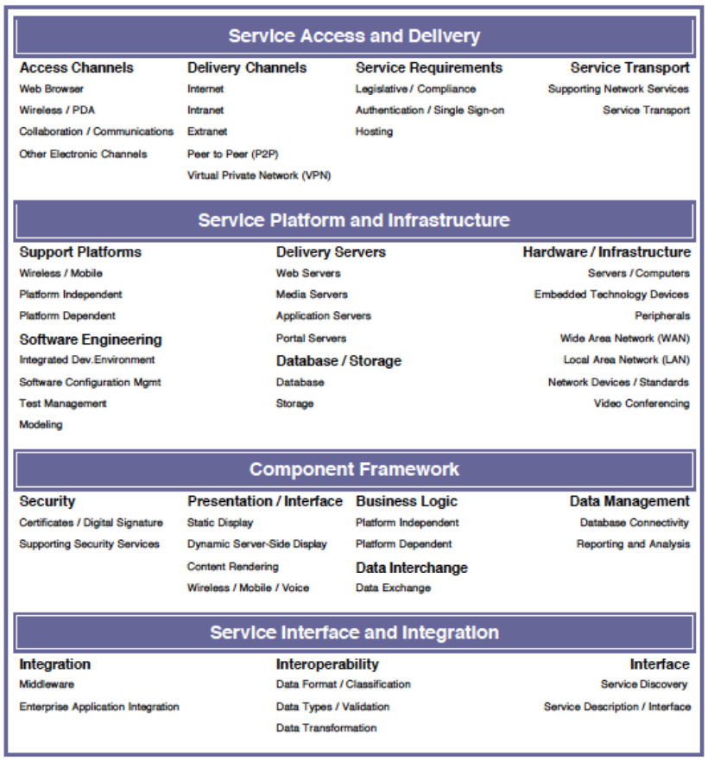
Exhibit 3-7: FEA TRM Overview
At the Service Platform and Infrastructure, Component Framework, and Service Interface and Integration levels, however, the geospatial industry has defined a number of specialized systems and standards described in Appendix F.

SmartBUY and Other Funding Vehicles
Many of the technological products needed to implement geospatially-enabled architectures are available through Government Wide Acquisition Schedules. These schedules provide a means for agencies to purchase components as needed, rather than necessarily buying integrated applications. There are, however, two SmartBUY agreements currently in place that may be leveraged for technological purchases under the Geospatial LoB. This does not preclude the use of other software with GSA, SmartBUY, or agency negotiated pricing. SmartBUY agreements may provide savings over other mechanisms for certain agencies. The following quotes are excerpted from the referenced SmartBUY agreements:
Oracle – “The Oracle SmartBUY agreement provides agencies a sophisticated database and application at discounted prices to support lines of business more effectively and efficiently. Oracle database software licenses, software maintenance support, training and consulting services are the primary goods and services available under this agreement.” Oracle technology provides not only the database services but also provides an applications platform for a number of the service identified in the service component target architecture, including Data Mining, OLAP, and spatial query support.
ESRI – “The SmartBUY agreement with the Environmental Systems Research Institute (ESRI) makes available geographic information systems (GIS) software tools and applications for providing geography about the Earth's surface along with objects found on it.” ESRI specializes in GIS applications and provides a broad solution set for map- and feature-based geospatial business problems.
In addition, to the existing SmartBUY agreements above, the Federal geospatial community will explore additional SmartBUY (and other) procurement agreements that support the use of open consensus-based interoperability standards as described in Appendix F.

Geospatial Performance Reference Model (PRM) and Program Maturity
The Performance Reference Model (PRM) is a framework for performance metrics providing common output measurements throughout the Federal government. It allows agencies to better manage the business of government at a strategic level by providing a means for using an agency’s enterprise architecture to measure the success of information technology investments and their impact on strategic outcomes. The PRM accomplishes these goals by establishing a common language for agency enterprise architectures to describe the outputs and measures used to achieve program and business objectives. The model articulates the link between internal business components and the achievement of business and customer-centric outputs. Most importantly, it facilitates resource-allocation decisions based on comparative determinations of programs and organizations to identify those that are more efficient and effective. The PRM focuses on three main objectives:
- Help produce enhanced performance information to improve strategic and daily decision-making
- Improve the alignment and better articulate the contribution of inputs to outputs, thereby creating a clear line of sight to desired results
- Identify performance improvement opportunities that span traditional organizational structures and boundaries
The PRM measures the performance of an activity, service, or investment by applying multiple measurement indicators in a logical sequence called a “line of sight.” There are four generic steps in a line-of-sight sequence: technology (people or fixed assets), process/activity, customer service, and mission and business results. Each step can have one or more “operational indicators” to measure (i.e., quantify) performance. A performance line of sight is, in essence, a short narrative that explains the logic of how the activity, service, or investment is to be improved. Generically, improvement in technology supports improvement in process. This in turn improves customer service, which in the end improves a mission or business result.
Exhibit 4–8 illustrates the line-of-sight concept graphically. At the top of each step, the diagram provides the questions to be asked:
- What is the relevant technology (or fixed asset or human resource) involved?
- What are the processes, activities, or services?
- Who are the customers?
- What is the ultimate purpose or mission?
The sequence can also be thought of as a progression of inputs, outputs, and outcomes as indicated at the bottom of the figure.
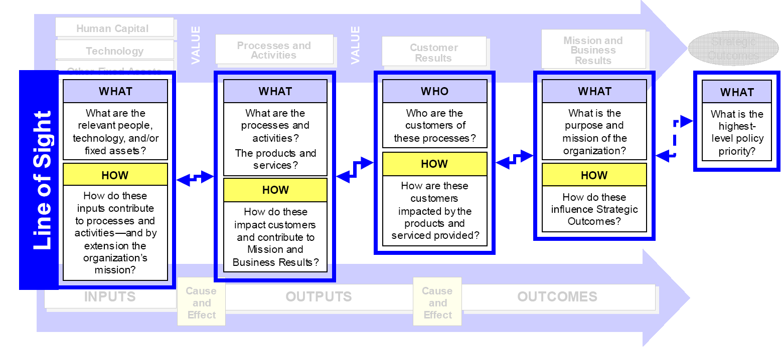
Exhibit 3-8: The PRM Line of Sight
The PRM is the only FEA reference model that internalizes another reference model as a building block. The FEA Business Reference Model is the PRM’s Mission and Business Results measurement area. The BRM Lines of Business are the PRM’s mission and business measurement categories, and BRM’s sub-functions are the PRM’s mission and business measurement groupings. Agencies can elect to elaborate this measurement area to reflect their own decomposition of FEA BRM sub-functions. The other measurement areas are unique to the PRM—they do not refer to any other reference models.
Exhibit 4–9 shows the full list of measurement categories—the axis is turned vertical to show these more easily. (Refer to the PRM for the list of measurement groupings within each of these measurement categories.)
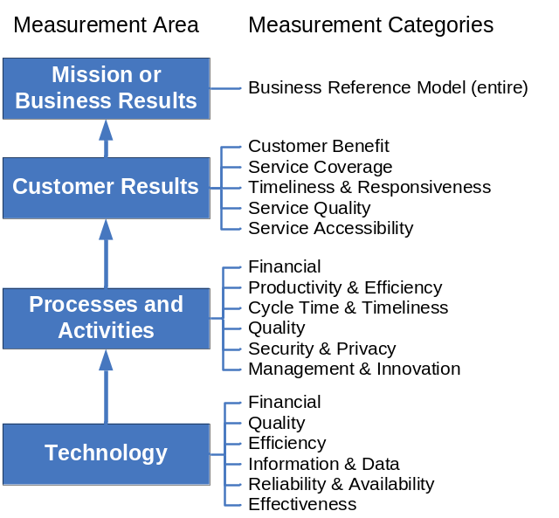
Exhibit 3–9: PRM Measurement Categories and Measurement Areas
It is an implicit requirement of the PRM that every operational indicator must have an identified and reliable data source. This is perhaps not adequately emphasized in other documentation, but must be kept in mind whenever the PRM is applied. In practice (i.e., in a review of Table 2 from selected Exhibit 300s), it is not uncommon to find indicators for which no obvious source of data is identified. Under Customer Results Service Quality, for instance, an indicator might be to “increase customer satisfaction” with a particular database. How is this to be measured? Through an annual customer satisfaction survey? What is the starting point? What is the objective? Every operational indicator must have a measurable baseline and objective and should identify the source data.
Note that the bottom layer of the PRM, as published to date, is called “Technology.” It does not include reference to human capital or non-technology fixed assets. This is because the mandatory application of the PRM currently covers only CPIC investments, which are primarily information technology systems. This layer will be elaborated in future iterations of the PRM to include more than technology.

PRM Measurement Areas
Mission results and business results should be distinguished from each other. The BRM provides a useful structure for doing this that directly relates to the development of geospatial programs.
Mission results yield benefits to citizens. They are the outcomes of the functions and activities of the top layer of the BRM Services to Citizens. Conveniently, every agency already has operational indicators that can apply to the Services to Citizens layer of the BRM Government Performance and Results Act (GPRA) goals as defined in the agency’s strategic plan. Since GPRA goals are quantified measures of agency performance and are officially adopted, they can and should be used whenever mission results (as opposed to business results) are the end point of a performance line of sight.
Business results are internal process results within an agency. They measure productivity or efficiency of functions that support the delivery of Services to Citizens. They therefore correlate to the Support Delivery of Services and Management of Government Resources layers of the BRM. An agency’s geospatial program is one such support function. Support functions may or may not have formal goals or objectives defined by their agencies. Where they do, these should be used as the relevant operational business results indictors in the PRM (see Section 3.2 for more discussion).
Unlike the mission and business results area, where operational indicators may already be available, the three other measurement areas of the PRM require practitioners to develop their own context-specific indicators to measure performance in alignment with the various measurement groupings. These groupings are universally applicable—as far as they go, they are as valid for geospatial programs and investments as they are for any other crosscutting support function.

Measuring the Performance of Geo-Enabled Business Processes and Investments
The goal of examining FEA through a geospatial lens is to improve the ability of an agency to perform its mission or support its processes using geospatial resources. The measurements can be examined in two related areas:
- measures of the performance of geo-enabled business processes and investments, and
- measures of the maturity of a geospatial program responsible for developing an agency’s geospatial architecture.
The PRM is of particular use to the development of fledgling geospatial programs across government because it provides a structure for analyzing both means and ends. Unlike other FEA–profiled functions (records management and security), which are derived from demands of other activities, geospatial programs are frequently elective and opportunity-driven. The PRM provides a tool for effectively focusing scarce geospatial resources and for communicating to outsiders the benefits that a geospatial program will provide and how it will provide them.
To date, use of the PRM is only required as part of the FEA for major investments under the Capital Planning and Investment Control (CPIC) program. The PRM provides an opportunity, however, to support performance evaluation of business programs, processes, and services as well as information technology systems. All activities of an agency’s geospatial program—developing policies and using standards, implementing geospatial services and geo-enabling functions within the organization, and implementing and providing geospatial data services both inside and outside the agency—can benefit by evaluating performance.
A methodology for use of the FEA PRM to geospatial programs and resources includes construct of a line of sight, although it is not always clear where to start this process. A geospatial program, for instance, might want to refer to the hiring of a qualified Geospatial Information Officer (GIO) as the step of a geospatial program performance line of sight. In this case, one might align the hiring of the GIO under the “Reliability & Availability” measurement category, under the measurement grouping, “Availability” (i.e., a qualified GIO will now be “available” to run the program). Obviously, this is not exactly what is meant by technology availability as used in the PRM, but such an alignment might suffice. An option is to omit the technology step of the line of site when measuring performance of an activity or service. (Specific measurement categories and groupings may be developed if measures of performance of human capital assets or non-information technology fixed assets are needed. The success of geospatial services depends largely on the availability of adequately trained personnel, so the human capital dimension of a geospatial performance architecture is critically important.

Geospatial Performance Architecture Guidance
Three basic business functions form the foundation for measuring geospatial program performance:
- Use of Geospatial Policies, Standards, and Guidance. This essentially involves localizing national and international geospatial standards for agency use, providing policies and procedures for implementing agency geospatial services, and developing guidance and training to improve an agency’s geospatial awareness and abilities throughout the organization.
- Geospatial Services. This involves providing useful geospatial services—usually technological services—that are of most use for a particular agency, and “geospatially-enabling” existing applications and systems to take advantage of geospatial analysis.
- Dissemination of Geospatial Data to External Users. Not all agencies will be in the position of hosting geospatial data for external users, so this function and its related indicators may not always apply. When it does, this involves managing geospatial data resources to serve not only internal users, but potential government and private sector users outside the agency.
These functions imply a number of cases for developing geospatial performance indicators, including the following:
- A complete geospatial program encompassing
  - Definitions of policies, standards, and guidance needed for managing geospatial resources and maintenance and support for geospatial resources (e.g., data, technology, software).
  - Approaches for inventorying and geo-enabling processes within the agency and the means to provide internal geospatial services to support those processes.
  - If possible, the means to operate and maintain data services for external users, including data maintenance and documentation.
- Dedicated geospatial investments or services that generate their own CPIC documentation
- Other agency activities that can be geo-enabled (and that are subject to CPIC requirements)
In the first case, the starting point is to develop quantifiable goals and objectives that are appropriate to the geospatial program in its agency context. Because geospatial services are a support program, the program’s goals and objectives will probably not align directly to the agency’s GPRA goals, especially if the agency’s business does not have a strong geographic component. Geospatial programs may exist in multiple forms and may in some cases be distributed throughout an agency without identifiable governance. In such cases, it will be difficult to provide useful indicators of program performance in any measurement area, especially for customer results. Indicators of program performance will generally not include indicators for the technology measurement area, although programs may wish to develop indicators for the performance of human capital or non-IT fixed assets.
The second case is the easiest context for performance measurement, as the PRM is already mandatory and in operation. In this case, the investment, by definition, has a geospatial support function, so its measurement indicators can and must directly evaluate geospatial performance. An example might be the purchase of an enterprise license for GIS software, thereby making geospatial analysis available to every staff member of the agency.
The third case is similar to the second, but it is probably optional. A geospatial program might, for instance, consult with an agency’s human resources operation to help them to geospatially-enable the agency’s human resources management system. In such a case, the outcome might be to use geospatial analysis to identify new facilities most conveniently located in relation to employee residences or options for car-pooling. Neither of these capabilities would be the primary function of the human resources management system, so a new line of sight would have to be added to existing performance measures for that system. This might unnecessarily add to the system’s data development and reporting burden.
In summary, the ability to demonstrate value and improvement in business processes is crucial to the continued support and availability of resources. Application of the PRM to geospatial architecture suggests areas of focus where indicators can be identified and quantified to provide improved resource management.

Relationship to Enterprise Architecture Assessment Framework
The OMB Enterprise Architecture Assessment Framework (EAAF) helps OMB and the agencies assess the capability of enterprise architecture programs to guide information technology investments and help support agency strategic objectives. It also helps to better understand the current state of an agency’s enterprise architecture and assists agencies in integrating their enterprise architecture into decision-making processes. By applying the assessment, agencies can identify strengths and weaknesses within their enterprise architecture programs and adjust them accordingly. As a result, the agency’s enterprise architecture will help improve the performance of information resource management and information technology investment decision-making. Future versions of this profile will evaluate further the geospatial aspects of the EAAF version 2.0.
APPENDIX A: References
Office of Management and Budget, FY 2003 Report to Congress on Implementation of The E-Government Act, March 8, 2004, http://www.whitehouse.gov/omb/egov/fy03_egov_rpt_to_congress.pdf
Federal Enterprise Architecture Program Management Office, Enabling Citizen-Centered Electronic Government: 2005-2006 FEA PMO Action Plan, March, 2005, http://www.whitehouse.gov/omb/egov/documents/2005_FEA_PMO_Action_Plan_FINAL.pdf
Office of Management and Budget, Circular A-16: Coordination of Geographic Information, and Related Spatial Data Activities (Revised), August 19, 2002, http://www.whitehouse.gov/omb/circulars/a016/a016_rev.html
Office of Management and Budget, Circular A–11: Preparation, Submission, and Execution of the Budget (Revised), June 2005, http://www.whitehouse.gov/omb/circulars/a11/current_year/a_11_2005.pdf
Federal Enterprise Architecture Program Management Office, Data Reference Model Version 2.0, November 17, 2005, http://www.whitehouse.gov/omb/egov/documents/DRM_2_0_Final.pdf
Federal Enterprise Architecture Program Management Office, Security and Privacy Profile, Phase I Final, 2005, http://www.cio.gov/documents/FEA_Security_Profile_Phase_I_Final_07-29-2004.pdf
Federal Enterprise Architecture Program Management Office, Security and Privacy Profile, Phase II Draft, 2005, Not currently available to the public.
Federal Enterprise Architecture Program Management Office, Records Management Profile, Version 1.3, 2005, http://www.cio.gov/documents/RM_Profile_v1.pdf
Federal Enterprise Architecture Program Management Office, FY07 Budget Formulation: FEA Consolidated Reference Model Document, May 2005, http://www.whitehouse.gov/omb/egov/documents/CRM.PDF
Office of Management and Budget, Circular A–130, Transmittal Memorandum #4, Management of Federal Information Resources, November 28, 2000, http://www.whitehouse.gov/omb/circulars/a130/a130trans4.pdf
Office of Management and Budget, Circular A–119, Transmittal Memorandum, Federal Participation in the Development and Use of Voluntary Standards, February 10, 1998, http://www.whitehouse.gov/omb/circulars/a119/a119.html
107th Congress of the United States of America, E-Government Act of 2002 (Public Law 44 USC Ch 36), http://thomas.loc.gov/cgi-bin/query/z?c107:H.R.2458.ENR: or http://www.cio.gov/archive/e_gov_act_2002.pdf
Office of Management and Budget, Implementing the President’s Management Agenda for E-Government, April, 2003, http://www.whitehouse.gov/omb/egov/documents/e-gov_strategy.pdf
NASA Geospatial Interoperability Office, Geospatial Interoperability Return on Investment Study, April 2005, http://gio.gsfc.nasa.gov/docs/ROI%20Study.pdf
Federal Enterprise Architecture Program Management Office, Enterprise Architecture Assessment Framework Version 2.0, December 2005, http://www.whitehouse.gov/omb/egov/documents/OMB_EA_Assessment_Framework_2_FINAL.pdf
National States Geographic Information Council, NSGIC State Model for Coordination of Geographic Information Technology, May 22, 2004, http://www.nsgic.org/states/statemodel_git.pdf
Department of Homeland Security, Geospatial View of the DHS Enterprise Architecture, Draft Version 0.61, June 2004, http://colab.cim3.net/cgi-bin/wiki.pl?HomelandSecurityGeospatialEnterpriseArchitecture
Federal Geographic Data Committee, Geospatial Applications and Interoperability Working Group, A Geospatial Interoperability Reference Model (GIRM), December 2003, http://gai.fgdc.gov/girm/v1.1/
Federal Chief Information Officers Council, Architecture and Infrastructure Committee, Service Component-Based Architectures, Version 2.0, June 2004, http://colab.cim3.net/file/work/geocop/SCBA_2.0_FINAL.pdf
APPENDIX B: Glossary of Terms
Bathymetry—the measurement of the depth of bodies of water
Block group—the name for a subdivision of a census tract. A census tract is a small, relatively permanent statistical subdivision of a county or statistically equivalent entity, delineated for data presentation purposes by a local group of census data users or the geographic staff of a regional census center in accordance with U.S. Census Bureau guidelines. The block group is the lowest-level geographic entity for which the U.S. Census Bureau tabulates sample data from a decennial census.
Cadastral data—the data representing the cadastre
Cadastre—a public record, survey, or map of the value, extent, and ownership of land as a basis of taxation
Catalog—A collection of entries, each of which describes and points to a feature collection or a service. Often used as synonym for register
Component—a reusable program building block that can be combined with other components across a distributed network to form an application. See also service component. (FEA Enterprise Architecture Glossary Of Terms)
Coverage—a function to return values from its range for any direct position within its spatial, temporal, or spatiotemporal domain. Examples include a raster image or a digital elevation model or a satellite image. See also Feature (ISO 19123:2005(E)).
Dataset—an identifiable collection of data (ISO 19113:2002(E)
Dataset Series—a collection of datasets sharing the same product specification (ISO 19113:2002(E)
Feature—an abstraction of real world phenomena (ISO 19101:2002(E))
Geocoding—the process of identifying the geographic location of a postal address—a subset of georeferencing
Geodetic control—Geodetic control surveys are usually performed to establish a basic control network (framework of known point locations) from which supplemental surveying and mapping work is performed. Geodetic network surveys are distinguished by use of redundant, interconnected, permanently monumented control points that comprise the framework for the National Spatial Reference System (NSRS) or are often incorporated into the NSRS.
Geographic Information System—a system for the storage, retrieval, analysis, display, and maintenance of geographic information
Georeferencing—the process of identifying the geographic location of a piece of information (The most common example is finding the latitude and longitude of a postal address, which is usually called geocoding, a subset of georeferencing.)
Geospatial Data—data with implicit or explicit reference to a location relative to the Earth (Adapted from ISO 19118:2005(E))
Geospatial Information—information concerning phenomena implicitly or explicitly associated with a location relative to the Earth (Adapted from ISO 19101:2002(E))
Geospatial Information System—an information system dealing with information concerning phenomena associated with location relative to the Earth (Adapted from ISO 19101:2002(E))
Geospatial Service—service that transforms, manages, or presents geospatial information to users (Adapted from ISO 19101:2002(E))
Geospatial Service Component—a component or service that has geospatial data or information as a primary input and/or output. (See component and geospatial service).
Hydrography—the scientific description and analysis of the physical conditions, boundaries, flow, and related characteristics of the Earth's surface waters. Hydrographic data typically refers to the boundaries of water bodies.
Line of Sight—the indirect or direct cause-and-effect relationship from a specific IT investment to the processes it supports, and by extension, the customers it serves and the mission-related outcomes it contributes to
Metadata—data about data [ISO 19115:2003(E)]
Orthoimage—a georeferenced image prepared from a perspective photograph or other remotely-sensed data in which displacement of objects due to sensor orientation and terrain relief have been removed. It has the geometric characteristics of a map and the image qualities of a photograph.
Orthorectification—the process of transforming raw imagery to an accurate orthogonal projection. Without orthorectification, scale is not constant in the image and accurate measurements of distance and direction cannot be made.
Patterns—unique combinations of architectural or design elements (e.g. processes, components, etc.) that have proven to be useful in solving recurring architectural or design problems. The naming and reuse of patterns forms the basis of a vocabulary for communicating past experience between architects and designers. (FEA Enterprise Architecture Glossary Of Terms)
Product Specification—description of a universe of discourse and a specification for mapping the universe of discourse to a dataset [ISO 19113:2002(E)]
Register—a set of files containing identifiers assigned to items with descriptions of the associated items [ISO 19135:2005(E), adapted from ISO/IEC 11179]
Registry—an information system on which a register is maintained [ISO 19135:2005(E), adapted from ISO/IEC 11179]
Shared Service—a form of internal outsourcing, enables corporations to achieve economies of scale by creating a separate internal entity within the company to perform specific services, such as payroll, accounts payable, travel, and expense processing. A typical shared services initiative takes advantage of enterprise applications and other technological developments, enabling the company to achieve further improvements to quality in processes, such as finance, accounting, procurement, IT, and human resources. At the core of shared services is the idea that new technologies offer businesses the opportunity to 1) make better use of scarce skills, 2) provide information and services more efficiently, and 3) reduce the cost of administration. See also Service. (FEA Enterprise Architecture Glossary Of Terms)
Service—1) a specific type of component that is explicitly intended to be shared and reused by multiple applications, either internal or external to the organization. (FEA Enterprise Architecture Glossary Of Terms), or 2) distinct part of the functionality that is provided by an entity through interfaces [ISO19119:2005 (E)]
Service Component—modularized service-based applications that package and process together service interfaces with associated business logic into a single cohesive conceptual module. The aim of a service component is to raise the level of abstraction in software services by modularizing synthesized service functionality and by facilitating service reuse, service extension, specialization, and service inheritance. See also Component and Service.
Service-Oriented Architecture (SOA)— a way of designing a system to provide services to either end-user applications or other services through published and discoverable interfaces. In many cases, services offer a better way to expose discrete business functions, and therefore, an excellent way to develop applications that support business processes. (FEA Enterprise Architecture Glossary Of Terms)

Appendix C: Methodology for Geo-enabling Business Processes
Figure C–1 below presents a structured overview of the process methodology in three stages: identification, analysis, and selection. Each step in the process is described in turn. A grant award process, taken from the U.S. Environmental Protection Agency (EPA), is used as an example. The methodology presented here is mainly aimed at using geospatial business processes to improve business processes for end-user benefits to citizens. To geo-enable a business process, architects, business managers, and geospatial support staff focus on the identification and analysis stages, which take them through the steps of identifying location-based approaches for mission functions and analyzing the most cost-effective combination of possible approaches. The “Select” phase is where investments in infrastructure are authorized.
Over time, the geospatial architecture should evolve to produce the best combination of infrastructure services necessary to support the widest array of geospatially-enabled services to citizens. With today’s technology, the use of geospatial information within a business process can and should be entirely transparent to the user. Geospatial services no longer require users to be experts in the technology and mathematics that make such services possible.

Stage I: Identification
A critical first step in geo-enabling an agency’s business is to identify new or existing business processes associated with a place and whose implementation would improve by incorporating place-based approaches into their procedures. The following questions are examples that agency geospatial staff or agency architects can use in discussions with program and business managers to determine if geo-enabling the business process is beneficial:
- Is the business process/function associated with a place or a location?
- Does the process/function’s description contain geospatially-relevant key words?
- Does place affect how the process/function is conducted (e.g., does the function vary by place or do the characteristics of a place affect the function)? For example, does the activity require knowing the location of any of the participants in the activity? Is it useful to know the address of the individuals or organizations being served by, or affected by, the activity?
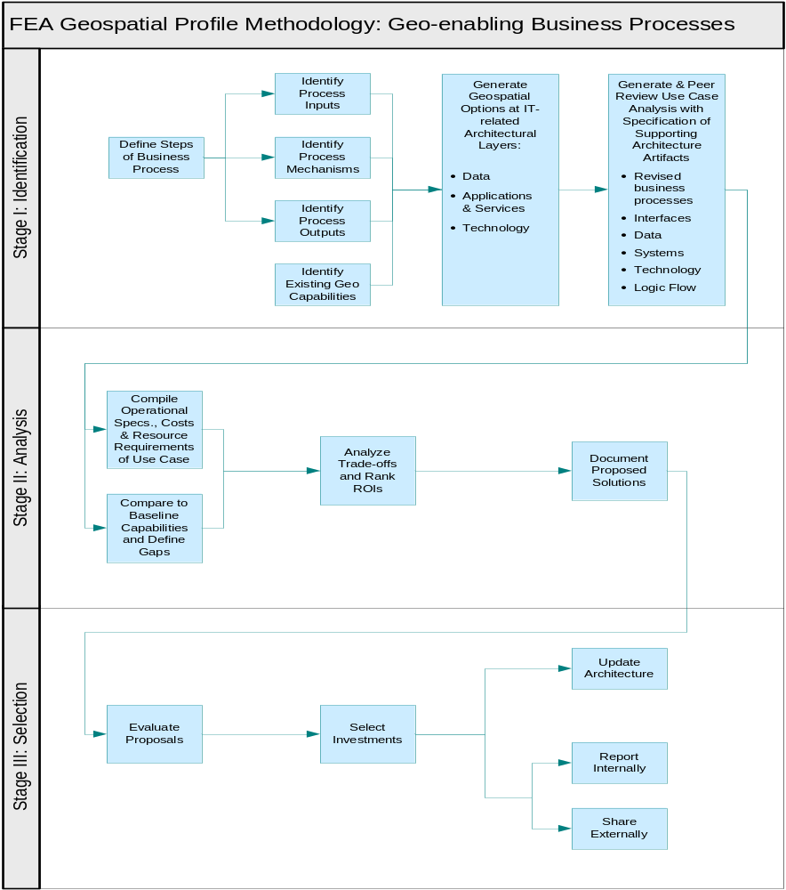
Figure C–1: Overview of Methodology for Geo-enabling Business Processes

Define Steps of Business Process
If the answer to these questions is “yes,” the chief architect can work with the program manager to map the principal steps within the business process and determine where geo-enabling is appropriate. The data inputs, documents, and outputs at each major step within the business process should be define at a general level—ideally within an architecture modeling tool so that relationships between elements are captured. Figure C–2 illustrates part of an EPA grant award process that was used to identify opportunities for location-based approaches.
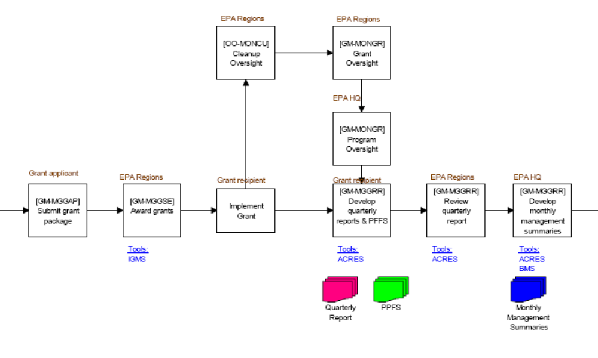
Figure C–2: Portion of Diagram Used to Define Steps of a Business Process
Note that virtually all the steps in this process relate in one way or another to location. For example:
- Is the location of the grant applicant important? Is the location to which it sent its application important?
- Would the grant award process benefit from knowing more about the prospective grant location than is available in the current application?
- In implementing a grant, could the awarding agency provide the grantee with useful information about locally available implementation assistance?
- In overseeing multiple cleanup grants, would it be helpful to generate geographically efficient routes for inspectors to follow?

Identify Process Inputs, Mechanisms, and Outputs
The next stage of the methodology is to define the inputs, mechanisms, and outputs of each step, as illustrated in Figure C–3 below, and to note any existing geospatial capabilities used in relation to opportunities for expansion or the need for a technical upgrade. The more detail available, the more opportunity there is to find new opportunities to apply geospatial techniques.
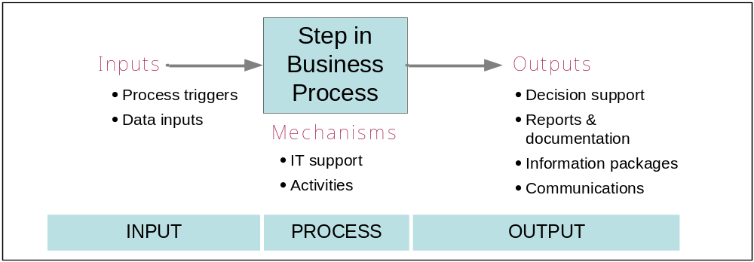
Figure C–3: Identifying Process Inputs, Mechanisms, and Outputs
Business managers and architects review the flow of a business process step by step, identifying the basic process triggers, input data, and process mechanisms (IT support, activities), asking the following questions with the geospatial services staff:
- Are there geospatial services or activities that can improve the business process (e.g., using geospatial tools to find the distribution of individuals around a facility undergoing clean-up)? These can be characterized as geospatial information inputs to the business process, as shown in Figure C–3.
- Are there specific geospatial technology tools that might change the business process itself to be cheaper or faster? (e.g., aerial photo vs. on-the-ground visit)
- Are there ways that the outputs of the process could be changed to more effectively communicate and use results (e.g., visualization of various scenarios)?

Generate Geospatial Options
Next, business managers and geospatial staff generate options for improving the business process—opportunities to conduct the process better, faster, or cheaper—by applying geospatial capabilities. Exhibit C–4 discusses each of the elements shown in Figure C–3.
Exhibit C–4: Types of Options and Examples for Geo-enabled Processes
Element | Description | Example Geo-enabled Options
INPUT | Process triggers:  - Example: receipt of a particular type of information (data trigger), an action by an IT system (system trigger), or an input from a technological platform (such as a GPS unit) | - GPS-enabled wireless sensors on field vehicles automatically trigger emergency response action if hazardous gases are detected  - Automated analysis of multi-spectral satellite data identifies locations of crop blight for analysis
 | Data inputs:  - Geospatial data that could be used by the process (e.g., proximity of individuals to hospitals or other sites for health services)  - Converting addresses or place names in existing input data into digital coordinates | - Access geo-spatial data from a digital library to provide adequate knowledge of local conditions  - Convert list of employee addresses to digital coordinates to plot commuting time or possible recruitment locations
PROCESS | Mechanisms:  - Use of digital imagery avoids need for on-ground site inspection | - NEPA Assist provides access to background information quickly and organized by location, would previously have taken weeks to gather all the info  - Wireless GPS sensors provide real-time knowledge of the location of emergency response staff, rather than relying on staff phoning in their positions.
OUTPUTS | Decision Support  - Complex report results are mapped and used to make management briefings clearer and more effective.  - Spatial statistics may offer business managers sophisticated new approaches to making decisions based on the results of a process step. | - Managers can know the exact location of a problem and/or the location of nearby response resources.  - Analysts can combine a wide variety of data sets by geo-coding them. They can bring new information to bear on decisions by using indirect locational information as such as addresses, place names, or membership in a location-based community.

The output of Stage I should be a reasonably detailed scenario or use case that includes
  - A statement of the goal of the proposed solution, relationship to existing business process, perceived gaps or problems, and technical opportunities available for improving the process with geospatial functionalities.
  - One or more operational scenarios or narratives detailing how the revised business process would make use of geospatial capabilities.
  - Inventory of the baseline architectural elements or “artifacts” (business functions/processes, data assets, applications and services, and technologies) that would be included in, or affected by, the solution.
The use case can be circulated to the staff or organization(s) involved for review and comment, and updated or refined as appropriate.

SIDEBAR: EPA Grant Management Use Case Summary or Diagram

Stage II: Analysis
The Analysis stage involves conversion of scenarios or use cases for applying geospatial capabilities into explicit operational statements. These are then compared as operational needs to define baseline geospatial capabilities to reveal opportunities for the reuse of existing services and resources and to identify gaps between existing capabilities and those required to implement the solution. The baseline geospatial capabilities may be unique to an agency or may exist as capabilities common to multiple organizations within the NSDI. Business managers and geospatial staff then conduct a return on investment (ROI) analysis of net costs, estimated schedules, and other resource requirements to yield a complete proposed solution.

Compile Operational Specifications and Resource Requirements
The first step in Stage II is to develop a detailed operational statement of the proposed solution that will consider all layers of the system, including required business process changes, data and data flows, applications and services, and associated technology.
Throughout this stage of the methodology, the architecture team works through each function and process of the use case, defining all operational specifications required to implement the solution outlined in the use case. Where more than one option exists for implementing a proposed function, the team develops all options in sufficient detail to compare implementation needs to existing capabilities (internal and external).

Compare Operational Specifications to Baseline Capabilities, Define Gaps
The resulting operational specifications—whether described in the swim lane format illustrated here or using some other notation—can then be compared to existing capabilities documented in the agency’s baseline (“as-built”) architecture. The team notes as gaps those requirements not satisfied by available components. Whereas some gaps may be filled by modifying or enhancing existing components, others may require the acquisition or construction of new components.
For each gap, the team compiles preliminary cost estimates based on existing documentation and best professional judgment. These estimates can be refined in the next step as needed.

Analyze Trade-offs and Rank ROIs
In developing scenarios for geo-enabling a business process, teams are likely to note multiple ways that geospatial services or a place-based approach might make an improvement. Where there are multiple options for geo-enabling a particular function or sub-function, or where different activities within a process can make use of different geospatial capabilities, trade-offs will be analyzed among the options and returns on investment ranked for each option.
The output of this step is creation of a cost-effective combination of geospatial capabilities for the functional improvement gained by a placed-based approach. The analyses may identify a need to change existing, or propose new, capabilities as a solution to gaps or sub-optimal capabilities. These can lead to trade-off analyses of alternative solutions. Multiple solutions to each problem may introduce different levels of residual risk and varying implementation costs. OMB directs agencies to consider alternative solutions and evaluate them based on functionality, risk, cost, and interoperability. Trade-off analyses result in a set of proposed investments that can then be mapped to the agency’s to-be architecture. Options to be explored include internal, government-wide, and commercial packages. When agencies evaluate options for leveraging, they should consider solutions from other agencies as well as solutions in their own agency. Reuse of solutions among Federal agencies is a goal of FEA efforts.
The results of the trade-off analysis support the investment prioritization process, both at the programmatic level and for the agency’s information technology investment review board. The trade-off analysis performed in the business cases, the references to the risk analyses, and the enterprise architecture content provide the basis for informed risk-based decision-making during investment review, prioritization, and funding decisions.

Stage III: Selection
Stage III is a program-wide, bureau-wide, or enterprise-wide evaluation of the geospatial solutions proposed in Stage II and the selection of major and non-major investments.

Evaluate Proposals
In Stage III the implementation team works with the appropriate level of agency financial officers and the appropriate level of IT investment review boards to integrate outputs from previous stages into the broader capital planning process to ensure the
- evaluation of individual proposals such that each fully reflects the outputs of Stages I and II;
- selection of individual geospatial proposals that best support the business needs of the organization, including potential reuse of geospatial assets and capabilities across the agency; and
- documentation of the updated target architecture and sharing of reusable components.
The appropriate financial officer and investment review board begin by evaluating all proposals using consistent criteria. Ideally, the Stage II trade-off analysis is consistent with the evaluation criteria. The financial office and review board are then merely enforcing expectations articulated in enterprise architecture principles and OMB Exhibit 300 budget justification criteria.
While not every proposal from Stage II will be a major investment, proposed solutions should undergo executive review to ensure they meet agency criteria and are consistent with the target architecture. Reuse solutions should be pursued wherever possible to ensure they meet agency criteria and are consistent with the target architecture.

Select Proposals
Stage II promotes solutions consistent with enterprise needs. Ultimately, it is the role and responsibility of the review board to select a mix of proposals that optimize business needs and maximize available funds. Review boards may wish to prioritize proposals based on various agency needs; OMB promotes selecting shared or sharable capabilities or unique, non-shareable solutions.

Update Architecture, Report Internally and Externally
Once the financial officer and review board make their selections, the program, bureau, or agency will document and capture the new capabilities in the agency enterprise architecture. The new capabilities will be reflected in the target architecture and transition plan. Agencies will communicate results internally to ensure program offices and geospatial stakeholders are aware of the new capabilities. Agencies should also consider publicizing externally leveraged capabilities registered at http://www.core.gov or available through OMB’s Geospatial line of Business (GeoLoB).
APPENDIX D: EXAMPLE Of GEo-Enabling Business Activities

Geospatial Business Statement Methodology—
Department of Homeland Security
The process described in this Appendix was used at the Department of Homeland Security in its Enterprise Architecture development process to develop the role of geospatial (technology, data, processes, functions, and applications) within agency business activities. The methodology begins with a set of agreed business activities. This example covers the business activities listed in Table 1.
The business activity being analyzed is the entry in the second column. There are three steps:
- Analyze business activity descriptions to determine possible roles for location-based information in the execution of the business activity. This may range from protecting citizens from environmental hazards to determining commuting patterns and alternative work options such as telecommuting.
- Determine the function of geospatial data, technology, and services in carrying out those activities.
- If a locational aspect of the business activity exists, develop or refine business statements that describe the role of geospatial data and technologies in support of the business activity. This statement is called a Geospatial Business Statement. Descriptions of the geospatial data, applications and services needed to support a business process may also be generated during this step to support the other perspectives of the enterprise architecture.
Table 1: Example Business Activities
Value Chain | Activity Name | Activity Description
Prepare for Incidents | Stockpile & Deploy Supplies | Identify, acquire, develop, maintain, and distribute resources (e.g., pharmaceutical and medical supplies) that would be required to respond to or prevent incidents and shortages. Monitor the potency of vaccines and replenish supplies as vaccines age.
Manage Facilities and Property | Manage Property | Starts after the Department accepts real or personal property (including facilities) and ends when the decision is made to dispose of the property. Property is controlled to meet maintenance, inventory, and accountability requirements. This includes the oversight and maintenance of bonded warehouses that may be storing uninspected or seized goods. This does not include seized, evidence, or custodial property.

A Geospatial Business Language is developed and refined, during the course of step 3, to describe the key concepts (ontology) for the role of geospatial business processes, data and technology within the agency enterprise. These definitions form the basis for a consistent business language to describe the role of “geospatial” in agency business activities. It embodies the geospatial semantics for the agency mission. Further, these terms are used to construct the Geospatial Business Statements, which describe the role of geospatial for each of the agency business activities.
The Geospatial Business Language is comprised of five basic types of terms:
- Application – A computer program with a user interface or computer program component that employs geospatial data and technology; a geospatial business process or sub-process that is implemented as a software program or program component.
- Data – A geospatial information class, type, or property.
- Function – A geoprocessing unit, a geoprocessing user tool, a geospatial service component.
- Process – A general business series of actions that employs geospatial data and technology.
- Technology – An application of science that generates, displays, manages or otherwise processes geospatial data (excluding general-purpose information technology).
Geospatial Business Language terms are developed via a) Internet research, b) interviews with business managers and technical staff, and c) documentation of the knowledge of the enterprise architects who work on the project. Examples of some of the Geospatial Business Language elements developed in DHS that apply to the example business activities are defined in Table 2. Note that the terms listed include other terms from the Geospatial Business Language that are not included for brevity.
Table 2: Example Geospatial Business Language Terms
Geospatial Term | Type | Definition/Description
Asset | Data | A valuable item that is owned. Generally, any equity used in HLS operations. Critical and key assets as defined by the HLS enterprise architecture team, Presidential Decision Directive (PDD)–63, and further defined by the joint USGS–National Geospatial Intelligence Agency (USGS-NGA) Homeland Security Infrastructure Program (HSIP) Tiger Team Report, September 2002
Asset Inventory | Data | The management data associated with equities (Assets critical, key, or other).
Asset Inventory Management | Application | Enterprise-level application(s) that is used to manage fixed and mobile equities (assets), in particular, to monitor and track the location/time/identity/activity/status for a set of equities
Contingency Plan | Data | A program of action designed for handling possible future circumstances or events. Geospatial and temporal context for contingency plans associated with any plan or operation. A type of HLS Framework Data under the Plan subcategory of the Geospatial Product category
Critical Asset | Data | Critical infrastructures are those physical and cyber-based systems essential to the minimum operations of the economy and government. They include, but are not limited to, telecommunications, energy, banking and finance, transportation, water systems and emergency services, both governmental and private. Any ‘Critical Assets’ as defined in PDD–63. The geospatial context of these assets is represented by a category of HLS Framework Data.
Critical Infrastructure Inventory Management | Application | The means to keep track of and report on the location and status of critical assets and key assets. To generate reports and maps conveying this information
Deployment Plan | Data | The procedures to bring forces, material, people, and systems into operation. Geospatial and temporal context for deployment plans associated with any operation. Depicts terrain, objectives, threats, (blue & white) assets, etc. A type of HLS Framework Data under the Plan subcategory of the Geospatial Product category.
Facilities | Data | Geospatial representations of surface, above surface and sub-surface structures, and installed heating, ventilation, and air conditioning (HVAC); plumbing; electrical; security systems; and other installed infrastructure for any facility identified as a critical or key asset. Also, associated real property (e.g., rights of way, easements, etc). A category of HLS Framework Data
Facility Mapping & Management | Application | The means to create and maintain detailed geospatial records of structure(s) for the purpose of managing the structure(s) and related land and infrastructure. Used in planning, construction, security and maintenance. Used to produce facility maps, plans, and reports. Assure compliance with all applicable laws regulating the development, use, or transfer of property. These include National Environmental Policy Act, Americans with Disabilities Act, Clean Water Act, Occupational Safety and Health Act, Superfund Act, State and local permitting, and so on. Any planned construction activity at Federally owned/operated facilities requires compliance with these laws. Used to manage space utilization of existing facilities to assure that space, furniture, and equipment are adequate to support current and future mission requirements.
Goods (Record) | Data | Assets being transported by conveyance. The records for description (including a digital record of credentials), tracking and monitoring of assets (e.g., place of manufacture, shipping history in geospatial context—location/time/identity/status), and money. May reference location, case, conveyance, risk, event (incident, occurrence, event) or party (person or organization) records. Subcategories include cargo, parcels/packages, evidence, money, hazmat and any other types of goods/things of interest. A category of HLS Framework Data
Incident | Data | A specific instance of carrying out a threat that may or may not result in harm to a party or asset. It requires a response above and beyond the normal daily operations. Current and historical geospatial and temporal context associated with any type of incident, whether natural or man-made. Incidents may be occurrences of an instance of a single threat type, or include combinations of occurrences of multiple threats (e.g., high explosive combined with radiological-dirty bomb; hurricane or typhoon with flooding, etc.). Incident data provide a complete historical geospatial and temporal context for all activities associated with the incident (preparation, mitigation, response, recovery) and may link to intelligence, maps, reports, analyses (risk, threat, vulnerability), plans (mitigation, preparation, response, recovery, etc.), consequence modeling outputs, assessments, and tracking of assets, parties, conveyances, goods, etc. associated with the incident. Includes location/time/identity/activity/status for all occurrences and activities associated with the incident. A category of HLS Framework Data
Key Asset | Data | Individual equities whose destruction would not endanger vital systems, but could create local disaster or profoundly damage our Nation’s morale or confidence. Key assets include symbols or historical attractions, such as prominent national, State, or local monuments and icons. Key assets also include individual or local facilities that deserve special protection because of their destructive potential or their value to the local community. Examples include national icons, monuments, and marine resources. Any key assets as defined in PDD–63. The geospatial context of these assets is represented by a category of HLS Framework Data
Logistics Plan | Data | The documented management of the details of an operation. The geospatial-temporal context of a logistics plan, which includes maps and reports that convey objectives, schedules, deployments, and contingencies concerning the distribution and use of goods (materials and supplies), assets, conveyances, and related personnel in meeting the needs of emergencies. A type of HLS Framework Data under subcategory Plan, under the Geospatial Product category
Map (and Charts) | Data | Generally, an annotated, symbolized graphical representation of select geospatial-temporal data for an intended purpose. Also, a map created by an orthorectified image. May contain annotations and marginalia. May be in hardcopy or softcopy form. May reference a report or plan. May be referenced by or embedded in a report or plan
Operational Plan | Data | A documented process for a particular method of efficient, productive activity. The geospatial-temporal context of an operations plan, which specifies the allocation of funds, activities, and resources by organization and geographic area (congressional district, State, territory, county, reservations, and cities). May also include maps and reports that convey objectives, schedules, deployments, contingencies, and the situation context for projected operations, including threat disposition, blue force disposition, contingency deployments, environmental constraints, etc. Plans may also include standard operating procedures for geospatial data acquisition, management and sharing, as well as the geospatial management and investment plans for all levels of government, developed in cooperation with private and public sector entities. A type of HLS Framework Data under subcategory Plan, under the Geospatial Product category
Operational Planning | Application | A program designed to document the process for a particular method of efficient, productive activity. The means to scheme, schedule, and allocate personnel and assets for emergency operations. To develop Operational Plans.
Route | Data | The representation of a route for navigation purposes. The route’s overall characteristics, such as its start point, waypoints, end point, transportation type, total distance, travel time and bounding box. Route geometry is defined as a list of geographic positions along the route, ordered in the sequence of planned travel, starting with the position of the route’s origin and ending with the position of the route’s destination, including waypoints. Also, a list of travel instructions consisting of turn-by-turn directions and advisories along the route, ordered in sequence of their occurrence. Routes are derived from navigable transportation networks. An HLS geospatial entity subtype
Situation Reports | Data | Reports that contain relevant geospatial-temporal situation context for any activity/event/incident/occurrence for command and control purposes. A type of HLS Framework Data under the Report subcategory of the Geospatial Product category

The role of geospatial data (location) and geospatial technology in the agency mission is defined in terms of Geospatial Business Statements. These statements are based upon the Geospatial Business Language. Most agency business activities have one or more such statements that describe the primary uses of geospatial data and technology and define the main geospatial applications (and application components) involved in the agency enterprise. Many of the applications include non-geospatial data and technology and may be predominantly non-geospatial in nature. As such, the value of geospatial service components is crucial to many agency business activities. Agency applications will need authorized access to these components when and where they are needed in the agency enterprise.
The following table (Table 3) maps the example agency business activities from Table 1 to geospatial roles, where each role is expressed in terms of Geospatial Business Statements and Geospatial Applications. The roles and applications were developed in an iterative process during the course of interviewing business and technical staff within the agency. Many times Geospatial Business Statements would be rewritten once key Geospatial Business Language terms were identified and standardized. Some Geospatial Business Statements are broad capabilities that apply across the entire enterprise, while others may only apply to specific activities that are unique to a particular business area.
Table 3: Example Geospatial Roles
Activity Name | The Role of Geospatial in the Business Activity (Geospatial Business Statements) , | Geospatial Applications
Stockpile & Deploy Supplies | Conduct logistics planning to coordinate and plan the use of assets and personnel for incidents and shortages. Conduct routing and distribution analyses to achieve supply and logistics staging. Determine stockpile locations. Create, update, reference, and share logistics plans and situation reports/maps.  Manage the assets required for incidents and shortages, including response equipment and materials, reserve of vaccines, pharmaceuticals, and other response supplies in anticipation of a future shortage or emergency. Create, update, reference, and share asset inventory data.  Conduct operations planning. Update operations plans (deployment and contingency plans) to reflect asset and personnel resources and locations.  Assemble, distribute, and monitor deployable technologies and data to support response and recovery activities. | Logistics Planning  Asset Inventory Management  Operations Planning
Manage Property | Conduct facility mapping and management to manage real property and facilities. Create, update, reference, and share real property and facilities data for management and security purposes. Manage space utilization of existing facilities to assure that space, furniture, and equipment are adequate to support current and future mission requirements. Assure compliance with all applicable laws and regulations. (e.g., National Environmental Policy Act requires map and photographic characterization of the site and its immediate surrounds for potential environmental constraints to proposed action including wetlands; floodplains; rare, threatened, and endangered species habitat; property boundaries; hazardous materials; cultural and historic considerations; archaeological findings; environmental justice; accessibility; demographics; and so on.)  Conduct critical infrastructure inventory management to update, reference, and share the status of critical asset and key asset inventories.  Manage personal property assets/goods. Create, update, reference, and share asset/goods inventory data (location/time/identity/status). | Facility Mapping & Management  Critical Infrastructure Inventory Management  Asset Inventory Management

APPENDIX E: Lines of Business and Geospatial APPROACHES
Business Area | Line of Business | Primary or Secondary Element—Line of Business Description | Geospatial Aspects of the Activities
Services for Citizens | Homeland Security | Primary—protecting the Nation against terrorist attacks. This includes analyzing threats and intelligence, guarding borders and airports, protecting critical infrastructure, and coordinating responses to emergencies | Training exercises  Assessment of and planning for areas of vulnerability  Conducting response operations  Tracking potential suspects  Monitoring border areas
Services for Citizens | Intelligence Operations | Primary—collecting and analyzing information to meet the national security challenges of the U.S. by processing reliable, accurate foreign intelligence and disseminating intelligence products to policymakers, military commanders, and other consumers | Planning operations in areas of potential conflict  Conducting assessments of threat  Integrating information from multiple sources  Tracking movements of groups of individuals who may be targets for international terrorist threats
Services for Citizens | Defense & National Security | Primary—involves information to understand the needs for where to establish national and multinational military objectives, sequence initiatives, define limits and assess risks for the use of military and other instruments of national power, developing global plans or theater war plans to achieve these objectives | Developing a common operating picture of an area  Planning troop operations and movements  Determining optimal logistics supply routes  Monitoring opposition forces  Providing assistance to civilian populations to minimize risk from threats.
Services for Citizens | International Affairs and Commerce | Primary—the non-military activities that promote U.S. policies and interests beyond our national borders, including the negotiation of conflict resolution, treaties, and agreements. Also includes foreign economic development and social/political development, diplomatic relations with other nations, humanitarian, technical and other developmental assistance to key nations, and global trade | Identifying factors contributing to conflict and seeking resolution  Identifying areas with need for foreign economic development assistance  Addressing social/political development priority needs in regions of the world.  Maintaining knowledge of borders of nations and of trans-boundary issues.  Assessing natural resource and/or economic conditions which might impact negotiation of treaties  Producing maps to enhance foreign policy analysis
Services for Citizens | Disaster Management | Primary—involves information to conduct the activities required to prepare for, mitigate, respond to, and repair the effects of all disasters, whether natural or manmade regardless of where the threat may come from or the disaster may occur. | Tracking deployment of resources  Tracking distribution/location of evacuees  Targeting and setting priorities for monitoring and response activities  Status of infrastructure operations  Providing an overview of damage to natural and manmade entities.  Routing for the dispatch of emergency vehicles for emergency response  Delineating areas which are more susceptible to regional natural hazard events
Services for Citizens | Law Enforcement | Primary—activities to protect people, places, and things from criminal activity resulting from non-compliance with U.S. laws. This includes patrols, undercover operations, response to emergency calls, as well as arrests, raids, and seizures of property. | Crime tracking  Pattern-based Crime prediction (e.g. analysis  of the relationship between newly developed transportation corridors and increases in crime rate).Deployment of enforcement resources to maximize effectiveness  Connecting information from different departments to create a bigger picture
Services for Citizens | Education | Primary—Activities for all government programs that promote the education of the public, including formal school, college, university, or other training program at any location | Tracking of results of programs  Geographically displaying and analyzing school performance, trends, and corrective actions taken  Tracking of resources by district  Tailoring programs based on demographics  Determining boundaries for schools  Developing school buses routes
Services for Citizens | Energy | Primary—all actions performed by the government to ensure the procurement and management of energy resources, including the production, sale, and distribution of energy, as well as the management of spent fuel resources | Siting for man made facilities such as power plants  Overview of location of natural resources such as coal, oil, and natural gas deposits.  Determination of transportation facilities such as power lines, pipelines, and railroads  Determining impacts of energy operations and risks due to natural events such as weather  Tracking of materials, both hazardous and nontoxic  Tracking release and dispersion of fissile material and radioactive material  Modeling and monitoring pipelines
Services for Citizens | Environmental Management | Primary—all functions required to monitor the environment and weather, determine proper environmental standards and ensure their compliance, and address environmental hazards and contamination | Assessing ecological impacts from development  Monitoring air and water quality and determining impact on specific populations  Determining levels of pollutants released from a hazardous materials spill and predicting impacts upon humans as well plant and animal species  Predicting future air quality levels for transportation corridors based on differing emission standards  Setting priorities for monitoring, permitting, inspections, compliance assurance activities, enforcement etc.  Designing monitoring networks  Characterizing populations around hazardous release sites and/or stacks/outfalls and to protect potentially sensitive sub populations  Monitoring environmental restoration and clean up
Services for Citizens | Health | Primary—Federal programs and activities to ensure and provide for the health and wellbeing of the public, including the direct provision of health care services and immunizations as well as the monitoring and tracking of public health indicators for the detection of trends and identification of widespread illnesses/diseases | Monitoring emergent infectious diseases or outbreaks of disease and their spread  Planning for the distribution of vaccines to meet needs of aging or young populations  Determining the distribution of medical personnel in an area to meet the needs of populations  Planning for the location of medical facilities to take advantage of transportation routes  Studying historical health trends to understand potential future issues
Services for Citizens | Natural Resources | Primary—all activities involved in conservation planning, land management, and national park/monument tourism that affect the Nation's natural and recreational resources, both private and Federal | Establishing and managing outdoor recreational areas  Planning and managing timber production and economic effects on nearby communities.  Assessing the biological health of wildlife populations and developing management plans for species which may be at risk  Collecting and maintaining basic mapping data for use in all government and services programs  Conducting seeding, replanting, or other rehabilitation actions after wild land fires  Analyzing and defining areas suitable for development and others more suitable for conservation
Services for Citizens | Community and Social Services | Primary—information about location for activities aimed at creating, expanding, or improving community and social development, social relationships, and social services in a community in the United States. This includes all activities aimed at locality-specific or nationwide social development and general social services | Planning the level of social services which are needed by communities  Determining underserved communities and providing facilities and services to meet needs  Monitoring impact of programs on the health or educational achievement of communities  Identifying locations in need of after school facilities  Planning maintenance and upgrade of playgrounds and community recreational facilities
Services for Citizens | Economic Development | Primary—information to know where to promote commercial/industrial development and to regulate the American financial industry to protect investors nationally. It also includes the management and control of the domestic economy and the money supply and the protection of intellectual property and innovation across the Nation. | Planning Rural Development programs based on community needs  Planning for and stimulating the recovery of business affected by natural disasters  Developing a picture of the flow of commerce domestically and its economic effects  Identifying areas that can benefit most from commercial and industrial development
Services for Citizens | General Science and Innovation | Secondary—all Federal activities to meet the national need to advance knowledge in general research and technology programs, space exploration activities, and other research and technological programs that have diverse goals | Understanding the research capabilities for different geographic areas of the Nation  Coordinating research activities to share results  Supporting the establishment of research priorities
Services for Citizens | Correctional Activities | Secondary—Federal activities that ensure the effective incarceration and rehabilitation of convicted criminals | Making site selection decisions for the placement of new facilities within a community.  Identifying areas prone to inmate violence in institutional settings  Assigning probation and parole officers by geographic location;  Directing probationers and parolees to services and treatment centers;  Identifying Patterns of offenders and targeting efforts to high-risk areas,  Tracking probationers in terms of risk and need for resources.
Services for Citizens | Litigation and Judicial Activities | Secondary—activities relating to determining an issue of fact and reaching a decision based on that evidence, determining a legal question or matter or attempting to prove guilt/responsibility | Monitoring compliance and required public notification  Tracking and enforcing land use controls by red-flagging properties that have residual contamination after cleanup.  Mapping the physical situation on the ground immediately after a spill or the air after a release to prove liability  Analyzing demographics for civil rights actions
Services for Citizens | Income Security | Secondary—activities designed to ensure that members of the public are provided with the necessary means – both financial and otherwise – to sustain an adequate level of existence. This includes all benefit programs, hat promote these goals for members of the public | Targeting programs to benefit the poor – households ( income generation, health, housing, and sanitation)  Estimating extent of poverty in a regions / Mapping where the poor live and/or regions with less potential for economic  development to help target resource allocation  Planning and targeting infrastructure programs  Analyzing the spatial relationships between the providers’ infrastructures/ public service centers and the clients’ locations to help optimize the delivery of services  Providing detailed demographic and business information for strategic planning  Codifying objective criteria for needed geographic distribution of assistance
Services for Citizens | Workforce Management | Secondary—those activities that promote the welfare of the Nation’s workforce by improving their working conditions, advancing opportunities for profitable employment, and strengthening free collective bargaining | Providing view of where workers are located, the work being performed, and what resources are needed  Analyzing clusters of jobs and workers  Determining if a proposed public transportation will connect workers to jobs  Targeting recruitment efforts  Designing facilities /work spaces to optimize worker needs
Services for Citizens | Transportation | Primary—all Federally supported activities related to the safe passage, conveyance, or transportation of goods and/or people including air, ground, water, and space operations | Evaluating a proposed roadway or other transportation /transmission corridors  Planning for long-term infrastructure development and/or short term projects (e.g., which potholes to fill next).  Identifing highway deficiencies and applies economic criteria to select the most cost-effective mix of highway system improvements.  Summarizing freight movement trends in the United States  Evaluating the scope and performance of the transportation system
Support Delivery of Services | Legislative Relations | Secondary—activities aimed at the development, tracking, and amendment of public laws through the legislative branch of the Federal government | Assessing regional impacts/benefits of proposed and existing legislation  Tracking the implementation of public laws  Assessing public support for proposed legislation over regions, States, districts, etc.  Assessing conditions that would support the passage of legislation
Support Delivery of Services | Regulatory Development | Secondary—involves activities associated with developing regulations, policies, and guidance to implement laws | Assessing economic impacts in specific areas related to implementation of proposed regulations  Assessing chemical levels in waterways, air, etc. to determine need for regulation  Providing visualization to regulated communities on applicability of laws and compliance requirements
Support Delivery of Services | Public Affairs | Secondary—the exchange of information and communication between the Federal government, citizens, and stakeholders in direct support of citizen services, public policy, and/or national interest | Outreach to potential applicants for assistance in underserved areas or among populations.  Informing local and State legislators  Ensuring environmental justice  Providing the public with access to information about their neighborhoods  Communicating about natural/manmade disasters  Summarizing alternatives in public meetings  Providing travelers to public sites with the ability to plot their course for visits  Providing easy access to information, thus reducing need to travel into a government center/office
Support Delivery of Services | Planning and Resource Allocation | Secondary—determining strategic direction, formulating and executing budgets, identifying and establishing programs for defining and allocating the organizational workforce and technological requirements among those programs and processes | Targeting funding decisions to maximize their effectiveness  Planning for deployment of emergency assistance resources  Identifying the crew in closest proximity to a new, urgent work site for optimal dispatching  Tracking distribution of grants, contracts, and assets
Support Delivery of Services | Revenue Collection | Primary—includes the collection of government income from all sources, except for tax collection, which is accounted for in General Government | Evaluation of patterns of loan delinquencies  Evaluation of distribution of publication sales by region
Support Delivery of Services | Internal Risk Management and Mitigation | Primary—all activities relating to the processes of analyzing exposure to risk in the event of a catastrophic or damaging event and determining appropriate countermeasures | Assessment of health, environmental, or economic risk from environmental or economic hazards in specific areas or of specific projects  Targeting areas for preventive activities  Managing deployment of resources to mitigate risks  Evaluating effectiveness of risk planning and countermeasure after event occurs
Support Delivery of Services | Controls & Oversight | Primary—operations and programs of the Federal government and its external business partners determine the effectiveness of and the extent to which they comply with applicable laws and regulations and prevent waste, fraud, and abuse | Identifying geographic patterns of fraud or identification of waste or fraud by a single entity across similar geographic areas  Targeting compliance and/or enforcement actions  Evaluating effectiveness of control measures
Support Delivery of Services | General Government | Primary—general overhead costs of the Federal government, including legislative and executive activities; provision of central fiscal, personnel, and property activities; and the provision of services that cannot reasonably be classified in any other line of business. Includes Tax Collection | Tracking resource distribution and use  Managing facilities and properties  Tracking real estate transactions that take place  Gathering organizing and analyzing information on properties
Manage Govt Resources | Financial Management | Secondary—The use of financial information to measure, operate and predict the effectiveness and efficiency of an entity's activities in relation to its objectives. The ability to obtain and use such information is usually characterized by having in place policies, practices, standards, and a system of controls that reliably capture and report activity in a consistent manner | Tracking and allocation of grants and/or contract dollars by State, congressional districts etc and assessing against goals.
Manage Govt Resources | Human Resource/ Resource Management | Secondary—all activities associated with the recruitment and management of personnel | Identifying locations of academic centers of excellence for targeted recruitment in relationship to recruiting personnel  Tracking the distribution of workers throughout an organization’s various facilities/locations  Comparing regional economic conditions when determining salaries to support raises and compensation packages  Assessments of demographics to assess deployment and/or redeployment of employees  Assessment of minority populations in various components of an organization
Manage Govt Resources | Admin Management | Primary—the day-to-day management and maintenance of the internal infrastructure. Includes maintaining and operating office buildings, fleets, machinery, and other capital assets; the physical protection of an organization’s personnel, assets, and facilities and business related travel for an organization’s employees | Managing phone/network/cubicle management; personnel rosters by facility for emergency evacuation purposes  Providing information on public utilities supporting government facilities
Manage Govt Resources | Information and Technology Management | Secondary—involves the coordination of information and technological resources and systems required to support or provide a service | Identifying facility/personnel locations in planning network/bandwidth leasing
Manage Govt Resources | Supply Chain Management | Primary—the purchasing, tracking, and overall management of goods and services | Tracking shipments of sensitive cargo; manifest tracking/management  Assessing purchase patterns for future procurement  Maintaining inventories
APPENDIX F: GEOSPATIAL SERVICE COMPONENTS
This appendix lists the set of geospatial service components that might apply within an agency services architecture. This list will be updated periodically to reflect changes as they become known by the GEA COP WG. Please see the following URL for the most up-to-date listing:
http://colab.cim3.net/cgi-bin/wiki.pl?GeoSpatialCommunityofPractice/GeospatialServiceComponents
The first three columns in the table below represent the service domains, service types, and service components represented in the FEA SRM. The last three columns identify and describe the geospatial service components. The description includes the level of service component granularity defined, where BCS represents Business Component System, BC represents Business Component and DC represents Distributed Component. The distinction is important because it emphasizes opportunities for integration, interoperability, and component sharing, which is important in OMB Exhibit 300 formulation and improved business effectiveness.
To submit a modification to this list, send an e-mail with the subject, “Geospatial Service Components Modification Request” to geo-forum@colab.cim3.net. In the content of the e-mail include the following information:
Requesting Organization—the name of the organization making the change request
Requesting POC Name—the name of a cognizant point of contact with the requesting organization
Requesting POC Telephone—the telephone number of a cognizant point of contact with the requesting organization
Requesting POC Email—the e-mail address of a cognizant point of contact with the requesting organization
Modification Type—one of Update (to update an existing entry), Insert (to add a new entry), or Delete (to delete an existing entry)
FEA Service Domain—the FEA service domain for the entry
FEA Service Type—the FEA service type for the entry
FEA Service Component—the name for the FEA service component entry
FEA Service Component Description—the description for the FEA service component entry
Geospatial Service Component—the name for the geospatial service component entry
Geospatial Service Component Description—the description for the geospatial service component entry
Component Granularity Level—the component granularity level for the entry (must be BCS, BC, or DC, as defined in section Error: Reference source not found)
Justification—text that justifies the modification requested
Implications—text that describes any implications of note that would result from accepting the modification (e.g., this change will require the deletion of another entry, the addition of another entry, or similar)
A separate geospatial service components modification request should be made for each desired modification. All requests will be registered for processing at the next meeting of the GEA COP WG.
The asterisk (*) on a geospatial service component is used to indicate that there is more than one entry for this component. This is done for cases in which the geospatial service component does not fit neatly under the FEA SRM taxonomy of service components. There are also instances where the list suggests new, recommended FEA service components.

FEA Service Domain | FEA Service Type | FEA Service- Component | FEA Service Component Description | Geospatial Service Component  (* = multiple entries) | Geospatial Service Component Description | Component Granularity Level
Back Office Services Domain | Assets - Materials Management | Facilities Management | Defines the set of capabilities that support the construction, management and maintenance of facilities for an organization. | Facilities Management System | A GIS-based Facilities Management System | BCS
Back Office Services Domain | Assets - Materials Management | Property - Asset Management | Defines the set of capabilities that support the identification, planning, and allocation of an organization's physical capital and resources | Property - Asset Management System | A GIS-based Property - Asset Management System | BCS
Back Office Services Domain | Data Management | Data Exchange | Support the interchange of information between multiple systems or applications; includes verification that transmitted data was received unaltered | Geospatial Data Exchange and Translation Services | The ability to import/export, manipulate, and convert geospatial data through standard data exchange and transformation services. Services to transform geospatial data schemas between disparate systems | DC
Back Office Services Domain | Data Management | Data Exchange | Support the interchange of information between multiple systems or applications; includes verification that transmitted data was received unaltered | Coordinate Transformation Service | The ability to transform geospatial data between different coordinate reference systems, pieces of data, and units. Support map re-projections on the fly for map viewing, as well as permanent coordinate transformations that result in a transformed output data set | DC
Back Office Services Domain | Data Management | Data Exchange | Support the interchange of information between multiple systems or applications; includes verification that transmitted data was received unaltered | Geospatial Information Broker | A key component used in moving geospatial data between systems. Involved in data sharing and collaboration operations. Involved in Geospatial Data Roll-up/Roll-down Operations | BC
Back Office Services Domain | Data Management | Extraction and Transformation | Defines the set of capabilities that support the manipulation and change of data | Feature Update Service | An application and supporting services for selection, browsing, extraction, transformation, integration and update of a feature database. Assures that requestor credentials are sufficient for requested changes and that changes requested do not violate validation rules | BC
Back Office Services Domain | Data Management | Extraction and Transformation | Defines the set of capabilities that support the manipulation and change of data | Coverage Update Service | An application and supporting services for selection, browsing, transformation, integration, and update of a coverage (e.g., imagery) database. Assures that requestor credentials are sufficient for requested changes and that changes requested do not violate validation rules | BC
Back Office Services Domain | Data Management | Extraction and Transformation | Defines the set of capabilities that support the manipulation and change of data | Gazetteer Update Service | An application and supporting services to support browsing, data entry, transformation, integration and update of a gazetteer database. Supports adding, changing, and deleting gazetteer records. Assures that requestor credentials are sufficient for requested changes and that changes requested do not violate validation rules | BC
Back Office Services Domain | Data Management | Extraction and Transformation | Defines the set of capabilities that support the manipulation and change of data | Geospatial Resource Metadata (Catalog) Update Service | An application and supporting services for browsing, data entry, transformation, integration and update of the metadata for geospatial resources, and optionally, update of associated geospatial resource records. (Geospatial resources include maps and data from which maps may be derived, and may include ancillary products and services. A geospatial catalog includes various ways by which geospatial resources are characterized and associated.) Assures that requestor credentials are sufficient for requested changes and that changes requested do not violate validation rules. Accesses one or more resource catalog servers | BC
Back Office Services Domain | Data Management | Extraction and Transformation | Defines the set of capabilities that support the manipulation and change of data | Geospatial Service Metadata (Catalog) Update Service | An application and supporting services for browsing, data entry, integration, and update of the metadata for geospatial services. Assures that requestor credentials are sufficient for requested changes and that changes requested do not violate validation rules. Accesses one or more Service Catalog Servers | BC
Back Office Services Domain | Data Management | Geographic Data Management (GIS) | A general-purpose set of capabilities for extracting, loading, transforming, integrating, storing, archiving, and managing geospatial information and related metadata | Geographical Information System* | An integrated system for collecting, storing, accessing, sharing, disseminating, integrating, manipulating, visualizing, analyzing, and otherwise exploiting geospatial information. GIS focuses on producing and exploiting “digital maps” that convey geospatial information in graphical form. It is used widely in government, education, and business.  Also, a general-purpose collection of tools for processing geospatial data. Normally consists of one or more applications with one or more databases. May be configured as a desktop application and/or as a collection of client and server components | BCS
Back Office Services Domain | Data Management | Geographic Data Management (GIS) | A general-purpose set of capabilities for extracting, loading, transforming, integrating, storing, archiving, and managing geospatial information and related metadata | GIS Server* | Comprised of one or more bundled geospatial processing services that support the generation, revision, management, processing, and output of geospatial data. Server-based GIS | DC
Back Office Services Domain | Data Management | Geographic Data Management (GIS) | A general-purpose set of capabilities for extracting, loading, transforming, integrating, storing, archiving, and managing geospatial information and related metadata | Native Geospatial DBMS Server | The capabilities for an Enterprise DBMS to provide native support for storing and managing all types of geospatial data. Capabilities should include geospatial indexing, open SQL query support with geometry and topology operators, geospatial analytics, geospatial data mining, coordinate transformation and linear referencing | DC
Back Office Services Domain | Data Management | Imagery Data Management (GIS) | A general-purpose set of capabilities for extracting, loading, transforming, integrating, storing, archiving, and managing geospatial imagery and related metadata | Imagery Processing System (IPS)* | An integrated system for collecting, storing, accessing, sharing, disseminating, integrating, manipulating, visualizing, analyzing, and otherwise exploiting geospatial imagery. IPS focuses on producing and exploiting “digital orthoimagery” that conveys geospatial information in raster image form. It is used widely in government, education, and business.  Also, a general-purpose collection of tools for processing geospatial imagery. Normally consists of one or more applications with one or more databases. May be configured as a desktop application and/or as a collection of client and server components. | BCS
Back Office Services Domain | Data Management | Imagery Data Management (GIS) | A general-purpose set of capabilities for extracting, loading, transforming, integrating, storing, archiving and managing geospatial imagery and related metadata | Geospatial Imagery Processing Server* | Comprised of one or more bundled geospatial imagery processing services that support the generation, revision, management, processing, and output of geospatial imagery. Server-based Imagery Processing System. | DC
Business Analytical Services Domain | Analysis and Statistics | Geographic Analysis (GIS) | A general-purpose set of capabilities for analyzing and processing geospatial data | Geographical Information System* | An integrated system for collecting, storing, accessing, sharing, disseminating, integrating, manipulating, visualizing, analyzing, and otherwise exploiting geospatial information. GIS focuses on producing and exploiting “digital maps” that convey geospatial information in graphical form. It is used widely in government, education, and business.  Also, a general-purpose collection of tools for processing geospatial data. Normally consists of one or more applications with one or more databases. May be configured as a desktop application and/or as a collection of client and server components | BCS
Business Analytical Services Domain | Analysis and Statistics | Geographic Analysis (GIS) | A general-purpose set of capabilities for analyzing and processing geospatial data | GIS Server* | Comprised of one or more bundled geospatial processing services that support the generation, revision, management, processing, and output of geospatial data. Server-based GIS | DC
Business Analytical Services Domain | Analysis and Statistics | Geographic Analysis (GIS) | A general-purpose set of capabilities for analyzing and processing geospatial data | Geocoder/ Reverse Geocoder Service | Able to determine geospatial coordinates, given an address (Geocoder), or determine address, given geospatial coordinates (Reverse Geocoder). A Geocoder transforms a description of a feature location, such as a place name, street address or postal code, into a normalized description of the location, which includes coordinates. A Geocoder Service receives a description of a feature location as input and provides a normalized address with coordinates as output. The feature location descriptions are any terms, codes, or phrases that describe the features and that are well-known to the Geocoder Service, such as a street addressing or postal coding scheme. These services are very important across many enterprises, as they enable enterprise users to exploit the geospatial-temporal context of the wide diversity of business data that contain location references, such as address, building name, census tract, etc. They are also key to correlating, integrating, and fusing dissimilar data on the basis of geospatial-temporal characteristics | DC
Business Analytical Services Domain | Analysis and Statistics | Geographic Analysis (GIS) | A general-purpose set of capabilities for analyzing and processing geospatial data | Geolocate Service | The capability to use GPS or some other means to determine a geospatial location for a fixed or mobile object of interest (e.g., geospatial feature, person, asset, conveyance, goods, cargo, device, etc.) Mobile Objects must be equipped with GPS, Radio Frequency ID (RFID), and/or other position determination technologies. | DC
Business Analytical Services Domain | Analysis and Statistics | Geographic Analysis (GIS) | A general-purpose set of capabilities for analyzing and processing geospatial data | Gateway Service | Determines the geospatial position of a known mobile terminal from a wireless network. Position is expressed in geographic coordinates. Mobile terminals (cell phones, PDAs, etc) must be equipped with GPS or some other position determination technology. An important service used in LBS, in the wireless realm | DC
Business Analytical Services Domain | Analysis and Statistics | Geographic Analysis (GIS) | A general-purpose set of capabilities for analyzing and processing geospatial data | Route Service | Able to determine (or fetch a predetermined) route and navigation information for autonomous or semi-autonomous navigation between two or more points on a network. An important service used in LBS, in the wireless realm | DC
Business Analytical Services Domain | Analysis and Statistics | Geographic Analysis (GIS) | A general-purpose set of capabilities for analyzing and processing geospatial data | Navigation Service | An enhanced version of the Route Service, which determines routes between two or more points with enhanced navigation information. An important service used in LBS | DC
Business Analytical Services Domain | Analysis and Statistics | Geographic Analysis (GIS) | A general-purpose set of capabilities for analyzing and processing geospatial data | Monitoring Service | Able to determine (or fetch a predetermined) location/time/identity/status/activity series for a location. | DC
Business Analytical Services Domain | Analysis and Statistics | Geographic Analysis (GIS) | A general-purpose set of capabilities for analyzing and processing geospatial data | Tracking Service | Able to determine (or fetch a predetermined) location/time/velocity/identity/status/activity series (track) for a mobile object (e.g., persons, goods, assets, devices, etc.) | DC
Business Analytical Services Domain | Analysis and Statistics | Geographic Analysis (GIS) | A general-purpose set of capabilities for analyzing and processing geospatial data | Weather Service | The means to access weather conditions for an area of interest or location for a specified time period | DC
Business Analytical Services Domain | Analysis and Statistics | Geographic Analysis (GIS) | A general-purpose set of capabilities for analyzing and processing geospatial data | Traffic Service | The means to access traffic information regarding incidents and/or conditions for a specified area of interest, road, or road segment, for a specified time period. Also, the means to access traffic information regarding incidents and/or conditions for a designated route (that has been determined by a route service or navigation service) for a specified time period | DC
Business Analytical Services Domain | Analysis and Statistics | Geographic Analysis (GIS) | A general-purpose set of capabilities for analyzing and processing geospatial data | Model Service | Able to determine and access the extent and nature of a geospatial model (e.g., Toxic Dispersion Model—plume for a chemical or biological event in air or water). The model output is characterized by features. “Toxic Dispersion” refers to the effects of introducing a chemical, radioactive, or biological agent into the atmosphere or a water supply at a point source. Simulation is employed to understand the effects of a toxic agent within its medium. The objective of the simulation is to ascertain contamination levels in a geospatial-temporal context, and thus, to understand the nature of toxic plumes, danger zones, warning zones, and related features, and to be able to view or analyze the output from a simulation run in conjunction with any other geospatial data, e.g., as plumes or danger/warning zones within a geospatial decision support tool. Also, the ability to determine and access weather, hydrographic, and other environmental parameters through environmental simulation. The simulation output is characterized by observations | DC
Business Analytical Services Domain | Analysis and Statistics | Geographic Analysis (GIS) | A general-purpose set of capabilities for analyzing and processing geospatial data. | Geoparser Service | Geoparsing refers to the capability to scan and parse a textual document, identifying key words and phrases that have geospatial-temporal context. A Geoparser Service works in the context of two bodies of information: a reserved vocabulary (a dictionary of place names, a gazetteer or a directory of points of interest (POIs) and a text source (e.g., a newspaper or cable.). The Geoparser returns all occurrences of the use (in the text source) of any term in the reserved vocabulary. Each occasion establishes a geolinks (geospatial/temporal-aware hyperlink) between text terms and the geospatial location associated with the reserved word. That result is an annotated text document with geolinks | DC
Business Analytical Services Domain | Analysis and Statistics | Geographic Analysis (GIS) | A general-purpose set of capabilities for analyzing and processing geospatial data | Sensor Planning Service | A service by which a client can determine sensor collection feasibility for a desired set of collection requests for one or more mobile sensors/platforms, or the client may submit collection requests directly to these sensors/platforms. | DC
Business Analytical Services Domain | Analysis and Statistics | Geographic Analysis (GIS) | A general-purpose set of capabilities for analyzing and processing geospatial data | Sensor Observation Service | A service by which a client can obtain observations from one or more sensors/platforms (can be mixed types). Clients can also obtain information that describes the associated sensors and platforms. | DC
Business Analytical Services Domain | Analysis and Statistics | Geographic Analysis (GIS) | A general-purpose set of capabilities for analyzing and processing geospatial data. | Sensor Alert Service | The SASs produce alert messages when given observation conditions are met by a sensor. Provides the means for client services/users to specify and register user profiles that contain user information, applicable sensors/observations, alert conditions (e.g., maximum/minimum values), and alert actions (what happens if conditions are met). Also, the means for client services/users to update user profiles. Clients are able to control the nature of alerts. For example, a client is able to activate/deactivate an alert capability. Also provides the means to support push/pull capabilities, e.g., to wait for observation input from associated sensors (for on/off sensors like a detector), or to actively poll for (current/historical/predicted) sensor observations | DC
Business Analytical Services Domain | Analysis and Statistics | Geographic Analysis (GIS) | A general-purpose set of capabilities for analyzing and processing geospatial data | Topology Service | The ability to detect topological errors (e.g., overshoots and undershoots of common linear and polygonal features within a definable tolerance), automatically correct errors, if possible, and define topological relationships between connected/collocated linear, polygon, and point features | DC
Business Analytical Services Domain | Analysis and Statistics | Imagery Analysis (IPS) | A general-purpose set of capabilities for analyzing and processing geospatial imagery and related metadata | Imagery Processing System (IPS)* | An integrated system for collecting, storing, accessing, sharing, disseminating, integrating, manipulating, visualizing, analyzing, and otherwise exploiting geospatial imagery. IPS focuses on producing and exploiting “digital orthoimagery” that conveys geospatial information in raster image form. It is used widely in government, education and business.  Also, a general-purpose collection of tools for processing geospatial imagery. Normally consists of one or more applications with one or more databases. May be configured as a desktop application and/or as a collection of client and server components. | BCS
Business Analytical Services Domain | Analysis and Statistics | Imagery Analysis (IPS) | A general-purpose set of capabilities for analyzing and processing geospatial imagery and related metadata. | Geospatial Imagery Processing Server* | Comprised of one or more bundled geospatial imagery processing services that support the generation, revision, management, processing, and output of geospatial imagery. Server-based Imagery Processing System | DC
Business Analytical Services Domain | Knowledge Discovery | Simulation | Defines the set of capabilities that support the representation of the interaction between real-world objects | Terrain Simulator | The application and supporting services for viewing 3D geospatial information. Many specialized types of this service. Accesses one or more terrain servers | BC
Business Analytical Services Domain | Reporting | Ad-Hoc | Ad Hoc - defines the set of capabilities that support the use of dynamic reports on an as needed basis | Location Report Generator* | The application and supporting services for composing a report based upon location-based (geospatial) information. Many specialized types of this service, e.g., situation reports, after action reports, alert/warning reports, incident reports, activity reports, etc. | BC
Business Analytical Services Domain | Reporting | Standardized - Canned | Defines the set of capabilities that support the use of pre-conceived or pre-written reports | Location Report Generator* | The application and supporting services for composing a report based upon location-based (geospatial) information. Many specialized types of this service, e.g., situation reports, after action reports, alert/warning reports, incident reports, activity reports, etc. | BC
Business Analytical Services Domain | Visualization | Imagery | Defines the set of capabilities that support the creation of film or electronic images from pictures, paper forms, or graphics for static or dynamic use | Coverage Client* | An application that provides the means to visualize and interact with coverages (e.g., geospatial imagery and raster data). Provides tools to select coverage data for viewing, enhancement, annotation layer control, setting view window, display chosen view, coordinate transformation, measure and pinpoint, navigate through view with pan and zoom, etc. Usually associated with one or more coverage servers | BC
Business Analytical Services Domain | Visualization | Imagery | Defines the set of capabilities that support the creation of film or electronic images from pictures, paper forms, or graphics for static or dynamic use | Annotation Service* | A service that accesses map/image annotations. Annotations are useful for any activity that requires linking or tagging geospatial data in order to present and discuss it with others, to make joint decisions, collaborate, or to communicate spatially. | DC
Business Analytical Services Domain | Visualization | Mapping, geospatial (GIS), elevation, GPS | Provide for the representation of position information through the use of attributes such as elevation, latitude, and longitude coordinates | Map(ping) Client | An application that provides the means to visualize and interact with geospatial data in rendered map form. Provides tools to select base map/image data for viewing, layer control (e.g., Features, locations, structures, routes, observations, and mobile-objects), set view window, display chosen view, coordinate transformation, measure and pinpoint, navigate through view with pan and zoom, etc. Optionally choose symbology, map display template or select previous views. Usually associated with one or more Map Servers | BC
Business Analytical Services Domain | Visualization | Mapping, geospatial (GIS), elevation, GPS | Provide for the representation of position information through the use of attributes such as elevation, latitude, and longitude coordinates | Situation Awareness | An application and associated services for viewing an area of interest, incident, or event in a geospatial context. May include related geospatial services for selection, analysis, manipulation, reporting, collaboration, etc. | BC
Business Analytical Services Domain | Visualization | Mapping, geospatial (GIS), elevation, GPS | Provide for the representation of position information through the use of attributes such as elevation, latitude, and longitude coordinates | Coverage Client* | An application that provides the means to visualize and interact with coverages (e.g., geospatial imagery and raster data). Provides tools to select Coverage data for viewing, enhancement, annotation layer control, setting view window, display chosen view, coordinate transformation, measure and pinpoint, navigate through view with pan and zoom, etc. Usually associated with one or more Coverage Servers | BC
Business Analytical Services Domain | Visualization | Mapping, geospatial (GIS), elevation, GPS | Provide for the representation of position information through the use of attributes such as elevation, latitude, and longitude coordinates | Feature Client | Sends requests to one or more feature servers for detailed information pertaining to a particular feature within a map. Provides the means to visualize feature information. Provides tools to query feature data, display chosen view, and designate target coordinate transformation system. Often combined with Map Client | BC
Business Analytical Services Domain | Visualization | Mapping, geospatial (GIS), elevation, GPS | Provide for the representation of position information through the use of attributes such as elevation, latitude, and longitude coordinates | Personal Map Software | Personal Map Software includes a variety of tools for viewing, annotating, and manipulating map data. Typically include map data for standalone operations. Often includes Global Positioning System (GPS) capability for mobile applications. Commercial map software for desktop or Personal Digital Assistant (PDA) | BC
Business Analytical Services Domain | Visualization | Mapping, geospatial (GIS), elevation, GPS | Provide for the representation of position information through the use of attributes such as elevation, latitude, and longitude coordinates | Geospatial Client | An application that provides the means to visualize and interact with a variety of geospatial data, including maps, features and coverages. Provides tools to select data for viewing, enhancement, annotation layer control, setting view window, display chosen view, coordinate transformation, measure and pinpoint, navigate through view with pan and zoom, etc. Usually associated with one or more geospatial data servers. | BC
Business Analytical Services Domain | Visualization | Mapping, geospatial (GIS), elevation, GPS | Provide for the representation of position information through the use of attributes such as elevation, latitude, and longitude coordinates | Specialized Geospatial Business Components (Various) | Geospatial-based business applications and associated services that provides visualization and interaction with geospatial data. Provides access to underlying business components and geospatial services. Many such specialized geospatial business components will exist within enterprises, each of which may have a client application and one or more business components and/or geospatial services | BC
Business Analytical Services Domain | Visualization | Mapping, geospatial (GIS), elevation, GPS | Provide for the representation of position information through the use of attributes such as elevation, latitude, and longitude coordinates | Location Client* | Sends requests to one or more location servers for a) geo-coding an address, yielding a coordinate; b) reverse geo-coding a coordinate, returning an address; c) routing from a start point to an end point (perhaps with intervening via points); d) a point of interest given a coordinate or an address (either precisely or within a proximity). Provides the means to visualize location information. Provides tools to query location data and display chosen view, often on a map. Normally implemented as wireless, location-based services (LBS) | BC
Business Analytical Services Domain | Visualization | Mapping, geospatial (GIS), elevation, GPS | Provide for the representation of position information through the use of attributes such as elevation, latitude, and longitude coordinates | Gazetteer Client | Sends requests to one or more gazetteer servers a for place names by a given location or for locations by a given place name. Provides the means to visualize gazetteer information. Provides tools to query gazetteer data and display chosen view. Often combined with other clients | BC
Business Analytical Services Domain | Visualization | Mapping, geospatial (GIS), elevation, GPS | Provide for the representation of position information through the use of attributes such as elevation, latitude, and longitude coordinates | Style Management Service (SMS) | The means to create update and manage styles and symbols. The SMS must manage distinct objects that represent styles and symbols and provide the means to discover, query, insert, update, and delete these objects. Styles provide the mapping from feature types and feature properties and constraints to parameterized symbols used in drawing maps. Symbols are bundles of predefined graphical parameters and predefined fixed graphic “images.” | BC
Business Analytical Services Domain | Visualization | Mapping, geospatial (GIS), elevation, GPS | Provide for the representation of position information through the use of attributes such as elevation, latitude, and longitude coordinates | Annotation Service* | A service that accesses map/image annotations. Annotations are useful for any activity that requires linking or tagging geospatial data in order to present and discuss it with others, to make joint decisions, collaborate, or to communicate spatially. | DC
Business Management Services Domain | Supply Chain Management | Catalog Management | Defines the set of capabilities that support the listing of available products or services that an organization offers | Services Catalog Client | An application that sends requests to one or more service catalog servers for geospatial service catalog records. Includes tools to select and view this information | BC
Business Management Services Domain | Supply Chain Management | Catalog Management | Defines the set of capabilities that support the listing of available products or services that an organization offers | Resources Catalog Client | An application that sends requests to one or more resource catalog servers for geospatial resource catalog records. Includes tools to select and view this information. (Geospatial resources include maps and data from which maps may be derived, and may include ancillary products and services. A geospatial catalog includes various ways by which geospatial resources are characterized and associated.) | BC
Business Management Services Domain | Supply Chain Management | Catalog Management | Defines the set of capabilities that support the listing of available products or services that an organization offers | Location Client* | Sends requests to one or more location servers for information about a point of interest (e.g., store) and associated products and services. Provides capabilities to support a) geo-coding an address, yielding a coordinate; b) reverse geo-coding a coordinate, returning an address; c) routing from a start point to an end point (perhaps with intervening via points); d) a point of interest given a coordinate or an address (either precisely or within proximity). Provides the means to visualize point of interest information. Provides tools to query point of interest data and display chosen view, often on a map. Normally implemented as wireless, location-based services (LBS) | BC
Digital Asset Services Domain | Content Management | Map Production (GIS) | A general-purpose set of capabilities for authoring, publishing and sharing softcopy and hardcopy digital map data | Geographical Information System* | An integrated system for collecting, storing, accessing, sharing, disseminating, integrating, manipulating, visualizing, analyzing, and otherwise exploiting geospatial information. GIS focuses on producing and exploiting “digital maps” that convey geospatial information in graphical form. It is used widely in government, education, and business.  Also, a general-purpose collection of tools for processing geospatial data. Normally consists of one or more applications with one or more databases. May be configured as a desktop application and/or as a collection of client and server components | BCS
Digital Asset Services Domain | Content Management | Map Production (GIS) | A general-purpose set of capabilities for authoring, publishing, and sharing softcopy and hardcopy digital map data | Map Publication Service | A lightweight application for publishing maps. Able to automatically generate and publish maps of interest for inclusion in a plan, report, or other document, with select content and symbolization (map template). E.g., to produce a map for inclusion in a word or graphic document. | BC
Digital Asset Services Domain | Content Management | Map Production (GIS) | A general-purpose set of capabilities for authoring, publishing, and sharing softcopy and hardcopy digital map data. | GIS Server* | Comprised of one or more bundled geospatial processing services that support the generation, revision, management, processing, and output of geospatial data. Server-based GIS | DC
Digital Asset Services Domain | Content Management | Imagery Production (IPS) | A general-purpose set of capabilities for authoring, publishing, and sharing softcopy and hardcopy geospatial imagery data | Imagery Processing System (IPS)* | An integrated system for collecting, storing, accessing, sharing, disseminating, integrating, manipulating, visualizing, analyzing, and otherwise exploiting geospatial imagery. IPS focuses on producing and exploiting “digital orthoimagery” that conveys geospatial information in raster image form. It is used widely in government, education, and business.  Also, a general-purpose collection of tools for processing geospatial imagery. Normally consists of one or more applications with one or more databases. May be configured as a desktop application and/or as a collection of client and server components | BCS
Digital Asset Services Domain | Content Management | Imagery Production (IPS) | A general-purpose set of capabilities for authoring, publishing, and sharing softcopy and hardcopy geospatial imagery data | Geospatial Imagery Processing Server* | Comprised of one or more bundled geospatial imagery processing services that support the generation, revision, management, processing, and output of geospatial imagery. Server-based imagery processing system | DC
Digital Asset Services Domain | Knowledge Management | Information Sharing | Defines the set of capabilities that support the use of documents and data in a multi-user environment for use by an organization and its stakeholders | Feature Server | Responds to requests from a feature client for detailed information pertaining to a particular feature within a map. Optionally supports coordinate transformation from a source coordinate reference system to a target coordinate reference system | DC
Digital Asset Services Domain | Knowledge Management | Information Sharing | Defines the set of capabilities that support the use of documents and data in a multi-user environment for use by an organization and its stakeholders | Coverage Server | Responds to requests from a coverage client to deliver a rendered orthoimage/map. Optionally supports coordinate transformation from a source coordinate reference system to a target coordinate reference system. May act as a proxy to multiple remote coverage services to return a single composite orthoimage/map | DC
Digital Asset Services Domain | Knowledge Management | Information Sharing | Defines the set of capabilities that support the use of documents and data in a multi-user environment for use by an organization and its stakeholders | Map(ping) Server | The means to render 2D views of geospatial data. Responds to requests from a map client to deliver a rendered map. Supports coordinate transformation from a source coordinate reference system to a target coordinate reference system. Supports the specification of remote layer styles. May act as a proxy to multiple remote map services to return a single composite map | DC
Digital Asset Services Domain | Knowledge Management | Information Sharing | Defines the set of capabilities that support the use of documents and data in a multi-user environment for use by an organization and its stakeholders | Terrain Server | The means to render 3D views of geospatial data. Responds to requests from a terrain simulator to deliver a rendered 3D data. Supports coordinate transformation from a source coordinate reference system to a target coordinate reference system. Supports the specification of layer styles. May act as a proxy to multiple remote terrain services to return a single composite view | DC
Digital Asset Services Domain | Knowledge Management | Information Sharing | Defines the set of capabilities that support the use of documents and data in a multi-user environment for use by an organization and its stakeholders | Gazetteer Server | Responds to gazetteer client requests for place names by a given location or for locations by a given place name | DC
Digital Asset Services Domain | Knowledge Management | Information Sharing | Defines the set of capabilities that support the use of documents and data in a multi-user environment for use by an organization and its stakeholders | Location Server | A service with multiple functions that responds to location client requests for a) geo-coding an address, yielding a coordinate; b) reverse geo-coding a coordinate, returning an address; c) routing from a start point to an end point (perhaps with intervening via points); d) a point of interest given a coordinate or an address (either precisely or within a proximity). Normally implemented as wireless, location-based services (LBS) | DC
Digital Asset Services Domain | Knowledge Management | Information Sharing | Defines the set of capabilities that support the use of documents and data in a multi-user environment for use by an organization and its stakeholders | Resource Catalog Server* (or Registry Service) | Responds to client requests for geospatial resource metadata. (Geospatial resources include maps and data from which maps may be derived and may include ancillary products and services. A geospatial catalog includes various ways by which geospatial resources are characterized and associated.) | DC
Digital Asset Services Domain | Knowledge Management | Information Sharing | Defines the set of capabilities that support the use of documents and data in a multi-user environment for use by an organization and its stakeholders | Service Catalog Server* | Responds to client requests for geospatial service metadata | DC

APPENDIX G: Geospatial Standards and Extended TRM
At the service platform and infrastructure, component framework, and service interface and integration levels, the geospatial industry has defined a number of specialized systems and standards described in the following sections.

Service Platform and Infrastructure

Database / Storage
Database / Storage refers to a collection of programs that enables storage, modification, and extraction of information from a database, and various techniques and devices for storing large amounts of data.

Database
Refers to a collection of information organized in such a way that a computer program can quickly select desired pieces of data. A database management system (DBMS) is a software application providing management, administration, performance, and analysis tools for databases.
“Geospatial database support” at a minimum means that the database software has
- a native geospatial data format
- geospatial indexing
- geospatial data access and processing functions
Less common is geospatial database support for advanced functions such as replication, long transactions, ACID transactions, etc. This level of geospatial awareness, if present, is usually found only in products with native geospatial support described above.

Component Framework
The component framework consists of the design of application or system software that incorporates interfaces for interacting with other programs and for future flexibility and expandability. This includes, but is not limited to, modules that are designed to interoperate with each other at runtime. Components can be large or small, written by different programmers using different development environments, and may be platform independent. Components can be executed on standalone machines, a LAN, Intranet, or the Internet.

Presentation / Interface
This refers to the connection between the user and the software, consisting of the presentation that is physically represented on the screen.

Content Rendering
This defines the software and protocols used for transforming data for presentation in a graphical user interface. The following are available standards:
- OpenGIS® Styled Layer Descriptor Implementation Specification (SLD) version 1.0 https://portal.opengeospatial.org/files/?artifact_id=1188
SLD is an XML encoding for how the Open GIS Web Mapping Service (WMS) specification can be extended to allow user-defined symbolization of feature data.
- OpenGIS Web Map Service Implementation Specification / ISO:19128 2005 (WMS) version 1.3 http://portal.opengeospatial.org/files/?artifact_id=5316
Provides three operations (GetCapabilities, GetMap, and GetFeatureInfo) in support of the creation and display of registered and superimposed map-like views of information that come simultaneously from multiple sources that are both remote and heterogeneous.
- ISO Geographic Information—Portrayal (ISO 19117:2005)
This is an abstract document and is not intended for direct implementation. It gives general guidelines to application developers about the mechanism that shall be used to portray the feature instances of a dataset. The portrayal mechanism described makes it possible to have general rules valid for the whole dataset, and at the same time rules valid for a specific value of a feature attribute only.

Wireless / Mobile / Voice
This consists of software and protocols used for wireless and voice enabled presentation devices. Standards include
- OpenGIS Location Service OpenLS: Core Services Implementation Specification (OpenLS) version 1.1 http://portal.opengeospatial.org/files/?artifact_id=8836
The primary objective of OpenLS is to define access to the Core Services and Abstract Data Types (ADT) that comprise the GeoMobility server, an open location services platform. The GeoMobility server provides content such as maps, routes, addresses, points of interest, traffic, etc. It can also access other local content databases via the Internet.

Data Interchange
Define the methods in which data is transferred and represented in and between software applications.

Data Exchange
Data exchange is concerned with the transmission of data over a communications network and the definition of data communicated from one application to another. Data exchange provides the communications common denominator between disparate systems.

Relevant standards:
- OpenGIS Web Feature Service / ISO 19142 (WFS) version 1.1 https://portal.opengeospatial.org/files/?artifact_id=8339
Allows a client to retrieve and update geospatial data encoded in OpenGIS Geography Markup Language (GML) from multiple Web Feature Services. The requirements for a Web Feature Service are:
1. The interfaces must be defined in XML.
2. GML must be used to express features within the interface.
3. At a minimum, a WFS must be able to present features using GML.
4. The predicate or filter language will be defined in XML and be derived from Collection Query Language (CQL) as defined in the OpenGIS Catalogue Interface Implementation Specification.
5. The data store used to store geographic features should be opaque to client applications and their only view of the data should be through the WFS interface. The use of a subset of XPath expressions for referencing properties.
- OpenGIS Web Coverage Service Implementation Specification (WCS) version 1.0 https://portal.opengeospatial.org/files/?artifact_id=3837
Initially designed to extend the OpenGIS Web Mapping Service (WMS) interface to allow access to whole or portions of geospatial “coverages”—regularly varying gridded datasets such as aerial imagery. Over time WCS has diverged from WMS and become more targeted towards the remote-sensing community (note that WMS may also output geospatial coverages, but must always output standard Web formats such as JPEG and PNG).
- OpenGIS Filter Encoding Implementation Specification / ISO 19143 (Filter) version 1.1 http://portal.opengeospatial.org/files/?artifact_id=8340
This document defines an XML encoding for filter expressions based on the BNF definition of the OpenGIS Common Catalog Query Language as described in the OpenGIS Catalog Interface Implementation Specification, Version 1.0.
- OpenGIS Coordinate Transformation Service Implementation Specification (CT) version 1.0 http://portal.opengeospatial.org/files/?artifact_id=999
To minimize errors associated with projecting a 3D surface (the earth) into a 2D plane, different earth projections are used by various State, local, and Federal agencies. This makes it crucial to have the ability to transform data from one projection to another as needed.
- Spatial Data Transfer Standard (SDTS): FGDC–STD–002 http://mcmcweb.er.usgs.gov/sdts/
The SDTS was designed by the USGS working with academic, industrial, and Federal, State, and local government users of computer mapping and GIS that saw a requirement for a robust way of transferring earth-referenced spatial data between dissimilar computer systems with the potential for no information loss. The SDTS is a standard for data transfer, as opposed to a standard for data processing. SDTS does not replace existing Geographic Information System (GIS) processing formats.
NOTE: a modified version was adopted as ANSI INCITS 320:1998, which is undergoing periodic review through INCITS Technical Committee L1.
- SDTS Part 5: Raster Profile and Extensions: FGDC–STD–002.5 http://www.fgdc.gov/standards/projects/FGDC-standards-projects/SDTS/sdts_pt5/index_html
Contains specifications of a profile for use with geo-referenced two dimensional raster data, and excludes vector data and three dimensional and higher dimension raster data. It is intended to provide a common transfer format to be used for interchange of raster image and raster grid data among all members of the data producer and user community.
- SDTS Part 6: Point Profile: FGDC–STD–002.6 http://www.fgdc.gov/standards/projects/FGDC-standards-projects/SDTS/sdts_point/index_html
Contains specifications for a SDTS profile for use with geographic point data only, with the option to carry high precision coordinates (by increasing the number of decimal places or significant figures) such as those required for geodetic network control points can be attained.
- SDTS Part 7: Computer-Aided Design and Drafting (CADD) Profile: FGDC–STD–002.7–2000 http://www.fgdc.gov/standards/projects/FGDC-standards-projects/SDTS/sdts_cadd/index_html
Contains specifications for an SDTS profile for use with vector-based geographic data as represented in CADD software. The purpose of this profile is to facilitate the translation of this data between CADD packages without loss of data, and support the translation of this data between CADD and mainstream GIS packages. This profile supports two-dimensional vector data and three-dimensional vector data, where the third dimension is the height of the object. These data may or may not have topology.

Service Interface and Integration

Integration
Integration defines the software services enabling elements of distributed business applications to interoperate. These elements can share function, content, and communications across heterogeneous computing environments. In particular, service integration offers a set of architecture services such as platform and service location transparency, transaction management, basic messaging between two points, and guaranteed message delivery.

Middleware
Middleware increases the flexibility, interoperability, and portability of existing infrastructure by linking or “gluing” two otherwise separate applications. Standards include

- Information technology—Database languages—SQL multimedia and application packages—Part 3: Spatial: ISO 13249–3:2006 http://www.iso.org
ISO/IEC 13249-3:2006 defines spatial user-defined types, routines, and schemas for generic spatial data handling. It addresses the need to store, manage, and retrieve information based on aspects of spatial data such as geometry, location, and topology.
Implementations of ISO/IEC 13249–3:2006 may exist in environments that also support geographic information, decision support, data mining, and data warehousing systems. Application areas addressed by implementations of ISO/IEC 13249–3:2006 include, but are not restricted to, automated mapping, desktop mapping, facilities management, geoengineering, graphics, location-based services, multimedia, and resource management applications.
- Simple Features for SQL version 1.1 http://portal.opengeospatial.org/files/?artifact_id=829
The OpenGIS Simple Feature Specification application programming interfaces (APIs) provide for publishing, storage, access, and simple operations on Simple Features (point, line, polygon, multi-point, etc). This specification describes a SQL implementation of Simple Features.

Interoperability

Data Format / Classification
Defines the structure of a file. There are hundreds of formats, and every application has many different variations (database, word processing, graphics, executable program, etc.). Each format defines its own layout of the data. The file format for text is the simplest. Standards include
- OpenGIS Geography Markup Language Encoding Specification (GML) version 3.1.1 http://portal.opengeospatial.org/files/?artifact_id=4700
The Geography Markup Language (GML) is an XML encoding for the transport and storage of geographic information, including both the geometry and properties of geographic features.
- OpenGIS Web Map Context Implementation Specification (Context) version 1.1 https://portal.opengeospatial.org/files/?artifact_id=8618
This document is a companion specification to the OpenGIS Web Map Service Interface Implementation Specification version 1.1.1 (WMS 1.1.1). WMS 1.1.1 specifies how individual map servers describe and provide their map content. The present context specification states how a specific grouping of one or more maps from one or more map servers can be described in a portable, platform-independent format for storage in a repository or for transmission between clients. This description is known as a “Web Map Context Document,” or simply a “Context.” Presently, context documents are primarily designed for WMS bindings. However, extensibility is envisioned for binding to other services. A Context document includes information about the server(s) providing layer(s) in the overall map, the bounding box and map projection shared by all the maps, sufficient operational metadata for client software to reproduce the map, and ancillary metadata used to annotate or describe the maps and their provenance for the benefit of human viewers. A Context document is structured using eXtensible Markup Language (XML). Annex A of this specification contains the XML Schema against which Context XML can be validated.
- ESRI Shapefile Technical Description 1998 http://www.esri.com/library/whitepapers/pdfs/shapefile.pdf
A shapefile stores non-topological geometry and attribute information for the spatial features in a data set. The geometry for a feature is stored as a shape comprising a set of vector coordinates. This document provides all the technical information necessary for writing a computer program to create shapefiles without the use of ESRI® software for organizations that want to write their own data translators.
- KML, or Keyhole Markup Language http://earth.google.com/kml/
KML, or Keyhole Markup Language, is an XML grammar and file format for modeling and storing geographic features such as points, lines, images, and polygons for display in Google Earth™ and Google Maps™.
A KML file is processed in much the same way that HTML (and XML) files are processed by Web browsers. Like HTML, KML has a tag-based structure with names and attributes used for specific display purposes. Thus, Google Earth and Maps act as browsers for KML files.
KML can be used to:
- Specify icons and labels to identify locations on the planet surface
- Create different camera positions to define unique views for each of your features
- Use image overlays attached to the ground or screen
- Define styles to specify feature appearance
- Write HTML descriptions of features, including hyperlinks and embedded images
- Use folders for hierarchical grouping of features
- Dynamically fetch and update KML files from remote or local network locations
- Fetch KML data based on changes in the 3D viewer
- Display COLLADA textured 3Ds

Data Types / Validation
Refers to standards used in identifying and affirming common structures and processing rules. This technique is referenced and abstracted from the content document or source data.

Relevant standards:
- Content Standard for Digital Geospatial Metadata (version 2.0):
FGDC–STD–001–1998 http://www.fgdc.gov/standards/projects/FGDC-standards-projects/metadata/base-metadata/index_html
The objectives of the standard are to provide a common set of terminology and definitions for the documentation of digital geospatial data. The standard establishes the names of data elements and compound elements (groups of data elements) to be used for these purposes, the definitions of these compound elements and data elements, and information about the values that are to be provided for the data elements. ISO harmonization efforts are underway.
- ISO Geographic Information—Metadata (ISO 19115:2003) http://www.iso.org
This document defines the schema required for describing geographic information and services. It provides information about the identification, the extent, the quality, the spatial and temporal schema, spatial reference, and distribution of digital geographic data.
- ISO Geographic information—Metadata—Part 2: Extensions for imagery and gridded data (ISO 19115–2) http://www.iso.org
ISO 19115–2 defines metadata elements to support imagery and gridded data and will extend the UML model for metadata to include the following:
• It will support the collection and processing of natural and synthetic imagery produced by remote sensing and other imaging processes.
• It will support the collection and processing of geospatial metadata for imagery, gridded, and coverage data.
• It will define a data model for information describing geographic imagery
and gridded data, establishing the names, definitions, and permissible values for new data elements including new classes relevant to imagery and
gridded data.
- Content Standard for Digital Geospatial Metadata, Part 1: Biological Data Profile: FGDC–STD–001.1–1999 http://www.fgdc.gov/standards/projects/FGDC-standards-projects/metadata/biometadata/index_html
Provides a user-defined or theme-specific profile of the FGDC Content Standard for Digital Geospatial Metadata to increase its utility for documenting biological resources data and information. This standard supports increased access to and use of biological data among users on a national (and international) basis. This standard also serves as the metadata content standard for the National Biological Information Infrastructure (NBII). This standard can be used to specify metadata content for the full range of biological resources data and information. This includes biological data which are explicitly geospatial in nature, as well as data which are not explicitly geospatial (such as data resulting from laboratory-based research). This also includes information categories, such as research reports, field notes, or specimen collections.
- Content Standard for Digital Geospatial Metadata: Extensions for Remote Sensing Metadata: FGDC–STD–012–2002 http://www.fgdc.gov/standards/projects/FGDC-standards-projects/csdgm_rs_ex/MetadataRemoteSensingExtens.pdf/view
These extensions define content standards for additional metadata, not defined in the Metadata Content Standard, that are needed to describe data obtained from remote sensing. They include metadata describing the sensor, the platform, the method and process of deriving geospatial information from the raw telemetry, and the information needed to determine the geographical location of the remotely sensed data. In addition, metadata to support aggregation, both the components of an aggregate data set and the larger collection of which a data item may be a member, will be supported.
- Metadata Profile for Shoreline Data: FGDC–STD–001.2–2001 http://www.fgdc.gov/standards/projects/FGDC-standards-projects/metadata/shoreline-metadata/index_html
First in a series of standards that will define a Shoreline Data Content Standard. The metadata profile is to be used as an extension or profile to the existing Content Standards for Digital Geospatial Metadata (CSDGM). Because the CSDGM only allows for the documentation of generic geospatial data, the Bathymetric Subcommittee felt it was necessary to develop a metadata profile that addressed shoreline data and data that intersects with the shoreline. The objective of the metadata profile is to capture the critical processes and conditions that revolve around creating and collecting shoreline data. The metadata produced using this standard will be important for clearinghouse activities to locate potential data sets and to indicate the fitness for use and accuracy of a given data set. This standard is intended to serve the community of users who are involved with geospatial data “activities” that intersect the U.S. shoreline. The purpose is to clarify (standardize) some of the complexities of shoreline data by developing a metadata profile, bibliography, and glossary, which will be an extension or profile of the FGDC CSDGM.
- Cadastral Data Content Standard: FGDC–STD–003 http://www.fgdc.gov/standards/projects/FGDC-standards-projects/cadastral/index_html
Support the automation and integration of publicly available land records information. It is intended to be useable by all levels of government and the private sector. The standard contains the standardization of entities and objects related to cadastral information including survey measurements, transactions related to interests in land, general property descriptions, and boundary and corner evidence data. Any or all of these applications are intended to be supported by the standard. The standard is not intended to reflect an implementation design.
- Classification of Wetlands and Deepwater Habitats of the United States: FGDC–STD–004 http://www.fgdc.gov/standards/projects/FGDC-standards-projects/wetlands/index_html
Provides a system that allows communication about wetlands and their features in a national context. Doing so enhances the ability of all agencies and individuals to interpolate and extrapolate wetland resource data, wetland loss and gain data, and restoration efforts in the same semantic and ecological context. The classification system was developed by wetland ecologists with the assistance of many private individuals and organizations and local, State, and Federal agencies.
- Vegetation Classification Standard: FGDC–STD–005 http://www.fgdc.gov/standards/projects/FGDC-standards-projects/vegetation/index_html
Supports the use of a consistent national vegetation classification system (NVCS) to produce uniform statistics in vegetation resources from vegetation cover data at the national level. It is important that, as agencies map or inventory vegetated Earth cover, they collect enough data accurately and precisely to translate it for national reporting, aggregation, and comparisons. Adoption of the Vegetation Classification and Information Standards in subsequent development and application of vegetation mapping schemes will facilitate the compilation of regional and national summaries. In turn, the consistent collection of such information will eventually support the detailed, quantitative, geo-referenced basis for vegetation cover modeling, mapping, and analysis at the field level.
- Soil Geographic Data Standard: FGDC–STD–006 http://www.fgdc.gov/standards/projects/FGDC-standards-projects/soils/index_html
This document proposes a set of data standards for the inventory, mapping, and reporting of the soil resources of the United States. It includes a description of the proposed data elements to be used when reporting and transferring data which describes soil map units and their components. These map units are associated with soil maps developed by the National Cooperative Soil Survey.
- Content Standard for Digital Orthoimagery: FGDC–STD–008–1999 http://www.fgdc.gov/standards/projects/FGDC-standards-projects/orthoimagery/index_html
Defines the orthoimage theme of the digital geospatial data framework envisioned by the FGDC. It is the intent of this standard to set a common baseline that will ensure the widest utility of digital orthoimagery for the user and producer communities through enhanced data sharing and the reduction of redundant data production.
- Content Standard for Remote Sensing Swath Data: FGDC–STD–009–1999 http://www.fgdc.gov/standards/projects/FGDC-standards-projects/swath_data/index_htm
The standard defines the minimal content requirements for a remote sensing swath and the relationships among its individual components. It also discusses the treatment of optional supporting information within the swath model. In the classification system of the Federal Geographic Data Committee Standards Reference Model (FGDC 1997), this standard is a data content standard. Data content standards provide semantic definitions of a set of objects and of the relationships among them. This standard defines a concept called a swath that provides a means for associating certain kinds of remote-sensing data with their geolocation. To that end, it defines those items of information content that are necessary for the realization of the swath concept. As a content standard, the Content Standard for Remote Sensing Swath Data does not specify encoding. Encoding may be specified at some future time by a separate standard or standards.
- Utilities Data Content Standard: FGDC–STD–010–2000 http://www.fgdc.gov/standards/projects/FGDC-standards-projects/utilities/index_html
This Utilities Standard supports large-scale, intra-city applications such as engineering and life cycle maintenance of utility systems. The components of each utility system described in this Utilities Standard are considered to represent features located outside the foundation of an enclosed structure. This Utilities Standard describes eleven feature classes: compressed air, electrical distribution, electrical monitoring/control, fuel distribution, heating/cooling systems, industrial waste, natural gas distribution, saltwater, storm drainage collection, wastewater collection, and water distribution. This standard does not contain all features necessary to describe or model communications, alarm systems, or long distance utilities networks that stretch between cities. As with the Spatial Data Transfer Standard (SDTS), this standard uses a logical data model.

Data Transformation
Data transformation consists of the protocols and languages that change the presentation of data within a graphical user interface or application.

Relevant standards:
- OpenGIS Styled Layer Descriptor Implementation Specification (SLD) version 1.0 https://portal.opengeospatial.org/files/?artifact_id=1188
SLD is an XML encoding for how the Open GIS Web Mapping Service (WMS) specification can be extended to allow user-defined symbolization of feature data.
- OpenGIS Web Map Service Implementation Specification / ISO:19128 2005 (WMS) version 1.3 http://portal.opengeospatial.org/files/?artifact_id=14416
Provides three operations (GetCapabilities, GetMap, and GetFeatureInfo) in support of the creation and display of registered and superimposed map-like views of information that come simultaneously from multiple sources that are both remote and heterogeneous.

Interface
Interface defines the capabilities of communicating, transporting, and exchanging information through a common dialog or method. Delivery Channels provide the information to reach the intended destination, whereas Interfaces allow the interaction to occur based on a predetermined framework.

Service Discovery
Defines the method in which applications, systems, or Web services are registered and discovered. Standards include
- OpenGIS Catalogue Service Implementation Specification (CAT) version 2.0.1 http://portal.opengeospatial.org/files/?artifact_id=5929&version=2
Defines a common interface that enables diverse but conformant applications to perform discovery, browse, and query operations against distributed and potentially heterogeneous catalog servers.

Service Description / Interface
Defines the method for publishing the way in which Web services or applications can be used.
OGC has done work in this area. Services may use WSDL as a way to describe endpoint bindings. More information is usually available by invoking a given service’s GetCapabilities operation. This operation provides the calling application with more detailed, service domain-specific information. For example, in the case of the OGC Web Mapping Service, the GetCapabilities operation catalogs such features as available data layers and supported image formats. Standards include

- OpenGIS Reference Model (ORM) version 0.1.3 http://portal.opengeospatial.org/files/?artifact_id=3836
The ORM describes a framework for the ongoing work of the Open Geospatial Consortium and its specifications and implementing interoperable solutions and applications for geospatial services, data, and applications.
- OpenGIS Web Service Common Implementation Specification (OGC Common) version 1.0 https://portal.opengeospatial.org/files/?artifact_id=8798
This document specifies many of the aspects that are, or should be, common to all or multiple OWS interface Implementation Specifications. Those specifications currently include the Web Map Service (WMS), Web Feature Service (WFS), and Web Coverage Service (WCS). These common aspects include operation request and response contents, parameters included in operation requests and responses, and encoding of operation requests and responses.

Standards List
A list of the geospatial standards that might apply within an agency technology architecture can be found at the link below. This list will be updated periodically to reflect changes as they arise.
http://colab.cim3.net/cgi-bin/wiki.pl?GeoSpatialCommunityofPractice/GeospatialStandardsList
To submit a modification to the list, send an e-mail with the subject, “Geospatial Standards List Modification Request” to geo-forum@colab.cim3.net. In the content of the e-mail include the following information:
Requesting Organization—the name of the organization making the change request.
Requesting POC Name—the name of a cognizant point of contact
with the requesting organization.
Requesting POC Telephone—the telephone number of a point of contact
with the requesting organization.
Requesting POC E-mail—the e-mail address of a point of contact with the requesting organization.
Modification Type—one of Update (to update an existing entry), Insert (to add a new entry),
or Delete (to delete an existing entry)
Organization—the organization entry for the standard affected by the modification
Identifier or Nickname—the identifying entry or entries for the standard
affected by the modification
Title—the title entry for the standard affected by the modification
Revision—the revision entry for the standard affected by the modification
Description—the description entry for the standard affected by the modification
Purpose/Benefit/Limitation—the purpose entry for the standard affected by the modification.
Justification—text that justifies the modification requested.
Implications—text that describes any implications of note that would result from acceptance of the modification (e.g., this change will require the deletion of another entry, the addition of another entry, or similar).
APPENDIX H: GEA COP SUGGESTIONS FOR FEA CHANGES
The Geospatial Profile recommends that the following geospatial business functions be incorporated into an organization’s BRM:
- Develop Geospatial Policies, Standards, and Guidance. This essentially involves localizing national and international geospatial standards for agency use, providing policies and procedures for implementing agency geospatial services, and developing guidance and training to improve an agency’s geospatial awareness and abilities throughout the organization. This function can also cover external awareness of the geospatial data and service capabilities provided under the third function below.
- Implement Geospatial Services. This involves providing useful geospatial services—usually technology services—that are of most use for a particular agency and “geo-enabling” existing applications and systems to take advantage of geospatial analysis. This function covers the intra-agency sharing of geospatial data and services.
- Disseminate Geospatial Data to External Users. Not all agencies will be in the position of hosting geospatial data for external users, so this function and its related indicators may not always apply. When it does, this involves managing the geospatial data resource to make it responsive not only to internal users, but to all potential government and private sector users to whom it is made available outside the agency. This function covers the extra-agency sharing of geospatial data and services including the organizations participation in NSDI and in service level agreements with other organizations.
These functions should be placed within the organizational BRM wherever they make the most sense. For example, the location may be
- under the “Support Delivery of Services” business area as a new line of business named “Geospatial Services,”
- under the “Management of Government Resources” business area (possibly under the “Information and Technology Management” line of business), or
- under the organization’s “Enterprise Architecture” function (wherever that is placed).
The three geospatial business functions are intended to serve the geospatial data and technology management needs of the organization and should be viewed as independent of specific IT initiatives that may be executing within organization. Organizational IT initiatives may relate to and benefit from or provide benefit to these functions. A strong implementation of these three business areas (measured as described in Chapter 3) will contribute greatly to the geospatial maturity of an organization (organizational maturity is described in more detail in Chapter 8).



Geospatial data are those data that are referenced to a location on the surface of the earth
http://www.whitehouse.gov/omb/egov/a-1-fea.html
Geospatial “resources” is used in this document to mean a combination of data and information, tools and applications, services, and technologies.
The distinction between geospatial data and information is subjective and depends on the outlook of the observer and the context of the observation. The terms are used interchangeably throughout this document.
http://en.wikipedia.org/wiki/Gis
http://en.wikipedia.org/wiki/Global_Positioning_System
http://en.wikipedia.org/wiki/Remote_sensing
http://earth.google.com/
http://local.live.com/
http://www.spc.noaa.gov/exper/firecomp/sw/
http://www.whitehouse.gov/omb/circulars/a016/a016_rev.html
http://www.whitehouse.gov/omb/circulars/a119/a119.html
http://www.whitehouse.gov/omb/circulars/a130/a130trans4.pdf
Section 216 (“Common Protocols for Geographic Information Systems”, Public Law 107-347) is part of the E-Government Act of 2002, available at http://www.access.gpo.gov/nara/publaw/107publ.html
In U.S. Federal law and policy, the terms “spatial”, “geospatial”, “geographic”, “mapping”, and “locational” when linked with the terms “data” or “information”, and/or the terms “system” or “resource”, are used interchangeably unless noted otherwise.
http://www.whitehouse.gov/omb/egov/documents/2005_FEA_PMO_Action_Plan_FINAL.pdf
http://www.whitehouse.gov/omb/memoranda/fy2006/m06-07.pdf
http://govinfo.library.unt.edu/npr/library/direct/orders/20fa.html
www.fgdc.gov
The President’s E-Government Strategy is available as http://www.whitehouse.gov/omb/egov/documents/e-gov_strategy.pdf
http://gos2.geodata.gov/wps/portal/gos
Available at http://www.fgdc.gov/metadata/contstan.html
http://nmviewogc.cr.usgs.gov/viewer.htm
Orthorectification is the process of transforming raw imagery to an accurate orthogonal projection. Without orthorectification, scale is not constant in the image and accurate measurements of distance and direction can not be made.
http://www.isotc211.org/
http://www.iso.org/iso/en/stdsdevelopment/tc/tclist/TechnicalCommitteeDetailPage.TechnicalCommitteeDetail?COMMID=4637
http://www.opengeospatial.org/ogc
Appendix D provides examples of the FEA Lines of Business and how geospatial resources can support them.
http://en.wikipedia.org/wiki/Service-oriented_architecture
The work accomplished for GSA can be found at http://fgdc.gov/geoportal/
This is available as http://colab.cim3.net/cgibin/wiki.pl?HomelandSecurityGeospatialEnterpriseArchitecture
FEA PMO, “Data Reference Model, Version 2.0,” November 17, 2005, http://www.whitehouse.gov/omb/egov/documents/DRM_2_0_Final.pdf
Communities of Interest are collaborative groups of user who use a shared vocabulary to exchange information to in pursuit of common goals, interests, and business objectives.
It is recognized that many geospatial data are cross-cutting and may support several BRM functions or sub-functions. Therefore, it is appropriate to associate geospatial data with multiple BRM functions.
These FIPS Standards are being deprecated and all FIPS codes will be moved to and managed within the GNIS system, described above, and will be nominated as an American National Standard (ANS).
USNG is primarily used to define a ‘grid’ position for a point or small rectangular area; it is not intended to be used as a coordinate reference system.
Typically a TRM in an architecture developed using the Federal Enterprise Architecture Framework (FEAF), a TV-1 in an architecture developed using the DoD Architecture Framework (DoDAF), or simply a Technology Architecture in The Open Group Architecture Framework (TOGAF).
http://www.gita.org/
The Geospatial Applications and Interoperability Working Group of the FGDC has created an excellent reference model called, A Geospatial Interoperability Reference Model (GIRM), that was used to ensure coverage of topics within this TRM. It is available at http://gai.fgdc.gov/girm/v1.1/
Note that the PRM does not involve the Mode of Delivery layer of the BRM. Mode of Delivery is essentially an attribute of a service to citizens—it describes how that service is delivered, not what it is.
“We will hire a qualified GIO by January, so that he or she can design a geospatial program tailored to our agency by June, so that we can provide geospatial services to our agency by December, so that our agency can improve its response to natural disasters in time for hurricane season the following summer.”
OMB released the Enterprise Architecture Assessment Framework, version 2.0 (EAAF 2.0) in November 2005. It is available as http://www.whitehouse.gov/omb/egov/documents/OMB_EA_Assessment_Framework_2_FINAL.pdf
http://colab.cim3.net/cgi-bin/wiki.pl?Enterprise_Architecture_Glossary_Of_Terms
For example: address (physical), address (postal), area, bearing, bearings, city, community, compass, country, direction, distance, district, domicile, event, facility, geography, house, household, incident, latitude, locale, locality, locate, location, longitude, neighborhood, pinpoint, place, point, port, position, post, property, region, reservation, residence, river reach, route, scene, site, situation, space, spot, station, street, suburb, terrain, territory, topography, town, tract, venue, vicinity, village, watershed, where, whereabouts, ZIP code, zone
In the example above, the grant award process in question had already been reviewed for potential applicability of location-based approaches, and was not flagged as a likely candidate. As will be seen in this example, significant opportunities were nevertheless found.
Note that this work was accomplished before the FEA BRM was finalized. However, the Value Chain element corresponds to the Sub-function level in the BRM hierarchy and the Activity is a next level of decomposition below the Sub-function level. In the above example, the Line of Business would be Disaster Management and the Sub-function would be Disaster Preparedness and Planning in the first case and Line of Business would be Public Goods Creation and Management and the Sub-function would be Public Resources, Facility & Infrastructure Management in the second case.
The Geospatial Business Statements are based upon a common Geospatial Business Language, a lingua franca comprised of the key terms used in describing the role of geospatial in the HLS enterprise. (See HLS Geospatial Business Language: Key Terms, Attachment G.Bus.1)
The main classes of geospatial data used in agency business activities are denoted in italics. (these would be found in a data dictionary)
Any applications or application components that create, update, reference, share and/or exploit geospatial data and/or the geospatial properties of any agency business data.
A complex business component system such as a GIS, featured here, does not fit neatly under the FEA SRM taxonomy. GIS cuts across many FEA service domains and types. A new geospatial service component, GIS, has been created here and elsewhere, to reflect the predominant role of GIS in an enterprise.
A complex business component system such as an Imagery Processing System (IPS), featured here, does not fit neatly under the FEA SRM taxonomy: IPS cuts across many FEA service domains and types. A new geospatial service component, IPS has been created here and elsewhere, to reflect the predominant role of IPS in an enterprise.
A complex business component system such as a GIS, featured here, does not fit neatly under the FEA SRM taxonomy. GIS cuts across many service domains and types. A new geospatial service component, GIS is created here and elsewhere, to reflect the predominant role of GIS in an enterprise.
Client, as used here, means any software component or application that invokes a service.
A complex business component system such as an Imagery Processing System (IPS), featured here, does not fit neatly under the FEA SRM taxonomy. IPS cuts across many FEA service domains and types. A new geospatial service component, IPS, is created here and elsewhere, to reflect the predominant role of IPS in an enterprise.
May come bundled with one or more Coverage Servers, and/or may be more open-ended and integrate with one or more Distributed Component Coverage Servers.
This is the only reference having to do with geospatial in the entire FEA SRM, version 1.0. (This FEA Service Component could be changed to “Geospatial Visualization”, described as “Provide for the representation of geospatial information.”)
May come bundled with one or more Map Servers, and/or may be more open-ended and integrate with one or more Distributed Component Map Servers.
May come bundled with one or more Coverage Servers, and/or may be more open-ended and integrate with one or more Distributed Component Coverage Servers.
May come bundled with one or more Feature Servers, and/or may be more open-ended and integrate with one or more Distributed Component Feature Servers.
May come bundled with one or more geospatial data servers, and/or may be more open-ended and integrate with one or more Distributed Component servers.
May come bundled with one or more geospatial data servers, and/or may be more open-ended and integrate with one or more Distributed Component servers.
May come bundled with one or more Location Servers, and/or may be more open-ended and integrate with one or more Distributed Component servers.
May come bundled with one or more Gazetteer Servers, and/or may be more open-ended and integrate with one or more Distributed Component servers.
A complex business component system such as a GIS, featured here, does not fit neatly under the FEA SRM taxonomy. GIS cuts across many service domains and types. We have created a new geospatial service component, GIS, here and elsewhere, to reflect the predominant role of GIS in an enterprise.
Likewise, a complex business component system such as an Imagery Processing System (IPS), featured here, does not fit neatly under the FEA SRM taxonomy. IPS cuts across many FEA service domains and types. A new geospatial service component, IPS, has been created, here and elsewhere, to reflect the predominant role of IPS in an enterprise.
“In databases, ACID stands for Atomicity, Consistency, Isolation, and Durability. They are considered to be the key transaction processing features/properties of a database management system, or DBMS. Without them, the integrity of the database cannot be guaranteed.” –Wikipedia (http://en.wikipedia.org/wiki/ACID)
http://mcmcweb.er.usgs.gov/sdts/whatsdts.html
The shapefile is a very common format for geospatial information and the technical description is openly published on the Internet.

