Application modernization
Analyst Manual

How to Research Application Linkages

Analysts Office
Health Systems Design & Development
Office of Information
Veterans Affairs

1 Introduction 6
About this Book 6
What is Encapsulation? 6
What is an Application Linkage? 7
What Application Linkages are researched? 7
What you will find in this manual 7
What you will not find in this manual 8
How is information presented in this book? 8
Introductory Text 8
Instructions for Gathering Data 8
Screen Captures of the Process 8
Example of Captured Data 9
Examples of Formatted Data 9
What You Need to Know Before You Start 9
Basic Requirements 9
VistA Environment – What you need to know, Knowledge Requirements 9
2 Commonly Used VistA Skills and Other Information 11
How to get access to a VistA test account 11
How to Access FileMan 11
Online Resources for FileMan: 11
How to run various utilities like XINDEX and %RFIND 12
How to find Resources for MUMPS Language 12
How to determine File Ownership 13
How to Determine Application Ownership: 13
When the file number is known 14
When the Prefix is known 14
When the Global Name of the File is known 15
When the file name is known 15
How to Determine File Number Range and Namespace 17
3 Outbound References 19
What are Outbound References? 19
What are Illegal References? 19
Why Examine Outbound References? 19
What you should know before you start 19
How to Identify Application Linkages Using Outbound References: 20
A Graphical Representation of how to Research Outbound References 21
Identifying Outbound References 22
Running the XINDEX for Specific Package 22
Output from the XINDEX Run 23
Global Variables Section 23
Routines Invoked Section 23
Creating the Outbound Global References Table 24
Formatting the Outbound Global Reference Table 24
Creating the Outbound Routine Reference Table 26
Formatting the Outbound Routine Reference Table 26
Finding Additional Global Variable References with %RFIND 27
4 Cross- References 29
What are Cross References? 29
Why Examine Cross-References 29
What you should to know before you start 29
How to Identify Application Linkages Using Cross-References: 30
A Graphical Representation of how to Research Cross- References 30
How to Print Cross References for an Application 31
Formatting the Cross References Table 32
5 Integration Agreements 33
Definitions 33
Why Examine Integration Agreements 33
What you should know before you start 33
A Graphical Representation of how to Print Custodial Integration Agreements 34
How to Access and Print IAs for Custodial Package 35
How to Format Integration Agreements, Custodian Output 36
Example of Formatted Data 36
6 Forward Pointers 37
What is a Forward Pointer? 37
What is a Variable Pointer? 37
Why Examine Forward Pointers? 37
What you should to know before you start 37
How to Identify Application Linkages Using Forward Pointers: 37
A Graphical Representation of how to Research Forward Pointers 38
How to Create a List of Forward Pointers 39
Printing a Pointers Relations Map 39
Identifying a Forward Pointer outside Application’s Domain 40
Formatting the table of Forward Pointers 42
Multiple Instances 42
Required Fields 43
Screen Restrictions 43
LAYGO 43
7 Templates 45
What are Templates? 45
Definitions 45
Why Examine Templates? 45
What you should know before you start 45
How to Identify Application Linkages from Templates 46
A Graphical Representation of how to Research Templates 46
How to obtain a detailed list of Templates in FileMan 47
Identifying Linkages 48
How to Format the Output for Templates: 49
8 Inbound References 50
What are inbound references? 50
What are illegal references? 50
Why Examine at Inbound References? 50
What you should know before you start 50
How to Identify Application Linkages Using Inbound References: 51
A Graphical Representation of how to print Inbound References 51
Using the %RFIND Utility to Identify Inbound References 52
How to Find Inbound References 54
Formatting the Table of Inbound References 55
9 Backward Pointers 56
What is a Backward Pointer? 56
What is a Variable Pointer? 56
Why Examine at Backward Pointers? 56
What you should know before you start 56
How to create a list of backward pointers 56
A Graphical Representation of how to find Backward Pointers 57
Printing Pointer Relations Map 58
Finding the Backward Pointers 60
Formatting the Information 60
10 Health Level Seven (HL7) Data 62
What is HL7? 62
Why Examine HL7 Data? 62
What you should know before you start 63
How to look for HL7 Data for an Application 63
A Graphical Representation of how to look for HL7 Data 64
HL7 Application Parameter (#771) 65
Printing the Application Parameters 65
How to Format the Output for HL7 APPLICATION PARAMETER 66
HL Logical Link (#870) 67
How to Print the HL LOGICAL LINK Information 67
How to Format the information for HL LOGICAL LINK 68
PROTOCOL (#101) 69
What are Protocols? 69
How to Identify Event Driver and Subscriber protocols 69
How to Obtain a Detailed list of Protocols in FileMan 69
Identifying Event Driver and Subscriber protocols 71
How to Format the output for Event Driver Protocols 71
How to format the output for Subscriber Driver Protocols 73
11 Database Extracts 75
What is Database Extract Research? 75
Why Examine Database Extracts? 75
What you should know before you start 75
How to Research Database Extracts 76
A Graphical Representation of how to Research Data Extracts 77
Identifying Data Extracts 78
Code Level Research 80
Gathering General Information about the Extract 80
Gathering Files and Fields Related Information 81
How to Format the Database Extract 81
12 List Templates 83
What are List Templates? 83
Why Examine List Templates? 83
What you should know before you start 83
Graphical Representation of how to Print List Templates 84
How to obtain a detailed list of List Templates in FileMan 84
How to Format the Data for List Templates 86
13 Protocols 87
What are Protocols? 87
Why examine protocols? 87
What you should know before you start 87
Graphical Representation of how to Print Protocols 88
How to Print a Detailed list of Protocols in FileMan 89
Formatting the Output for Protocols 90

Important Note
The Analysts Office has developed tools that decrease the time and effort required to gather data; these parsers simplify the research process through automated text/data editing. You can contact our analysts for access and use of these parser tools.
http://vista.med.va.gov/migration/analysis/Contacts.htm

Introduction

About this Book
The Analyst Manual- AL&ER Section has been written as a reference resource for HealtheVet development teams; it is a companion to the Application Linkages and Encapsulation Research document. The purpose of the research and analysis in this manual is to present VistA application information in an easy-to-use format. It identifies key elements of research for modernization teams, providing them with a platform to start their reengineering efforts and draw up a plan of action.

The instructions and research resources listed in this manual allow developers to update or gather all the information shown in our Application Linkages and Encapsulation Research (AL&ER) document. The detailed instructions on how to gather, organize and format technical data act as a timesaving tool for reengineering teams. This manual not only acts as a how-to guide, but also provides the means to obtain current information about each element that is key to encapsulation research in an application.

Although our goal is to provide this manual as a companion document to Application Linkages and Encapsulation Research (AL&ER) document, this manual also acts as a stand-alone guide that will help analysts easily locate technical/functional information for particular Vista applications.
If you already have an AL&ER document available to you and only need to update and validate the information, you can find detailed instructions to that effect in this Analyst’s Manual.

What is Encapsulation?
Encapsulation can be viewed as putting data into "black boxes that implement critical business functions." When another application needs that data, it uses predefined data access methods. When a function is encapsulated, its form, database location, etc. can be changed without need to coordinate with all other applications that may use that function. For example, if the patient primary diagnosis is encapsulated, then other applications would simply issue a request to know the diagnosis and the "box" would answer. If the application that "owns" the diagnosis needs to relocate the data or rules, it can do so and the "box" will still look the same to others. Thus, encapsulation allows software to evolve without compromising other applications or disturbing critical dependencies.

Application encapsulation must enable existing VistA applications to function as other VistA applications are replaced by either reengineered systems or reengineered systems. Encapsulation is a transitional and temporary design concept in HealtheVet. Other initiatives are being developed such as the Health Data Repository that may offer different transition solutions for Data access. The research shows the linkages and dependencies that must be addressed by any type of transition solution.

Encapsulation facilitates several OI goals, including partnership with COTS products, access to data to support extracts, unambiguous definition of "results" data, capture and definition of "business rules", effective reengineering, increased data quality, and promotion of software reusability.

What is an Application Linkage?
The term ‘application linkage’ in this document is any global (data) or routine (method) reference made between a legacy application and anything outside of its domain. This can be any inbound or outbound global or routine reference, a legal application programming interface (API) (sanctioned by an Integration Agreement or established relationship via FileMan’s data dictionary) or an illegal interface (unsanctioned; no Integration Agreement in place). Other terms used that refer to ‘application linkages’ include ‘integration points’, ‘integration touch-points’ and ‘interfaces’.

What Application Linkages are researched?
The following lists all of the application linkages identified in this research along with a brief explanation of each. Step-by-step instructions on how to research each linkage are included within this manual.
- Cross-References – identity and analyze all M and Trigger type cross-references that call out to other packages; includes bulletin type cross-references.
- Database Extracts – identify all data that the legacy application sends out via Mailman messages, HL7 messages, etc.; identify all data owned by the legacy application that other applications send out
- HL7 data – include any HL7 data elements that the application use; identify any HL7 formats used by incoming or outgoing HL7 messages
- Inbound References – identify and analyze all references made by other applications to the legacy application; associate applicable integration agreements
- Integration Agreements – a list of both custodial and subscriber IAs that the legacy application owns or subscribes to. IA’s that are not currently used will be highlighted.
- Outbound References – identify and analyze all references made by the legacy application to anything outside of its domain; associate applicable integration agreements
- Pointers in DD – identify forward and backward pointer relationships outside the scope of application domain.
- Templates – identify all templates that contain linkages to files or routines outside of the application domain
- Protocols - review the three categories of protocols.

What you will find in this manual
This book includes instructions for gathering information about technical details for any VistA application. Most of the raw technical data comes either from the program code itself, or from extract and summary capabilities available via VistA Kernel XINDEX, RFIND or FORUM.
Links to online resources that have more information about these systems are also included. Each chapter is dedicated to a single element of research, and includes a brief introduction and details on where to get the information, how to access the resources and then how to extract the data. Screen captures and examples of formatted data as shown in this manual provide a better context for the type of research data that developers can gather.
This introductory section describes the contents briefly and provides some general information about scope, detail, and approach used in writing this book. The contents are used most effectively in electronic format. However we have designed most chapters to be easily printable as well.

What you will not find in this manual
This Analyst Manual does not provide details on how each individual application within VistA works. It is not a VistA or MUMPS reference manual. It is only designed to help you identify the key elements of an application and describes how you can research and gather data for each of these elements. It does not include any information on how modernization teams can redesign a VistA application. It is not a reference manual for any particular application.
We have not attempted to replicate or update the VistA application documents. The VistA Documentation Library, at http://www.va.gov/vdl/ contains the application-specific documents, including technical and users manuals, although these documents are not always current.

How is information presented in this book?
This Analyst Manual has been divided into chapters; each chapter includes the following information:

- A brief explanation or introduction for an element
- Detailed instructions on how to gather all the data relevant to the element
- An example of the data as captured (screen captures)
- An example of formatted data

Introductory Text
Most chapters begin with an explanation or introduction for the specific element of research; this provides some background for what role the element plays in an application. Some definitions are also included in this part of the chapter.

Instructions for Gathering Data
The information for gathering the data is listed as numbered steps you follow within a particular system like FORUM or FileMan. These steps allow you to access particular options and print the data that you need. Most user responses are in bold.

Screen Captures of the Process
The instructions shown in the numbered steps are repeated in the form of a screen capture, an exact representation of what you would see on your screen when you follow the instructions for printing or capturing data.

Example of Captured Data
The chapters also include screen captures of raw data as it is captured through the extract capabilities available via VistA Kernel XINDEX or FORUM. This data can be saved to a text file and can be formatted to make it easier to read.

Examples of Formatted Data
The data that you capture can be formatted in MS Word, Excel or a tool of your choice to make it easier to read and study; an example of formatted data is provided for each element.

What You Need to Know Before You Start
You should have a basic understanding of the VistA structure and should have functional knowledge of the various systems like FileMan and FORUM. These are character-based systems that use specific commands and options to display and print data; you should have some familiarity with such character-based systems.

If you need help finding training resources and material for these systems, contact the Analysts Office at: VHA OI SDD Migration Analyst Office@med.va.gov

Basic Requirements
Before you start, you must have access to:
- A terminal emulator software
- Programmer level access to a VistA test account
- FORUM
- FileMan
- Internet and intranet sites like the VistA Documentation Library, the TSPR and PAS sites, the Corporate Database Monograph
- Microsoft Office Suite and a Text Editor

VistA Environment – What you need to know (Knowledge Requirements)
- Terminal Emulator
  - How to set up a connection (resources etc)
  - How to create a screen capture
  - How to change the line length and eliminate word wrap

- VistA Test Account
- How to Access Programmer Mode
- How to use command line prompts such as RFIND and XINDEX
- How to access FileMan.
- How to use VPE or other programming environment
- Global Lister
- Routine Reader
- General Knowledge
- How to use the MenuMan Options in KERNEL

- FORUM
  - How to get User Name and Password
  - How to access FORUM
  - How use various option like the DBA menu

- MUMPS environment, and characteristics (see next chapter for more information)
- How to use Programmer Conventions
- How to run FileMan, KERNEL and MUMPS Utilities
    - Run Routines
    - Knowledge of %RFIND, %RD,%RO,%G
    - Run KERNEL Routines %ZTP1, %ZTPP, XINDEX)
    - P^DI
- Web
  - How to use an internet/intranet browser
  - Word Search

Commonly Used VistA Skills and Other Information

Although we assume that you will have familiarity with VistA environment and associated utilities, this chapter includes brief sets of instruction on how to look up information that you may require repeatedly throughout this manual.

How to get access to a VistA test account
VistA test accounts can be obtained from the Bay Pines Test Lab (http://vista.med.va.gov/testlab/Default.htm ). These accounts are copies of actual VAMC VistA configurations including all local modifications and data. The Test Lab has images from various medical centers throughout the country. Once the account is obtained, it is the responsibility of the development team to keep the account patched and current to any software releases.

Ask your supervisor/manager to initiate a request for access to a test account. Your local ISO (Information Security Officer) can apprise you of the conditions/rules for access to a test account. Your access level may vary according to your professional responsibilities. Once your ISO establishes that you are eligible, your access codes will be sent to you.

The Analysts Office uses a VistA Platinum account that is maintained by the VistA DBA, Cameron Schlehuber. The Platinum account is composed of nationally released software only (Class 1); no local modifications are included.

How to Access FileMan
FileMan can be accessed through various methods including the following:
- From the programmer’s prompt, enter D P^DI
- Your test account may have a menu option from the System Manager’s Menu to directly access FileMan.

Online Resources for FileMan:
You can find additional information about FileMan and its functionality on the VDL. Given below are links to FileMan documentation on the Vista Documentation Library:

http://www.va.gov/vdl/Infrastructure.asp?appID=5
http://vaww.vista.med.va.gov/fileman/docs/u1/ov_intro.asp

How to run various utilities like XINDEX and %RFIND
In order to run these utilities, the user must be in programmer mode. Programmer mode can be accessed from the System Manager’s Menu. (See the screen capture below.) A greater than sign (>) indicates the user is in programmer’s mode. After accessing programmer mode, the user should enter the DO command (or just “D”) and the routine name proceeded by “^”.

Core Applications ...
Device Management ...
Menu Management ...
Programmer Options ...
Operations Management ...
Spool Management ...
Information Security Officer Menu ...
Taskman Management ...
User Management ...
Application Utilities ...
Capacity Planning ...
HL7 Main Menu ...
Select Systems Manager Menu Option: Programmer Options
KIDS Kernel Installation & Distribution System ...
PG Programmer mode
Delete Unreferenced Options
Error Processing ...
Global Block Count
Routine Tools ...
Select Programmer Options Option: PG Programmer mode
PLT7A>
Figure 1, System Manger’s Menu

How to find Resources for MUMPS Language
There are several print resources for the MUMPS language. Two of the more popular books are:

M Programming, A Comprehensive Guide by Richard F. Walters; published by Digital Press. ISBN number 1-55558-167-6

The Complete MUMPS, An Introduction and Reference Manual for the MUMPS Programming Language by John Lewkowicz; published by Prentice Hall. ISBN number 0-13-162125-5

Another valuable reference is the 1995 Standard M Pocket Guide by Rick Marshall published by M Technology Association.

Several times a year, the Central Education Program, CEP, (http://vista.med.va.gov/training/about_us.htm ) sponsors MUMPS related courses taught by Greg Kreis from Pioneer Data Systems (http://www.pioneerdatasys.com/home.html ) at various field offices. The CEP web site also offers many references for M programming.
The OI National Training and Education Office, through VistAU, offers an online self-paced M training program. For M training, follow this link
http://vaww.vistau.med.va.gov/VistaU/MTraining/Default.htm

There is also a fairly active M community web site that is based at HardHats.org.

How to determine File Ownership
All files are “owned” by an application or a package. The maintenance and upkeep of a file is the responsibility of the owning application. Although some file owners are obvious, such as the LAB DATA file (#63) belonging to the Laboratory package, some are less obvious, such as the NEW PERSON file (#200) belonging to the Kernel package or the RACE file (#10) belonging to the Registration application.

How to Determine which Application Owns a File:
There are numerous ways to determine which application owns a file. If the file number is known, the application can be determined in FORUM’s DBA menu. If only the prefix (beginning namespace) is known, the application can be determined through FileMan’s Package File.

You can use step-by-step instructions for determining application ownership using the following criteria:

- When the File Number is known
- When the Prefix is known
- When the Global Name of the file is known
- When the File Name is known

When the file number is known
To determine which package or application owns a file, access the DBA menu in FORUM (^DBA)
- At prompt Select DBA Option, select Package file inquire by # option
- At prompt Select Package File Number, type the file number and press <Enter>

In the example below, REGISTRATION is the application that owns file 10; DG is the namespace of the application.
Select DBA Option: Package file inquire by #
Select Package File Number: 10 Registration DG
Name: Registration Prefix: DG
Short Description: Patient Registration, Admission, Discharge, Tracking
Description: ADT
Figure 2, Application Ownership Procedures and Results

When the Prefix is known
To determine which application or package owns a file follow the instructions shown below:
- Access VA FileMan.
- At prompt Select Option, select Print File Entries.
- At Output from what File prompt, specify Package.
- At the Sort by: Name prompt, specify Prefix.
- At the Start with Prefix: First prompt, specify Prefix (DG) and press <Enter.>
- At FileMan prompt Go to Prefix: Last, specify Prefix (DG) and press <Enter.>
- At prompt Within Prefix, Sort by, press <Enter.>
- At prompt First Print Field select Name from the two options and press <Enter.>
- At the FileMan prompt Then Print Field press <Enter.>

Alternately, the package can be determined by utilizing the “Inquire to File Entries” option from FileMan. The process follows with user responses in bold.
- Access VA FileMan
- Select Option: Inquire to File Entries
- Output from what file: Package//
- Select PACKAGE NAME: Registration DG
- Standard Captioned Output? Yes// <Enter> (Yes)
- Include Computed fields: (N/Y/R/B): NO// Y Computed Fields

When the Global Name of the File is known
To determine the package by global name (^LR for example) the package can be determined by accessing the Software report in FORUM:

VistA Software Report on Forum
Select Mailman Menu Option: ^VISTA Software Report
DEVICE: UCX DEVICE Right Margin: 80//
DHCP APPLICATION LIST AUG 20,2004 19:21 PAGE 1
NAME CURRENT RELEASE
PACKAGE SPACE VERSION DATE STATUS
-----------------------------------------------------------------------
ACCOUNTS RECEIVABLE PRCA 4.5 OCT 1,1995 ACTIVE
ADP PLANNING (PLANMAN) PRAP 9.0 INACTIVE
ADVERSE REACTION TRACKING GMRA 4.0 APR 18,1996 ACTIVE
ASISTS OOPS 2.0 MAR 12,2003 ACTIVE
AUTHORIZATION/SUBSCRIPTION ASR 1.0 SEP 29,1997 ACTIVE
AUTO REPLENISHMENT/WARD STOCK PSGW 2.3 MAR 1,1994 ACTIVE
AUTOMATED INFO COLLECTION SYS IBD 3.0 APR 29,1997 ACTIVE
Figure 3, VistA Software Report

Note: When the global name includes a number, this is usually the file number. In cases where the global name is missing a number such as ^LR, look at the 0 node of the global to determine the file number

When the file name is known
To determine the package if only the name is known, access VA FileMan and perform the following look-up on the File file (#1).
- At Select File prompt, type in file name for example RACE.
- At CHOOSE 1-3 prompt: select the appropriate number, for example, 1 RACE
- At prompt Another One, press <Enter>
- At the Standard Captioned Output? Yes prompt, press <Enter> to accept the default (Yes)
- At the Include Computed Fields: (N/Y/R/B) prompt, select Y for Computed Fields

Shown below is a screen capture of the look up and the result using Race File as an example.

Select FILE: RACE
1 RACE
2 RACE AND ETHNICITY COLLECTION METHOD
3 RACE CODE FOR ONCOLOGY
CHOOSE 1-3: 1 RACE
ANOTHER ONE:
STANDARD CAPTIONED OUTPUT? Yes// (Yes)
Include COMPUTED fields: (N/Y/R/B): NO// Y Computed Fields
NUMBER: 10 NAME: RACE
APPLICATION GROUP: VA
DESCRIPTION: This file contains the list of valid races. The allowable entries are maintained by VA Central Office and, as such, alteration and/or addition of entries is not allowed.
GLOBAL NAME (c): ^DIC(10, ENTRIES (c): 13
DD ACCESS (c): @ RD ACCESS (c): d
WR ACCESS (c): @ DEL ACCESS (c): @
LAYGO ACCESS (c): @ VERSION (c): 5.3
DISTRIBUTION PACKAGE (c): DG COMPILED CROSS-REFERENCES (c): NO
Figure 4, Determining Ownership with File Name

How to Determine File Number Range and Namespace
The file number range and Namespace of a package is available from the DBA Menu on FORUM.

To determine the file number range and namespace of a package:
- Access FORUM.
- Enter ^DBA to access the DBA menu.
- From the DBA menu, enter Package File Inquire.
- You will see the following FORUM prompts:
1 Package file inquire
2 Package file inquire by #
Choose 1-2:
- Select 1 Package File Inquire and press <Enter.>
- At Select Package Name prompt enter the package name.
- Press <Enter>at the device prompt.

FORUM will display the package information including the namespace and file numbers for the package.

Select Developer's Menu Option: ^DBA
Select DBA Option: ?
List Package file by Name
List Package file by Prefix
Find lo-high range of file numbers
Package file inquire
Package file inquire by #
Institution file inquire
VISN Institution List by VISN
PRNT Institution List by Parent
SACC Exemptions ...
Domain file inquire
Integration Agreements Menu ...
Standards and Conventions
MOP-UP ...
TCP Print TCP/IP Domain Data Summary
Children of a package
Dot names assigned
Facility Type list
GUI Standard Guidelines
Institution file by Station Number list
List Manager Standards ...
Port Assignments for TCP
SAGG Access to Albany CIOFO
Press 'RETURN' to continue, '^' to stop:
Enter ?? for more options, ??? for brief descriptions, ?OPTION for help text.
Select DBA Option: PACKAGE FILE INQUIRE
1 Package file inquire
2 Package file inquire by #
CHOOSE 1-2: 1 Package file inquire
Select PACKAGE NAME: LAB
1 LAB SERVICE LR
2 LAB SITE CODE LBAR
CHOOSE 1-2: 1 LAB SERVICE LR
DEVICE: UCX DEVICE Right Margin: 80//

Figure 5, Sample of FORUM run to determine file range and number

Outbound References

What are Outbound References?
Outbound references are any reference made by the legacy application to anything outside of its domain. These references include access to VistA files and using MUMPS routines. These references can be found in the application routines, in the underlying support code of the database structure or in any of the many types of templates. A reference can be a legal application programming interface (API) (sanctioned by an Integration Agreement or established relationship via FileMan’s data dictionary) or an illegal interface (unsanctioned; no Integration Agreement in place).

What are Illegal References?
All references made by an application must have a related Integration Agreement between the application making the reference and the application that owns the resource. A package can also create a supported Integration Agreement that provides unrestricted access to the resource by all applications. If neither of the cases exists, the use of the resource is not allowed and is considered illegal.

Why Examine Outbound References?
All data within other applications that are currently used by the application will still be needed in the future in the reengineered application. The reengineering team needs to know all of the interfaces with outside applications and all the places where there is a dependency between the reengineering application and other applications (regardless of who is dependent on whom).

What you should know before you start
In order to identify and examine the outbound references for an application, the user must know and have access to the following:

- Have access to a VistA test account
- Know the namespace and the file number range of the package
- How to run the XINDEX Utility
- How to print Supported and Subscriber Integration Agreements from FORUM (See IA chapter in this manual)
- How to search the IA database in FORUM for subscriber type IAs.
- How to run the %RFIND Utility

How to Identify Application Linkages Using Outbound References:
You will need to complete all of the following individual set of tasks to be able to identify application linkages.

- Run the XINDEX, print routines
- Identify the outbound global references and create a table
- Print specific integration agreements and examine the usage
- Identify the outbound routine references and create a table
- Find any additional global variable references with %RFIND

On the next page, you will see the above shown list represented in a flow chart diagram; this provides a quick look at the steps involved in identifying linkages using outbound references.

A Graphical Representation of how to Research Outbound References
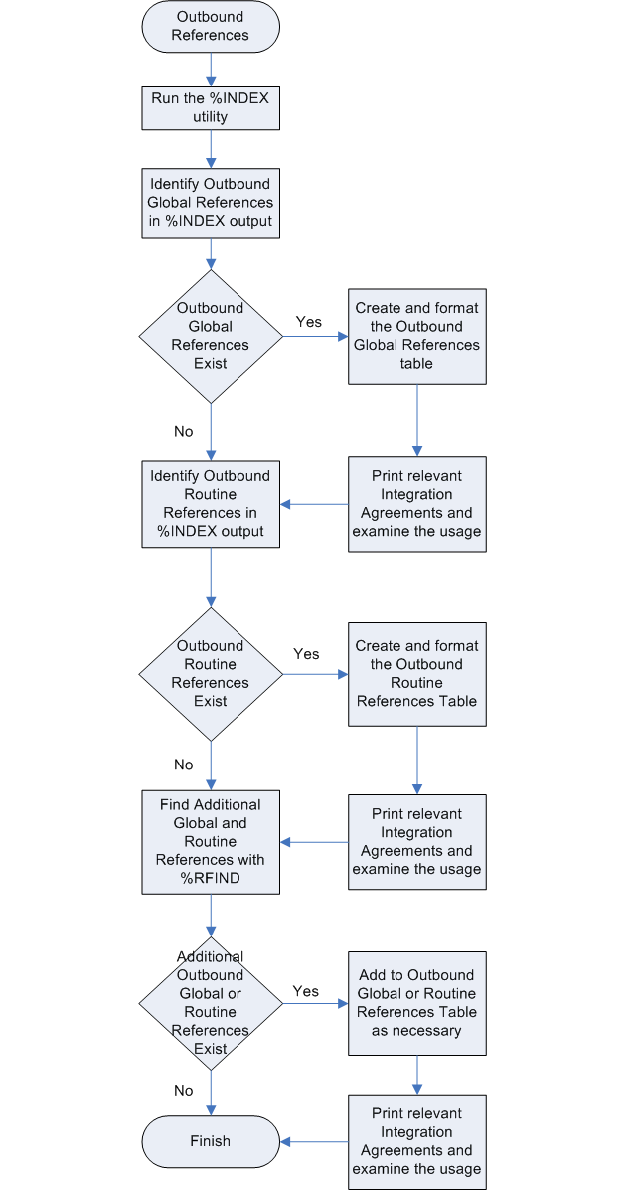

Identifying Outbound References
The XINDEX utility creates a cross referenced list of global references and routines invoked by a selected list of routines, a build or a package. While XINDEX will show all routines that are called, it will not identify all global references in the routines. After running XINDEX, use the %RFIND utility to find entries that were missed by XINDEX. Details on the XINDEX utility can be found in the tools section of the Kernel Toolkit User Manual http://www.va.gov/vdl/VistA_Lib/Infrastructure/Kernel_Toolkit/ktk7_3um.pdf

Running the XINDEX for Specific Package
XINDEX can be run as an option from the menu system or directly from the programmer command prompt. In the example below, Laboratory has been used as an example.

- Access your VistA test account
- From the Programmer Options, run the % Index of routines.
Cautionary Note: Do not say yes to the All Routines prompt. This will run all MUMPS routines through the utility.
- At the Routine prompt, enter the package namespace followed by an asterisk (for example LR*.)
- At the Package Name prompt enter the package namespace.
- At the Include the Compiled Template Routines prompt, accept the default No.
- At the Print More Than Compiled Errors and Warnings prompt, accept the default Yes.
- At the Print Summary Only prompt, press <Enter> to accept the default Yes.
- At the Save Parameters in Routine File prompt accept the default No.
- At the Index all Called Routines prompt accept the default No.
- At the device prompt, type “;80;999999”. This will reduce the number of times you have to press <Enter> at the end of each section.
Before pressing <Enter> on the device prompt, turn on the terminal emulator’s screen capture utility.
- Turn off screen capture at the end of the output.

You will need to study various portions of the output at this point; examples of the output are shown on the next page

V. A. C R O S S R E F E R E N C E R 7.3
UCI: PLT7A CPU: VISTA JUL 26, 2005@12:59:37
SYSTEMS MANAGER MENU ... [EVE]
Programmer Options ... <locked with XUPROG> [XUPROG]
Routine Tools ... [XUPR-ROUTINE-TOOLS]
^Index of Routines [XUINDEX]
All Routines? No => No
Routine: LR*
Routine:
1077 routines
Select BUILD NAME:
Select PACKAGE NAME: LAB SERVICE LR
Include the compiled template routines: N//
Print more than compiled errors and warnings? YES//
Print summary only? NO//Y
Save parameters in ROUTINE file? NO//
Index all called routines? NO//
This report could take some time, Remember to QUEUE the report.
DEVICE: ;80;9999999
Figure 6, Sample Run of XINDEX

Output from the XINDEX Run
The screen captures in the following paragraphs are examples of the output you will see when you run the XINDEX as specified. You will need to examine various sections of the output to create a list of outbound global references.

Global Variables Section
The global variables section of the output contains all references to globals that the utility was able to find.

Global Variables
^%ZIS(1 LRORDST
^%ZIS(2 LRPARAM
^DD(69.99 LR7OPRE
^DD(95.11 LRARU
^DG(405.2 LRAPQOR3,LRAURV
^DG(43 LRPARAM
^DGPM( LRACSUM,LRAPQOR3,LRAURV,LRBLJPP1,LRBLPC1,LRMISEZ1,LROR4
Figure 7, Sample Global Variables

Routines Invoked Section
The Routines Invoked section contains all calls to routines within the selected list of routines.
Routine Is Invoked by:
NOW^%DTC LR7OC0,LRAC14,LRAPMRL,LRAPMRL1,LRAPR,LRAPRES,LRAR04,LRARCR3,
LRARREP,LRARU,LRARU1,LREPIRP,LREPIRS,LREPISV1
$$CODE2PTR^DGUTL4 LRDPAREX
$$PTR2CODE^DGUTL4 LREPI3
UID^LAGEN LRVR1,LRVRW
UPDT^LAGEN LRLLS,LRVR1,LRVRW
Figure 8, Sample of Routines Invoked

Creating the Outbound Global References Table
You can use any text editor on your PC to process the Global Variables section of the XINDEX output. Notepad works very well for this process.

- Copy the Global Variables section of the XINDEX output to a working text file.
- Delete entries for the files that belong to the package.
- Delete entries for temporary globals. These include ^UTILITY, ^TMP and ^XTMP
- Save the output file. It holds all identified external global variable references.
- Create the final table of outbound global references.
- You will need a copy of the outputs from Forum for all supported Integration Agreements and all Integration Agreements for which the package is a subscriber.
- Since the XINDEX utility can miss some external global references in the package routines, follow the instructions for using %RFIND later in this document to identify additional global variable references.

External Routine/File | Custodial Package | Reference Description | Calling Routines | IA Reference
^%ZIS(1 | Kernel | DEVICE (#3.5) | LADJOB | 10114 - Supported
^%ZIS(2 | Kernel | TERMINAL TYPE (#3.2) | LAKUR | Documentation - Supported
^DD(3.8 | FileMan | Data Dictionary | LA7VLL | 999 - Controlled Subscription
^HL(771.2 | HL7 (VistA Messaging) | HL7 MESSAGE TYPE (#771.2) | LA7POST | Not Supported
Table 1, Sample Outbound Global Reference Table

Formatting the Outbound Global Reference Table
- Import the global variables text file into excel. It is a column delimited file. Use two columns with the first column as the global variable and the second column as the calling routines.
- Importing the file will put additional lines of routines for each global into cells on following lines in the spreadsheet. These will have to be combined using a cut and paste process.
- For each reference, do the following:
  - Use the search utility of the text editor to find the related Integration Agreement in the Supported and Subscriber files. Search for “FILE: xxx” where xxx is the file number.
  - When the entry is found copy the custodial package, description and IA reference to the table line. The IA reference is composed of the Integration Agreement number and the usage. In the sample Integration Agreement below it would be 3449 – Controlled Subscription.
  - An Integration Agreement may only allow access to a subset of the file’s fields. It may be necessary to read through the referencing routines and confirm that the routine is only using fields allowed by the Integration Agreement.
- Any remaining global variable references are not supported.

3449 NAME: ADVERSE REACTION ASSESSMENT
CUSTODIAL PACKAGE: ADVERSE REACTION TRACKING Salt Lake City
SUBSCRIBING PACKAGE: BAR CODE MED ADMIN
USAGE: Controlled Subscri ENTERED: SEP 11,2001
STATUS: Active EXPIRES:
DURATION: Till Otherwise Agr VERSION:
FILE: 120.86 ROOT: GMR(120.86,
DESCRIPTION: TYPE: File
^GMR(120.86,D0,0)
2 ASSESSING USER 0;3 Read w/Fileman
This field contains the name of
the user who made the last
reaction assessment for this
patient.
3 ASSESSMENT DATE/TIME 0;4 Read w/Fileman
This field contains the
date/time of the last reaction
assessment for this patient.
1 REACTION ASSESSMENT 0;2 Direct Global Read
Set of codes that indicates the
patient's allergy assessment
level. Value of 1 indicates
that the patient has allergies
while a value of 0 indicates
that the patient has no known
allergies (NKA).
ROUTINE:
Figure 9, Sample Integration Agreement

Creating the Outbound Routine Reference Table
Any text editor on your PC can be used to process the Routine is Invoked by section of the XINDEX output. Notepad works very well for this process.

- Copy the Routine is Invoked by section of the XINDEX output to a working text file.
- Delete entries for the routines that belong to the package.
- Save the output file. It holds all identified external routine references.
- Create the final table of outbound routine references by importing the output file created in steps 1 to 3 and adding Integration Agreement information to each reference.
- You will need a copy of the outputs from Forum for all supported Integration Agreements and all Integration Agreements for which the package is a subscriber.

External Routine/File | Custodial Package | Reference Description | Calling Routines | IA Reference
^%DT | FileMan | These are FileMan date/time utilities that format or manipulate FileMan date values | LA7SBCR,LAPFICH | 10003 - Supported
DD^%DT | FileMan | This is a FileMan date/time utility that converts external format dates to FileMan date values. | LA7UTIL | 10003 - Supported
DUZ^XUP | Kernel - Security | Builds DUZ for a user. Used by MailMan. | LA7VIN1A | 4129 - Controlled Subscription
$$DIV4^XUSER | Kernel | Returns the Divisions that this user is assigned to. | LA7VHLU4,LA7VOBX1,LA7VOBX2,LA7VOBX3 | Not Supported - IA 2343 does not cover entry point.
Table 2, Sample outbound routine reference table

Formatting the Outbound Routine Reference Table
- Import the routine invoked by text file into excel. It is a column delimited file. Use two columns with the first column as the routine being invoked and the second column as the calling routines.
- Importing the file will put additional lines of routines for each reference into cells on following lines in the spreadsheet. These will have to be combined using a cut and paste process.
- For each reference, do the following:
  - Use the search utility of the text editor to find the related Integration Agreement in the Supported and Subscriber files. Search for “ROUTINE: xxx” where xxx is the routine name. If the reference contains an entry point, you have to search for the routine without the entry point and then find a COMPONENT: line for the entry point. An example would be RFILE^XTKERM4 where XTKERM4 is in Integration Agreement 2075. It has the entry point/component RFILE.
  - When the entry is found copy the custodial package, description and IA reference to the table line. The IA reference is composed of the Integration Agreement number and the usage. In the sample Integration Agreement in the global variables section it would be 3449 – Controlled Subscription.
  - Unfortunately, an Integration Agreement may not provide authorized access to all entry points in a routine. There may be more than one Integration Agreement for the routine or it may be unsupported.
- Any remaining routine references are not supported.

Finding Additional Global Variable References with %RFIND
The XINDEX utility can not always find all global variable references. A file number or global reference [ex ^DPT( ] can be enclosed in quotes and equated to a string variable by mumps. The variable can then be passed to many of FileMan routines. %RFIND provides a capability to search for strings within mumps routines. If the variable [ex DIE=] has another variable equated to it, search through the routine to find where the variable is set to a value.

- Execute %RFIND from the programmer prompt.
- At the each of the Search For prompts enter the list of strings to search for. They are DIC=, DIE=, DIK=, ^DIC(, ^DID(, ^DIE(, ^DIQ(, DIU=, DIAX= and DIAXU(.
- At the Exact Upper/Lowercase Match prompt, press <Enter> to accept the default Yes prompt.
- At the Routine(s) prompt enter the namespace followed by an asterisk [LR* in the example below].
- Do not enter any special device specifications as with the XINDEX process. Before pressing enter, turn on the terminal emulator’s screen capture utility.
- Using your preferred text editor, search through the output file looking for each of the strings entered for the %RFIND search. In the sample below, the routine LR105PO has “DIC="^LAB(64.2,"” on line EN+5. This sets up the DIC variable for a call to the FileMan routine ^DIC. Ignore all references to file numbers and global prefixes that belong to the package.
- For each external global reference check to see if the entry is in the outbound global reference spreadsheet. If the routine is not there, add it to the list of routines. If the global reference is not in the spreadsheet, add a new entry identifying the appropriate Integration Agreement. Check to be sure that the fields being used are covered by the Integration Agreement.

PLT7A>D ^%RFIND
Find routine lines that contain at least one of a set of strings
1. Search For: DIC=
2. Search For: DIE=
3. Search For: DIK=
4. Search For: ^DIC(
5. Search For: ^DID(
6. Search For: ^DIE(
7. Search For: ^DIQ(
8. Search For: DIU=
9. Search For: DIAX=
10. Search For: DIAXU(
11. Search For:
Exact Upper/Lowercase Match? Yes => Yes
Routine(s): LR*
Routine(s):
Display results on
Device: Right margin: 80=>
LR01NTEG.INT LR08KILL.INT
LR08KILL+4 S DIK="^DD(68,",DA=.091
LR104.INT LR105.INT LR105PO.INT
EN+5 K DIE,DIC,DA,DR S DLAYGO=64,DIC="^LAB(64.2,",DIC(0)="L",X="DSS ACC"
D ^DIC
Figure 10, Sample %RFIND output

Cross- References

What are Cross References?
Generally, a cross-reference in VA FileMan specifies that some action is performed when the field's value is entered, changed, or deleted. Most cross-references are used for sorting or lookup. These types of cross-references are not part of this research. For instruction on how to print a complete list of all cross-references found in a package’s files, please refer to the Cross-Reference chapter in the Analyst Manual- Application Information Book section (to be available soon.) This chapter is limited to a closer review of ‘trigger’, and ‘Mumps’ type cross-references. It also includes ‘bulletin’ type cross-references. These types of indices generally involve another field in a file that is possibly outside of the package’s domain or they may simply call another package in their set and kill logic. This chapter only shows you how to identify the cross-references that involve another application.

CROSS-REFERENCE: An attribute of a field or a file that identifies an action that should take place when the value of a field is changed. Often, the action is the placement of the field's value into an index.
MUMPS: Those with programmer access can create special cross-references by putting M code into the SET and KILL logic of a cross-reference. You can use the M code entered to accomplish any task that must be done when the value in a field is entered, changed, or deleted.
TRIGGER: Whenever the field is updated, a different field can be automatically updated at the same time.
BULLETIN: Whenever a field is updated, a MailMan message is sent notifying specified users that an update has occurred. Refer to the FileMan Programmer Manual or the Advanced User Manual in the VDL for further explanation on FileMan cross-references and types of cross-references.
Use the following URL to access the documentation: http://www.va.gov/vdl/Infrastructure.asp?appID=5

Why Examine Cross-References
Cross-references can be used to trigger a field in another file outside of the package’s domain, send a bulletin or an alert, or even change a value in another field. Cross references should be examined to fully understand the impact of reengineering on other applications.

What you should to know before you start
In order to print the cross references for an application, the user must know and have access to the following:
- How to access FileMan 22.0 in their VistA test account
- Have a working knowledge of the Mumps Programming Language
- The file range and the namespaces for the package being researched.

How to Identify Application Linkages Using Cross-References:
You will need to complete the following set of tasks in order to identify application linkages through cross references:
- Print a list of cross references for the specified application
- Create a table of cross references
- Identify all cross references that refer outside the application domain.

A Graphical Representation of how to Research Cross- References

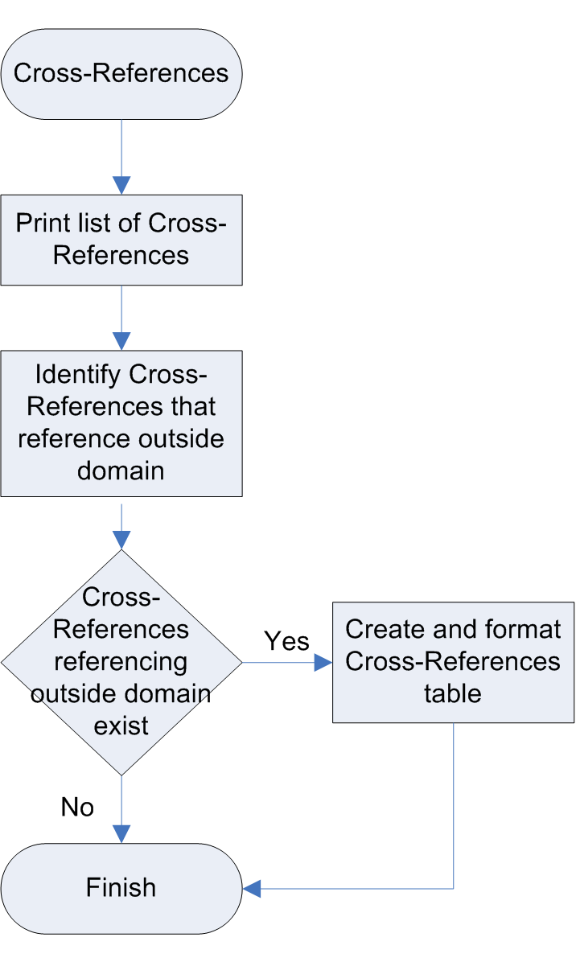

How to Print Cross References for an Application
- From the Select Option prompt in FileMan, type Data Dictionary Utilities
- At the Data Dictionary Utility Option prompt, enter List File Attributes
- At the FileMan prompts Start with what File and Go to what File, enter the appropriate file numbers. In the example below, the file range (111-119.9) is related to Nutrition and Food Service.
- At Select Listing Format prompt, enter Indexes Only
- At the What type of cross-reference (Traditional or New)? prompt, accept the default Both
- At the Which Field prompt, accept the default All
- Set the output parameters as shown for the device, turn on Capture Incoming Data and press <Enter>
- Turn off the data capture once the list of cross-references is complete.
- Open the .txt file created by capturing the incoming data.

Select OPTION: DATA DICTIONARY UTILITIES
Select DATA DICTIONARY UTILITY OPTION: LIST FILE ATTRIBUTES
START WITH WHAT FILE: PACKAGE// 111 DIETS (247 entries)
GO TO WHAT FILE: DIETS// 119.9 FH SITE PARAMETERS
(1 entry)
Select LISTING FORMAT: STANDARD// INDEXES ONLY
What type of cross-reference (Traditional or New)? Both// BOTH
Which field: ALL//
DEVICE: ;132;99999 TELNET TERMINAL
Figure 11, Sample Run of Data Dictionary Utilities
INDEX AND CROSS-REFERENCE LIST -- FILE #111 09/10/03 PAGE 1
File #111
Traditional Cross-References:
AC MUMPS
Field: INACTIVE? (111,99)
Description: This cross-reference is used to create an 'I' node for inactive entries.
1)= K:X'="Y" ^FH(111,DA,"I")
2)= K ^FH(111,DA,"I")
B REGULAR
Field: NAME (111,.01)
Description: This is the normal B cross-reference of the NAME field.
1)= S ^FH(111,"B",$E(X,1,30),DA)=""
2)= K ^FH(111,"B",$E(X,1,30),DA)
C REGULAR
Field: SYNONYM (111,1)
1)= S ^FH(111,"C",$E(X,1,30),DA)=""
2)= K ^FH(111,"C",$E(X,1,30),DA)
Figure 12, Sample of Cross Reference Output/ Data Displayed

Formatting the Cross References Table
- Work through the list of cross-references generated, determining if the cross-reference makes any reference outside of the package’s domain. You can ignore “Regular” style cross-references.
- If the cross-reference does make a reference outside of the package’s domain, add it to the summary table.
- In the notes column, explain what the cross-reference does and which file and package it is referencing.

File or Subfile Number | Cross Reference Name/Type | Field | Description
52.1 | ACRR (#462) FIELD MUMPS IR ACTION WHOLE FILE (#52) | DAYS SUPPLY (52.1,1.1); RELEASED DATE/TIME (52.1,17) | This cross-reference builds two indexes, one for finding all patients with a particular drug and one for finding all the drugs a patient has. The indexes are stored in the Clinical Reminders index global as: ^PXRMINDX(52,"IP",DRUG,DFN,START DATE,STOP DATE,DAS) ^PXRMINDX(52,"PI",DFN,DRUG,START DATE,STOP DATE,DAS) respectively. START DATE is the RELEASE DATE and STOP DATE is calculated by adding the DAYS SUPPLY to the RELEASE DATE. For all the details, see the Clinical Reminders Index Technical Guide/Programmer's Manual.
Table 3, Sample Table for Cross References

Integration Agreements

Analysis of Integration Agreements (IAs) is a critical step in pre-migration research; it establishes what other applications are linked to, or dependent on, the package being researched. In the event of upgrades and enhancements to a particular application, a developer can look at IAs and establish what changes need to be made to maintain usability.

Definitions
Custodial Package-Refers to the application that “owns the domain described in the IA.”
Integration Agreement (IA) – “An agreement between two or more VistA packages to allow access to one development domain by another.”
Illegal References – Applications access packages to gain information or data although there are no Integration Agreements in place. Such usage is called an illegal reference.
Referencing Package- An application that makes any reference to anything outside of its scope - this could be either legal or illegal.
Subscribing Package- Refers to the application that is “approved to use or work with the domain described in an IA.”

Why Examine Integration Agreements
Integration Agreements document approved access to another application’s data either through a direct global read or through an Application Program Interface (API). IAs signify applications that the reengineering team should contact to identify any data that needs to be encapsulated or any data that the reengineered application depends upon.

What you should know before you start
In order to print the IAs where the application is the Custodial Package, the user must know the following:
- How to access FORUM

A Graphical Representation of how to Print Custodial Integration Agreements

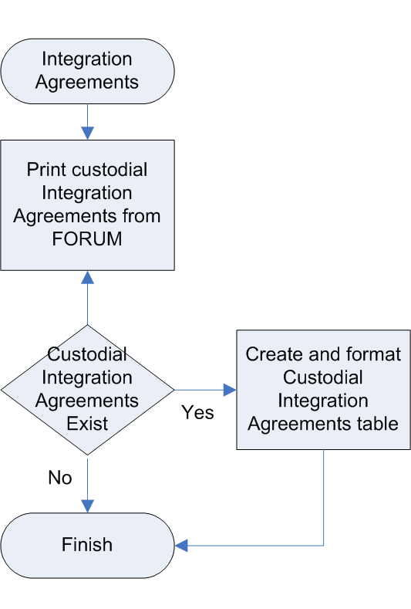

How to Access and Print IAs for Custodial Package
Use the following steps to access and print the IAs where the application is the custodial package:
- Access FORUM,
- From the user’s main menu, type “^Integration Agreements Menu”
- From the Integration Agreements Menu select the “Custodial Package Menu”
- Select “Active by Custodial Package” from the Custodial Package Menu
- Enter the package name or namespace at the Select Package Name prompt (In the example below, FH is the namespace for Dietetics)
- Turn on the Capture Incoming Data function in the terminal emulator. At the Device: Home// prompt, enter ;136;999999.
- Turn off the data capture after the output is complete.

Select FORUM Primary Menu Option: ^DBA
Select DBA Option: Integration Agreements Menu
Select Integration Agreements Menu Option: Custodial Package Menu
Select Custodial Package Menu Option: 1 ACTIVE by Custodial Package
Select PACKAGE NAME: FH DIETETICS FH
DEVICE: HOME//;136;999999
Figure 13, Screen Capture of the Process for Obtaining IAs for Custodial Package

**DIETETICS Custodial DBI Agreements **
-----------------------------------------------------------------------73 NAME: DBIA73
CUSTODIAL PACKAGE: DIETETICS Chicago
SUBSCRIBING PACKAGE: HEALTH SUMMARY Salt Lake City
USAGE: Private ENTERED: FEB 4,1991
STATUS: Active EXPIRES:
DURATION: Till Otherwise Agr VERSION:
FILE: ROOT:
DESCRIPTION: TYPE: Other
Permission has been granted for Health Summary to export the routine:
FHWHEA as GMTSFHWZ
GMTSPOST, the Health Summary post-init, will rename GMTSFHWZ as FHWHEA, if and only if FHWHEA is not found in the UCI by execution of ^%ZOSF("TEST").
ROUTINE:

Figure 14, Example of Displayed Data

How to Format Integration Agreements, Custodian Output
After capturing the custodial IAs for your package, can use the following instructions to create a summary table.

- Copy the IA number into the first column
- The next column contains the subscribing package, for controlled IAs, there may be many subscribing packages. If the IA is a supported type, there will be no entry for the subscriber.
- In the type column indicate the type of the IA. The most common types include file, routine, remote procedure, and other.
- If the IA supports a file reference, indicate the file in the “File” column. If the reference is routine or remote procedure, indicate the reference in the routine column. Leave both columns blank for “other” type references.

Example of Formatted Data
Number | Subscribing Package | Type | Routine | File
73 | Health Summary | Other | -
77 | Health Summary | File | - | 115
1407 | Nursing Service  Health Summary,  Order Entry /  Results Reporting | Routine | FHWHEA
Table 4, Sample Table of IAs: Custodial Package

Forward Pointers

What are Forward Pointers?
Forward pointers are regular pointers that initiate any researched application’s files.
That point from the researched application’s files to another file.
A Pointer to a file is a “field data type that contains an explicit reference to an entry in a file. Pointers to file-type fields are used to relate files to each other.”

In the VA FileMan Technical Manual, pointer relationships are described as “links between files that are created by the use of the POINTER TO A FILE or VARIABLE-POINTER data types.”

What is a Variable Pointer?
A Variable Pointer data type is similar to a ‘Pointer’ data type – in addition, it allows pointing to more than one file. For example, a variable pointer field called ‘pet’ may point to a ‘Dog’ file, a ‘Cat’ file or a ‘Fish’ file. An order, message and prefix are associated with each pointed-to file

Why Examine Forward Pointers?
Forward pointers or simply pointers are those explicit references established from application files to files outside of the application domain. They identify relationships between the applications that may not be readily visible. Pointers that point to files within the application domain are not considered part of this research.

What you should to know before you start
In order to print the forward pointers for an application, the user must know and have access to the following:
- How to access FileMan 22.0 in their VistA test account
- Know the file range of the application.
- Have a working knowledge of the Mumps Programming Language

How to Identify Application Linkages Using Forward Pointers:
- Print a Pointer Relations Map
- Identify Forward Pointers that leave the application domain
- Create a table of forward pointers

A Graphical Representation of how to Research Forward Pointers

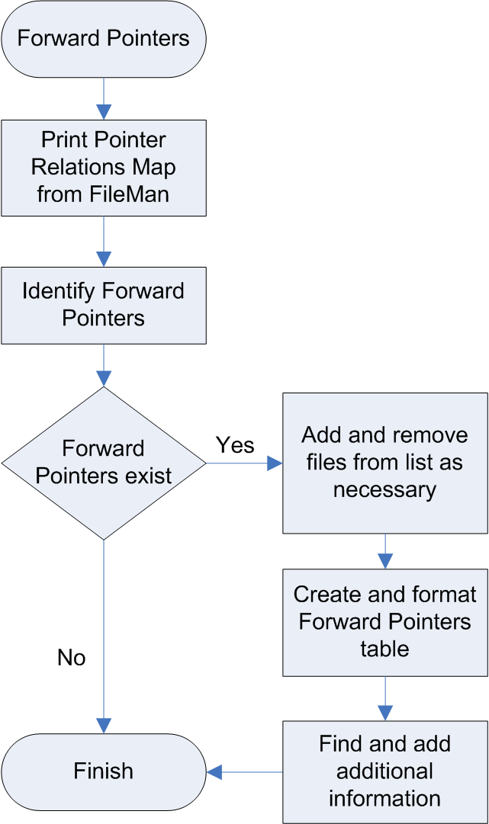

How to Create a List of Forward Pointers
You can create a list of forward pointers from the Data Dictionary Utility Map Pointer Relations.

Printing a Pointers Relations Map
- Access VA FileMan
- At Select Data Dictionary Utilities Option prompt, choose Map Pointer Relations option
- At the Select Package prompt enter the package name. Press <Enter.>
A list of files for the package will be displayed. In the sample below, most of the files were deleted for brevity.
- At the Remove File Prompt enter any files you want removed from the list. Press <Enter.> (This can be repeated multiple times.)
- At the Add File prompt enter any additional files you want included in the list. Press <Enter.> (This can be repeated multiple times.)
- At the Device prompt, enter ;132;999999. (This will prevent page breaks in the middle of the output.)
- Turn on the screen capture utility. Press <Enter.>
Note: Be sure that auto wrap of lines is turned off on your terminal emulator.

VA FileMan 22.0
Select DATA DICTIONARY UTILITY OPTION: ?
Answer with DATA DICTIONARY UTILITY OPTION NUMBER, or NAME
Choose from:
1 LIST FILE ATTRIBUTES
2 MAP POINTER RELATIONS
3 CHECK/FIX DD STRUCTURE
Select DATA DICTIONARY UTILITY OPTION: 2 MAP POINTER RELATIONS
Prints a graph of pointer relations in a database of FileMan files named in the Kernel PACKAGE file (9.4) or given separately.
Works best with 132 column output!
Select PACKAGE NAME: LAB
1 LAB MESSAGE LA7
2 LAB SERVICE LR
3 LAB AUTOMATED LAB INSTRUMENTS LA
CHOOSE 1-3: 2 LAB SERVICE LR
Files included 60 LABORATORY TEST
61 TOPOGRAPHY FIELD
95 LAB JOURNAL
Remove FILE:
Add FILE:
Enter name of file group for optional graph header: LAB SERVICE//
DEVICE: HOME// ;132;999999
Figure 15, Sample run of Map Pointer Relations

Important Note: After printing the Pointer Map, you will need to determine the File # of the “pointed to” file. You will also need to determine if the pointed to file is outside the application domain.

Identifying a Forward Pointer outside Application’s Domain

To determine if a forward pointer is outside of the package’s domain, do the following:
- Using the “File Pointed to” column of the Pointer Relations Map, determine the file number of the file being pointed to.
- If the file number is outside of the package’s file range, it should be considered as a forward pointer.
- The field that points to the file will be listed in the center column (“Pointer Field”)

FILE (#) POINTER (#) FILE
POINTER FIELD TYPE POINTER FIELD FILE POINTED TO
------------------------------------------------------------------------------------------------------------------------------------
L=Laygo S=File not in set N=Normal Ref. C=Xref.
*=Truncated m=Multiple v=Variable Pointer

-------------------------------
DRUG (#50) | |
LAB TEST MONITOR ............................... (N S )-> | 60 LABORATORY TEST |
*LAB TEST MONITOR .............................. (N S )-> | LAB COLLECTION SAMPLE |-> COLLECTION SAMPLE
CLOZAPINE LAB TEST:LAB TEST MONITOR ............ (N S )-> | PROCEDURE (SNOMED) |-> PROCEDURE FIELD
LABORATORY TEST (#60.02) | |
LAB TEST INCLUDED IN PANEL:LAB TEST ............ (N C )-> | HIGHEST URGENCY ALLOWED |-> URGENCY
LABORATORY INSTRUMEN (#61.393) | |
TEST CODE:LOCAL TEST ENTRY ..................... (N S )-> | FORCED URGENCY |-> URGENCY
DELTA CHECKS (#62.1) | |
TEST NAME FOR INPUT VALUE 1 .................... (N )-> | NATIONAL VA LAB CODE |-> WKLD CODE
TEST NAME FOR INPUT VALUE 2 .................... (N )-> | RESULT NLT CODE |-> WKLD CODE
TEST NAME FOR INPUT VALUE 3 .................... (N )-> | EDIT CODE |-> EXECUTE CODE
TEST NAME FOR OUTPUT VALUE 1 ................... (N )-> | *BATCH DATA CODE |-> EXECUTE CODE
COLLECTION SAMPLE (#62.21) | |
COLLECTION WKLD CODE:LAB TEST .................. (N )-> | EXECUTE ON DATA REVIEW |-> EXECUTE CODE
LAB CONTROL NAME (#62.31) | |
TEST ........................................... (N )-> | REQUIRED COMMENT |-> EXECUTE CODE
ACCESSION TEST ................................. (N )-> | DATA NAME |-> LAB DATA
AUTO INSTRUMENT (#62.4) | |
DEFAULT AUTO MICRO TEST ........................ (N )-> | m SITE/SPECIM:SITE/SPECIM* |-> TOPOGRAPHY FIELD
CHEM TESTS:TEST ................................ (N )-> | SITE/SPECIM:TYPE OF DEL* |-> DELTA CHECKS
ACCESSION TEST GROUP (#62.61) | |
TEST ........................................... (N )-> | SITE/SPECIMEN:LOINC CODE |-> LAB LOINC
LAB SHIPPING MANIFES (#62.801) | |
SPECIMENS:TEST ................................. (N S )-> | m LAB TEST IN:LAB TEST* |-> LABORATORY TEST
LAB SHIPPING EVENT (#62.85) | |
LAB TEST ....................................... (N S )-> | m COLLECTION :COLLECTION * |-> COLLECTION SAMPLE
LAB SHIPPING CONFIGU (#62.9001) | |
TEST/PROFILE ................................... (N S C )-> | COLLECTION :REQUIRED CO* |-> EXECUTE CODE
LAB DATA (#63.20211) | |
EM:SPECIMEN:EPON BLOCK:EM PROCEDURE ............ (N )-> | m SITE/SP:*AMIS/R:*AMIS/R* |-> WKLD CODE

Figure 16, Sample Pointer Map output

Formatting the table of Forward Pointers
You will need to create a table by excerpting key information from the Pointer Relations map; the table should have the following field headings:

Filed Number, Filed (#Number), Points to File (#Number), Var, LAYGO?, Screen, Owner, Req? (is it required) Mult? (Multiple)
- The sample pointer map output shown in Figure 11 provides the data that you can cut and paste into the forward pointer table above.
  - The center column divided by | | contains the file and fields pointing out to other files.
  - If the file pointer field ends with an asterisk, the name has been truncated on the output. You will have to identify the full field name. Note: an asterisk at the beginning of a name is part of the field name.
  - The right column contains the files being pointed to. Only copy pointers that point to files outside of the package.
  - A pointer field always points to the .01 field of the pointed to file.
  - To determine file numbers, field numbers and truncated names see the section on identifying file & field numbers below.
- The owner column contains the package that owns the file being pointed to. See the section in the user manual on how to find the owner of a file.
- Fill in the other fields in the file. Multiple, required, screen and LAYGO can be identified by using the List File Attributes option in the Data Dictionary Utilities.
The following screen captures are examples of each instance, the related key information is shown in bold.

Multiple Instances
In the sample capture below, the ACCESSION AREA (#6) is a multiple that is also subfile # 60.11.
DATA NAME GLOBAL DATA
ELEMENT TITLE LOCATION TYPE
-----------------------------------------------------------------------
60,6 ACCESSION AREA 8;0 POINTER Multiple #60.11
(Add New Entry without Asking)
LAST EDITED: SEP 06, 1984
DESCRIPTION: This is the appropriate institution/division this test is performed at.
60.11,.01 INSTITUTION 0;1 POINTER TO INSTITUTION FILE (#4)
INPUT TRANSFORM: S DINUM=X
Figure 17, Identifying Multiple Instances

Required Fields
In the sample capture below, COLLECTOR (#12) is a required field.
DATA NAME GLOBAL DATA
ELEMENT TITLE LOCATION TYPE
-----------------------------------------------------------------------
69.01,12 COLLECTOR 1;3 POINTER TO NEW PERSON FILE (#200) (Required)
LAST EDITED: MAR 31, 1992
DESCRIPTION: The phlebotomist who is accessioning the collected order.
Figure 18, Identifying required fields

Screen Restrictions
In the sample capture below, PARENT FILE (#.02) contains screen restrictions. The explanation contains the text of the restrictions. The screen contains the restricting mumps code.
DATA NAME GLOBAL DATA
ELEMENT TITLE LOCATION TYPE
-----------------------------------------------------------------------
63,.02 PARENT FILE 0;2 POINTER TO FILE FILE (#1) (Required)
INPUT TRANSFORM: S DIC("S")="I $D(^(""%"",""B"",""LR""))" D ^DIC
:X'?1"?".E K DIC S DIC=DIE,X=+Y K:Y<0 X I $D(X)
S DDIFN=X
LAST EDITED: NOV 04, 2002
DESCRIPTION: The file where the name of this entry may be found.
SCREEN: S DIC("S")="I $D(^(""%"",""B"",""LR""))"
EXPLANATION: Enter the appropriate parent you wish this entry associated with.
Figure 19, Locating screen restrictions

LAYGO
In the sample capture below, NAME (#.01) requires a LAYGO test
200,.01 NAME 0;1 FREE TEXT (Required)

INPUT TRANSFORM: K XLFNC K:($L(X,",")'=2) X I $D(X) S XLFNC=X,(X
,XLFNC)=$$FORMAT^XLFNAME7(.XLFNC,3,35,,,,,2) K:
$L(X)>35!($L(X)<3)!($L(X,",")'=2)!(X'?1.E1","1.
E) X,XLFNC K:'$G(XUITNAME) XLFNC
DELETE TEST: 1,0)= I 1 W *7," PERSONS CAN'T BE DELETED!!"
LAYGO TEST: 1,0)= D LAYGO^XUA4A7
NOTES: XXXX--CAN'T BE ALTERED EXCEPT BY PROGRAMMER
Figure 20, Identifying LAYGO

The next page shows an example of a formatted table of forward pointers.

File Number | Field (#Number) | Points to file (#Number) | Var? | LAYGO? | Screen | Owner | Req? | Mult?
LABORATORY TEST(#60)
60 | ACCESSION AREA(#60.11): INSTITUTION(#.01) | INSTITUTION(#4) | No | No | No | KERNEL | No | Yes
AUTO INSTRUMENT(#62.4)
62.4 | ECHO DEVICE(#1) | DEVICE(#3.5) | No | No | No | KERNEL | No | No
62.4 | DIRECT DEVICE(#29) | DEVICE(#3.5) | No | No | No | KERNEL | No | No
Table 5, Sample of Formatted Forward Pointers Table

Templates

What are Templates?
Templates are “a means of storing report formats; data entry formats, and sorted entry sequences. A template is a permanent place to store selected field specifications for use at a later time.”
There are three kinds of templates that VistA applications use: Print, Input and Sort.

Definitions
Print: Print Templates are the stored specifications of a printed report, including fields to be printed and formatting instructions.
Input: An Input Template is a pre-defined list of fields that together comprise an editing session.
Sort: The stored record of sort specifications. It contains sorting order as well as restrictions on the selection of entries; used to prepare entries for printing.

Why Examine Templates?
Templates can reference fields and functions from other packages in several different ways. These references will aid in determining inter-application linkages in the legacy system that could be important in the reengineered package.

Application linkages in templates can be any of the following:
- Global reference to an outside file
- Relational jump to an outside file like the following shown examples:
  - EDIT FIELD: PATIENT:// >>>>>>>the colon denotes that the editing has jumped to the PATIENT file
  - Extended pointer syntax – referring to a field in a file outside of the main/current file without actually jumping over to that file like this:
  - EDIT FIELD: PATIENT: SSN/// >>>>> this allows the user to edit the SSN field in the Patient file without moving over entirely to the Patient file.
- Routine references
- System variables like DUZ, DTIME
- Functions like NUMDATE

What you should know before you start
In order to print the templates for an application, the user must know and have access to the following:
- How to access FileMan 22.0 in their VistA test account
- Have a working knowledge of the Mumps Programming Language
- The file range and the namespaces for the package being researched.

How to Identify Application Linkages from Templates
You will need to complete the following:
- Print a detailed list of Templates from FileMan
- Examine the list of templates to identify linkages
- Format the information into a table

A Graphical Representation of how to Research Templates

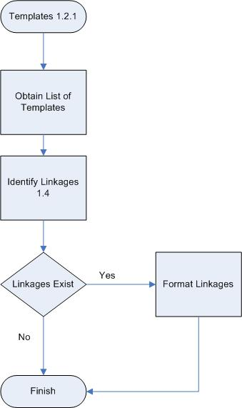

How to obtain a detailed list of Templates in FileMan
- Access VA FileMan from your Test Account
- From the VA FileMan 22.0 prompt, type Print File Entries and press <Enter.>
- At the Output from What File prompt enter the type of template. For example, for Print Templates enter Print Template
- At FileMan prompt Sort By: Name, press <Enter>
- At the Start With Name: First, prompt enter the package’s namespace (In the following example, FH is the namespace for Dietetics.)
- At the Go To Name: Last prompt enter the package’s namespace followed by a “Z” this will capture all the templates in the namespace. (In the following example, FH is the namespace for Dietetics.)
- At FileMan prompt Within Name, Sort By press < Enter.>
- At the First Print Field prompt, enter [Captioned. This will print all the fields in the template’s file.
- At FileMan prompt Include Computed fields: (N/Y/R/B): No, type Both and press< Enter.> FileMan will complete with Computed Fields and Record Number (IEN)
- At FileMan prompt Heading (S/C): Print Template List, press < Enter.>
- At FileMan prompt Start At Page: 1, press < Enter.>
- Turn on Capture Incoming Data. (Save this file to your local drive; it will be saved as a text file by default)
- At the Device prompt, enter “ ;132;9999”
- Turn off the data capture after FileMan prints the data.

>D P^DI
VA FileMan 22.0
Select OPTION: PRINT FILE ENTRIES
OUTPUT FROM WHAT FILE: INPUT TEMPLATE// PRINT TEMPLATE
SORT BY: NAME//
START WITH NAME: FIRST// FH
GO TO NAME: LAST// FHZ
WITHIN NAME, SORT BY:
FIRST PRINT FIELD: [CAPTIONED
Include COMPUTED fields: (N/Y/R/B): NO// BOTH Computed Fields and Record Number (IEN)
Heading (S/C): PRINT TEMPLATE LIST//
START AT PAGE: 1//
DEVICE: ;132;99999
Figure 21: Screen Capture of FM Dialogue for Print Templates

PRINT TEMPLATE LIST DEC 5,2003 13:48 PAGE 1
-----------------------------------------------------------------------
NUMBER: 2061 NAME: FHDIETL DATE CREATED: JAN 20, 1987 FILE: DIETS
DATE LAST USED: FEB 21, 2001
DESCRIPTION: This template is used to print a basic diet list.
HEADER (c): DIETS LIST
FIRST PRINT FIELD: NAME//
THEN PRINT FIELD: SYNONYM;C32//
THEN PRINT FIELD: DIET PRECEDENCE;"DIET PREC";C46//
THEN PRINT FIELD: ABBREVIATED LABEL;"ABBREV LABEL";C52//
THEN PRINT FIELD: PRODUCTION DIET;"PROD DIET";C66;L12//
THEN PRINT FIELD: ASK EXPIRATION DATE?;"ASK EXP";C80//
THEN PRINT FIELD: BULLETIN CLINICIAN?;"MAIL";C86//
THEN PRINT FIELD: INACTIVE?;"INACT";C92//
THEN PRINT FIELD: ALTERNATE NAME//
Figure 22: Example of Data Displayed (Print Template)

Identifying Linkages
- Open the text file that you saved to your local drive earlier.
- Identify and highlight the application linkages in the (Print/Sort/Input) template by looking for the key pieces of information shown below.
- Identify the external package that the template is referencing.

Note: The text in bold shows examples of the information you should be looking for.

- ‘D TAG^ROUTINE’ or ‘X ^GLOBAL(NODE) or function calls ($$SITE^VASITE)
For Example:
    - FIRST PRINT FIELD: NAME;L20//
    - THEN PRINT FIELD: S DFN=D0 D PID^VADPT6 W VA("PID");L12;"PT ID"//

- Relational jumps to an outside file in the template
For Example:
    - EDIT FIELDS (c): PATIENT: (the colon denotes that the editing has jumped to the PATIENT file)
    - EDIT FIELDS (c): S:+DGJUMP'=2 Y="@991"

- Global references to outside files:
For Example:
    - EDIT FIELDS (c): ETHNICITY INFORMATION;"ETHNICITY"
    - EDIT FIELDS (c): I $P($G(^DIC(10.3,+$P($G(^DPT(DA(1),.06,DA,0)),"^",2),0))
    - ,"^",2)="S" S Y="@61"

- Extended syntax:
For Example:
    - FIRST PRINT FIELD: PATIENT;L25//
    - THEN PRINT FIELD: PATIENT:PRIMARY LONG;"PT ID";L15//

- System Variables:
For Example:
    - FIRST PRINT FIELD: DUZ;L10//

- Functions
For Example:
    - THEN PRINT WKLD CODE SUB-FIELD: $P(NUMDATE(MONTH),"/",1)_"/"_$P(NUMDATE(MONTH),"/",3);C32;L5;"MONTH"//

How to Format the Output for Templates
As application linkages are discovered, copy the reference into the following table.
The Input Template column contains the name of the template. The File column refers to the file that owns the template (it will be referred to in the template header). The Reference-File/Routine column contains the actual file or routine being referenced. The Reference Custodial Package column contains the package name that the reference belongs to.

Input Template | File | Reference – File/Routine | Reference Custodial Package
NURSAED-I-STAFFPR | NURS STAFF | NEW PERSON (#200) | Registration
NURSAED-I-STAFFPR | NURS STAFF | DTIME – FileMan Variable | FileMan
NURSAED-I-STAFFPR | NURS STAFF | %DT(0) - FileMan Variable | FileMan
NURSAED-I-STAFF2 | NURS STAFF | %DT(0) - FileMan Variable | FileMan
NURSAED-I-STAFF8 | NURS STAFF | YN^DICN | FileMan
NURSAED-I-STAFF8 | NURS STAFF | DTIME – FileMan Variable | FileMan
NURSAED-I-STAFF1 | NURS STAFF | DTIME – FileMan Variable | FileMan
Table 6, Sample from Nursing Application Linkages and Encapsulation Document

Inbound References

What are inbound references?
Inbound references are any reference made by anything outside of a legacy application’s domain to a reference within the domain. These references include access to VistA files and using MUMPS routines. These references can be found in other application. A reference can be a legal application programming interface (API) (sanctioned by an Integration Agreement or established relationship via FileMan’s data dictionary) or an illegal interface (unsanctioned; no Integration Agreement in place).

What are illegal references?
All references made by an application must have a related Integration Agreement between the application making the reference and the application that owns the resource. A package can also create a supported Integration Agreement that provides unrestricted access to the resource by all applications. If neither of the cases exists, the use of the resource is not allowed and is considered illegal.

Why Examine at Inbound References?
All data within the applications that are used by other application will still be needed in the future in the reengineered application. The reengineering team needs to know all of the interfaces with outside applications and all the places where there is a dependency between the reengineering application and other applications (regardless of who is dependent on whom).

What you should know before you start
In order to identify and examine the outbound references for an application, the user must know and have access to the following:

- Have access to a VistA test account
- Know the namespace and the file number range of the package
- How to Run the %RFIND Utility
- How to print custodial Integration Agreements from FORUM (see chapter 5 in this manual)

How to Identify Application Linkages Using Inbound References:
You will need to complete all of the following individual set of tasks to be able to identify application linkages.
- Run the % RFIND utility,
- Identify the inbound references
- Find the related custodial Integration Agreement
- Format the table of Inbound References

A Graphical Representation of how to print Inbound References

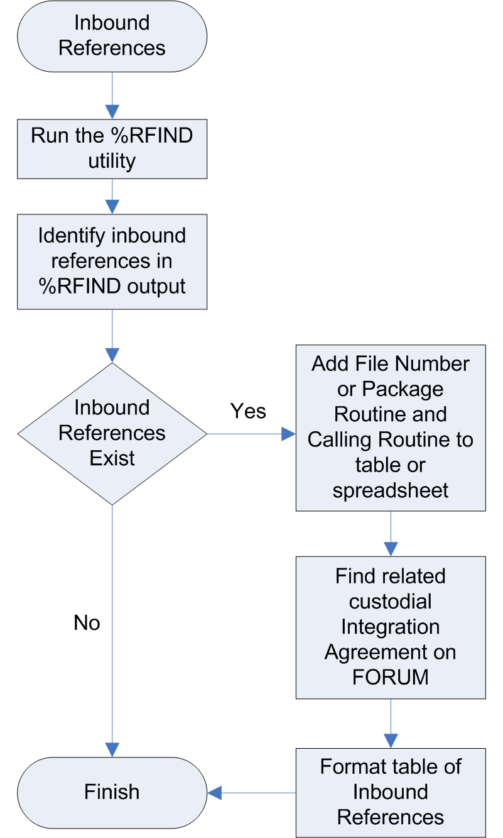

Using the %RFIND Utility to Identify Inbound References
The %RFIND utility provides a capability to search through a list of routines looking for strings of characters. Since inbound references can be in any routine that is outside of the package namespace, the output from %RFIND can be very extensive. Once an inbound reference has been identified, it must be linked to a related Integration Agreement.

%RFIND prompts for a series of search items and a list of routines that are to be searched. The utility is run from the programmer prompt. Depending on the file number range of files in the package, the list of search items can be long.

- The package namespace (example: LR) is searched as ^LR. This will identify all calls to routines within the namespace and all files that have a global name that is an extension of the namespace. For example: the Lab Order Entry file (#69) has a global name of ^LRO(69. Files that have a global name outside of the namespace will have to be searched for by the global name. For example: the Marital Status file (#11) has a global name of ^DIC(11. You would have to add “^DIC(11 to the search.
- Files can be referenced by number as well as name in routines. There are 9 references that can be used in conjunction with a file number as a passed variable. All of these must be searched for. Be as selective as you can in choosing what file numbers to add to each of the nine references. If you are looking for the file range 60 through 69, using 6 will return all file numbers that start with 6. The 10 references are: DIC=, DIE=, DIK=, DIU=, DIAX=, ^DIC(, ^DID(, ^DIE(, ^DIQ( and ^DIAXU(. For further information on these references, consult the FileMan Programmer’s Manuals in the VDL.
- This is an extensive search across all VistA routines outside of the package namespace. At the first “ROUTINE (S):” prompt type * (asterisk). This will include all VistA routines. At the second “ROUTINE (S):” prompt exclude the package namespace by typing ‘followed by the namespace (example: ‘LR*).

Cautionary Note: Once you start the search with %RFIND it can not be stopped by pressing CTRL-C. If you make a mistake and want to quit the process, entering the ^ as a response to a search for or routine question will stop the process.

PLT7A>D ^%RFIND
Find routine lines that contain at least one of a set of strings
1. Search For: DIC=6
2. Search For: DIE=6
3. Search For: DIK=6
4. Search For: ^DIC(6
5. Search For: ^DID(6
6. Search For: ^DIE(6
7. Search For: ^DIQ(6
8. Search For: DIU=6
9. Search For: DIAX=6
10. Search For: DIAXU(6
11. Search For: ^LR
12. Search For:
Exact Upper/Lowercase Match? Yes => Yes
Routine(s): *
Routine(s): ‘LR*
Routine(s):
Display results on
Device: Right margin: 80=>
DGBTUTL.INT DGBTUTQ.INT DGBTVUP.INT
SMSG+5 S %DT="T",X="NOW" D ^%DT,DD^LRX S DGBTNOW=Y
ECTFCS.INT ECTMENU.INT
LR+3 I VER<5 S DIC=68,DIC(0)="QEAM" D ^DIC K DIC I Y>0 S LRAA=+Y,LRAA(1)=$P(Y,U,2)
Figure 23, Sample %RFIND Output

How to Find Inbound References
- Execute %RFIND from the programmer prompt.
- At the Search For prompt, enter the list of strings to search for including the file number digits. They are DIC=, DIE=, DIK=, ^DIC(, ^DID(, ^DIE(, ^DIQ(, DIU=, DIAX= and DIAXU(. Enter the namespace of the package. (example ^LR) Enter any global names that do not start with the package namespace. (example ^DIC(11 )
- At the Exact Upper/Lowercase Match prompt respond Yes
- At the Routine(s) prompt enter *. This will select all routines
- At the Routine(s) prompt exclude the package’s files by entering apostrophe & the namespace followed by an asterisk [‘LR* in the example above].

Note: Do not enter any special device specifications. Before pressing enter, turn on the terminal emulator’s screen capture utility.

- The sample run of %RFIND below shows two references. In the routine DGBTVUP on line SMSG+5 is calls DD^LRX. In the routine ECTMENU on line LR+3 it sets the DIC variable to 68. Both of these are inbound references.
- You can now read through the %RFIND output and add items to the table of inbound references.

240 NAME: DBIA240-A
CUSTODIAL PACKAGE: LAB SERVICE Dallas
SUBSCRIBING PACKAGE: AUTOMATED MED INFO EXCHANGE Albany
USAGE: Private ENTERED: JUN 15,1993
STATUS: Active EXPIRES:
DURATION: Till Otherwise Agr VERSION:
FILE: 63 ROOT: LR(
DESCRIPTION: TYPE: File
Laboratory Package has given permission to AMIE to make the following calls:
GLOBAL REF. NODE;PIECE USAGE
^LR( "CH";11 Current Agreement number 95
"MI";11 Current Agreement number 95
^LR(D0,'CH',
^LR(D0,'MI',
ROUTINE:
Figure 24, Sample Integration Agreement

Formatting the Table of Inbound References
- Using your preferred text editor, read through the output file looking for each of the strings entered for the %RFIND search.
- For each qualifying entry found, add the file number or package routine and the calling routine to the table (or spreadsheet). If more than one routine use the same package file or call the package routine, place the additional ones in the same cell. Do not combine routines from different calling packages in the same cell. You will need to be able to sort the table by subscribing package.
- Find the package that owns the calling routine. See the section on finding a package’s namespace in the document or use ^%RO to read the owning package from the second line of the routine.
- A list of integration agreements for the package as custodian should be generated on Forum. Use this list to identify the related integration agreement for each reference. File references can be found by searching for FILE: 999 where 999 is the file number. Routine references can be found by searching for ROUTINE: XXX where XXX is the routine name. A tag being called within a routine is identified as YYY^XXX. The tag will be referenced in the Integration Agreement as a component. Not all components may be found in one Integration Agreement.

Subscribing Package | File Number  /Routine Reference | Calling Routines | IA Number
AMIE | 60 | DVBAB1 | 10054 - Supported
AMIE | 63 | DVBCLABR | 240 - Private
Beneficiary Travel | Routine - LRX | DGBTVUP | DD Tag not covered by 715 - Private
Table 7, Sample Inbound Global Reference Table

Backward Pointers

What is a Backward Pointer?
A Pointer to a file is a “field data type that contains an explicit reference to an entry in a file. Pointers to file-type fields are used to relate files to each other.” A backward pointer is a pointer to your current file from another file; it can be used in the extended pointer syntax.

In the VA FileMan Technical Manual, pointer relationships are described as “links between files that are created by the use of the POINTER TO A FILE or VARIABLE-POINTER data types.”

What is a Variable Pointer?
A Variable Pointer data type is similar to a ‘Pointer’ data type – in addition, it allows pointing to more than one file. For example, a variable pointer field called ‘pet’ may point to a ‘Dog’ file, a ‘Cat’ file or a ‘Fish’ file. An order, message and prefix are associated with each pointed-to file

Why Examine at Backward Pointers?
It is important to identify backward pointers because they identify relationships between the applications that may not be readily visible. Backward pointers or simply pointers are those explicit references established from application files to files outside of the application domain. Files that are pointed to by pointers within the application domain are not considered part of this research.

What you should know before you start
- How to access FileMan 22.0 in their VistA test account
- Have a working knowledge of the Mumps Programming Language
- The file range and the namespaces for the package being researched.
- How to determine file ownership (see chapter 2 for instructions)

How to create a list of backward pointers
You can create a list of backward pointers by using the Map Pointer Relations Utility in a Data Dictionary.
You will need to do the following to identify backward pointers:
- Print a Pointer Relations Map
- Identify which pointer leaves the application domain
- Format the information you identify

A Graphical Representation of how to find Backward Pointers
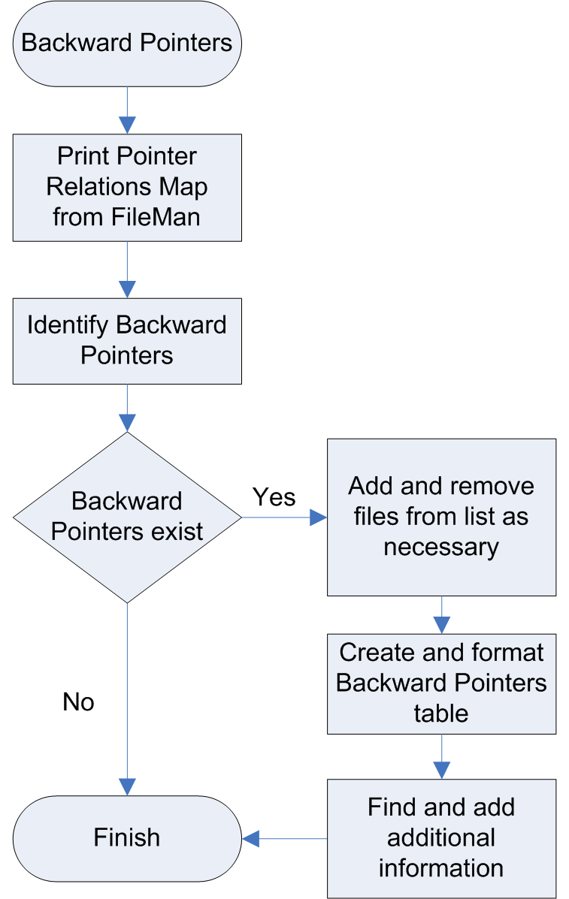

Printing Pointer Relations Map
- Access VA FileMan
- At the Select Option prompt, select Data Dictionary Utility.
- At Data Dictionary Utility Option prompt, select Map Pointer Relations.
- At the Select Package prompt enter the package name.
A list of files for the package will be displayed. In the sample below, most of the files were deleted for brevity.
- At the Remove File prompt enter any files you want removed from the list. This can be repeated multiple times.
- At the Add File prompt enter any additional files you want included in the list. This can be repeated multiple times.
- At the Device prompt enter ;132;999999. (This will prevent page breaks in the middle of the output.)
- Turn on the screen capture utility for your terminal emulator and press <Enter.>

Note: Be sure that auto wrap of lines is turned off on you terminal emulator.

VA FileMan 22.0
Select Option: DATA DICITONARY UTILITIES
Select DATA DICTIONARY UTILITY OPTION: ?
Answer with DATA DICTIONARY UTILITY OPTION NUMBER, or NAME
Choose from:
1 LIST FILE ATTRIBUTES
2 MAP POINTER RELATIONS
3 CHECK/FIX DD STRUCTURE

Select DATA DICTIONARY UTILITY OPTION: 2 MAP POINTER RELATIONS
Prints a graph of pointer relations in a database of FileMan files
named in the Kernel PACKAGE file (9.4) or given separately.
Works best with 132 column output!
Select PACKAGE NAME: LAB
1 LAB MESSAGE LA7
2 LAB SERVICE LR
3 LAB AUTOMATED LAB INSTRUMENTS LA
CHOOSE 1-3: 2 LAB SERVICE LR
Files included 60 LABORATORY TEST
61 TOPOGRAPHY FIELD
95 LAB JOURNAL
Remove FILE:
Add FILE:
Enter name of file group for optional graph header: LAB SERVICE//
DEVICE: HOME// ;132;999999
Figure 25: Screen Capture of Map Pointer Relations Run

FILE (#) POINTER (#) FILE
POINTER FIELD TYPE POINTER FIELD FILE POINTED TO
------------------------------------------------------------------------------------------------------------------------------------
L=Laygo S=File not in set N=Normal Ref. C=Xref.
*=Truncated m=Multiple v=Variable Pointer

-------------------------------
DRUG (#50) | |
LAB TEST MONITOR ............................... (N S )-> | 60 LABORATORY TEST |
*LAB TEST MONITOR .............................. (N S )-> | LAB COLLECTION SAMPLE |-> COLLECTION SAMPLE
CLOZAPINE LAB TEST:LAB TEST MONITOR ............ (N S )-> | PROCEDURE (SNOMED) |-> PROCEDURE FIELD
LABORATORY TEST (#60.02) | |
LAB TEST INCLUDED IN PANEL:LAB TEST ............ (N C )-> | HIGHEST URGENCY ALLOWED |-> URGENCY
LABORATORY INSTRUMEN (#61.393) | |
TEST CODE:LOCAL TEST ENTRY ..................... (N S )-> | FORCED URGENCY |-> URGENCY
DELTA CHECKS (#62.1) | |
TEST NAME FOR INPUT VALUE 1 .................... (N )-> | NATIONAL VA LAB CODE |-> WKLD CODE
TEST NAME FOR INPUT VALUE 2 .................... (N )-> | RESULT NLT CODE |-> WKLD CODE
TEST NAME FOR INPUT VALUE 3 .................... (N )-> | EDIT CODE |-> EXECUTE CODE
TEST NAME FOR OUTPUT VALUE 1 ................... (N )-> | *BATCH DATA CODE |-> EXECUTE CODE
COLLECTION SAMPLE (#62.21) | |
COLLECTION WKLD CODE:LAB TEST .................. (N )-> | EXECUTE ON DATA REVIEW |-> EXECUTE CODE
LAB CONTROL NAME (#62.31) | |
TEST ........................................... (N )-> | REQUIRED COMMENT |-> EXECUTE CODE
ACCESSION TEST ................................. (N )-> | DATA NAME |-> LAB DATA
AUTO INSTRUMENT (#62.4) | |
DEFAULT AUTO MICRO TEST ........................ (N )-> | m SITE/SPECIM:SITE/SPECIM* |-> TOPOGRAPHY FIELD
CHEM TESTS:TEST ................................ (N )-> | SITE/SPECIM:TYPE OF DEL* |-> DELTA CHECKS
ACCESSION TEST GROUP (#62.61) | |
TEST ........................................... (N )-> | SITE/SPECIMEN:LOINC CODE |-> LAB LOINC
LAB SHIPPING MANIFES (#62.801) | |
SPECIMENS:TEST ................................. (N S )-> | m LAB TEST IN:LAB TEST* |-> LABORATORY TEST
LAB SHIPPING EVENT (#62.85) | |
LAB TEST ....................................... (N S )-> | m COLLECTION :COLLECTION * |-> COLLECTION SAMPLE
LAB SHIPPING CONFIGU (#62.9001) | |
TEST/PROFILE ................................... (N S C )-> | COLLECTION :REQUIRED CO* |-> EXECUTE CODE
LAB DATA (#63.20211) | |
EM:SPECIMEN:EPON BLOCK:EM PROCEDURE ............ (N )-> | m SITE/SP:*AMIS/R:*AMIS/R* |-> WKLD CODE
Figure 26: Sample Pointer Map Output

Finding the Backward Pointers
Determine if the pointer is outside of the application domain. Remember, you need to know the file range for the application researching.
- Study the File (#) Pointer column of the Pointer Relations Map.
- Identify and note any files that are outside of the package’s file range.

Tip: The file number is displayed after the file name in parenthesis.

Formatting the Information
- Determine if the pointer is outside of the application domain.
- The sample pointer map output shown above provides the data you can cut and paste into the backward pointer table (see Table 8.)
- The center column divided by | | contains the file shown and fields being pointed to by other files.
- If the file pointer field ends with an asterisk, the name has been truncated on the output. You will have to identify the full field name. Note: an asterisk at the beginning of a name is part of the field name.
- The left column contains the files pointing to the package files. Only copy pointers of files that are outside of the package file range.
- A pointer field always points to the .01 field of the pointed to file.
- To find out file numbers, field numbers and truncated names see the section on identifying file & field numbers.
- The “VAR?” column value can be identified by a V in the pointer type column of the map output.
- The LAYGO value can be identified by an L in the pointer type column of the map output. Variable fields are sometimes mislabeled as being LAYGO.

Note: Codes in parenthesis for Pointer Type are identified and explained at top of the Pointer Map output

- The owner column contains the package that owns the file being pointed to. See chapter 2 in this manual on how to find the owner of a file. Filling in the screen column in the table can be done by using the List file attributes option in the Data Dictionary Utilities. The following example shows a sample.

Cautionary Note: The File (#) Pointer Field column will contain the file number of the subfile that points to the package file. The file name will be that of the parent file. Subfile names may be truncated. A sequence of subfiles is separated by colons. Example: EM:SPECIMEN:EPON BLOCK:EM PROCEDURE is a list of subfiles under the LAB DATA file (#63) while the file reference is LAB DATA (#63.20211).

DATA NAME GLOBAL DATA
ELEMENT TITLE LOCATION TYPE
-----------------------------------------------------------------------
63,.02 PARENT FILE 0;2 POINTER TO FILE FILE (#1) (Required)
INPUT TRANSFORM: S DIC("S")="I $D(^(""%"",""B"",""LR""))" D ^DIC
:X'?1"?".E K DIC S DIC=DIE,X=+Y K:Y<0 X I $D(X)
S DDIFN=X
LAST EDITED: NOV 04, 2002
DESCRIPTION: The file where the name of this entry may be found.
SCREEN: S DIC("S")="I $D(^(""%"",""B"",""LR""))"
EXPLANATION: Enter the appropriate parent you wish this entry associated with.
Figure 27: Screen Restrictions

PARENT FILE (#.02) contains screen restrictions. The explanation contains the text of the restrictions. The screen contains the restricting mumps code.

File Number | Is Pointed to by File (#No) | Field (#No) | Var? | LAYGO? | Screen | Owner
LABORATORY TEST(#60)
60 | DRUG(#50) | LAB TEST MONITOR(#17.2) | No | No | No | PHARMACY DATA MANAGEMENT
60 | DRUG(#50): CLOZAPINE LAB TEST(#50.02) | LAB TEST MONITOR(#.01) | No | No | No | PHARMACY DATA MANAGEMENT
Table 8, Sample Backward Pointer Table

Health Level Seven (HL7) Data

What is HL7?
Health Level Seven (HL7) is an American National Standards Institute (ANSI) standard messaging protocol that specifies the set of transactions and encoding rules for electronic data exchange between health care computer systems. HL7 provides an open, standards-based framework that computer systems can use to exchange health care data with each other. The HL7standards development group is directly focused on health care informatics standards and cooperates closely with developers of other standards.

The Veterans Health Information Systems and Technology Architecture VistA HL7 package enables M-based VistA applications running on core facility computer systems to exchange health care information with other computer systems. It provides messaging services and a single toolset for M-based VistA applications to create, send, receive, and process HL7 messages.

For more information on VistA HL7, refer to the documentation in the VistA Documentation Library:
http://www.va.gov/vdl/Infrastructure.asp?appID=8

Why Examine HL7 Data?
The HL7 research is important because it reveals the specific HL7 data elements that are used in sending or receiving messages between two systems.

This research provides information on how the reengineered application can communicate with a legacy application via HL7 messaging. This research contains entries in the legacy VistA HL7 application files that are necessary in processing the HL7 messages.

The VistA HL7 application looks at entries in the following files in order to be able to process an outgoing or incoming HL7 message correctly:
- HL7 Application Parameter (#771)
- HL Logical Link (#870)
- Protocol (#101)

Note: This research assumes some basic knowledge of the structure of HL7 messages and HL7 terminology. The steps in building, sending and processing of a HL7 message from a reengineered application to a legacy application are not described here. Please refer to the VistA HL7 documentation in the VDL for technical details. The following describes the necessary files and shows some examples in these files. The reengineering team will need to identify the exact entries in these files that will be needed in processing their outbound HL7 messages.

What you should know before you start
In order to print the HL7 data for an application, the user must know the following:
- How to access FileMan 22.0 in their VistA test account.
- Have working knowledge of the HL7 package in VistA.
- The file range and the namespaces for the package being researched.

How to look for HL7 Data for an Application
- Get the HL7 Application Parameter entries (data in SENDING APPLICATION; RECEIVING APPLICATION of the Event Driver and Event Subscriber Protocols)
- Get the HL LOGICAL LINK entries (data in LOGICAL LINK in Subscriber Protocols)
- Get the namespaced Event Driver Protocols
- Get the namespaced Event Subscriber Protocols

A Graphical Representation of how to look for HL7 Data
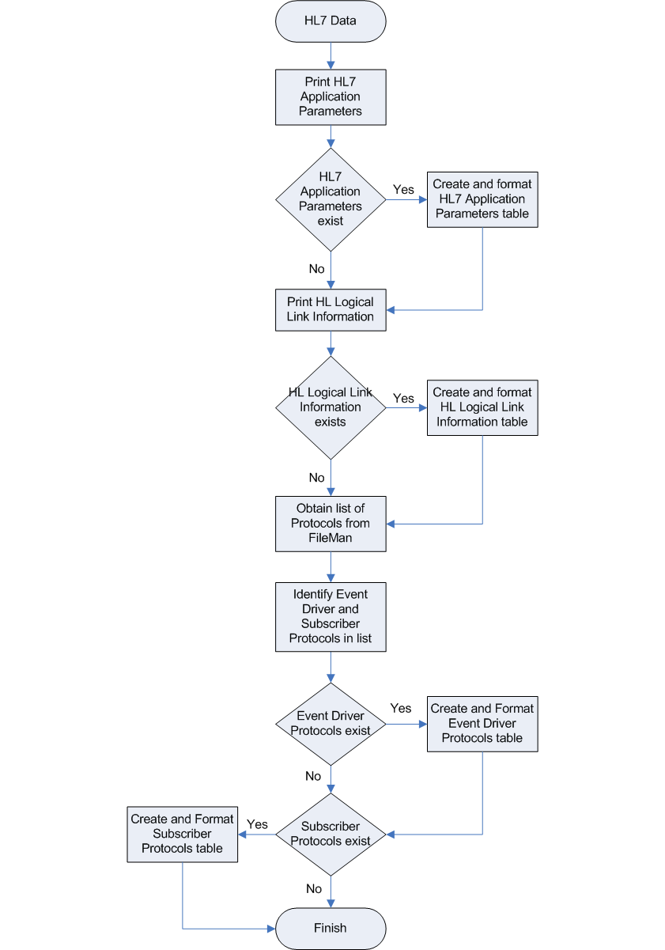

HL7 Application Parameter (#771)
This file contains a list of VistA applications that are capable of sending and receiving HL7 transmissions. It stores HL7 application definitions. Entries are unique by application name. Each protocol that is part of an application, i.e. entries in the Protocol file (#101,) points to the application entry in this file.

Note: Entries in this file may vary by site. Depending on the HL7 interfaces implemented at the site, there will be great variations on number of entries and amount of data defined per entry.

Printing the Application Parameters
- Access VA FileMan
- Select the Print File Entries option.
- At the Output From What File prompt, enter HL7 Application Parameter
- At the Sort By prompt, accept the default (NAME) by pressing <Enter.>
- Enter the application’s namespace at the Start with Name: First prompt. (In the example below, PS is the namespace for Pharmacy.)
- At the Go to Name: Last// prompt, enter the application’s namespace appended with a Z. (In the example below PS is the namespace for Pharmacy, hence we entered PSZ)
- At the Within Name, Sort By: prompt, press <Enter.>
- At the First Print Field prompt, enter NAME
- When prompted for the next print field, Then Print Field, enter Facility Name
- When prompted for the next Print Field, press<Enter.>
- Accept the defaults at the next two prompts by pressing<Enter.>
- At this point turn on the Capture Incoming Data function on your terminal emulator.
- At the DEVICE prompt enter ;132;9999, turn on Capture Incoming Data function and press <Enter.>
- Turn off Capture Incoming Data after the report finishes printing.

VA FileMan Version 22.0
Enter or Edit File Entries
Print File Entries
Search File Entries
Modify File Attributes
Inquire to File Entries
Utility Functions ...
Data Dictionary Utilities ...
Transfer Entries
Other Options ...
Select VA FileMan Option: Print File Entries
OUTPUT FROM WHAT FILE: HL7 APPLICATION PARAMETER//
SORT BY: NAME//
START WITH NAME: FIRST// PS
GO TO NAME: LAST// PSZ
WITHIN NAME, SORT BY:
FIRST PRINT FIELD: NAME
THEN PRINT FIELD: FACILITY NAME
THEN PRINT FIELD:
Heading (S/C): HL7 APPLICATION PARAMETER LIST Replace
START AT PAGE: 1//
DEVICE: ;;999 TELNET Right Margin: 80//
Figure 28, Sample of Application Parameter Run

HL7 APPLICATION PARAMETER LIST SEP 28,2005 10:46 PAGE 1
NAME FACILITY NAME
-----------------------------------------------------------------------
PSB BCBU CLIENT
PSB BCBU SERVER
PSB HL7 SRV
PSB HL7 SUB
PSB PMU RECV
Figure 29, Example of the output from Pharmacy

How to Format the Output for HL7 APPLICATION PARAMETER
To format the output for HL7 APPLICATION PARAMETER, simply copy and paste the appropriate data into the following table from the text file created above.

NAME | Facility Name
PSB BCBU CLIENT
PSB BCBU SERVER
PSB HL7 SRV
PSB HL7 SUB
PSB PMU RECV
PSB PMU SEND
Table 9, Example of the formatted output for Pharmacy

HL Logical Link (#870)
This file stores parameters that govern the behavior of the Low Layer Protocols.

Entries in this file define the target systems which can receive/exchange HL7 messages. Akin to the Kernel’s Device file and MailMan’s Domain file, this file contains the specific HLLP, X3.28, TCP, and MailMan information needed by VistA HL7 to reach destination systems.

The following are the fields in the file that need the necessary information to communicate with target systems.
- NODE: This is the name of the logical link that data will be communicated on.
- LLP TYPE: This is the Lower Level Protocol (LLP) for the logical link
- MAIL GROUP: The name of the mail group that messages should be sent to.

Note: Entries in this file may vary by site. Depending on the HL7 interfaces implemented at the site, there will be great variations on number of entries and amount of data defined per entry.

How to Print the HL LOGICAL LINK Information
- Access VA FileMan
- Select the Print File Entries option.
- At the Output From What File prompt, enter HL Logical Link.
- Accept the default (NODE) by pressing ENTER at the Sort By prompt.
- Enter the application’s namespace at the Start with Name: First prompt. (In the example below, PS is the namespace for Pharmacy.)
- At the Go to Name: Last prompt, enter the application’s namespace appended with a Z. (In the example below PS is the namespace for Pharmacy, hence we entered PSZ)
- At the Within Node, Sort By prompt, press <Enter.>
- At the First Print Field prompt, enter Node
- When prompted for the next print field Then Print Field, enter LLP Type
- When prompted for the next print field, enter Mail Group.
- When prompted for the next print field press, <Enter.>
- Accept the defaults at the next two prompts by pressing <Enter.>
- At this point turn on the Capture Incoming Data function on your terminal emulator.
- At the Device prompt enter, “;132;9999,” turn on Capture Incoming Data function and press <Enter.>
- After the report finishes printing, be sure to turn off Capture Incoming Data.

Select VA FileMan Option: print File Entries

OUTPUT FROM WHAT FILE: HL7 APPLICATION PARAMETER// HL LOGICAL LINK
(221 entries)
SORT BY: NODE//
START WITH NODE: FIRST// PS
GO TO NODE: LAST// PSZ
WITHIN NODE, SORT BY:
FIRST PRINT FIELD: NODE
THEN PRINT FIELD: LLP TYPE
THEN PRINT FIELD: MAIL GROUP
THEN PRINT FIELD:
Heading (S/C): HL LOGICAL LINK LIST Replace
START AT PAGE: 1//
DEVICE: ;132;9999
Figure 30, Sample of HL Logical Link Run

NODE LLP TYPE MAIL GROUP
-----------------------------------------------------------------------PSBCOTS1 TCP
PSCRIBE-RA TCP
PSD HLLP HLLP
PSD MM MAILMAN
PSD X3.28 X3.28
PSO DISP TCP
PSO LLP1 HLLP
PSO LLPO HLLP
PSOTPBAAC TCP
PSU SEND TCP
Figure 31, Example of the HL LOGICAL LINK information displayed for Pharmacy

How to Format the information for HL LOGICAL LINK
From the test file generated in the steps above, copy the following information into the table below.
- Node – This is the name of the logical link that data will be communicated on.
- LLP Type – This is the Lower Level Protocol (LLP) for the logical link.
- Mail Group – The name of the mail group that messages should be sent to.

Note: Entries in this file may vary by site. Depending on the HL7 interfaces implemented at the site, there will be great variations on number of entries and amount of data defined per entry

NODE | LLP Type | Mail Group
PSBCOTS1 | TCP
PSCRIBE-RA | TCP
PSD HLLP | HLLP
PSD MM | MAILMAN
PSD X3.28 | X3.28
PSO DISP | TCP
PSO LLP1 | HLLP
PSO LLPO | HLLP
PSOTPBAAC | TCP
PSU SEND | TCP
Table 10, Example of the formatted data from Pharmacy

PROTOCOL (#101)

What are Protocols?
Each HL7 entry in the Protocol file represents one side of a transaction, either message sender (event driver protocol) or message receiver (subscriber protocol). HL7 protocols use a completely different set of fields (numbered from 770 to 775) versus the fields used for Order/Entry functionality in the same file. Each subscriber protocol points to a single entry in file #870 (HL Logical Link), determining the destination a message for that transaction is delivered to.

How to Identify Event Driver and Subscriber protocols
You will need the following:
- Print a detailed list of the Protocol entries for the package in FileMan
- Examine the list to find the entries with a type of “event driver”
- Format the information into a table

How to Obtain a Detailed list of Protocols in FileMan
- Access VA FileMan
- From the FileMan prompt, type ‘P’ for Print File Entries.
- At the Output From What File prompt enter “Protocol.”
- At the Sort By prompt, enter “Name.”
- At the Start with Name prompt, enter the package namespace. In the following example DG is the namespace for Registration.
- At the Go to Name prompt enter the package namespace followed by one or more “Z” characters. This will capture all protocols in the namespace including any locally created protocols.
- At the Within Name, Sort By prompt, press <Enter.>
- At the First Print Field prompt, enter [Captioned. This will print all fields in the PROTOCOL file.
- At the Include Computed fields (N/Y/R/B) prompt, type “B” for BOTH
- At the Heading (S/C) prompt, press <Enter.>
- At the Start at Page prompt, press <Enter.>
- Turn on Capture Incoming Data. This will save the following screen contents on your local drive.
- At the Device prompt type ;80;9999.
- Turn off the data capture after FileMan prints the data.

Select OPTION: PRINT FILE ENTRIES
OUTPUT FROM WHAT FILE: PROTOCOL//
SORT BY: NAME//
START WITH NAME: FIRST// DG
GO TO NAME: LAST// DGZZ
WITHIN NAME, SORT BY:
FIRST PRINT FIELD: [CAPTIONED
Include COMPUTED fields: (N/Y/R/B): NO// BOTH Computed Fields and Record Number
(IEN)
Heading (S/C): PROTOCOL LIST//
START AT PAGE: 1//
DEVICE: ;80;9999 TELNET
PROTOCOL LIST SEP 29,2005 12:08 PAGE 1
-----------------------------------------------------------------------NAME: DG PATCH 244 ITEM TEXT: DG PATCH 244
TYPE: event driver CREATOR: SCHLEHUBER,CAMERON
PACKAGE: REGISTRATION
DESCRIPTION: This server protocol will be used by patch DG*5.3*244 to generate an HL7 Update Patient (event code A08) message. All local subscribers to VAFC ADT-A08 SERVER will be added as subscribers to this protocol by the post init included with DG*5.3*244.
TIMESTAMP: 59323,59468 SENDING APPLICATION: VAFC PIMS
TRANSACTION MESSAGE TYPE: ADT EVENT TYPE: A08
PROCESSING ID: P ACCEPT ACK CODE: NE
APPLICATION ACK TYPE: NE VERSION ID: 2.3
RESPONSE PROCESSING ROUTINE: Q
SUBSCRIBERS: RG ADT-A08 TRIGGER
NAME: DG PTF ADT-A01 CLIENT TYPE: subscriber
CREATOR: SCHLEHUBER,CAMERON PACKAGE: REGISTRATION
RECEIVING APPLICATION: NPTF-508 TRANSACTION MESSAGE TYPE: ADT
EVENT TYPE: A01 MESSAGE STRUCTURE: i
PROCESSING ID: P LOGICAL LINK: NPTF
VERSION ID: 2.2 RESPONSE MESSAGE TYPE: ADT
PROCESSING ROUTINE: Q SENDING FACILITY REQUIRED?: YES
RECEIVING FACILITY REQUIRED?: YES SECURITY REQUIRED?: NO
DATE/TIME OF MESSAGE REQUIRED?: YES
Figure 32, Screen capture of FM Dialog for Protocols

Identifying Event Driver and Subscriber protocols
The FileMan output creates a two column list of values for the Protocol fields. Not all fields will be contained in each Protocol. The type of protocol is found in the TYPE field of the FileMan listing. Event driver protocols have a value of “event driver”. Subscriber protocols have a value of “subscriber”. Ignore all protocols with other TYPE values.

How to Format the output for Event Driver Protocols

As each protocol is identified that has a TYPE of “event driver”, copy the fields to the respective columns in the table. Not all fields will be referenced in the FileMan output for each Protocol. The column values are taken from the associated fields in the FileMan output.

- Name - NAME field.
- Item Text - ITEM TEXT field.
- Type – TYPE field.
- Package – This is not in the FileMan output. It is the package that owns the protocol (the package being reengineered).
- Description – DESCRIPTION field. This can be a multiple line field.
- Subscribers – SUBSCRIBERS field. This may be a list of more than one subscriber. The list will not be separated by columns.
- Sending Application – SENDING APPLICATION field.
- Event Type – EVENT TYPE field.
- Transaction Message Type – TRANSACTION MESSAGE TYPE field.
- Version ID – VERSION ID field.

Name | Item Text | Type | Package | Description | Subscribers | Sending Application | Event Type | Transaction Message Type | Version Id
DGQE HL7 A08 VIC SERVER | HL7 server for a VIC event | Event Driver | Registration | This event is trigger from the stand-alone option when a user request an ID card | DGQE VIC A08 CLIENT | DGQE VIC EVENTS | A08 | ADT | 2.2
VAFC ADT-A04 SERVER | This protocol fires off of the PIMS Registration option | Event Driver | Registration | This server protocol fires when a patient is registered. It generates a Health Level Seven (HL7) register a patient (event code A04) message. | DG PTF ADT-A04 CLIENT, RG ADT-A04 CLIENT, RG ADT-A04 TRIGGER | VAFC PIMS | A04 | ADT | 2.3
VAFC ADT-A08 SERVER | Registration's ADT-A08 Server Protocol | Event Driver | Registration | This server protocol fires when a patient record is updated. It generates a Health Level Seven (HL7) update a patient (event code A08) message. | DG PTF ADT-A08 CLIENT, RG ADT-A08 CLIENT, RG ADT-A08 TRIGGER | VAFC PIMS | A08 | ADT | 2.3
VAFH A01 |  | Event Driver | Registration |  | VAFH CLIENT A01 | VAFH PIMS | A01 | ADT | 2.2
VAFH A02 |  | Event Driver | Registration |  | VAFH CLIENT A02 | VAFH PIMS | A02 | ADT | 2.2
Table 11, Example of HL7 ‘Event Driver’ Protocol

How to format the output for Subscriber Driver Protocols
As each protocol is identified that has a TYPE of “subscriber”, copy the fields to the respective columns in the table. Not all fields will be referenced in the FileMan output for each Protocol. The column values are taken from the associated fields in the FileMan output.
- Name - NAME field.
- Item Text - ITEM TEXT field.
- Type – TYPE field.
- Package - This is not in the FileMan output. It is the package that owns the protocol (the package being reengineered).
- Description – DESCRIPTION field. This can be a multiple line field.
- Receiving Application – RECEIVING APPLICATION field.
- Event Type – EVENT TYPE field.
- Transaction Message Type – RESPONSE MESSAGE TYPE field.
- Version ID – VERSION ID field.
- Logical Link – LOGICAL LINK field.
- Processing Routine – PROCESSING ROUTINE field.

Name | Item Text | Type | Package | Description | Receiving Application | Event Type | Transaction Message Type | Version Id | Logical Link | Processing Routine
DGQE VIC A08 CLIENT |  | subscriber | Registration | This is the client used for the HL7 interface with DataCard | DGQE DATACARD | A08 | ACK | 2.2 | VIC | D EN^DGQEACK
VAFH CLIENT A01 |  | subscriber | Registration |  | VAFHL7 TEMPLATE | A01 | ADT | 2.2 | VAFH-SEND | Q
VAFH CLIENT A04 |  | subscriber | Registration |  | VAFHL7 TEMPLATE | A04 | ADT | 2.2 | VAFH-SEND | Q
VAFH CLIENT A19 |  | subscriber | Registration |  | VAFHL7 TEMPLATE | A19 | QRY | 2.2 | VAFH-SEND | D ^VAFHQRY
VAFC ADT-A03 CLIENT |  | subscriber | Registration |  | VAFCHL7TEMPLATE | A03 | ADT |  | VAFC-SEND | Q
VAFC ADT-A04 CLIENT |  | subscriber | Registration |  | VAFCHL7TEMPLATE | A04 | ADT |  | VAFC-SEND | Q
VAFC ADT-A08 CLIENT |  | subscriber | Registration |  | VAFCHL7TEMPLATE | A08 | ADT |  | VAFC-SEND | Q
Table 12, Example of HL7 ‘Subscriber’ Protocols

Database Extracts

What is Database Extract Research?
The Data Extracts research is a compilation of all the VistA application-owned data, which is gathered and transported to an outside entity, a corporate database or registry. Corporate databases or registries are created for various purposes which include data warehousing, researching, and gathering national statistics.

The source of the extracted data is from the VistA application documentation and in depth source code review. The extracts are generally transported in predefined formats such as HL7 or MailMan messages. This research includes the following:
- The active extracts
- The custodial application for each extract
- Type of data extracted
- The destination database and location
- Other details pertinent to each extract

The details of ‘file’ and ‘field’ information are provided for each extract. This research does not include any information about the destination database other than the name and its location if this is known.

We provide links to a website where some details about the database may be found; we have no knowledge of any manipulation processes or any details about the data or its format once in the target entity. In addition, a code level search was done to verify the source for these extracts and the formats used by the extracts.

Why Examine Database Extracts?
It is critical for the reengineering team to know about the extracts that leave the legacy application. The information is needed in order to coordinate encapsulation efforts with other custodial applications that extract package data, and to make contact with the entities that receive the data. It is very important that this coordination happen as early as possible in the development process so that the transmission of expected information is not interrupted or terminated. It is also important to identify and discuss any necessary changes in the format or delivery mode very early on in the development process.

What you should know before you start
In order to research the database extracts for an application, the user must know the following:
- How to access the VistA Documentation Library (www.va.gov/vdl/)
- How to access the Corporate Database Monograph (http://vaww.va.gov/nds/Database_Inventory/MonoUpdate/Prod/MonoGdbRequestReadOnly.asp)
- How to access FileMan 22.0 in their VistA test account
- How to access Programmer Mode in their VistA test Account
- Have a working knowledge of the Mumps Programming Language
- How to access a routine editor or reader in their VistA test account

How to Research Database Extracts
Researching Database Extracts is a complicated and intensive search through an application’s documentation, options, routines, and M code to discover how and what data is being sent. The process involves several levels of discovery research followed by code level analysis of the extraction routines.

You need do the following to complete a thorough assessment of the database extracts and determine their impact on application linkages:

- Determine/identify all extract being completed by and application
  - Identify any routine that initiates the extracts process
- Complete a thorough code-level search of the extracts you have identified.

A Graphical Representation of how to Research Data Extracts
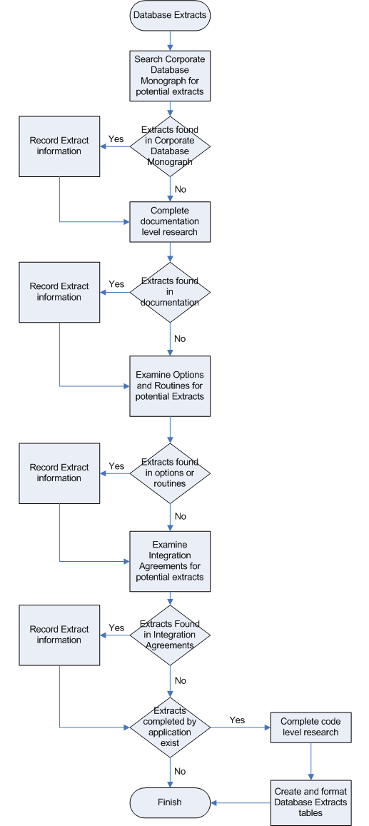

Identifying Data Extracts
The first step in researching database extracts is to determine which extracts are being completed by the application. There are several places to begin the discover process.
- Check the Corporate Database Monograph for any mention of extracts.
- Check the VDL for documentation
- Read the technical and installation manuals looking for any reference to Mail Group set-up, HL-7 formats, HL-7 protocols, and other keywords and phrases (see next);
- Search for the keywords ‘Austin’, ‘upload’, ‘extract’ ‘download’ ‘database’ ‘HL-7’ ‘mailman’ ‘domain’ ‘generic code sheets’, ‘transmit’, ‘send/sent’, ‘Hines’, ‘DSS’, “Decision Support System’, etc.
- Examine the Options for the application
- Print all the options for the application (See the Option Chapter in the Analysts Manual for complete instructions)
- Examine the resulting text file for any references to creating MailMan messages, HL-7 segments, or sending data to a database.
- Note any routines associated with the options.
- Examine the routines for the application
- Print a list of the routines for the application being researched. (See the Routine Chapter in the Analysts Manual for complete instructions)
- Examine the resulting routine descriptions for any references to creating MailMan messages, HL-7 segments, or sending data to a database.
- Note any routines that fit the criteria mentioned above, i.e. note routines that send data to a database.
- Gather the Integration Agreements, both subscriber and custodial, for the application
- Print all IAs for the application (See the Integration Agreements chapter in this document)
- Read the IA description for any reference to data extraction or external databases.
- Check for IAs between the application and MailMan, HL7, DSS, HDR, or Generic Code Sheet that may clue you in to some of the extracts that are going on. The IAs may contain specific fields that are extracted.
- Run XINDEX on the application’s Package file entry and its namespaced routines. (See the Outbound References chapter of this document for complete instructions on running XINDEX)
- With the XINDEX results, look for global variables or routine references to the following:
    - ^XMB(“NETNAME”)
    - ^XMB(1 – MAILMAN SITE PARAMETERS (#4.3)
    - ^XMB(3.6 – BULLETIN (#3.6)
    - ^XMB(3.8 - MAIL GROUP (#3.8)
    - ^XMB(3.9 - MESSAGE (#3.9)
    - SENDMSG^XMXAPI – API to send mail message
    - ^XMSEND – API to send mail message
    - ^XM*
    - ^HL(770 – HL7 NON-DHCP APPLICATION PARAMETER (#770)
    - ^HL(771 – HL7 APPLICATION PARAMETER (#771)
    - ^HL(772 – HL7 MESSAGE TEXT (#772)
    - ^HL*
    - ^GEC*
    - Local variables:
      - XMY – mailing list array
      - XMSUB – subject of message
- Note any routines with references to above.

- Use the Print option in FileMan to print a captioned output of the following files:
- HL LOGICAL LINK (#870) file (See the HL7 chapter in this Manual for more information about LOGICAL LINK file.)
eg. SR AAIS
SR SURGERY
  - DOMAIN (#4.2) file
eg. IMMUNOLOGY.VA.GOV
- Run ^%RFIND to look for the following key items in the package routines (See the Inbound References Chapter of this document for details on the RFIND utility):
  - ‘VA.GOV’ in routines – list of domains that are receiving messages
  - XMY ( - to find intended recipients of mail messages. This may include a list like ‘G.something@domain’ – for a mail group (get details in the MAIL GROUP file or ‘S.something@domain – for a SERVER name at the specified location (look for ?? (option?) server information) e.g. S.SRCOSERV@FO-HINES.MED.VA.GOV
  - XMSUB – message subject
  - Search for any mention of HL7 or databases.
- Print all Patches for the application out of FORUM. (For detailed instructions on printing a list of Patches, refer to the Analysts’ Manual)
  - Review the patch descriptions to identify any new extracts.

Note: Some extracts might be supported in patches and described there but not in the application documentation.

Code Level Research
After identifying any/all routines that initiate the extract process and the documented extract layout (if available,) begin the code level research. You will have to read through the data you have gathered and identify the key pieces of information.

Gathering General Information about the Extract
The following tips can help you gather general information about the data extract. The description of the database is available from the Corporate Database Monograph. As you gather this data, you can add the information in the blank tables shown at the end of this chapter.

Note: If the documentation contains record layouts, use them as a basis to help understand the code search. Frequently, extract structures change and the documentation does not keep pace.

- Location of the database - the search for 'VA.GOV' will clue you in
- What is being extracted – here the IAs can be very helpful. If available, the IA description can clue you in to the type of data.
- What is the message type - the XINDEX output will give a clue on what's being used by the application
- What triggers the extract - find the option that gets called that will trigger the extract - start with the top level menu and work down. Use the Manual or Option descriptions.
- How frequent is the extract – The option description may include the frequency of execution. If not, look in the routine called by the option and examine at the routine code. Another field to look at is if the Option is recommended for queuing, look at the recommended frequency (OPTION definition).

The following table is an example form the Laboratory EPI extract.
Message Type | HL-7
Message Format | EPI MESSAGE FORMAT
Destination Database | Emerging Pathogens Initiative (EPI)
Destination Location | Austin, TX
Trigger | AUTO^LREPIRM
Frequency | Monthly
Selection Criteria | All tests completed within month (lag period from file #69.5; field 10.5)
User Options | LREPI ENHANCE MANUAL RUN; LREPI NIGHTLY TASK
Table 13, Laboratory: EPI

Gathering Files and Fields Related Information
The following tips will help you gather the information.

- Research through the routine and called routines to locate the format of the record(s) being created or written out to HL7 or Mailman temporary globals.
Note: The HL7 data will be stored in a temporary array or global. You can work backwards from the call to GENERATE^HLMA to locate where the array elements are being loaded. It expects the data to be in the local array HLA (“HLS”) or the global ^TMP (“HLS”) prior to putting the records into the MESSAGE TEXT file (#772).
- MailMan message records will be stored in an array that can be identified from the XMTEXT variable. The XMSUB variable contains the message subject. The XMY array contains a list of recipients.
- MailMan messages can also use a post patch 50 API. If SENDMSG^XMXAPI is used, the XMTO array contains the list of recipients. It is the fourth variable passed in the call to SENDMSG^XMXAPI. The array may not be named XMTO. The array containing the text of the message is the third variable passed in the call.
- Track back through the routines to where the variables are being set. Record the source file name, file number, field name and field number.
  - It is likely that the records will be built in order within a series of programs containing a common name (i.e. ABCDEx where x is a digit).
  - It is useful to copy the routine(s) to text files on a PC and then use the find command to locate instances of the variable.
- If the source field is a pointer to another file, record the pointed to file name, file number, field name and field number as well.
- If the output record is in HL7 format, record the segment ID (OBR, OBX, PID etc) and field position in the file.
- If the output record is not in HL7 format, record the record id (if one exists), the piece number for the field or the starting character position and length if the record has fixed length fields.

How to Format the Database Extract
The next step is to complete the files and field columns and the segment column. As you discover a field that is extracted, complete the row in the table. You can sort the completed table by file number and field number when you have completed the analysis. Finally, complete the message format section of the table.
File | File Name | Field | Element | Description | Message Segment
2 | PATIENT | IEN | DFN | Internal ID number | PID
2 | PATIENT | 0.01 | NAME | Patient name | PID
2 | PATIENT | 0.02 | SEX | Sex | PID
2 | PATIENT | 0.03 | DATE OF BIRTH | Date of birth | PID
Table 14, Example of Files and Fields for LAB: EPI

PID – Patient ID Segment - Attributes
SEQ | LEN | DT | OPT | RP/# | ELEMENT NAME
0 | 3 | ST | R |  | "PID"
1 | 4 | SI | R |  | Segment ID
2 | 20 | CX | R |  | External ID
3 | 250 | CX | R |  | Patient ID - (DFN - Internal)
5 | 250 | XPN | R |  | Patient Name
7 | 26 | TS | O |  | Date of Birth
8 | 1 | IS | O |  | Sex
10 | 250 | CE | O | YES | Race
11 | 250 | IS | O | 1 | Address or "Homeless"
11 | <continuation> | IS | O | 2 | Address line 2
11 | <continuation> | IS | O | 3 | Address line 3
11 | <continuation> | IS | O | 4 | City
11 | <continuation> | IS | O | 5 | State
11 | <continuation> | IS | O | 6 | Zip code
19 | 16 | ST | R |  | Social Security Number
Table 15, Example of HL7 Format for LAB EPI

List Templates

What are List Templates?
A template is a permanent place to store selected field specifications for use at a later time. List Templates are used by the List Manager utility.
List Manager provides a generic method of presenting lists of items to terminal users. Its core functions are:
- Display a list of items.
- Users can browse through the list.
- Users can select one or more items from the list.
- Users can execute an action for selected list items.
- You can use List Manager recursively within an action.

A List Template is the core of a List Manager utility; all the crucial information that determines how a list works is stored in an application’s List Template.

For more information on List Manager, please refer to the documentation in the Vista Documentation Library at this location:
http://www.va.gov/vdl/Infrastructure.asp?appID=14

Why Examine List Templates?
List Templates provide information that links your application to CPRS/ Order Entry and Results Reporting. These entries will need to be identified and researched in order to provide continued functionality in the reengineered environment.

What you should know before you start
In order to print the protocols for an application, the user must know the following:

- How to access FileMan in their VistA test account.
- Know the namespaces for the package being researched.

Graphical Representation of how to Print List Templates
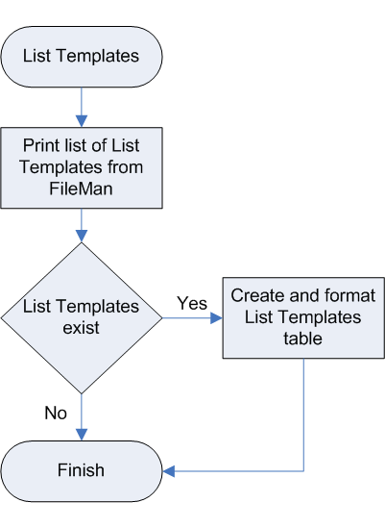

How to obtain a detailed list of List Templates in FileMan
- Access VA FileMan
- From the FileMan prompt, type Print File Entries and press <Enter.>
- At the Output From What File prompt enter “List Templates”
- At the Sort By prompt enter “Name”
- At the Start with Name prompt enter the package namespace. In the following example PS is the namespace for Pharmacy.
- At the Go to Name prompt enter the package namespace followed by one or more “Z” characters. This will capture all protocols in the namespace including any locally created protocols.
- At the Within Name, Sort By prompt press <Enter.>
- At the First Print Field prompt enter “[Captioned”. This will print all fields in the LIST TEMPLATE file.
- At the Include Computed fields: (N/Y/R/B) prompt, type “B” for BOTH
- At the Heading (S/C) prompt press <Enter.>
- At the Start at Page prompt press <Enter.>
- Turn on Capture Incoming Data. (This will save the following screen contents on your local drive.)
- At the Device prompt type “;132;9999”
- Turn off the data capture after FileMan prints the data

Select VA FileMan Option: Print File Entries
OUTPUT FROM WHAT FILE: LIST TEMPLATE//
SORT BY: NAME//
START WITH NAME: FIRST// PS
GO TO NAME: LAST// PSZ
WITHIN NAME, SORT BY:
FIRST PRINT FIELD: [CAPTIONED
Include COMPUTED fields: (N/Y/R/B): NO// BOTH Computed Fields and Record Number
(IEN)
Heading (S/C): LIST TEMPLATE LIST//
START AT PAGE: 1//
DEVICE: ;132;9999 TELNET
Figure 33, Sample Run of FileMan for List Templates
LIST TEMPLATE LIST SEP 29,2005 15:17 PAGE 1
-----------------------------------------------------------------------
NUMBER: 509 NAME: PSB ERROR LOG
TYPE OF LIST: PROTOCOL
RIGHT MARGIN: 80 TOP MARGIN: 4
BOTTOM MARGIN: 20
OK TO TRANSPORT?: OK USE CURSOR CONTROL: YES
PROTOCOL MENU: PSB ERROR LOG MENU
SCREEN TITLE: BCMAbu Error Log ALLOWABLE NUMBER OF ACTIONS: 1
AUTOMATIC DEFAULTS: YES
HIDDEN ACTION MENU: VALM HIDDEN ACTIONS
ARRAY NAME: ^TMP("ALPBELOG",$J)
EXIT CODE: D EXIT^ALPBELOG HEADER CODE: D HDR^ALPBELOG
HELP CODE: D HELP^ALPBELOG
ENTRY CODE: D INIT^ALPBELOG
NUMBER: 506 NAME: PSB SELECT ORDERS
TYPE OF LIST: PROTOCOL
RIGHT MARGIN: 80 TOP MARGIN: 7
BOTTOM MARGIN: 19
OK TO TRANSPORT?: OK USE CURSOR CONTROL: YES
PROTOCOL MENU: PSB ORDERS MENU
SCREEN TITLE: BCMAbu ACTIVE Orders List
ALLOWABLE NUMBER OF ACTIONS: 1
HIDDEN ACTION MENU: VALM HIDDEN ACTIONS
ARRAY NAME: ^TMP("ALPBORDS",$J)
ITEM NAME: OrderNum COLUMN: 2
WIDTH: 10
DISPLAY TEXT: Order No.
ITEM NAME: OrderType COLUMN: 22
WIDTH: 4
DISPLAY TEXT: Type
ITEM NAME: Status COLUMN: 14
WIDTH: 7
DISPLAY TEXT: Status
ITEM NAME: Meds COLUMN: 28
WIDTH: 45
DISPLAY TEXT: Medication(s)
EXIT CODE: D EXIT^ALPBSP1 HEADER CODE: D HDR^ALPBSP1
Figure 34, Example of the List Template data for Pharmacy.

How to Format the Data for List Templates
From the text file created in the above section copy the following fields into the table below:
- Name: The name of the list template
- Screen Title: This field contains the text that will be displayed/printed in the upper left corner of the screen display.
- Entity Name: This field contains the term that will be displayed to the user that best describes the items in the list. The term will be used if the developer wishes to use the generic ‘select’ action. For example, “Select Appointment(s):” could be displayed and the entity is ‘Appointment’.
- Type: This field indicates the type of list. A 'protocol' list will cause the List Manager to use the PROTOCOL entered in the 'PROTOCOL MENU' field. A 'display' list will use the standard VALM DISPLAY protocol supplied by the List Manager. This protocol allows user to view or scroll though the list. The user will be able to use the standard 'next screen', previous screen', etc. actions.

Name | Screen Title | Entity Name | Type
PSB ERROR LOG | BCMAbu Error Log |  | Protocol
PSB SELECT ORDERS | BCMAbu ACTIVE Orders List |  | Protocol
PSB SELECT PATIENT | BCMAbu Patient List (All) |  | Protocol
PSB SHOW ORDERS | BCMAbu Selected Order(s) |  | Display
PSJ LM ALLERGY DETAIL | DETAILED ALLERGY VIEW |  | Protocol
PSJ LM ALLERGY DISPLAY | Detailed Allergy Display |  | Display
PSJ LM BRIEF PATIENT INFO | Patient Information | Protocol | Protocol
Table 16, Example of the data recorded for Pharmacy

Protocols

What are Protocols?
A Protocol is described as an entry in the PROTOCOL file and can be viewed as a module of code. Each module of code may optionally contain other modules of code. Other fields in each file entry determine conditions under which the module should be executed, what should be presented to the user, etc.

Protocol usage can be listed under three categories:
- A Protocol is used by the Order Entry/Results Reporting (OE/RR) package to support the ordering of medical tests and other activities. The Kernel includes several protocol-type options for enhanced menu displays within the OE/RR package. The processing of protocols in OE/RR is made possible by the Kernel Unwinder (XQOR*). For more information, please refer to the Kernel Unwinder: documentation at: http://www.va.gov/vdl/Infrastructure.asp?appID=13
- Protocols of type ‘event driver’ and ‘subscriber’ are used in the HL7 messaging context. Please see the HL7 Data (if available) in the ‘Pharmacy Application Linkages and Encapsulation Research’ document for more details.
- The List Manager provides a generic method of presenting lists of items. ‘Menu’ type protocols are generally used by the List Manager utility. Please see the ‘List Template’ section to get more information on how ‘protocols’ are used in List Templates. OE/RR uses List Manager.

Why examine protocols?
An Extended Action protocol is an invitation for other applications to attach code
to the event that triggers the protocol. The execution of the other application’s code
is dependent on the Unwinder being invoked for that protocol. This is a broadcast communication to which applications subscribe. If the protocol no longer exists because the parent application has been replaced, another way of informing the subscribing applications must be implemented.

In addition, protocols implement sequences of dependent actions. If one of those actions has been taken by an application being replaced, the replacement application must somehow participate in the sequence or the protocol chain would be broken.

What you should know before you start
In order to print the protocols for an application, the user must know the following:
- How to access FileMan in their VistA test account.
- Know the namespaces for the package being researched.

Graphical Representation of how to Print Protocols

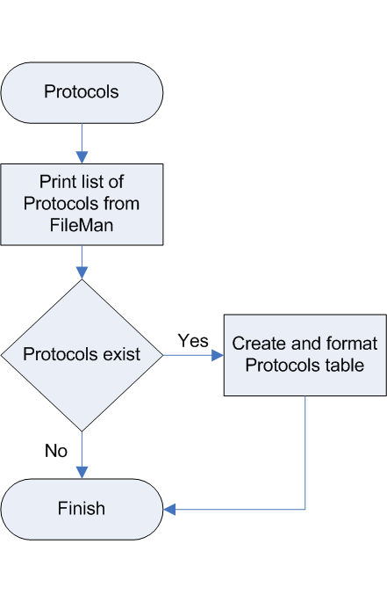

How to Print a Detailed list of Protocols in FileMan
- Access VA FileMan
- From the FileMan prompt, type ‘P’ for Print File Entries.
- At the Output from What File prompt enter Protocol.
- At the Sort By prompt, enter Name.
- At the Start with Name prompt enter the package namespace. In the following example DG is the namespace for Registration.
- At the Go to Name prompt enter the package namespace followed by one or more “Z” characters. This will capture all protocols in the namespace including any locally created protocols.
- At the Within Name, Sort By prompt, press <Enter.>
- At the First Print Field prompt, enter “[Captioned”. This will print all fields in the PROTOCOL file.
- At the Include COMPUTED fields: (N/Y/R/B) prompt type “B” for BOTH
- At the Heading (S/C) prompt press <Enter.>
- At the Start At Page prompt press <Enter.>
- Turn on Capture Incoming Data. This will save the following screen contents on your local drive.
- At the Device prompt type ;80;9999 and press <Enter.>
- Turn off the data capture after FileMan prints the data.

Select OPTION: PRINT FILE ENTRIES
OUTPUT FROM WHAT FILE: PROTOCOL//
SORT BY: NAME//
START WITH NAME: FIRST// DG
GO TO NAME: LAST// DGZZ
WITHIN NAME, SORT BY:
FIRST PRINT FIELD: [CAPTIONED
Include COMPUTED fields: (N/Y/R/B): NO// BOTH Computed Fields and Record Number
(IEN)
Heading (S/C): PROTOCOL LIST//
START AT PAGE: 1//
DEVICE: ;80;9999 TELNET
Figure 35, Sample run of FileMan for Protocols

NAME: DG PATCH 244 ITEM TEXT: DG PATCH 244
TYPE: event driver CREATOR: SCHLEHUBER,CAMERON
PACKAGE: REGISTRATION
DESCRIPTION: This server protocol will be used by patch DG*5.3*244 to generate an HL7 Update Patient (event code A08) message. All local subscribers to VAFC ADT-A08 SERVER will be added as subscribers to this protocol by the post init included with DG*5.3*244.
TIMESTAMP: 59323,59468 SENDING APPLICATION: VAFC PIMS
TRANSACTION MESSAGE TYPE: ADT EVENT TYPE: A08
PROCESSING ID: P ACCEPT ACK CODE: NE
APPLICATION ACK TYPE: NE VERSION ID: 2.3
RESPONSE PROCESSING ROUTINE: Q
SUBSCRIBERS: RG ADT-A08 TRIGGER
NAME: DG PTF ADT-A01 CLIENT TYPE: subscriber
CREATOR: SCHLEHUBER,CAMERON PACKAGE: REGISTRATION
RECEIVING APPLICATION: NPTF-508 TRANSACTION MESSAGE TYPE: ADT
EVENT TYPE: A01 MESSAGE STRUCTURE: i
PROCESSING ID: P LOGICAL LINK: NPTF
VERSION ID: 2.2 RESPONSE MESSAGE TYPE: ADT
PROCESSING ROUTINE: Q SENDING FACILITY REQUIRED?: YES
RECEIVING FACILITY REQUIRED?: YES SECURITY REQUIRED?: NO
DATE/TIME OF MESSAGE REQUIRED?: YES
Figure 36, Example of the Protocol output for Registration

Formatting the Output for Protocols
From the captioned output, copy the following elements into the table below (some entries will not contain the information listed below):
- Name: lists the name of the protocol.
- Item Text is the protocol's text as it appears to the user on the menu or sub-header.
- Type column lists the types of protocols which determine the way that particular protocol gets processed. For example, the Action protocol processes the entry and exit actions within the Kernel Unwinder. An Extended Action protocol “processes all sub-items of the protocol after the entry action and before the exit action. Sub-items may, in turn, be extended actions. The sub-items are processed in SEQUENCE order if the SEQUENCE field is defined.”
- Item column lists all protocols called by the protocol in the Name column, allowing one protocol to call multiple protocols and preventing a logical loop.
- Description column provides a brief explanation of the protocol’s function.

Name | Item Text | Type | Item | Description
DG FIELD MONITOR | DG Field Monitor | Extended Action | SCMC PCMM INACTIVATE ON DATE OF DEATH, SPN REG STATUS UPDATE, SPN REG STATUS DELETE, FB PATIENT DATA CHANGE, VAFC MPIPD FIELD TRIGGER | This protocol is an event point which monitors the editing of fields in DG* application files. At the time of this event point, the
DG MEANS TEST EVENTS | Means Test Event Driver | Extended Action | DG MEANS TEST AUDIT, IB MEANS TEST EVENT, IVM MEANS TEST EVENT, DGEN MT AUTOMATIC ENROLLMENT UPDATE, DGMTH DATE STAMP | This option is the means test event protocol.
Figure 37, Example of a Protocol table for Registration

From VA FileMan Advanced User Manual
From VA FileMan Advanced User Manual
From VA FileMan Technical Manual.
From FileMan Programmer’s Manual
From VA Fileman Advanced User Manual
Definition as found in Kernel Unwinder Documentation
Definition as found in Kernel Systems Manual

