Celtix Enterprise

Open Source

Distributed SOA Infrastructure

IONA Technologies December 2006


Table of Contents

Celtix Enterprise 1
SOA Defined 1
Enabling SOA: The ESB 1
Open Source for SOA 1
Distributed SOA Infrastructure 1
Pluggable Architecture 1
Components 1
Celtix Advanced Service Engine (ASE) 1
Language Bindings 1
Messaging Systems and Message Intermediaries 1
Runtime Containers 1
Monitoring 1
Design-Time Tools 1
Celtix Enterprise Services 1
Celtix History 1
Licensing 1

Celtix Enterprise
Celtix Enterprise is the open source enterprise service bus (ESB) from IONA. It is IONA’s open source offering for implementing a distributed service-oriented architecture (SOA) infrastructure to complement its proprietary offering, Artix. Independently of one another or mixed together, the Celtix and Artix families of products provide the essential tools customers need to build truly distributed SOA infrastructures for mission-critical IT environments. Celtix Enterprise is a certified, tested, and supported distribution of open source software.
With Celtix Enterprise, IONA has assembled a best-of-breed suite of open source components for building a SOA leveraging existing IT investments. Celtix Enterprise is an open source ESB distribution that simplifies the process of choosing and integrating the best components available. Companies seeking an open source option for system integration and SOA implementation will find a collection of the best design-time tools, messaging systems, runtime containers, and routing engines open source has to offer in one convenient package, fully integrated and tested by a SOA and integration market leader.
IONA offers subscription training, services, and support for Celtix Enterprise to insure that even the most complex deployments are successful. With IONA’s extensive experience and proven ability to deliver solutions in mission-critical environments, Celtix Enterprise brings the innovation of open source together with the stability of commercial software.

SOA Defined
The inspiration for SOA is the World Wide Web. The Web is the largest systems integration project ever undertaken. It is highly distributed, supports any implementation technology, and is scalable. Any system that can receive and interpret standard hypertext transfer protocol (HTTP) messages can expose its functionality or information to the Web. It doesn’t matter how the system is implemented or what technology it uses as long as it can talk HTTP. Many existing systems have found new uses by adding a standard HTTP interface layer.
SOA borrows the idea of interface abstraction from the Web. By providing an agreed interface contract between each programmatic element of a system (in the form of Web services description language, or WSDL) implementation details and local changes can be isolated from one another. Re-use of programmatic services, like customer information lookup, across business units becomes possible because each unit is shielded from the details of how that service is implemented. SOA can allow services to be exposed using any implementation technology in a standard way that can be accessed across the enterprise or the world.

Enabling SOA: The ESB
The ESB category is a class of software that makes it possible to build a SOA. The exact set of elements that comprise an ESB are far from universally accepted, and many vendors have labeled whatever they have to sell in the middleware space as an ESB. With the release of Celtix Enterprise IONA is defining ESB as a toolkit for implementing a distributed SOA infrastructure that does not require yet another hub-based stack of technology and is not tied to any particular vendor’s technology. The true promise of SOA can only be realized by technologies that leverage existing technology investments in a scalable, distributed system. A new hub-based integration server just introduces additional performance problems, vendor dependencies, and costs. IONA service-enables systems at the endpoint of the network, without a hub, and allows features to be added as needed via a pluggable architecture.

Open Source for SOA
Open source is a model for the development and use of software. In contrast to closed source, open source provides an environment in which people can interact and collaborate freely. Employees of companies that might compete in a closed source environment can contribute to a shared project, learn from each other, and jointly produce a better product than either could produce alone. End users can also review the code and fix bugs, or hire their own experts to help them enhance or fix the software as they see fit.
Open source provides a new model for innovation that can produce new features of very high quality faster than traditional commercial models. It also reduces the dependence customers have on a single vendor, thereby reducing end user risk.
Integration and SOA is an ideal problem domain in which to collaborate using open source because it is a natural meeting point of many technologies created by many vendors. Open source lets all parties collaborate to make systems work together and it removes the incentives to lock end users into a particular technology or particular company’s vision of how systems should interact.
Companies have often been reluctant to adopt open source software because of the typical lack of enterprise support. Closed source, commercial, software has remained a popular model because it gives corporate users a single legal entity to deal with regarding the acquisition, installation, maintenance, upgrade, and support of software. Open source, by contrast, often presents consumers with a confusing array of developers and Web sites. It can be hard to figure out who is responsible for software errors, or who might be helpful in fixing problems in production.
IONA bridges the gap between open and closed source by providing the cutting edge technology and rapid development only available in the world of open source, and at the same time providing world class, enterprise support companies can trust.

Distributed SOA Infrastructure
IONA’s approach to SOA is a highly distributed one consisting of making existing systems into a distributed SOA infrastructure consisting of smart endpoints. Using Celtix Enterprise, existing systems are exposed for re-use in new ways without the need for a central integration hub. Celtix Enterprise provides the intelligence for existing systems to communicate with previously incompatible systems, including existing middleware and messaging systems.
IONA’s software is designed to address customers’ greatest challenges: to increase the value of existing systems at a lower cost while streamlining operations for increased business agility. To do this, IONA provides distributed and standards-based software with Celtix Enterprise that allows incremental adoption of SOA in a way that is both technology neutral and adaptable as needs change.
Celtix Enterprise provides best-of-breed components fully integrated to ease adoption, but they are not dependent on one another. The IONA approach allows mixing and matching Celtix Enterprise components with components you may already own or components from any other vendor. For example, if a company has a significant investment in one vendor’s JMS implementation, Celtix Enterprise can take advantage of that, providing connectivity to the exiting system from other parts of the network. Celtix Enterprise smart endpoints do not depend on the messaging layer for essential features like security, transactions, or routing. It does not require a central message queuing or integration hub, but it can work with one if a customer prefers that topology.

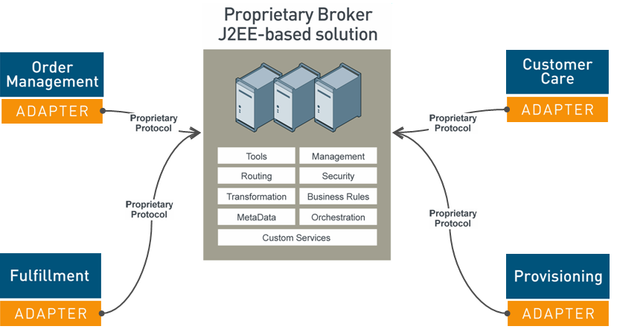
Figure 1. Integration using a central hub and customized, inflexible adapters
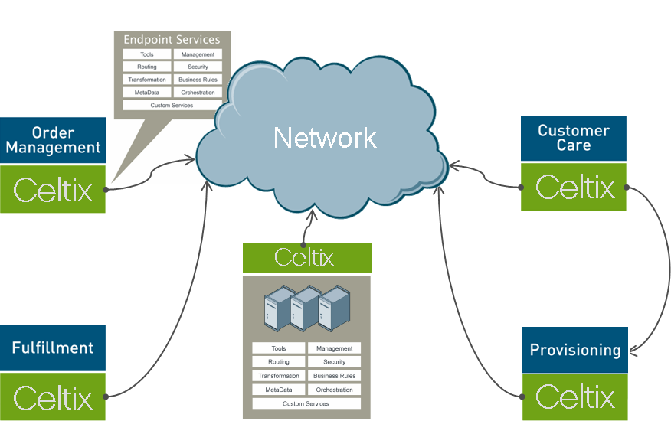
Figure 2. Distributed SOA Infrastructure
Figure 1 shows a typical approach to integration using a central application server as an integration hub. Each non-JMS system requires a custom built adapter to transform the message data and the protocol. Changes to these adapters are not easy and require extensive time, expertise, and expense. Celtix Enterprise smart endpoints can not only replace the functionality of these adapters with a standards-based, easily changed service enablement engine, but they also provide other integration features once only available in large-scale, centralized middleware stacks.
With Celtix Enterprise customers can retain the features and qualities of service (QoS) of a central hub-based system and gain the flexibility of calling directly between systems for some performance-critical functions. It is possible with Celtix Enterprise to have all systems within a SOA talk to each other as peers. What was once a single central bottleneck point for all communications can now become just another endpoint, leveraging special functionality implemented on that server while reducing its load to improve performance and reduce costs. IONA Celtix Enterprise is a flexible ESB system that gives end users the greatest degree of flexibility possible to build a SOA.

Pluggable Architecture
Celtix Enterprise is based on Celtix Advanced Service Engine (ASE), the pluggable services framework, which borrows many architectural elements from IONA’s long background in ESB and integration technology. Celtix ASE allows users to purpose-build solutions using plug-ins for specific features. Leveraging IONA’s adaptive runtime (ART) microkernel ESB architecture, Celtix ASE provides a high-performance, lightweight engine to build-in the capabilities and components that users need for specific situations. Unlike heavyweight, centralized stacks of functionality, Celtix ASE gives users the opportunity to leave out features they don’t need. This makes for a system that is faster and easier to install alongside existing functionality, thus reducing the need for new hardware and associated maintenance.

Components
IONA Celtix Enterprise is a collection of the best design-time tools, messaging systems, runtime containers, routing engines, monitoring, and management capabilities available in open source. The components that comprise Celtix can be used as separate parts or together in an integrated package.

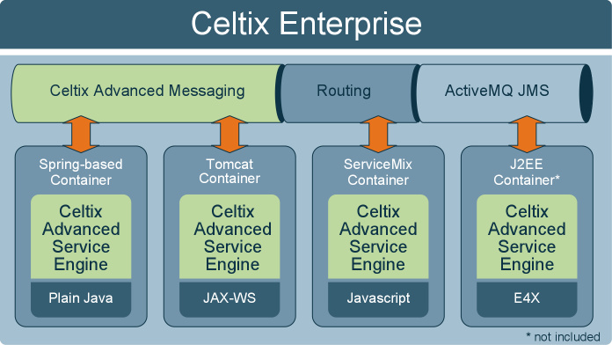Figure 3. Celtix Enterprise Deployment Model

Figure 3 shows the Celtix Enterprise runtime architecture. The picture shows how each of the pieces of the Celtix Enterprise distribution works with the others. These parts include Celtix ASE, messaging systems and messaging intermediaries, and the included runtime containers. Celtix Enterprise also provides design-time and monitoring capabilities not shown in the picture.

Celtix Advanced Service Engine (ASE)
Celtix ASE provides SOAP and Web services capabilities to programs Java using JAX-WS, Javascript, and ECMAScript for XML (or E4X, a variant of Javascript with advanced XML processing capabilities). Celtix ASE provides a consistent and simplified Web services abstraction layer that allows programs written in any of these languages and styles to work in a variety of server contexts, supporting most popular application server containers. Celtix Enterprise comes with 3 container packages for the maximum degree of deployment flexibility. It also supports any Java Enterprise Edition application server, like JBoss.
Celtix ASE provides a pluggable architecture to allow additional capabilities to be added or removed as needed.

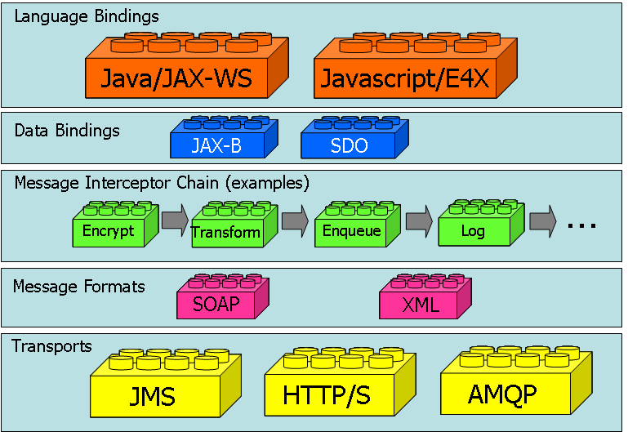
Figure 4. Celtix ASE Architecture

Figure 4 shows the layers of Celtix ASE. Each layer supports a different kind of pluggable functionality. The diagram depicts each of the functions and technologies Celtix ASE supports.
Celtix ASE provides the easiest environment available for Java developers to expose functionality as a Web service. ASE is the only services framework that fully implements the JAX-WS 2.0 specification radically simplifying the process of exposing existing Java code as a Web service or writing new Web services. With ASE it is possible to build high performance Web services in minutes, freeing developers from having to address many of the more difficult details of building scalable, secure, and robust services and allowing them to concentrate on the critical aspects of their problem domain.
Celtix ASE provides design-time tools, including tools to generate Web services description language (WSDL) contracts from Java code and vice-versa, and a high-performance runtime SOAP message engine. Celtix Core runtime provides additional QoS on top of basic SOAP over HTTP messaging, including an implementation of WS-RM for reliable SOAP messaging.
Celtix ASE tools can be used by businesses to minimize the time required to code new Web services or to expose existing functionality as reusable components accessible across the enterprise. By leveraging the latest Java innovations, including Java 5 and JAX-WS 2.0, and providing QoS including WS-RM, Celtix ASE provides a state-of-the-art platform for service creation with minimal time and effort.

Language Bindings
Celtix ASE allows programs written in Java, Javascript, and E4X to be exposed as Web services. Java programs (using JDK 1.5 or later) can use JAX-WS annotations or make use of Web service enablement functions provided by Celtix ASE through traditional Java classes. Celtix ASE also provides much of the ease of JAX-WS to Javascript and E4X through an interface library. Celtix ASE is the service-enablement framework that provides an easy-to-use programming interface including a full JAX-WS 2.0 implementation for Java and Javascript software.

Messaging Systems and Message Intermediaries
Celtix Enterprise includes the best open source messaging capabilities as well. Celtix is designed to be vendor-neutral and work with any messaging system. Celtix qualities of service, like message reliability for instance, does not depend on the choice of a particular messaging subsystem. In this release Celtix Enterprise is bundled with two messaging systems in addition to the base SOAP over HTTP messaging. Celtix ASE is different from other JAX-WS implementations in that it provides a pluggable messaging layer and can support any messaging system or message format on the wire. Included with Celtix Enterprise are the following:
- Celtix Advanced Messaging
Celtix Enterprise includes Celtix Advanced Messaging, based on Apache Qpid (in incubation). Qpid is an implementation of the advanced message queuing protocol (AMQP) specification. Unlike Java Message Service (JMS), which only specifies how a program interacts with the messaging layer via an API, AMQP is a wire format specification which describes exactly how messages should be encoded for network transmission. The protocol, AMQP, has been developed by a consortium including employees of JPMorgan Chase Bank in cooperation with Cisco Systems, IONA, Red Hat, and others.
Celtix Advanced Messaging is a high performance messaging platform supporting multiple messaging modalities, including point-to-point, publish and subscribe, and others.
A major goal of Celtix Advanced Messaging is to provide an alternative to expensive, proprietary messaging systems from vendors like IBM and TIBCO. IONA also provides an add-on to its closed source ESB, Artix, that allows easy extension of existing investments in MQ Series and Rendezvous with Celtix Advanced Messaging.
- JMS
ActiveMQ JMS broker included with Celtix Enterprise. In addition to ActiveMQ, Celtix works with any JMS broker.
- Routing
Celtix Enterprise includes a routing engine for conditional message routing. Messages can be routed to different destinations based on network load, message content, or any other criterion. Messages can also be received from one messaging system and routed using another.

Runtime Containers
Celtix Enterprise supports multiple deployment options using a variety of container technologies. A container is a service hosting environment for Java programs that provides an abstract interface to commonly used capabilities and resources like connection management, database connectivity, and network optimization. Celtix Enterprise provides several options to match the demands of the widest community of developers. The containers include:

- Lightweight Spring-based Container
Celtix Enterprise comes with a lightweight container based on the Spring framework. Spring was developed as a simplified environment for application server development that requires minimal disk space and memory footprint. The programming environment is also simpler than the traditional Java Enterprise Edition model.

- Tomcat
Celtix Enterprise also ships with Apache Tomcat, a popular container for Java servlets. Tomcat is used in the official reference implementations of Sun’s Java Servlet and Java Server Pages technologies.
- Apache ServiceMix (in incubation) JBI Container
Celtix Enterprise includes the JBI container component from Apache ServiceMix. Developers familiar with the JBI component model can use existing JBI skills and tools with Celtix Enterprise.
- Java Enterprise Edition Containers
Celtix Enterprise works with standard Java Enterprise Edition containers as well, including JBoss and others. Enterprise Java Beans (EJBs) can access non-EJB services using the CXF-based JCA adapter included with Celtix Core which provides a familiar JNDI interface.

Monitoring
Any system that exposes Web services using Celtix ASE can be monitored and controlled using Java management extensions, or JMX. Since Celtix endpoints are instrumented using JMX they can be monitored by a variety of open source monitoring and management tools. The Java 5 development kit (JDK 5) comes with a JMX console tool, but many others are available commercially or from open source communities.

Design-Time Tools
In addition to the command-line code generation tools provided with Celtix ASE, Celtix Enterprise provides design-time tools based on Eclipse. Eclipse is a popular open source integrated development environment. As the leader of the Eclipse SOA Tools Platform project, IONA has contributed to the creation of tools that ease the visual development and maintenance of SOAs. The extensions to Eclipse included with Celtix Enterprise include a WSDL editor and code generation tools to convert WSDL to Java and Javascript as well as container deployment wizards. This environment significantly reduces the time required to learn how to use Celtix Enterprise and to create, test, and maintain a SOA.

Celtix Enterprise Services
Celtix Enterprise is a certified, tested, and supported distribution of open source software. IONA offers training, support, and services to make adopting the components of Celtix Enterprise as easy as adopting any commercial software offering. With Celtix Enterprise users can eliminate many of the uncertainties and risks of assembling mission-critical solutions from open source providers.
IONA has provided complete integration and SOA solutions to many of the world’s largest companies for more than 15 years. IONA knows how to make integration and SOA work in real deployments and has become a trusted partner in firms with complex IT environments.
IONA provides 3 levels of support: developer, standard, and enterprise. Support is provided for Celtix Core, Celtix Advanced Messaging, or the entirety of the Celtix Enterprise distribution.

Celtix History
The Celtix project began as an open source project in the ObjectWeb community in 2005. The vision of the Celtix project was to deliver an open source ESB. Celtix 1.0 implemented a pluggable services framework that focused on SOAP and JAX-WS in Java. The services framework capabilities of the ObjectWeb Celtix 1.0 project were merged with the high performance XFire SOAP Stack open source project from Codehaus into a single project in the Apache Incubator called CXF. CXF is specifically focused on delivering a service framework, but is not intended to deliver a full ESB product.
Celtix Enterprise is a continuation of the vision of the original ObjectWeb Celtix project and provides the full breadth of ESB capabilities in a single open source licensed product. Celtix Enterprise includes Celtix Advanced Service Engine, based on the Apache CXF services framework (in incubation). Celtix Enterprise now refers to much more than just CXF, however. Today Celtix Enterprise is an IONA branded ESB distribution comprising many open source components in addition to CXF.

Licensing
Celtix Enterprise is provided under open source licenses that give the end user the maximum degree of functionality with the least restrictions. The majority of the distribution is provided under the Apache 2.0 license which allows end users to use or redistribute any component as they see fit. For more details on licenses of each constituent part of the offering please see the license readme file.
IONA Technologies PLC  The IONA Building  Shelbourne Road  Dublin 4  Ireland | IONA Technologies Inc.  200 West Street  Waltham MA 02451  USA | IONA Technologies Japan Ltd  Akasaka Sanchome Building 7/F  3-21-16 Akasaka  Minato-ku Tokyo  Japan
Phone +353 1 637 2000  Fax +353 1 637 2888 | Phone +1 781 902 8000  Fax +1 781 902 8001 | Phone +813 3560 5611  Fax +813 3560 5612
www www.iona.com |  | Sales info@iona.com
IONA, IONA Technologies, the IONA logo, Orbix, High Performance Integration, Artix, Adaptive Runtime Technology and Making Software Work Together are trademarks or registered trademarks of IONA Technologies PLC and/or its subsidiaries. CORBA is a trademark or registered trademark of the Object Management Group, Inc. in the United States and other countries. All other trademarks that may appear herein are the property of their respective owners.
COPYRIGHT NOTICE. No part of this publication may be reproduced, stored in a retrieval system or transmitted, in any form or by any means, photo- copying, recording or otherwise, without prior written consent of IONA Technologies PLC. Copyright © 1999-2006 IONA Technologies PLC. All rights reserved.

