The Sustainable Water Resources Roundtable
SWRR  November 2007

Since 2002, the Sustainable Water Resources Roundtable (SWRR) has brought together federal, state, corporate, non-profit and academic sectors to advance our understanding of the nation’s water resources and to develop tools for their sustainable management.

Because water resources have such a great influence on the vitality of our ecosystems, society, and economy, there is great interest throughout the country both in understanding trends in water quality and use, and in learning what can be done to manage the resource sustainably. We depend highly on water resources yet no single organization has the mission or mandate to address the full spectrum of water resource issues. This fragmentation of responsibility and a widespread interest in identifying water indicators of sustainability brought about the formation of SWRR.

Just as the participants in SWRR represent a wide range of interests and responsibilities related to water resources, we hope that its work is useful to a wide and diverse audience. To this end, we invite interested people and organizations throughout the country to participate in Roundtable activities.


Waterfalls at Yosemite David Berry

Supporting Organizations
University, Nonprofit and State  Alice Ferguson Foundation  American Water Resources Association  Annis Water Resources Institute  Ecological Society of America  Electric Power Research Institute  Illinois State Water Survey  Metropolitan Washington Council of Governments  Minnesota Environmental Quality Board  Rural Community Assistance Partnership  Universities Council on Water Resources  University of California, Santa Barbara  University of Illinois  University of Michigan, Ann Arbor  Water Environment Federation  Western Pennsylvania Watershed Program | Federal  Advisory Committee on Water Information  President’s Council on Environmental Quality  U.S. Department of Agriculture  Natural Resources Conservation Service  Forest Service  U.S. Department of Commerce  National Oceanic and Atmospheric Administration  U.S. Department of Energy  National Energy Technology Lab  National Renewable Energy Lab  U.S. Department of the Interior  Bureau of Land Management  Bureau of Reclamation  Fish and Wildlife Service  U.S. Geological Survey  U.S. Environmental Protection Agency

Mission and Activities

The Roundtable mission is to promote sustainability of the nation’s water resources through:

- Evaluation of information
- Development and use of indicators
- Targeting of research
- Engagement of people and partners

The end goal is to improve the management, conservation and use of water and related resources at local, watershed, national, and global levels.

The Roundtable is one of four natural resource groups supporting the efforts of the White House Council on Environmental Quality to develop a comprehensive set of national environmental indicators. The others address issues and indicators for the management of forests, rangelands, and minerals and energy.

The Roundtable has hosted multi-stakeholder meetings on indicators, innovative initiatives, and research needs from December 2002 through May 2007 in California, Colorado, Maryland, Michigan, Minnesota, Virginia, and Washington, D.C. About 500 people from over 200 organizations have participated in these meetings.

The Roundtable is chartered by the Advisory Committee on Water Information, which advises federal agencies responsible for managing water resources. It receives funding from public agencies and the private sector.

Reports

A September 2005 Roundtable report describes conceptual foundations of the group’s work, the role and selection of indicators, and a set of draft criteria and indicators on the sustainability of water resources. This preliminary report also outlines research needs for sustainable water management identified at various meetings and covered in depth at an April 2005 University of Michigan workshop. The report present conclusions, recommendations and needed future work, and suggestions on how various partners might work to achieve the sustainability of water resources. The appendices present a discussion of the water budget approach to

management, and a full list of candidate indicators. The SWRR report can be found at http://acwi.gov/swrr/Rpt_Pubs/prelim_rpt/index.html.

Sustainability Principles

Discussions of water sustainability offer most promise when they take place with an understanding of major driving forces like population, income, land use, climate change, and energy use. To help it navigate within such a context, SWRR identified a set of four sustainability principles for water resources management:

- The value and limits of water. Water supports all life and provides great value. While water is abundant, people need to understand and appreciate that it is limited in many regions, that there are environmental and economic costs of depleting or damaging water resources, and that unsustainable water and land use practices pose serious risks to people and ecosystems. A renewable natural resource is sustainable only if the rate of use does not exceed the rate of natural renewal.

- Shared responsibility. Water does not respect political boundaries. Sustainable management of water requires consideration of the needs of people and ecosystems up- and down-stream and throughout the hydrologic cycle, and avoiding extreme situations that may deplete water in some regions to provide supplies elsewhere.

- Equitable access. Sustainability suggests fair and equitable access to water, water dependent resources, and related infrastructure. Equitable access requires continuous monitoring to detect and address problems as they occur, and means to correct the problems.

- Stewardship. Meeting today’s water needs sustainably challenges us to continually address the implications of our water resources decisions on future generations and the ecosystems upon which they will rely. We must be prepared to correct policies and decisions if they create adverse unintended consequences.

Systems Concepts

The Roundtable created a set of concepts based on a general “systems” perspective to guide it in its work. These concepts are useful in the development of a framework for indicators to measure sustainability of water resources, and to determine what research is needed. The figure below displays the relationship between ecosystems, which include all living things and their physical environment, and society, which represents all the human elements of the biosphere, including the economic system.

General Systems Perspective: Essential Relationships of Sustainability
Ecosystems
Social System
Biophysical
Environment
Economic
System
Source:
Sustainable Water Resources Roundtable

Indicators

Indicators of water resource sustainability tell us “where we are” in meeting short and long-term ecological, social, and economic needs. Indicators highlight trends, help evaluate causes and effects, and give us a common language and understanding of issues.

SWRR believes that effective indicators provide tools to make good decisions – and an opportunity to achieve sustainable and adaptive management of water resources. The analysis of sustainability indicators is an ongoing, iterative process. The current SWRR indicator framework is presented as a separate insert to this document and is posted at http://acwi.gov/swrr/Rpt_Pubs/prelim_rpt/index.html

Water-Related Research

At SWRR meetings, experts share perspectives on decision-making for sustainability of water resources and on research needs and opportunities for collaboration. SWRR and the University of Michigan convened a workshop of 75 experts in April 2005 to explore research priorities with a focus on the Great Lakes Region. Research priorities were discussed in six areas: power generation, agriculture and forestry, urban issues, manufacturing and industry, ecological protection, and ethics, law and policy.
Several key observations emerged including the need to:
- Improve understanding of the critical water resource processes that impact sustainability.
- Develop decision support models and tools.
- Conduct a better inventory of critical data.
- Adopt new monitoring technologies.
- Develop a conceptual approach to quantify the value of water.
- Establish new policies and law to manage water on a regional basis.
- Solve the forecast shortfall in human resources educated in water resource issues.

Tasks Ahead for the Roundtable and its Participants

- Revise and refine the indicators for tracking the sustainability of water resources, making them scalable to national, state, and local levels.
- Describe the need for Federal, State, and local agency programs to collect, manage, and analyze the information necessary for generating indicators.
- Expand contacts in the private sector.
- Continue meetings in different regions of the nation to disseminate information and to gain knowledge.
- Expand ties within the scientific community to ensure that SWRR employs state-of-the-art ideas in indicators development and to encourage additional research into water sustainability.
- Continue to consult with other indicator initiatives including the other four Resource Roundtables, Federal and State agencies, the Heinz Center for Science and the Environment, the State of the USA, and others on water-related indicators.
- Explore development of a National Forum on Sustainable Water Resources in partnership with other organizations and forums as recommended by Harvard University study on the work of the four Roundtables on Sustainable Resources.
- Develop a training workshop for education in water sustainability principles.
- Continue briefings on SWRR projects, products, meetings, and related water resource information

Sample Indicator: Total Freshwater Withdrawal in 1995 (as % of available precipitation)
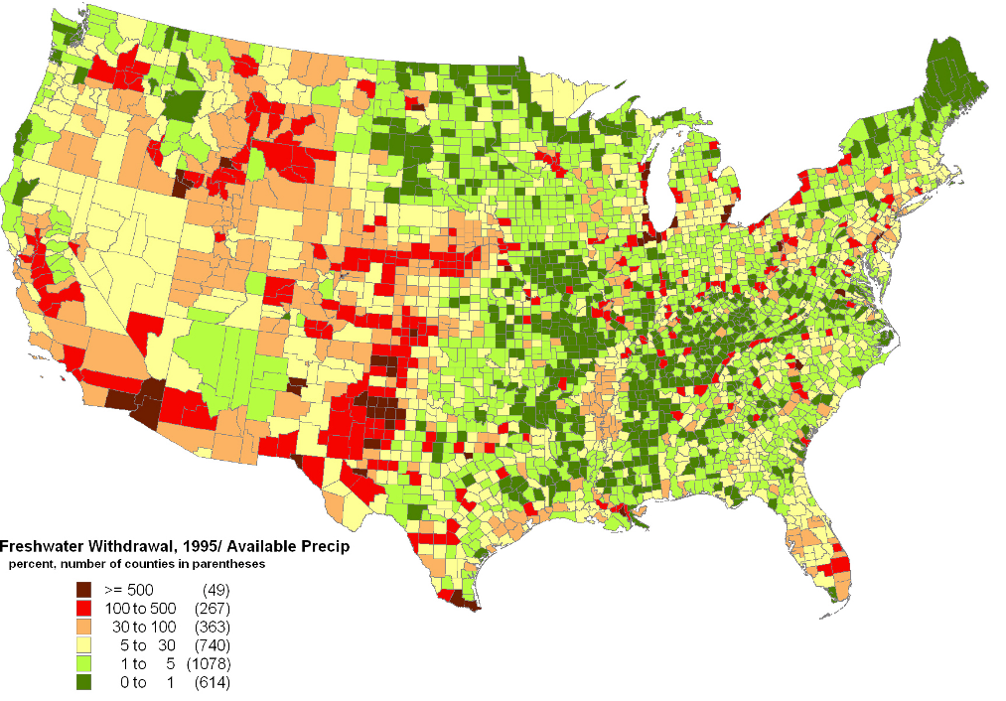
Source: Paper presented at SWRR meeting in Palo Alto, CA, March 2004. Roy, S.B., Ricci, P.F., Summers, K.V., Chung, C.-F. and Goldstein, R.A. Published as Evaluation of the Sustainability of Water Withdrawals in the United States, 1995-2025; Journal of the American Water Resources Association, 41(5):1091-1108, October 2005
We welcome your participation in and support of the Sustainable Water Resources Roundtable. Further information on SWRR can be found at http://acwi.gov/swrr Contact David Berry at davidberry@aol.com or Tim Smith at etsmithsiri@aol.com

