5/19/2006
Shenandoah Valley-VA-WV-Mid-Atlantic Region Pilot Project
Document URL: http://web-services.gov/ ShenandoahValleyVAWVMidAtlanticPilot.doc
Wiki Page: http://colab.cim3.net/cgi-bin/wiki.pl?ShenandoahValleyVAWVMidAtlantic

Background:
May 5, 2005, Tom Christoffel, Senior Planner Northern Shenandoah Valley Regional Commission (NSVRC), submitted a draft proposal entitled “Sub-State Regions for National Analysis” to the National Infrastructure for Community Statistics Community of Practice (NICS CoP) of which he was a member. See other side of this page.

February 21, 2006, Collaborative Expedition Workshop #48, Networking the Geospatial and DRM Communities: Piloting Profiles, Metadata Harmonization, and Semantic Interoperability, Tom Christoffel and US EPA Region 3 Participating, it was decided to network several CoPs around this proposal and region.

March 21-23, 2006, USGS Workshop on Scientific Information Management was used as a first opportunity to network several CoPs around this proposal and region using Semantic Wiki technology from the SICoP/SWIM Work Group.

March 27, 2006, Informal Presentation to Shenandoah Valley CoP in Woodstock, Virginia, where the following framework was recommended: Historical Perspective using animations; Baseline and Projections based on the integration of multiple data sources and the use of advanced visualization techniques like flyovers; and Sensor Networks for real-time data at selected locations to identify emergency conditions, etc.

April 12, 2006, EPA presentation on this new pilot to NARC, NICS, and SHEN CoP members with the following suggested action items: NARC and SHEN reviews the NICS Draft White Paper excerpts and provides comments; NARC provides involvement of 2-3 additional NARC regions in the Mid-Atlantic Region; SHEN provides boundaries for those additional NARC regions; and NICS or Susan Turnbull hosts SHEN CoP Workshop in Fall to discuss this pilot.

April 25, 2006, Discussion at the Sustainable Water Resources Roundtable Meeting about coordination of this pilot with their indicators work for CEQ and the KNII.

Pilot Collaboration:
National Infrastructure for Community Statistics, National Association of Regional Councils, EPA Data Architecture for DRM 2.0, Great Valley Water-Resources Science Forum, and Sustainable Water Resources Roundtable

Contacts:
Tom Christoffel, AICP, Senior Planner Northern Shenandoah Valley Regional Commission (NSVRC), 103 East Sixth Street, Front Royal, Virginia (VA) 22630-3499, Phone: 540-636-8800, mailto:tchrist@shentel.net, http://www.lfpdc7.state.va.us/
Brand Niemann, US EPA, http://colab.cim3.net/cgi-bin/wiki.pl?BrandNiemann
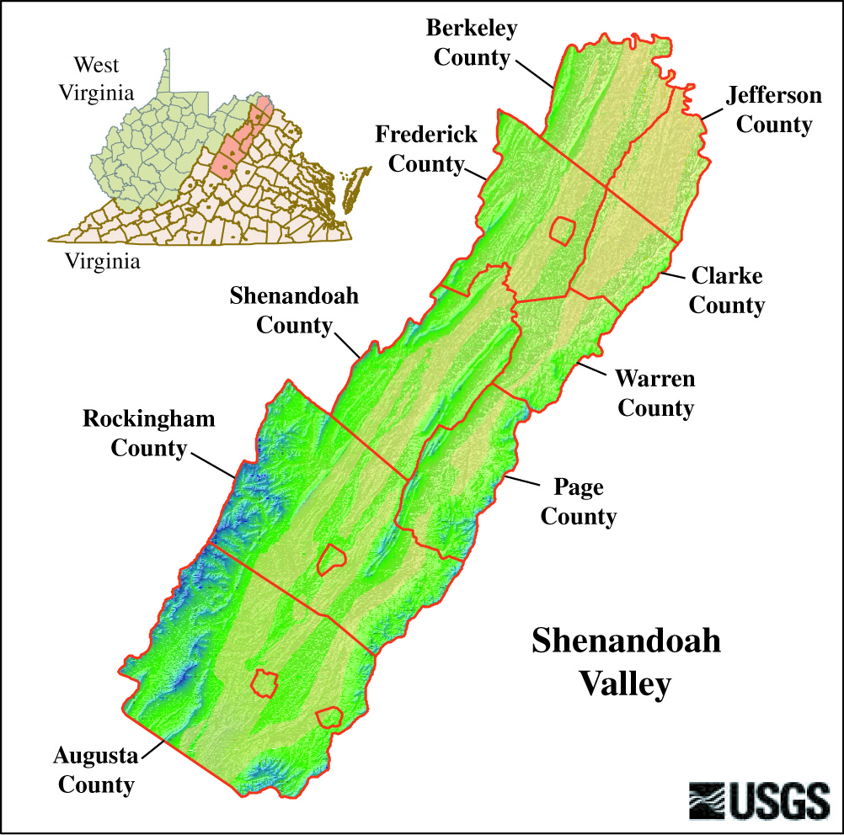

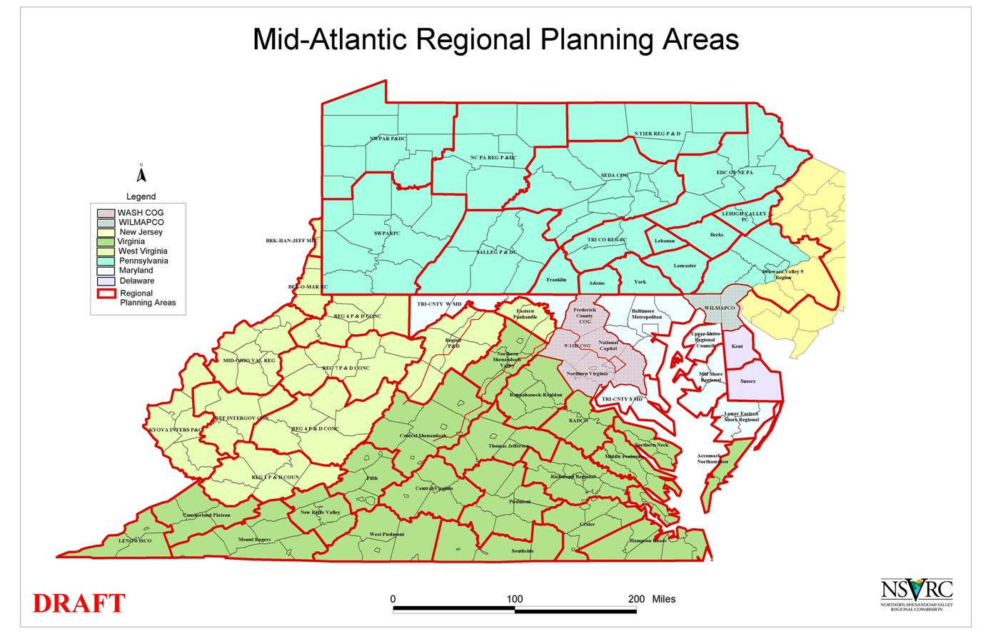
Sustainable Water Resources Roundtable Preliminary Report: September 30, 2005
Original Report at: http://water.usgs.gov/wicp/acwi/swrr/
DRM 2.0 - Compliant Semantic Wiki Version at: http://web-services.gov/lpBin22/lpext.dll/Folder16/Infobase1/3?fn=main-j.htm&f=templates&2.0
Created by Brand Niemann, May 1, 2006

Table of Contents
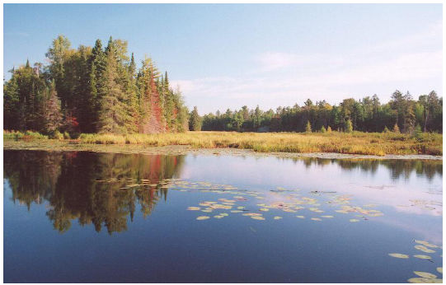

Table of Contents
Acknowledgements
Executive Summary
1. Introduction
2. Conceptual Foundations for the Sustainable Water Resources Roundtable
3. Selecting Sustainability Indicators
4. The SWRR Indicators (see next page)
5. Research Needs for Sustainable Water Resources Management: The SWRR Ann Arbor Meeting on Research
6. Future Work and the Role of Organizations
References
List of Figures
List of Tables
Appendices
Appendix A: The Hydrological Cycle
Appendix B: Terms of Reference for the Sustainable Water Resources Roundtable
Appendix C: Full list of Candidate Indicators
The SWRR framework of indicators encompasses the following set of categories/subcategories for key indicators. For each of the 17 candidate indicators, we provide the following information:

• What is the indicator?
• Why is this indicator important?
• What does the indicator show?
• Endnotes

A. System capacities, quality and allocation:
1. Gross water availability.
2. Total withdrawals for human uses.
3. Water in the environment.
4. Water quality.
5. Total capacity to store, deliver, and treat the water supply over unit of time.
6. Social and organizational capacity.

B. Consequences of the way we allocate water capacity.
7. Environmental conditions.
8. Resources and conditions.
9. The quality and quantity of water for human uses.
10. Resources withdrawals and use.

C. Effects on people of the conditions and uses of water resources.
11. Human conditions.

D. Important factors affecting water resources.
12. Land use.
13. Residual flows.
14. Social and economic processes.
15. Ecosystem (environmental) processes.

E. Composite sustainability assessment.
16. Water use sustainability.
17. Water quality sustainability.
Chesapeake Bay 2005 Health and Restoration Assessment
Original Report at: http://www.chesapeakebay.net/assess/index.htm
DRM 2.0-Compliant Semantic Wiki Version at: http://web-services.gov/lpBin22/lpext.dll/Folder16/Infobase2/1?fn=main-j.htm&f=templates&2.0


March 2006 DRAFT
A Report to the Citizens of the Bay Region
http://www.chesapeakebay.net

Introduction
Part One: Ecosystem Health
Part Two: Restoration Efforts
This Report
Data Sources and Background Information

Data Reference Model 2.0 and Metadata Pilot by Brand Niemann, May 9, 2006
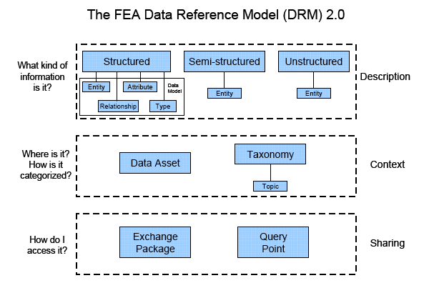
Source: Expanding E-Government, Improved Service Delivery for the American People Using Information Technology, December 2005, pages 2-3.
http://www.whitehouse.gov/omb/budintegration/expanding_egov_2005.pdf
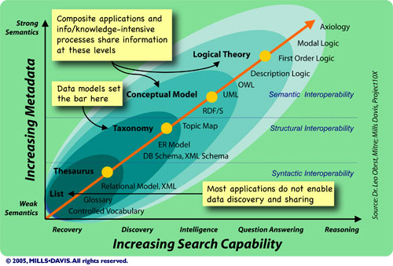

Source: SICoP Module 2 White Paper for Review: "Semantic Wave 2006: Executive Guide to the Business Value of Semantic Technologies", January 6, 2006, page 25, http://web-services.gov/SICOPsemwave2006v1.0.doc

List of Indicators

Part One: Ecosystem Health

1. Summary: 2005 Bay Health Assessment
1.a Water Quality
1.b Habitats and Lower Food Web
1.c Fish and Shellfish

2. Water Quality
2.a Dissolved Oxygen Map and Side View
2.b Dissolved Oxygen
2.c Mid-Channel Water Clarity
2.d Chlorophyll a
2.e Chemical Contaminants
2.f River Flow and Nitrogen Loads Reaching Chesapeake Bay

3. Habitat and Lower Food Web
3.a Bay Grass Abundance
3.b Phytoplankton (Index of Biological Integrity)
3.c Bottom Habitat (Benthic Index of Biotic Integrity)
3.d Tidal Wetlands
List of Indicators (continued)
4. Fish and Shellfish
4.a Blue Crab Abundance
4.b Striped Bass Abundance (Spawning Female Biomass)
4.c Native Oyster Abundance (Biomass)
4.d Shad Returning to the Susquehanna River
4.e Menhaden
5. Assessing the Health of the Bay Over Multiple Years
5.a Three Year Dissolved Oxygen Standards Attainment
5.b Three Year SAV-Based Clarity Standards Attainment
5.c Three Year Chlorophyll a Guidance Attainment
6. Goals

Part Two: Restoration Efforts
7. Summary: 2005 Bay Restoration Efforts
7a. Reducing Pollution Summary
7.b Restoring Habitats Summary
7.c Managing Fisheries Summary
7.d Protecting Watersheds Summary
7.e Fostering Stewardship Summary

8. Reducing Pollution
8.a Wastewater Pollution Controls
8.b Agricultural Pollution Controls
8.c Urban Suburban Lands
8.d Air Pollution

9. Restoring Habitats
9.a Bay Grasses Planted
9.b Wetlands Restoration
9.c Opening Rivers to Migratory Fish
9.d Oyster Reef Restored

10. Managing Fisheries
10.a Blue Crabs
10.b Oysters
10.c Striped Bass
10.d Shad
10.e Menhaden

11. Protecting Watersheds
11.a Riparian Forest Buffers Planted
11.b Watershed Management Plans Developed
11.c Watershed Land Preservation
11.d Reducing Sprawl
12. Goals

Collaborative Expedition Workshop #51, Tuesday, June 20, 2006 at NSF
Open Collaboration: Networking Geospatial Information Technology
DRAFT AGENDA, May 19, 2006

8:30am - Check-in and Coffee
8:40am - Welcome and Overview
Susan Turnbull, Todd Pehle, Tom Christoffel, and Brand Niemann

9:00am - Introductions: What are your interests in light of the workshop purpose?

Keynote:
9:30am - Geospatial Line of Business and Task Force, Ivan DeLoatch,
FGDC Staff Director
What's New:
10:00 - W3C Geo XG and Geospatial Semantic Web Interoperability Experiment (GSW IE) Report, Joshua Lieberman, Traverse Technologies
10:15 - DHS Geospatial Data Model, Michael Lee, Geospatial Liaison Department of Homeland Security, Geospatial Management Office

10:30 - BREAK

Featured Demonstrations and Questions:
10:45- Google Earth and Maps, Michael Jones, CTO, Google (invited)
11:30 - Mashup Beyond Google Maps, Harry Chen's Geospatial Semantic Web Blog

12 - Networking Lunch (on your own)

Featured Presentations and Questions:
1 - Interoperability Among Geospatial Ontologies by Jerry Hobbs, ISI
1:45 - Geospatial Ontologies Workshop, June 21-22, 2006, Overview, Todd Pehle, Northrup Grumman IT TASC
2:15 Semantic Wiki for Collaborative Development and Use of Geospatial
Ontologies, Conor Shankey, CEO, Visual Knowledge

3 - BREAK

3:15 – Geospatial Units and Cyber-Infrastructure for the Shenandoah Valley - Mid-Atlantic Region Pilot Project, James Wilson, Old Dominion University, and Tom Christoffel, Senior Planner Northern Shenandoah Valley Regional Commission

3:45 - Discussion of Next Steps

4:30pm - ADJOURN

