

Semantic Interoperability Community of Practice (SICoP)
White Paper Series Module 1

Introducing Semantic Technologies and the Vision of the Semantic Web

Created on March 29th, 2004
Version 1
THIRD DRAFT (In-progress)

SICoP White Paper Series Module 1

Introducing Semantic Technologies and
the Vision of the Semantic Web

SICoP Co-chairs:

Dr. Rick (Rodler F.) Morris, Army CIO
Dr. Brand Niemann, EPA
Nancy G. Faget, Army Corps of Engineers

Managing Editor:

Jie-hong Morrison, Computer Technologies Consultants, Inc.

Authors:

Irene Polikoff, TopQuadrant Inc
Ken Fromm, Loomia Inc.
Dr. Leo Obrst, The MITRE Corporation
Mike Daconta, Smart Data Associates
Richard Murphy
Joram Borenstein, Unicorn Solutions, Inc.
Nancy G. Faget, Army Corps of Engineers
Jie-hong Morrison, Computer Technologies Consultants, Inc.

We would also like to thank the following individuals who have contributed invaluable materials and insights:

Norma Draper, Northrop Grumman Mission Systems
Jeff Pollock, Network Inference
Ralph Hodgson, TopQuadrant

TABLE OF CONTENTS

1.0 Executive Summary 5
2.0 Introduction to Semantic Computing 10
3.0 The Vision of the Semantic Web 14
3.1 What the Semantic Web Is and Is Not 16
3.2 The Semantic Web vs. Semantic Technologies 18
4.0 Key Concepts 19
4.1 Smarter Data, Flexible Associations 19
4.2 Forms of Data 21
4.3 Metadata 22
4.3.1 Standards 24
4.4 Semantic Models (Taxonomies and Ontologies) 25
4.4.1 Standards 32
4.5 Logics, Pragmatics, and Intelligent Reasoning Error! Bookmark not defined.
4.6 Semantic Continuum Error! Bookmark not defined.
5.0 Core Building Blocks 32
5.1 Semantic Web Wedding Cake 32
5.2 Languages 34
5.2.1 XML (eXtensible Markup Language) 34
5.2.2 RDF (Resource Description Framework) 34
5.2.3 OWL (Web Ontology Language) 36
5.3 Schemas 37
5.3.1 XML Schema 37
5.3.2 RDF Schema 37
5.3.3 Schemas Examples 37
6.0 Semantic Tools and Components 38
6.1 Publishing Tools (Metadata creation) 39
6.2 Modeling Tools (Ontology creation) 39
6.3 Data Mappers (Ontology population) 40
6.4 Data Stores 41
6.5 Inference Engines 42
6.6 Other Components 44
7.0 Applications of Semantic Technologies 45
7.1 Semantic Web Services 45
7.2 Semantic Interoperability 46
7.3 Intelligent Search 47
7.3.1 Intelligent Search 48
7.4 Introduction to Module 2: Exploring the Business Value of Semantic Interoperability in the Federal Government 48
8.0 Roadmap to the Semantic Web 50
8.1 A High Level Roadmap 51
8.2 Where your agency lies on the roadmap to the Semantic Web 51
8.3 Introduction to Module 3: Implementing the Semantic Web 52
9.0 References 53
Appendix A: Organizational Charter 54
A.1 Semantic Interoperability Community of Practice (SiCoP) 54
Appendix B: Definitions and Terms 55
Appendix C: Case Studies 60

TABLE OF FIGURES
Figure 1 Semantic Computing Capabilities Assessment Error! Bookmark not defined.
Figure 2 Three Dimensions of Semantic Computing Error! Bookmark not defined.
Figure 3 Vision of the Semantic Web Error! Bookmark not defined.
Figure 4: Semantic Web Subway Map 20
Figure 5: Data Structure Continuum 21
Figure 6 The Ontology Spectrum 26
Figure 7: Example of a Taxonomy for e-Government 28
Figure 8 Strong Taxonomy: Subclass is a Subsumption Relation 28
Figure 9: Part of the FEA Capabilities Manager Ontology Model 31
Figure 10: Europe Media Monitor 61
Figure 11: German Environmental Information Network Portal 62
Figure 12: GEIN Architecture 63
Figure 13: Aviation Security – Passenger Threat Analysis 64
Figure 14: Semantic Design Assistant 65
Figure 15: Dynamically generated Form for collecting clinical trial data 66
Figure 16: Semantic ontology model and semantic mappings 68

Executive Summary
“Semantic Technologies are driving the next generation
of the Web, the Semantic Web, a machine-readable web of smart data and automated services that amplify the Web far beyond current capabilities.”
"Semantic Technologies for eGov", White House Conference Center, Monday, September 8th, 2003

Children are extremely susceptible to environmental contaminants, much more so than adults, and so the public is rightly concerned about the quality of their environment and its effects on our children. The increased public awareness of environmental dangers and the accessibility of the Internet and other information technologies have conditioned both the public and various government officials to expect up-to-date information regarding public health and the environment, all presented in a way that adequately assesses the public health risks environmental contaminants pose to our children.

Unfortunately, the current state of the information sharing between agencies, institutions, and other third parties as well as the level of tools to intelligently query, infer, and reason over the amassed data do not adequately meet these expectations. Public health and environmental data comes from many sources, many of which are not linked together. Vocabularies and data formats are unfamiliar and inconsistent especially when crossing organizational boundaries (public health vs. environmental bodies). Data structures and the relationships between data values are difficult to reconcile from data set to data set. Finding, assembling, and normalizing this data is time consuming and prone to errors and currently, no tools exist to make intelligent queries or reasonable inferences across this data.

In fairness, tremendous strides have been made in physically connecting computers and exchanging large amounts of data in highly reliable and highly secure manners. A number of reputable vendors offer proven middleware solutions that can connect a wide variety of databases, applications, networks, and computers. But while these technologies will connect applications and various silos of information and enable them to move data around, they do not address the real challenge in connecting information systems – that of enabling disparate systems to make effective operational use of the information being queried or exchanged (without having to overhaul IT systems or fundamentally change the way organizations operate).

It is this logical integration of information – understanding what the information means and how it is used in one system versus what it means and how it is used in another – that is one of the larger impediments to making rational use of the available data on public health and the environment. The goal is not just to connect systems but to make the information within the data sets interoperable and accessible for both machine processing and human understanding.

In an attempt to provide solutions to redress these issues, a pilot is underway in the EPA to make use of semantic technologies to connect information from the Center for Disease Control and Prevention (CDC) and the Environmental Protection Agency (EPA), as well as from their state partners, in ways that can move us further down the path to answering the public’s question: Is my child safe from environmental toxins?

This story is but just one example of the tremendous IT challenges that the federal government faces. The complexity of the federal government, the size of its data stores, and its interconnected nature to other government state, local, and tribal agencies as well as, increasingly, to private enterprise and NGOs has placed increasing pressure on finding faster, cheaper, and more reliable methods of connecting systems, applications, and data. Connecting these islands of information within and between government agencies and third parties is seen as a key step to improving government services, streamlining finances and logistics, increasing the reliable operation of complex machinery, advancing people’s health and welfare, enabling net-centric defense capabilities, and ensuring the safety of our nation.

The notion of widespread information interoperability is one of the early benefits that many researchers, thought-leaders, and practitioners see for semantic technologies but by no means is it the only benefit. Building on top of this notion of smarter more accessible and autonomic information, intelligent search, intelligent reasoning, and truly adaptive computing are seen as coming ever closer to reaching reality.

Although pioneers in the field of semantic computing have been at work for years, the approval of two new protocols by the World Wide Web Consortium (W3C) early in 2004 marked an important milestone in the commercialization of semantic technologies, also spurring development towards the goal of the Semantic Web. In the words of the W3C, “The goal of the Semantic Web initiative is as broad as that of the Web: to create a universal medium for the exchange of data.” “The Semantic Web is a vision: the idea of having data on the web defined and linked in ways so that it can be used by machines -- not just for display purposes -- but for automation, integration and reuse of data across various applications, and thus fully harness the power of information semantics.”

These new capabilities in information technology will not come without significant work and investment by early pioneers. Semantic computing is like moving from hierarchical databases to relational databases or moving from procedural programming techniques to object-oriented approaches. It will take a bit of time for people to understand the nuances and architectures of semantics-based approaches. But as people grasp the full power of these new technologies and approaches, a first generation of innovations will produce impressive results for a number of existing IT problem areas. Successive innovations will ultimately lead to dramatic new capabilities that fundamentally change the way we share and exchange information across users, systems, and networks. When taken within a multi-year view, these innovations hold as much promise to define a new wave in computing much as did the mainframe, the IBM 360, the PC, the network, and the first version of the World Wide Web.

Figure 1 contains a breakdown of the key capabilities of semantic computingand the resulting impact for stakeholders.

Capability | Purpose | Stakeholders | Impact | Take-away
Integration of Disparate Heterogeneous Data | Reduce integration complexity from n² to n | Data and Metadata Architects | Reduced cost to integrate heterogeneous data sources | Increased interoperability at improved speed and reduced cost
Adaptive and Autonomic Computing | Provides the ability for applications to diagnose and forecast system administration | System Administrators | Increased reliability and reduced cost through self diagnostics and planning of  complex systems | Reduced cost to maintain systems with limited human intervention
Intelligent Search | Provides context sensitive search on defined terms and more personalized filtering | Citizens and Cognitive Agents | Reduced human filtering of search results | Higher search accuracy increases confidence and productivity
Intelligent Reasoning | Support machine inference based on smart data | Applications and Cognitive Agents | Reduced requirements for embedding logic in applications | Reduced application development cost
Figure 1: Computing Capabilities Assessment
This set of white papers is the combined effort of KM.Gov (www.km.gov) and the Semantics Interoperability Community of Practice (SICoP), two working groups of the Federal CIO Council. (The SICoP charter is contained in Appendix A.) The purpose of the white papers is to introduce semantic technologies and the vision of the Semantic Web. They will make the case that these technologies are substantial progressions in information theory and not yet-another-silver-bullet technology promising to cure all IT ills.

The papers are written for agency executives, enterprise architects, IT professionals, program managers, and others within federal, state, and local agencies with responsibilities for data management, information management, and knowledge management. The white papers are presented in a modular format so that three modules can stand-alone or be incorporated as a whole to detail a complete approach to adopting semantic technologies to resolve inter-agency and cross-agency challenges or to take advantage of the emerging Semantic Web.

Specifically, these white papers will pay particular attention to the topics of information interoperability and intelligent search, two areas believed to have the greatest near-term benefits for agencies and government partners alike. They will also discuss the state and current use of protocols, schemas, and tools that will pave the road towards the Semantic Web. Lastly, they provide guidance in planning and implementing semantic-based projects and lay out steps to help government agencies do their part to operationalize the Semantic Web.

Module 1: Introducing Semantic Technologies and the Vision of the Semantic Web
- This module is intended to introduce and educate executives about the principles and capabilities of semantic technologies and the goals of the Semantic Web. It will provide a basic primer on the field of semantics along with information on the emerging standards, schemas, and tools that move semantic concepts out of the labs and into real-world use. The module will provide details on a wide range of semantics-based projects with specific capabilities annotated and described. Finally, it will describe a high level roadmap to provide general guidelines on how to take advantage of these new technologies.
- Takeaway: Readers will gain a better understanding of semantic technologies, gain exposure to some of the promises of the next generation of the World Wide Web, and see how new approaches to dealing with digital information can be used to solve difficult information-sharing problems.

Module 2: Exploring the Business Value of Semantic Interoperability
The second module is designed to examine the present information environment and pitfalls of operating in a disparate, un-integrated world. The federal government and its stakeholders and citizens expect an evolution in managing and creating intelligent data and technologies to capitalize on being able to connect the dots.
- Takeaway: Readers will gain new insights into assembling scenarios and business use cases for the use of semantic technologies as ways to confront difficult information challenges and provide better citizen-centered services.

Module 3: Implementing the Semantic Web
The last module provides the steps and implementation recommendations, based on which an agency can gauge its progress and schedule future projects to that take advantage of this new technology.
- Takeaway: Readers will learn about new efforts and communities that are progressing in their Semantic Web implementation.

Introduction to Semantic Computing
"You keep using that word. I do not think it means what you think it means."
Inigo Montoya
The challenge in sharing and making sense of information contained within federal, state, and local agencies – whether it is in the context of law enforcement, marine transportation, environmental protection, child support, public health, or homeland security, to name just a few – is a daunting one. Agencies can expend a large amount of time and money creating common vocabulary standards and then systems integrators can laboriously work to get each data store owner to adopt and adhere to these standards. Unfortunately, this approach (if it even reaches the point of creating a standard vocabulary) quickly devolves into problems and delays in implementation. The real challenge in sharing information among disparate sources is not a creating a common language but in addressing the organizational and cultural differences that all too often prevent adherence or adaptation to a particular vocabulary standard.

The reason is because structural and cultural differences embedded within organizational IT systems reflect their unique missions, hierarchies, vocabularies, work flow, and work patterns. “Price” may appear in one system; “cost” in another. A “Captain” in the Army is equivalent to a “Lieutenant” in the Navy; a “Captain” in the Navy is a “Colonel” in the Army. (These differences extend beyond the armed forces. Many state police organizations use ranks modeled after the marines; many public health organization use ranks modeled after the navy; many police and investigative bodies have their own unique command structures.) Similarly, an “informant” in a law enforcement organization might be termed an “information source” in an intelligence organization (the latter of which might include sources other than just people.) These are relatively simple differences in semantics. The more complex and abstract a concept, the more differences there are in syntax, structure, and most importantly, meaning.

These examples are relatively simple illustrations of semantic conflicts. More complex conflicts require more extensive semantics-based solutions of one sort or another. For instance, different systems may use of the same term for different concepts or stages within a value chain. The term “cost” in many systems is a reference to the price for which a consumer purchases an item, and yet “cost” might simultaneously be used in other systems as a reference to the price at which a supplier might sell an item to a distributor.

Meanings also change contextually over time. Personnel changes, organizational history, organizational politics/culture, and corporate-driven mandates are just several of the forces which could alter meanings over time. (It goes without saying that terminologies also frequently change for much the same reasons.) Figure 2 shows the types of semantic conflicts that can found when comparing various data sets.

Type | Description
Data Type | Different primitive or abstract types for the same information.
Labeling | Synonyms/antonyms have different text labels.
Aggregation (structure and cardinality) | Different conceptions about the relationships among concepts in similar data sets or alternatively, collections or constraints have been modeled differently for the same information.
Generalization | Different abstractions used to model the same domain.
Value Representation | Different choices are made about what concepts are made explicit.
Impedance Mismatch | Fundamentally different data representations are used.
Naming | Synonyms/antonyms exist in the same/similar concept instance values.
Scaling and Unit | Different units of measures with incompatible scales.
Confounding | Similar concepts with different definitions.
Domain | Fundamental incompatibilities in underlying domains.
Integrity | Disparity among the integrity constraints.
Figure 1: Types of Semantic Conflicts
These issues are becoming increasingly apparent within both corporate enterprises and government agencies. With messaging and transport solutions becoming increasing commonplace and commoditized and with XML becoming a basic building block for exchanging data, it is readily apparent to most that these steps only partially complete the picture. Additional technologies are needed in order to effectively rationalize the processes and information sets between and among organizations – without requiring point-to-point data and terminology mappings, processes that are both time and personnel intensive.

The problem is not only within and between organizations and their business or operating partners; it also exists in various forms on the World Wide Web. Information on the Web is becoming increasingly fragmented and varied in terms of appropriateness, timeliness, and trustworthiness. Search engines are wonderful tools but, increasingly, fault lines are appearing whether that be in doubts about completeness of search; growing use of script-like search commands such as “filetype”; or the rise in search engines focusing on specific types of data or media such as RSS feeds, images, or music. Federal and state governments have expended enormous resources in making information available to the public online and yet the current state of the World Wide Web has placed limiting factors on the accessibility and applicability of this information.

Fortunately, just as Internet and World Wide Web protocols helped connect vast amounts of information for human consumption, new approaches are emerging that help connect equal or greater amounts of information for machine manipulation and processing. These innovations will simplify information interoperability, provide better information relevance and confidence within the enterprise and on the World Wide Web, and, over time, pave the way for new intelligent brokering and knowledge reasoning capabilities across the field of collected information.

New software protocols recently approved by the World Wide Web consortium (W3C) -- an international standards body directed by Tim Berners-Lee, the creator of the World Wide Web -- are making it possible to represent information in ways that make information smarter and more autonomous and, therefore, far more accessible and adaptive. These standards -- in conjunction with new tools and infrastructure components built in support of them -- are driving the development of adaptive computing within the enterprise as well as the growth of the next generation of the web, called the Semantic Web.

The vision of the Semantic Web is to extend the current web by enriching the information transmitted and accessed over the Internet with well-defined meaning, thus enabling computers to do more of the work in assembling and processing data in order to turn it into highly relevant information and knowledge. In other words, the initiatives underlying the Semantic Web establish a set of protocols and technologies that promise to improve the categorization and association of data thereby enhancing the ability to create relationships and generate inferences between diverse systems and data.

For example, asking a librarian for a map of Gettysburg at the time of the Civil War will typically lead to books containing maps from that era. A search in a search engine, however, will include many results with text concerning maps of Gettysburg but these may or may not contain actual maps. Additionally, citations may be missed that did not match the exact form of date specified in the search string. Likewise, a search for networking security events in the Washington, D.C. area might miss an anti-spam talk in McLean, VA because the relationship between networking security and anti-spam and the concept of McLean, VA being in the Washington, D.C. area are not yet fundamental associations within the realm of the World Wide Web. The steps taken by the W3C are targeted towards filling this gap in data association and collective understanding.

The W3C efforts in this area have made extensive use of knowledge management constructs resulting in the creation of two new knowledge representation markup languages – RDF (Resource Description Framework) and OWL (Web Ontology Language). RDF provides a protocol for establishing relationships between data whereas OWL enhances RDF with the ability to specify business rules and constraints on different data elements and their relationships to each other.

Building on XML, these languages are beginning to be woven into the fabric of web-based tools and the World Wide Web. Figure 3 illustrates how the W3C’s standards address information interoperability within the spectrum of semantic computing.I

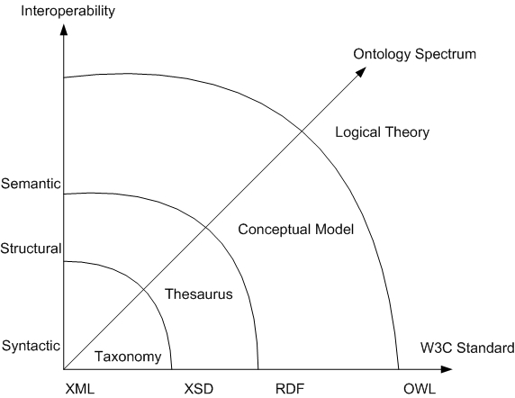
Figure 3: Three Dimensions of Semantic Computing

W3C has also defined initial architectures and logic required to implement semantic solutions alongside existing applications and data sets. A wide range of companies have adopted semantic approaches and the vision of the Semantic Web and are actively pursuing technology strategies that advance the field further. These technologies and approaches are being used today by a growing number of early adopters. Initial applications clearly demonstrate that they can be implemented incrementally and can deliver ROI-supported value. Several government agencies are planning or beginning pilot programs that use these newly approved standards to address complex challenges within narrowly defined problem spaces.

The Vision of the Semantic Web
"The Semantic Web is an extension of the current web in which information is given well-defined meaning, better enabling computers and people to work in cooperation."
Tim Berners-Lee, James Hendler, Ora Lassila

According to the World Wide Web Consortium (W3C), the Web can reach its full potential only if it becomes a place where data can be shared, processed, and understood by automated tools as well as by people. For the Web to scale, tomorrow's programs must be able to share, process, and understand data even when these programs have been designed independently from each other.

Still in its definition stage, the term Semantic Web is perhaps new to many people, even to those within IT circles. But the problems it aims to address are what we have been struggling to solve for decades – issues such as information overload, stovepipe systems, and poor content aggregation. The fundamental roots to these problems are the lack of semantic definitions in individual systems, the lack of semantic integration between data, and the lack of semantic interoperability across disparate systems. The Semantic Web extends beyond the capabilities of the current Web and existing information technologies, enabling more effective collaborations and smarter decision-making. It is an aggregation of intelligent websites and data stores accessible by an array of semantic technologies, conceptual frameworks, and well-understood contracts of interaction to allow machines to do more of the work to respond to our service requests -- whether that be taking on rote search processes, providing better information relevance and confidence, or performing intelligent reasoning or brokering.

Figure 4shows a conceptual stack for the Semantic Web, illustrating how semantic technologies can be added to extend the capabilities of the current web.

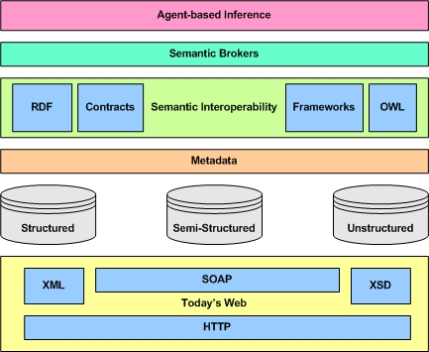
Figure 4: Semantic Web Conceptual Stack

The steps to reach this state, however, are not ones that are likely to be accomplished with a few short years. Certainly rapid progress will be made on some ends, just as numerous websites appeared soon after the introduction of low-cost/no-cost web servers and free graphical browsers. But the progression in the development of websites moved relatively chaotically over the course of a half dozen years – starting from an ad-hoc set of scripting languages, low-end tools, and custom-built server components and steadily progressing to a relatively unified set of core languages, application servers, content management systems, e-commerce engines, asp services, and other enterprise-worthy components and offerings. The growth of the Semantic Web is likely to go through similar exercise in market dynamics. Although the business models of a connected world are better understood and the level of awareness within current IT leaders of emerging technologies more greatly heightened, there will still be a significant time lag until many of the pieces in the vision are assembled.

What the Semantic Web Is and Is Not

- The Semantic Web is not a new and distinct set of websites.
The Semantic Web is an extension of the current World Wide Web, not a separate set of new and distinct websites. It builds on the current World Wide Web constructs and topology but adds further capabilities by defining machine-processable data and relationship standards along with richer semantic associations. Existing sites may use these constructs to describe information within web pages in manners more readily accessible by outside processes such as search engines, spider searching technology, and parsing scripts. Additionally, new data stores, including many databases, can now be exposed and made available to machine processing which can do the heavy lifting to federate queries and consolidate results across multiple forms of syntax, structure, and semantics. The protocols underlying the Semantic Web are meant to be transparent to existing technologies that support the current World Wide Web.

- The Semantic Web is not being constructed with just human accessibility in mind.
The current Web mainly relies on text markup and data link protocols for structuring and interconnecting information at a very coarse level. The protocols are primarily used to describe and link documents in the forms presentable for human consumption (but which have useful hooks for first-order machine searching and aggregation). Semantic Web protocols define and connect information at a much more refined level. Meanings are expressed in formats understood and processed more easily by machines in ways that can bridge structural and semantic differences within data stores. This abstraction and increased accessibility means that current web capabilities can be augmented and extended and new powerful ones introduced.

- The Semantic Web is not built upon radical untested information theories.
The emergence of the Semantic Web is a natural progression in accredited information theories, borrowing concepts from the knowledge representation and knowledge management worlds as well as from revised thinking within the World Wide Web community. The newly approved protocols have lineages that go back many years and embody the ideas of a great number of skilled practitioners in computer languages, information theory, database management, model-based design approaches, and description logics. These concepts have been proven within a number of real-world situations although the unifying set of standards from the W3C promises to accelerate and broaden adoption within the enterprise and on the Web.

With respect to issues about knowledge representation and its yet-to-be-fulfilled promise, a look at history shows numerous examples of a unifying standard providing critical momentum for acceptance of a concept. HTML was derived from SGML, an only mildly popular text markup-language, and yet HTML went on to cause a sea change in the use of information technology. Many in the field point to the long acceptance timeframes for both object-oriented programming and conceptual-to-physical programming models. According to Ralph Hodgson, “knowledge representation is a fundamental discipline that now has an infrastructure and a set of supporting standards to move it out of the labs and into real-world use.”

- The Semantic Web is not a drastic departure from current data modeling concepts.
According to Tim Berners-Lee, the Semantic Web data model is very directly connected with the model of relational databases. “A relational database consists of tables, which consist of rows, or records. Each record consists of a set of fields. The record is nothing but the content of its fields, just as an RDF node is nothing but the connections: the property values. The mapping is very direct -- a record is an RDF node; the field (column) name is RDF propertyType; and the record field (table cell) is a value. Indeed, one of the main driving forces for the Semantic Web, has always been the expression, on the Web, of the vast amount of relational database information in a way that can be processed by machines." That said, the Semantic Web is a much more expressive, comprehensive, and powerful form of data modeling. It builds on traditional data modeling techniques – be they entity-relation modeling or another form – and transform them into much more powerful ways for expressing rich relationships in a more thoroughly understandable manner.

- The Semantic Web is not some magical piece of artificial intelligence
The concept of machine-understandable documents does not imply some form of magical artificial intelligence which allows machines to comprehend human mumblings. It only indicates a machine's ability to solve a well-defined problem by performing well-defined operations on existing well-defined data.. Current search engines perform capabilities that would have been magical 20 years ago but that we recognize now as being the result of IP protocols, HTML, the concept of websites, web pages, links, graphical browsers, innovative search and ranking algorithms, and, of course, a large number of incredibly fast servers and equally large and fast disk storage arrays. Semantic Web capabilities will likewise be the result of a logical series of interconnected progressions in information technology and knowledge representation formed around a common base of standards and approaches.

- The Semantic Web is not an existing entity, ready for users to make use of it.
The Semantic Web currently exists as a vision, albeit a promising and captivating one. Similar to the current Web, the Semantic Web will be formed through a combination of open standard and proprietary protocols, frameworks, technologies, and services. The W3W-approved standards -- XML, RDF, and OWL -- form the base protocols. New data schemas and contract mechanisms, built using these new protocols, will arise around communities of interest, industry, and intent; some will be designed carefully by experienced data architects and formally recognized by established standards bodies; others will appear from out of nowhere and gain widespread acceptance overnight. A host of new technologies and services will appear such as semantically-aware content publishing tools; context modeling tools; mediation, inference, and reputing engines; data-cleansing and thesaurus services; and new authentication and verification components. Roll out of these technologies, coordination amidst competitive forces, and fulfillment of the vision will take many years, although various elements of it already exist.

The Semantic Web vs. Semantic Technologies
While the full vision of the Semantic Web may be a bit distant, on the near horizon, however, are capabilities that many think will make enterprise software more connectable, interoperable, and adaptable as well as significantly cheaper to maintain. The use of semantic approaches in combination with the existing and emerging semantics-based schemas and tools can bring immediate and/or near-term benefits to many corporate enterprise and government agency IT initiatives.

Semantic interoperability represents a more limited or constrained subset of the vision of the Semantic Web. Significant returns, however, can still be gained by using semantic-based tools to arbitrate and mediate the structures, meanings, and contexts within relatively confined and well-understood domains for specific goals related to information sharing and information interoperability. In other words, semantic interoperability addresses a more discrete problem set with more clearly defined endpoints.

Semantic technologies can also provide a loosely connected overlay on top of existing Web service and XML frameworks, which in turn can offer greater adaptive capabilities than those currently available. They can also make immediate inroads in helping with service discovery and reconciliation, as well as negotiation of requests and responses across different vocabularies. Considering the depth and difficulty of issues the federal, state, and local agencies have in these regards, semantic technologies may provide the first flexible, open, and comprehensive solution to date to solve them.

Key Concepts
"A little semantics goes a long way."
James Hendler
Semantic computing is an emerging discipline being formed and shaped as this is written. As such, there are many definitions and interpretations and even a few low-intensity religious wars among thought-leaders and practitioners. That said, the release of RDF and OWL as W3C Recommendations earlier in the year has created a greater commonality in expression.
Because semantic computing makes use of various forms of abstraction and logical expression, it can be difficult to see how the languages provide many of the powerful capabilities expressed in earlier sections. But just as the Internet and World Wide Web is built upon layers of protocols and technologies, so is the Semantic Web. Understanding several key concepts as well as becoming familiar with the core building blocks of the Semantic Web will form a basis for visualizing how higher order tools, components, and technologies can deliver on the promise of smarter and more flexible machine-processable data.

Smarter Data, Flexible Associations
Semantic technologies differ from database schemas, data dictionaries, and controlled vocabularies in an important way. They have been designed with the connectivity in mind allowing different conceptual domains to work together as a network. The “subway map” shown below is a canonical Semantic Web diagram used to show how concepts can be connected or associated with related and/or non-related concepts.

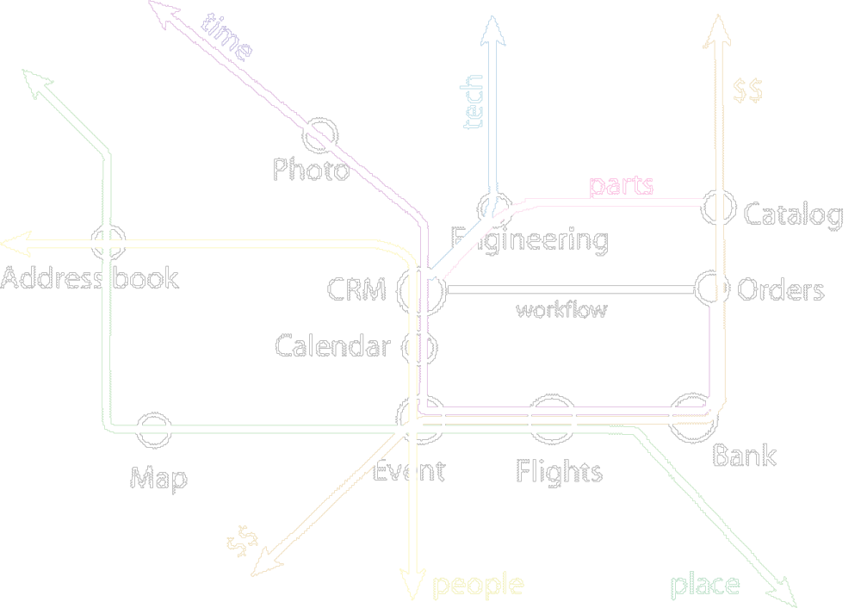
Figure 2: Semantic Web Subway Map

Fundamental concepts can be seen as lines in the diagram, each identifying a particular atomic form of data such as person, price, time, or place. The intersection of one or more of these fundamental concepts forms an entity with some higher level of associated meaning. The concept of an Address Book is a combination of people and addresses (and other contact information). The concept of a Catalog is a collection of parts and prices.
Although simple in nature, the diagram shows that when data is made smarter about what it is – a date or a location, for example – it can then be related in ways that are greater than the specific form or representation of data. In other words, using a search for a map of Gettysburg in 1863 as an example, if the data associated with the map is “smart” (meaning that a date is tagged or identified as a date), then intelligent searches can be made using flexible representations of date that would include a variety of date representations (July 1863; 1863; or even 1860s, for example) as well as associations with concepts (such as “Battle of Gettysburg” or “Civil War” which in and of themselves have a date ranges associated with them -- July 1-3, 1963 and April 1861 to April 1865, respectively).
Likewise, in the example of the anti-spam seminar in Maclean, VA, the concept of place carries with it associations that can put cities (Maclean, VA) within larger more flexible boundary areas (Washington, D.C. area) or connects cities, zip codes, parks, monuments, and other location-based information into a transversable conceptual domain. Intelligent searches using semantic approaches use the combination of knowing the data type (such as a date or a location) along with flexible models of associations (many of which are still in progress) that can bridge between syntaxes, structural representations, or contexts. This idea of “decentralized, but connectable” is fundamental to the vision for the Semantic Web.

Forms of Data
The structure of the data has direct bearing, at least at this point in the evolution of the technology, on what approaches are used in order to provide data with greater ability to describe itself to non-native processes. Enterprise data has many formats and structures. Not only is enterprise data different in internal binary formats, such as the difference between a text file and an object but the information is also organized within a particular structure and representation. The continuum of data structure formats range from very unstructured to very structured.

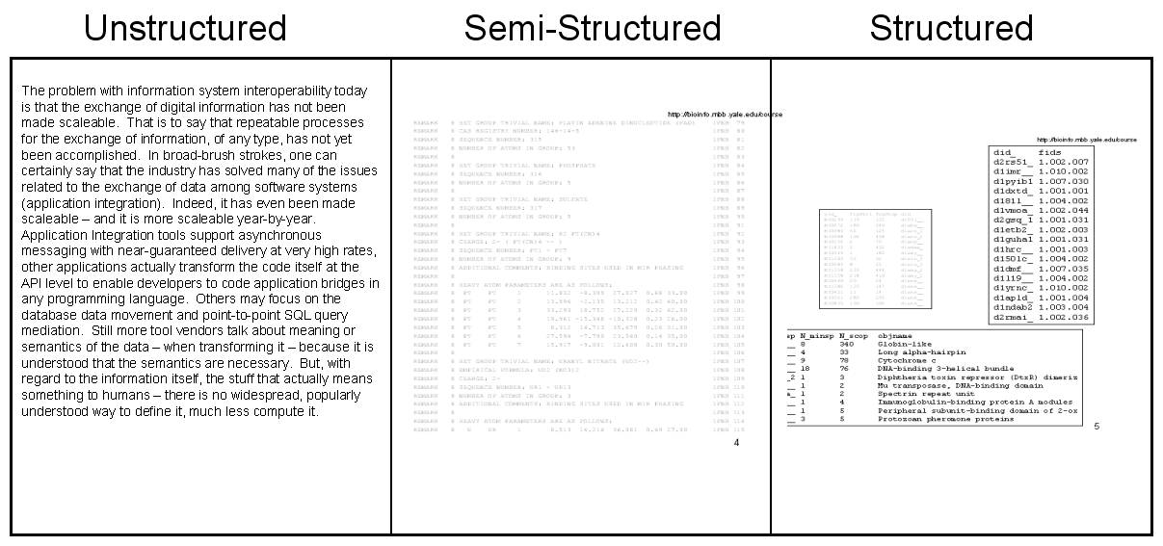
Figure 3: Data Structure Continuum

Structured data is the most organized of this continuum. Typically it will have definitions of metadata such as type, length, table, and constraints. Examples of structured data include RDBMS entity-relationship databases, object models, and to some extent XML documents. Structured data is typically created for machine processing and consumption.

Unstructured data is data that possesses no inherent structure or relationships (aside from certain layout conventions) that can communicate its meaning aside from linear progression or other general form of organization. The canonical example is a document containing free-form text that is arbitrary in presentation and lacking in any meta-data or structure that can be useful in describing its relevance to other documents aside from title and author. Unstructured data is most commonly created for human interpretation although machines (especially in the age of the Internet) are able to do some powerful things with unstructured data.

Semi-structured data is the area in between the two but its boundaries are a little fuzzy in that there are no specific delineations as to where to draw them. For the most part it is acceptable to think of semi-structured data as data that is organized but not explicitly defined in a highly associative way. Traditional examples of semi-structured data include positional text messages, such as EDI, comma separated value (CSV) proprietary data files, PostScript files, or HTML files. Semi-structured data tends to be transitional data (data in transit from one system to another) or data created for a specific processing purpose and not intended as a data store in its own right.

Metadata
One of the earliest forms of supplemental data description is metadata. Metadata is quite literally “data about data.” In its simplest form, metadata can be the label of a data field. Other items can include data type and data length. XML uses the concept of metadata by establishing a protocol for using descriptive terms for data fields and facilitating the creation of logical schemas and namespaces around associated data elements.

A certain amount of metadata is almost a given within the concept of highly structured data sets. Less structured data sets, however, have less inherent metadata and so a growing practice is to provide metadata by tagging data with information about itself, such tags commonly being expressed in XML. Tagging a photo as a “photo” or a map as a “map” adds tremendous value when searching a set of image files. Going further, a photo can be annotated with information concerning the subject of the photo and the date and location it was taken. A map can be categorized as a type of map such as a street map, topographical map, or battle command map and can include a date or location associated with it.

A form of metadata, called meta tags, was included as part of the specification of well-formed Web pages and intended to provide better information about Web page content. Meta tags have fallen out of favor because search engines stopped using the tags due to issues about tricking search engines and concerns about trustworthiness. However, metadata in other forms is making a comeback as a fundamental data association approach within the enterprise and on the Web. New approaches for assessing the reputation or trustworthiness of a data source are also being developed, the combination of which will help increase relevance and improve confidence.

A prime example of the growing popularity of metadata is the dramatic increase in RSS feeds in 2003 and 2004. RSS stands for Real Simple Syndication and is a format for syndicating news and news-like content. Simply put, RSS is a metadata standard (expressed in XML) that is used to describe news headlines and item information (such as author and creation timestamp) within news distribution channels. RSS is a relatively lightweight metadata description form but one that is both multipurpose and extensible. The standard has been in existence for several years, but only since 2003 has it found widespread use, especially within the blogging community. Over 600,000 RSS channels exist within the Web, with thousands being added every day. Some users of this very popular standard include Reuters, W3C News, Slashdot, XML News and others. Increased media coverage and emerging RSS development strategies within technology circles only serve to validate the viability of this technology.

The use of metadata within the enterprise has also grown steadily throughout the last several years, one impetus being the emergence of XML and common metadata schemas. When the form and meaning of metadata are agreed upon, XML is a simple yet powerful tool for making information independent of the system and application it was originally created in or resides in.

Problems arise, however, when organizations or individuals opt to implement metadata in a proprietary manner that goes undocumented and/or insufficiently described for others to understand. This proprietary approach often results in a situation in which basic information becomes unknownand largely inaccessible by anyone other than the data store owners.

Handling inconsistencies and reconciling disparities in terminology, structure, and semantics within metada, however, is one of the early applications for semantic technologies. For instance, when a large Federal agency tried to determine the best manner through which it would be possible to share health and pollutant information brought together into a single Web portal from a variety of sources, they clearly understood the importance of metadata but they faced challenges in bringing various data forms together. The overriding challenge of this project was the consolidation of disparate information in terms of both format and source (including sources not within their control or circle of influence). After analyzing the problem, system designers concluded that the need to reconcile diverging terminological inconsistencies and discrepancies in meaning could be best accomplished by leveraging a metadata management tool equipped for handling such scenarios.

This tool contains at its core capabilities to reconcile semantic conflicts and provide normalized and consistent queries and views of the various data sources. Semantic technologies accelerate the use of metadata within the enterprise for a variety of reasons. These technologies make metadata a) useful, b) easily manageable, and c) reusable. Metadata that can be reused by developers, accessed more than once by users, and guaranteed to be accurate by analysts is metadata which improves performance and productivity. Metadata which is deemed to be relevant for specific needs, as well as something which can contribute to the organization as a whole, is metadata which will be invested in by employees and others.

Standards
Metadata standards include DCMI, the Dublin Core Metadata Initiative (www.dublincore.org). DCMI is “dedicated to promoting the widespread adoption of interoperable metadata standards and developing specialized metadata vocabularies for describing resources that enable more intelligent information discovery systems.” ISO 16642 specifies a guiding framework on the basic principles for representing data recorded in terminological data collections. This framework includes a meta-model and methods for describing specific terminological markup languages in XML. ISO/IEC 11179 is a 6 part standard on standardization of data elements. It specifies rules and guidelines for constructing definitions for data elements. PRISM (http://www.prismstandard.org/) is a publishing industry initiative developing a standard metadata vocabulary. Metadata standards and/or standardzation efforts also exist for a number of industries ranging from the geospatial information to healthcare.

Semantic Models (Taxonomies and Ontologies)

"It’s possible to use the term ‘ontology’ these days and have people know what you mean."
Michael Daconta
The pursuit of data models that can adequately and accurately describe the vast array of relationships within an organization, body of information, or other knowledge domain space is an ongoing one. The challenge is heightened when trying to arrive at approaches that are machine computational, meaning that the models can be used by computers in a deterministic and largely autonomous way. Numerous knowledge representation technologies have been devised, some successfully and some not. As a result of these efforts, computer scientists have made significant progress towards finding out the most appropriate manner in which to express highly descriptive relationships and other elements existing within everyday life, business environments, and standard interactions.

Overcoming the communication gaps resulting from reliance on numerous vocabularies remains a challenge. Technical challenges have until recently had to do with overlapping and redundant terminological inconsistencies. Without knowing it, business units, individuals, and others have expended scarce resources referring to identical elements using different terminologies and different relationship models, causing confusion and limiting communication possibilities. Identifying and reconciling these semantic distinctions is the core focus of semantic models known as taxonomies and ontologies.

A common approach that is used to explain the differences in semantic models is to represent them using a spectrum as shown in Figure X.

weak semantics
strong semantics
Is Disjoint Subclass of with transitivity property
Modal Logic
Logical Theory
Thesaurus
Has Narrower Meaning Than
Taxonomy
Is Sub-Classification of
Conceptual Model
Is Subclass of
DB Schemas, XML Schema
UML
First Order Logic
Relational
Model, XML
ER
Extended ER
Description Logic
OWL
RDF/S
XTM
Syntactic Interoperability
Structural Interoperability
Figure 5: The Ontology Spectrum

This diagram shows a range of models, from models with on the lower left with less expressive or “weak” semantics to models on the upper right with increasingly more expressive or “strong” semantics. In general, the progression from the lower left to the upper right also indicates an increase in the amount of structure a model exhibits, with the most expressive semantic models having the most structure. We also include along the spectrum some types of models and languages that may be familiar to the reader such as the relational database model and XML on the lower left, followed by XML Schema, Entity-Relation models, XTM (the XML Topic Map standard), RDF/S (Resource Description Framework/Schema), UML (Unified Modeling Language), OWL (Web Ontology Language), and up to First Order Logic (the Predicate Calculus), and higher. In truth, the spectrumextends beyondmodal logic but any such discussion is still largely theoretical as well as outside the scope of this document.

One of the simplest forms of semantic model is a taxonomy. A taxonomy might be thought of as a way of categorizing or classifying information within a more or less tightly defined associative structure. The form of association between two items is inherent in the structure and in the connections between items. A taxonomy captures that fact that connections between terms or concepts exist but does not define their nature. All the relationships become hierarchical “parent-child” links between its concepts. In hierarchies, there is an ordered connection between each item and the item or items below it. A common example of a taxonomy is the hierarchical structure used to describe fauna and flora within the biological sciences.

Figure 6 shows a portion of the taxonomy describing government concepts that are part of Federal Enterprise Architecture (FEA). Because of the hierarchical nature of a taxonomy, some concepts have to be grouped under more then one category. For example, “Programs” is repeated twice under “Agencies” and Partnerships. Taxonomies are good for classifying things. In themselves, they are not good for modeling the meanings of things.
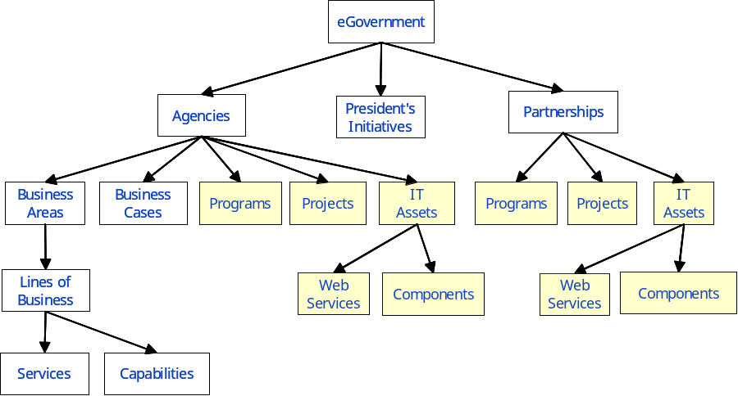
Figure 6: Example of a Taxonomy for e-Government
<the sections below goes into too much depth for this paper >
In general, the semantics of the parent-child relation of a taxonomy can only be considered to be the “is_subclassification_of” relationship (as displayed in Figure N1), meaning that the child “is a subclassification of” the parent. This is because the relationship is less tighly defined than it could be. However, a strong taxonomy – and by “strong” we mean a taxonomy having a more strict, principled, and consistent semantic relationship between the parent and child, such as does the biology taxonomy – has a more tighly defined relationship between a parent and child node. That strong relationship is sometimes called the “subclass” relationship, which is usually exemplified by Conceptual Models and Logical Theories (see Figure N1), the basis of ontologies. In fact, strong taxonomies having the well-defined, sound, and consistent “subclass” relationship between parents and children nodes are the backbones of ontologies. We will note here that the “subclass” relation is a “subsumption” relation, meaning that the parents are more general than their children nodes, and inversely, children nodes are more specialized than their parent nodes, meaning often that they have a narrower meaning than their parents. An example is: in Figure N2, the parent node “Person” is more general than its children nodes “Male” or “Female” is Parents “subsume” children.
Figure 7 Strong Taxonomy: Subclass is a Subsumption Relation
male
person
female
subclass of
subclass of
We also introduce Thesaurus, Conceptual Model, and Logical Theory in Figure N1 because these act as “way stations” of increasing complexity and semantic richness as you go up the Ontology Spectrum.

A Thesaurus is more complex than a Taxonomy because its parent-child relationship is characterized consistently as “broader_than”/”narrower_than”, i.e., a parent node has a broader than relationship to it children nodes; a child node has a narrower than relationship to its parent node. These are subsumption relations too, so a parent subsumes a child. However, in a Thesaurus, the nodes are not just classifications as they are in a Taxonomy, nor are they “classes” or “concepts” as they are in a Conceptual Model or a Logical Theory (i.e., in very structured semantic models that we call ontologies). The nodes instead are “terms”, meaning words or phrases, and these terms have narrower than or broader than relationships to each other.
<the section above goes into too much depth for this paper >

The reason why taxonomies are limited in their semantic expressiveness is because terms and concepts are different things. Terms are words or phrases. Concepts are the meaning behind the terms, that is, they represent the structure, relationships, and nuances of those terms within a framework or model. Take for instance the concept of a Person. The terms “person”, “people”, and “human”, among others, all refer to this concept. Terms are either broader than or narrower than or are synonymous with other terms. However, concepts are the meaning nodes or blocks behind those terms and represent the meaning of those terms. Concepts and their relationships to other concepts, their properties, attributes, and the rules among them, cannot be modeled using a taxonomy. Other more sophisticated forms of models, however, can represent these elements.

A semantic model in which relationships (associations between items) are explicitly named and differentiated is called an ontology. (In Figure N1, both Conceptual Models and Logical Theories can be considered Ontologies, the former a weaker ontology and the latter a stronger ontology). Because the relationships are specified, there is no longer a need for a strict structure that encompasses or defines the relationships. The model essentially becomes a network of connections with each connection having an association independent from any other connection. This variability provides tremendous flexibility in dealing with concepts, because many conceptual domains cannot be expressed adequately with a taxonomy (nor with a thesaurus, which models term relationships, as opposed to concept relationships). Too many anomalies and contradictions occur, thereby forcing unsustainable compromises. Moreover, moving between unlike concepts often requires brittle connective mechanisms that are difficult to maintain or expand.
Using the map of Gettysburg as an example, the idea of using a concept such as “Battle of Gettysburg” or “Civil War” to infer a date range is difficult if not impossible using taxonomies. Having associations whereby the associations can be defined independent of an ordered relationship structure makes it possible to include a “date” or “date range” association between “Battle of Gettysburg” and “July 1-3, 1863.” As a result, an inference can be made within in a search engine about a date range if it has the ability to “walk” any associations within an ontology of a concept having to do with dates. As noted previously, none of this implies some magical artificial intelligence which allows machines to comprehend human mumblings. It only indicates a machine's ability to solve a well-defined problem by performing well-defined operations on existing well-defined data..
Figure 8 shows an ontology for part of an FEA Capabilities Manager produced by TopQuadrant. The model below could be used to infer that a specific IT component has been developed in support of a given President’s initiative. The model also identifies agencies that partnered in developing a specific component.
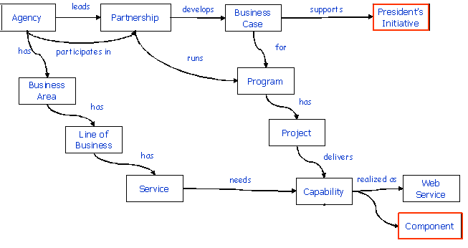
Figure 8: Part of the FEA Capabilities Manager Ontology Model

What’s the difference between a Conceptual Model and an Ontology? In general, a conceptual model is a semantic model of the concepts of a particular system, database, or increasingly more often today, an enterprise. An ontology is a semantic model of some portion of the world, whether it represents the general buying-selling model of electronic commerce, for example, or your company’s specific buying-selling model of electronic commerce. In either case, by creating or reusing an ontology or ontologies, you intend to model the semantics of that portion of the world, its concepts (class, properties, attributes, relations, constraints, rules), not just its structures for your particular databases, the object model for your system or even for your enterprise. The target is what is the meaning behind those structures and those objects and those conceptual models.

Simple ontologies are just networks of connections; richer ontologies can include rules and constraints governing these connections. Just as improvements in languages and approaches to model-based programming increased the ability to move from conceptual models to programmatic models without the need for human coding steps, similar advancements have taken place within ontological development. Whereas once ontologies were created primarily for human consumption, the development of robust protocols for expressing ontologies along with a growing infrastructure that support such models, provides increased capabilities for models to deduce the underlying context and draw logical conclusions based on these associations and rules.

Standards
The current state of the art on representing and using ontologies has grown out of several efforts that started in the 1980s. Early semantic systems initially suffered from a lack of standards for knowledge representation along with the absence of ubiquitous network infrastructures. With the advent of the World Wide Web and the acceptance of XML as a de-facto standard for exchange of information on the Web, ontology effortshave started to converge and solidify. RDF, OWL and Topic Maps, which is an ISO standard for representing networks of concepts to be superimposed on content resources, all use XML for serialization. This results in strongly typed representations (with public properties and fields contained in a serial format) making it easy to store and transport these models over the Webas well as integrate them with other web standards such as Web services.

A few standards bodies are working on the integration of knowledge models and “meta models”. One example is the Object Management Group’s (OMG) Meta Object Facility (MOF), which is used both for this purpose and also to assist in overall meta information management. Another highly relevant example is the OMG’s Common Warehouse Metamodel(CWM) for metadata interchange.

Core Building Blocks

Semantic Web Wedding Cake

Tim Berners-Lee, a co-founder of the World Wide Web Consortium and the inventor of the World Wide Web as we know it, published a description of the Semantic Web Wedding Cake (or “layer cake”) in a conference talk he presented in 2000. The description has garnered widespread interest within the Semantic Web community and has been referenced by numerous other writers, analysts, and the like.
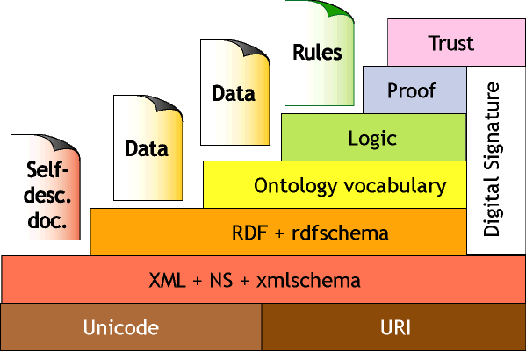
Figure X: Semantic Web Wedding Cake

This figure serves as a corollary to the Semantic Web Conceptual Stack shown previously in Figure 4. In this case, the emphasis is on the protocols and languages that will be used as foundations to technical components. The bottom of the Wedding Cake shows standards that are well-defined and widely accepted. Unicode is the 16-bit character set representation is the almost universally adopted successor to ASCII. URI stands for Universal Resource Identifier and is the W3C’s codification for describing the name and location of current and future objects within the Internet. It is an expansion on the concept of Universal Resource Locator or URL which is the commonly known identifier for websites and webpages.

Languages

XML (eXtensible Markup Language)
XML stands for eXtensible Markup Language and is a standard way of describing, transporting, and exchanging data that was pioneered by the W3C in the late 1990s. XML serves as a mechanism for marking up data through the use of customized "tags" in such a way as to describe the data. XML is not necessarily related to HTML and in fact, the two were designed for entirely different purposes. Despite this fact, the two can complement one another in various ways, depending on a user's needs.
The tags are typically the labels for the data such as “FirstName” or “StreetAddress”. When trying to use XML to define a standard interchange format, it is important to have agreement on the tags. For example, two book suppliers might wish to formalize a partnership involving data exchange. Specifying at the outset that Supplier A’s definition of “Author” is identical to Supplier B’s definition of “Writer” and codifying that in the XML structure would be essential part of formulating proper data agreement. Additional terms that overlap and have the same meaning would also need to be formally identified, usually in something called a DTD or XML Schema. (XML Schema is a mechanism for defining XML documents in a formal way, thereby ensuring the accurate exchange of information.)
In the context of semantics and the Semantic Web effort, XML is a set of syntax rules for creating semantically rich markup languages in particular domain. XML allows users to add arbitrary structure to their documents but says nothing about what the structures mean. In other words, whereas IT systems, databases, and content management systems have become good at describing things, they have not done so well at describing associations. More concrete and faithful descriptions are needed that provide better senses of words, terms, and domains.

RDF (Resource Description Framework)
RDF stands for Resource Description Framework and has been specifically designed to provide this associative information. RDF offers ways to make data smarter and more flexible, and therefore able to exist in environments outside those explicitly defined by system programmers and data modelers. RDF encodes information in sets of triples, each triple being rather like the subject, verb and object of an elementary sentence. (This same model can also represent resource, property, and value constructs.) RDF provides an infrastructure for linking distributed metadata and also serves in conjunction with OWL as a core language for describing and representing ontologies.

One of the primary benefits in using RDF to describe data associations is the scalability and flexibility it provides. Explicit database tables can be created that do much the same thing but the unique nature of RDF provides a flexible mechanism that allows far greater associative capabilities, thereby increasing the ability to query and make inferences on topic matters not explicitly hard-wired into tables. The benefits only increase when trying to integrate new data sources, especially when they have different structures or semantics or, even more importantly, when they cross conceptual domains as in the case of environmental and public health data or, alternatively, law enforcement and intelligence data.

RDF triples are serialized in XML providing a way to describe relationships between data elements using XML tags or other syntax in a format that can be easily processed by machines. In an effort to support a loosely coupled and/or virtual architecture, a Universal Resource Identifier (URI) is used to identify each of the triple elements. The purpose of a URI is to uniquely identify a concept in the form of subject, verb or object by linking to the origin where the concept is defined.

RDF Schema (sometimes written as RDFS or RDF-S) offers a way of semantically describing and extending RDF. It provides mechanisms for describing groups of related resources and the relationships between these resources. RDF Schema does the same thing for RDF that DTD and XML Schema do for XML.

OWL (Web Ontology Language)
OWL stands for Web Ontology Language. (The acronym is purposely transposed from the actual name – OWL instead of WOL – as a conscious link to the name of the owl in the book Winnie the Pooh.) Whereas RDF's primary value can be seen in enabling association and integration of distributed data, OWL's main value is in enabling reasoning over distributed data.
OWL is a highly expressive modeling language that is compatible with existing data stores and modeling constructs including XML, Rational, and object-oriented approaches. OWL also provides loosely-coupled “views” of data which makes federated knowledge-bases easy to build and evolve. Most importantly, OWL has machine-actionable semantics. Run-time and design-time software tools can do “things” with models, data, metadata, rules, and logic without human assistance or highly specific application code.

OWL is derived from a number of efforts to develop a set of flexible and computational logic constructs, many of which go back many years. It is the next generation of the ontology language called DAML+OIL, which in turn integrated two efforts, DAML, the DARPA Markup Language, an effort that was based in the United States and OIL, the Ontology Inference Layer (or Language), an effort that was based in Europe. It also has roots in SHOE (Simple HTML Ontology Extensions), an effort led by James Hendler at the University of Maryland, created specifically for incorporating machine-readable knowledge into web documents thereby facillitating intelligent agent capabilities.

- There are three levels of OWL defined (OWL Lite, OWL DL and OWL Full) with progressively more expressiveness and inferencing power. These levels were created to make it easier for tool vendors to support a specified level of OWL.

RDF and OWL can operate together or separately. In some cases, supporting the distributed nature of data may be the most important thing in which case OWL may not be present. In others it is distribution plus reasoning, yet in others just reasoning would suffice.

Other Languages
Other languages are in development to address additional layers within the Wedding Cake. For example. the Logic Layer calls for a rule system and universal language for monotonic logic and for validating proofs. RuleML was initially proffered as a rule language although Semantic Web Rules Language (SWRL) is currently underway at W3C. Constructs, schemas, and architectures for inferring reputation and trust are also being developed. These approaches are being looked at not just to infer reputation and trust by and between individuals but also of groups of people (such as companies, media sources, non-government organizations, and political movements), inanimate objects (such as books, movies, music, academic papers, and consumer products), and even ideas (such as belief systems, political ideas, and policy proposals).

Semantic Tools and Components
"Semantic Web tools are getting better every day. New companies are starting to form. Big companies are starting to move."
James Hendler
Several models exist that describe the cycle or stages of maturity that technologies go through. Typically these have four stages: entry (or definition), growth (or validation), maturity (or refinement), and decline (or consolidation). By most measures, the Semantic Web, as experienced in a publicly available format, is still in entry or definition phase. Many of the semantic technologies, however, are well into the growth and validation phase. (The shift into maturity is often illusive to predict or determine; the tipping point being visible usually only after the fact, and after possibly passing through a period of hype and unmet expectations.).

Leaders in technology applications across government and private industry have been forging new paths and obtaining success results from their semantic implementation projects. There are semantic research projects in a number of federal agencies. Semantic products are available from large and established companies such as Adobe, Hewlett Packard, and IBM as well as many small but pioneering companies such as Unicorn, Network Inference, and Semagix. In addition, there are a number of open source and publicly available tools created by public and private research institutions and organizations.

What follows is a brief survey of commercial and open source tools that can be used to create applications powered by Semantic Web technologies. One way to understand how these tools work together is to view them as either design-time tools or run-time tools. In other words, some of the tools are used by document authors, system designers, and others as part of the creation, design, or authoring process. Examples include tools to create metadata or to create or populate ontologies. Other software components are used as run-time components to process queries, transform data, or otherwise produce operational results. Examples here include mediation servers and inference engines. Many of the tools are used as a set within an implementation process – for example, modeling and mapping tools during design-time in partnership with query facilities and mediation servers at run-time.

Metadata Publishing and Management Tools
The process for creating metadata about a document or data item can take place when that item is created or authored, when it is imported into a content management system or a website, or when it is viewed or read by users. It can also be added by some other explicit or implicit action at any point over the course of the existence of that data item. In other words, metadata creation is not just a one-time occcurence. Metadate can continue to accummulate and/or be modified at any time by conceivably any number of people.
At content creation, authors typically connect information such as the subject, creator, location, language, and copyright status with a particular document. This information makes the document much more searchable. RSS consists essentially of this type of information providing newsreading applications with significantly expanded capabilities for searching and filtering information. Moveable Type from a company called SixApart is one of the more popular tools in the blogging community for creating RSS-compliant documents. The increasing popularity and simplicity of RSS causing its use to extend outside of the blogging community into the general media and even into the enterprise. Other vendors of desktop and web-authoring tools are also moving quickly to provide RSS publishing capabilities.

- The creation of metadata is only one step in the process. Metadata management are needed in order to maintain metadata vocabularies, perform metadata-driven queries, and provide visualization tools for monitoring changes in areas of interest. An example of a website that uses metadata as a key aspect of creating a collaborative and shared system of data is Flickr (www.flickr.com), a site for people to easily upload and share digital photos. What sets it apart from other digital photos services is that provides photo-tagging capabilities as well as an innovative interface for viewing the categories of photos. (The tags are contained in a map and vary in size depending on the frequency of the tag within the data store.) What sets it apart from earlier metadata implementations is that the feedback loop is extremely tight, meaning that the assignment of tags is bound closely to their use. As soon as photos and sets of photos are tagged, users see clusters of items carrying the same tag. Users can easily change tags to refine the clusters.

In terms of tools for querying metadata, the components are not all that much different than current search engines although the inclusion of metadata makes for smarter data and therefore more precise and relevant searches. Query scripts and languages will likely adapt to allow users more precision although the balance between simplicity and features is constantly in flux, especially in more publicly available search engines. As with the Flickr example above, however, new visualization tools are being developed to help users navigate through complex fields of related data.

Modeling Tools (Ontology creation)
Modeling tools are used to create and modify ontologies. Knowledge modelers used them to create and edit class structures and model domains. The tools often have an interface that is similar to a file system directory structure or bookmark folder interface. They also tend to offer the ability to import, transform, and re-purpose, in whole or in part, existing ontological structures often which are in the form of database schemas, product catalogues, and yellow pages listings. Other prominent feature includes advanced mechanisms for organizing, matching, and associating similar terms and concepts.

Also, since it is a common practice for modeler to create smaller interconnected ontologies instead of a single large monolithic model – primarily for better reusability and ease of use – support for splitting, merging, and connecting models can be an important capability in the ontology editor. Some editors even support collaborative work methods and rich visualization and graphical interaction modes.

Protégé-2000 is a free ontology editor from Stanford Universitywith a large and active user community. It features an open architecture which allows independent developers to write plug-ins that can significantly extend Protégé capabilities.

Commercial modeling tools are available from a number of vendors including Network Inference, Language and Computing, and Intelligent Views.

Mapping Tools (Ontology population)

Once ontology model is created it needs to be populated with data (class instances in “ontology speak”). This is usually done by linking various data sources to the concepts in an ontology using a mapping tool.. Once “maps” have been created, a query in one data source could be transformed its map to the ontology and then from the ontology to the other data sources using their maps. The corresponding data could then be returned in the same manner without any of the data stores knowing or caring about the others. In other words, each data source may have a unique “map” to an over-arching ontology. Providing this abstraction layer requires some effort on the part of creating the ontology and then creating the data maps but once this has been done, each data source can interoperate with other data source strictly within run-time processes. Bring new data sources onboard will, in most cases, have little if no effect on existing data sources.

This process drastically limits the amount of data value mapping and semantic conflict resolution that typically takes place using current enterprise application approaches, approaches which up to now typically require n-squared mappings (mapping from and to each and every data source) or alternatively, exporting to hard-coded, inflexible and explicit standards. The modeling and mapping process makes the process far less political and far more flexible and adaptable. Anomalies specific to a single data source, for example, can be handled almost transparently whereas addressing it within the typical standards process would entail a significant time and energy hit.

Most of the tools that are used to map structured data have features that seamlessly map database fields to ontologies. A few of these vendors include Network Inference and Unicorn. Tools that aggregate, normalize, and map free-form data to ontologies typically work with a variety of unstructured data forms including Word, RTF, text files, and HTML. Semagix is a leading vendor in this category.

Data Stores
Ontologies and other RDF data models can be stored in native RDF data stores or in relational databases that have been customized to support associative data techniques. Native RDF-data stores are inherently designed to support the concept of triples and can offer an efficient out-of-the box approach to storing ontologies. RDF native databases are available from companies such as Intellidimensions and Tucana Technologies. In order to use a relational database, however, the database has to be designed in somewhat non-traditional way. Instead of having a table that describes each major concept, the database design typically mimics the concept of triples by using a single table containing four columns. Three of the columns store the triple while the forth column is used to store its id. (A report entitled “Mapping Semantic Web Data with RDBMSes” is an excellent resource for finding out more about implementing triple stores in relational databases.

Issues related to representing, storing, and querying using triples (i.e. RDF) versus traditional relational approaches, as well as the use and/or co-existence of the two types of data stores within implementations, are still working themselves. Each store-and-query facility provides unique capabilities that the other, at present, does not. RDF is great for situations when it is difficult to anticipate the types of queries that will be performed in the future. It is also terrific for handling metadata and for making queries that require inferences across imprecise or disparate data. For example, a query along the lines of “how many energy producers qualify for ‘green’ status this year” is much easier to perform in RDQL (the RDF query language) than in SQL (once the models have been created to tie together various data stores). At the same time, queries that are trivial in SQL, such as “which energy producers reduced their CO2 output the most this year” can be quite complicated using RDQL.

It is important to note that RDF query languages are still evolving which, in part, may explain this limitation. Other limitations of using RDF relate to performance issues. Because queries can be broadened to include concepts instead of just terms, for example, search space can be dramatically increased. Because the RDF data stores are relatively new and the number of implementations relatively small, system developers need to iterate over their designs paying particular attention to areas that can limit performance. In terms of industry growth, it is difficult to predict the how RDF will affect the database industry. RDF data stores may remain a distinct data storage category in its own right or its capabilities may be subsumed into relational databases much as what happened soon after object-oriented databases came into being.

.

Mediation Engines
Mediation engines are automated tools that can dynamically transform data between different syntaxes, structures, and semantics using models instead of hard-wired transformation code. They are critical components of any interoperability architecture. Using data maps, ontologies, and other forms of conceptual models, mediation engines are run-time processes that provide an abstraction layer between heterogeneous data sets, allowing organizations to essentially agree to disagree about how data and information should be represented. Mediation engines typically work with highly structured data. Unstructured and semi-structured data must first be bound to a schema prior to creating the mediation maps.

Inference Engines
Inference engines (sometimes referred to as reasoners) are software tool that derive new facts from existing information. It is often said that an inference engine emulates the human capability to arrive at a conclusion by reasoning. In reality, inferencing is not some mythical AI capability but rather is quite common in data processing. One can think of complex datamining exercise as a form of inferencing.

The figure below shows a simple example of how inferencing works with RDF and OWL data. In this example relationships between Persons A and B, and A and C are given. Based on them the inference engine identifies a relationship between B and C.
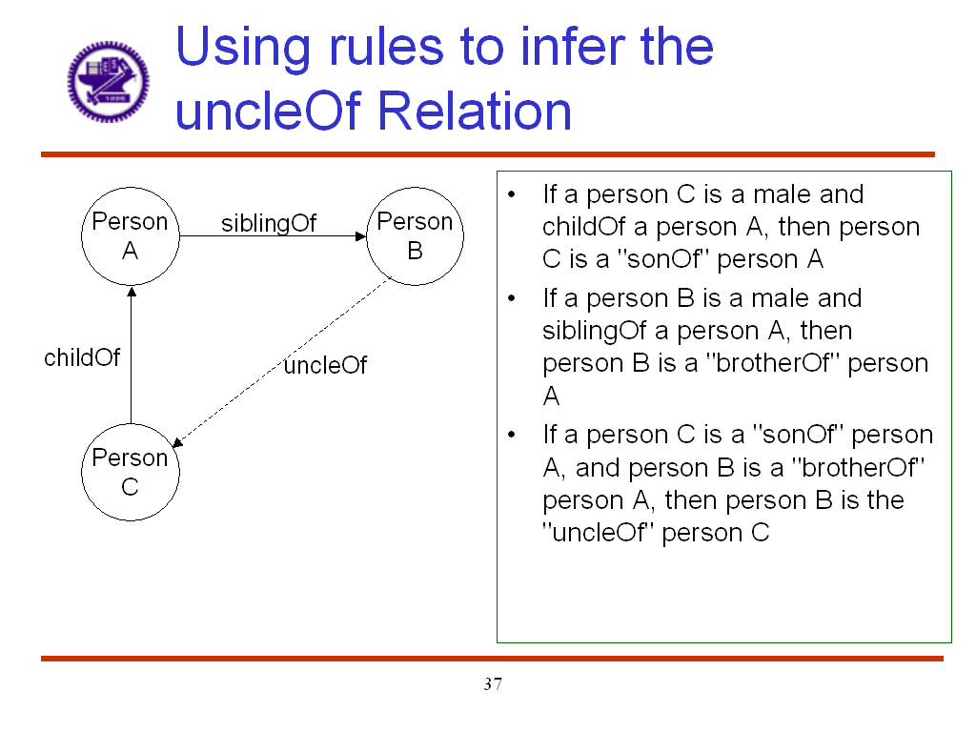
By creating a model of the information and relationships, we enable reasoners to draw logical conclusions based on the model. In the example above, people and their connections are explicitly defined making it possible to infer their relationships to other people. The inferred RDF triple encoding that "Person B is the uncleOf Person C" can now be added to the existing set of RDF statements.

Both, free and commercial versions of inference engines are available. For example, Jena, an open source Java framework for writing Semantic Web applications developed by HP Labs, has a reasoner subsystem. Jena reasoner includes a generic rule based inference engine together with configured rule sets for RDFS and for the OWL-Lite subset of OWL Full.

JESS is a popular OWL inference engine from Carnegie Melon University. Network Inference offers a commercial reasoner based on description logic (OWL-DL).

IBM Ontology Management System (also known as SNOBASE, for Semantic Network Ontology Base) is a framework for loading ontologies from files and via the Internet and for locally creating, modifying, querying, and storing ontologies. Internally SNOBASE (http://www.alphaworks.ibm.com/tech/snobase ) uses an inference engine, an ontology persistent store, an ontology directory, and ontology source connectors. Applications can query against the created ontology models and the inference engine deduces the answers and returns results sets similar to JDBC (Java Data Base Connectivity) result sets.

Other Components

Ordinary web pages are a good source of instance information; so many tools for populating ontologies are based on annotation of web pages. W3C Annotea project offers free annotation tools. Commercial vendors include Ontoprise and Lockheed-Martin.

Several software vendors offer products that use ontologies to categorize information and to provide improved search and navigation. These include Semagix, Siderian Software and Entopia.

Applications of Semantic Technologies
"Semantic technologies can solve problems that, using current technologies, are unsolvable at any price."
Don Hall

Semantic Web Services
A Web service is a software system designed to support interoperable machine-to-machine interaction over a network. A Web service has an interface described in a machine-processable format using Web Services Description Language(WSDL). The combination of WSDL, UDDI, and SOAP form a triad of technologies that will shift the entire market toward service-oriented architectures (SOA). Together, these technologies provide directory, component lookup, and exchange protocol services on top of an HTTP or SMTP network protocol.

Microsoft, IBM, and most other large software vendors have embraced the concepts and languages that underlie the Web services model and an increasing number of books and industry articles point to the benefits of adopting a service oriented architecture. Web services, however, are not without shortcomings. Security issues have long been a concern but several solutions that address these issues have been introduced over the last couple of years. Perhaps the most significant improvement opportunities for Web services that remain are in the areas of a) flexible look-up and discovery and b) information management and schema transformation. Fundamentally, Web services technologies handle messages in a loosely coupled manner but they do not currently bridge differences in description terminologies nor do they inherently enable the recipient to understand a message that has been sent. With Web services, these parts of the exchange rely on custom-coded solutions and/or widespread community agreement upon some kind of document exchange standard (the latter of which is rarely achieved).

This difficulty in ensuring flexible discovery and service initiation as well as seamless operational use of information exchanged with Web services has led to W3C’s efforts to incorporate semantic technologies as part of its Semantic Web Services initiative. Semantic Web Services are a Web Service implementation that leverages the Web Ontology Language Service specification (OWL-S) to provide a flexible framework for describing and initiating web services. OWL-S supplies Web service providers with a core set of markup language constructs for describing the properties and capabilities of their Web Services in unambiguous, computer-interpretable form. OWL-S markup of Web services will facilitate the automation of Web service tasks including automated Web service discovery, execution, interoperation, composition and execution monitoring. Following the layered approach to markup language development, the current version of OWL-S builds on top of W3C’s standard OWL.

Semantic Interoperability
OMB directives and guidance call for the unification and simplification of business processes and information technology across the federal government. In order to achieve this goal, each agency must ensure that its information can be readily shared across the federal government. In an information environment where different agencies – and organizations they are working with – have and will continue to have diverse terminology and definitions, information sharing requires interpreting the meaning of data in different contexts. The semantic technologies support this requirement by offering a platform for connecting distributed data and describing it in a context-sensitive way.

Formally put, the use of semantic technologies makes it possible to describe the logical nature and context of the information being exchanged, while allowing for maximum independence between communicating parties. The result is greater transparency and more dynamic communication between information domains regardless of business logic, processes, and workflows.

The technical vision is one where flexible information models, not inflexible programs or code, are used to drive a dynamic, self-healing, and emergent infrastructures for the sharing of mission critical data in massively scaleable environments. Recent advances in the areas of inferencing technology, taxonomy and thesaurus technology, context modeling approaches, and ontology-driven interoperability can be applied in a cohesive framework that dramatically changes the way information is managed in disperse, decentralized communities of knowledge.

Design-time tools can be used to create RDF and OWL models that encompass a particular domain. These models could be based on existing XML standards or defined via other means. Other design-tools can be used to flexibly map specific data representations to these models eliminating the need to explicitly convert applications to adopt a certain data standard. Run-time processes can then use these models and maps as sort of pivot tables to transform data from source to target or to perform federated queries from a single query statement. Semantic interoperability frameworks provide the basis for better resolving differences in syntax, structure, and semantics – ushering in a future where organizations can agree to disagree, yet still share data and interoperate without having to change their current methods of operation.

Semantic interoperability will not require adoption of new integration technology, databases, or software applications. A semantic framework made up of various semantics-based components and APIs can be deployed with web services or traditional middleware APIs to leverage existing infrastructure investments yet still provide massive benefits by virtually centralizing the query, transformation, and business rules meta-data that flows through the network infrastructure’s pipes. As such, the software will fit into the customers existing IT ecosystem with low overhead for installation, minimal coding, and maximum reusability.

Intelligent Search
Related in some regards to semantic interoperability is the area of intelligent search. As mentioned above, semantic interoperability techniques can allow queries native to one system to be federated to other non-native systems. This eliminates the need to convert systems to a universal query language and enables systems to continue maintaining the information they have in the format they have it. By overlaying a virtual layer on top of the data sources, queries can be defined in a universal manner, thereby enabling access of all mapped assets. Federated searching can also be made smarter by making them semantically precise. In other words, searches can be broadened to include concepts or narrowed to include only specific key words. The depth – or granularity – of such searches enables the specification of the search which the individual desires.

One other aspect of intelligence search is the ability to make searches more relevant to the person searching by making use of identity and relationship information. Relationships between people and information about them can be key links to greater relevance and confidence. Despite investments in knowledge management systems, many people still rely on their personal network of friends, neighbors, co-workers, and others to locate experts or find trusted information. Personal relationships are also useful in sales situations and in many organizational interactions. Social networking schemas and software are making broad use of this.

An example of how this information can be used on a larger scale is the case of a telephone company exploring technologies for providing more intelligent phone number look-up. Instead of providing a generic list of matched names, the telecommunications company is looking at combining information about the person searching and the list of possible names in order to provide a more intelligent match. For example, inferring relationships between social networks could provide information on whether a person is known or could be expected to be known to the other person (by employing friend-of-a-friend forms of calculation). Other information such as locations or schools attended or past or current jobs could be used to infer matches. To be sure, there are significant privacy issues involved; however, many believe that techniques such as hashing of personally identifiable information and progressive disclosure - among others – will likely resolve many privacy concerns.

Some feel that semantic approaches for enabling intelligent search will find their ways into knowledge management systems. Whereas current knowledge management systems tend to exist within their own silos and have difficultly crossing organization boundaries, intelligent search techniques can be added as overlays to existing information infrastructures, thereby bridging knowledge domains, organizational structures, physical data formats, and more.

Intelligent Search
The aging wiring systems of the NASA Space Shuttle fleet is known to be a key contributor to serious and ongoing maintenance problems. Troubleshooting such wiring problems requires timely access to all facets of wiring system data, the breadth of which is enormous. Fixing the problem requires access to many cross-organizational systems, databases, and knowledge repositories in order to solve problems. The situation becomes especially critical for diagnosing and troubleshooting in-flight anomalies where timely resolution is mission- and life-critical.

The existing set of Space Shuttle wire databases contains information about failure tracking and reporting, repair disposition, standard practices, test procedures, test reports, inspection reports, part specifications, bill of materials, drawings, change orders, and work orders. Tens of diverse databases and systems -- each supporting different but related aspects of engineering and design work -- are in use within NASA. Related data is dispersed among several contracting companies that support the Space Shuttle program.

Introduction to Module 2: Exploring the Business Value of Semantic Interoperability in the Federal Government
Module 2 of this three-part series will examine the business case for the semantic interoperability in the federal government by using business scenarios and storyboarding approaches to describe why and how semantic interoperability can deliver ROI-supported value. The business cases will contain a detailed description of a business problem, expressed in both business and in architectural terms.

Our goal is to select scenarios that will reflect real world problems faced by specific agencies. Presently we are considering for inclusion in Module 2 business cases for using semantic technologies to address problems and opportunities in one or more of the following agencies:
- Environmental Protection Agency
- NASA Space Shuttle Program
- World Trade Bank
- Office for Domestic Preparedness

Roadmap to the Semantic Web

More than ever, governmental organizations are asked to move very quickly. Whether it is federal agencies responding to crisis or working diligently to form ad-hoc alliances to better improve government services – the simultaneous demands for the real-time, fluid, and frequent alignment of government agencies and organizations is on the rise. Accordingly, IT infrastructures must evolve to meet these new demands.

Imagine if federal government had an infrastructure that dynamically adapted to new requirements for communication, connections, and integration. Imagine if it only took seconds to look up, connect, and establish interoperability, rather than manually repurposing information or taking months to go through design, development, and testing phases for every individual integration requirement that arises. Moreover, try to imagine if this process was partially or entirely automated. Costs per integration would be significantly lower, errors would be drastically reduced, and government’s ability to respond to needs of the citizens and to react to changes in the business and social environment would increase dramatically .

At the federal level, the KM working group (www.km.gov) has made significant progress in sharing information about taxonomy and semantics projects across agencies. The information professional associations and agencies have taken a leadership role in developing standards and adopting markup languages that allow information to be shared. The XML.Gov (www.xml.gov) has a mission to facilitate efficient and effective use of XML across agencies in order that seamless sharing of documents and data can be achieved. Many government agencies have existing taxonomies or have begun to develop taxonomies for their information domain.

Though these efforts help build incremental progress towards the reality of the Semantic Web, a more comprehensive approach is needed in order to successfully operationalize Semantic Web technologies. The following two sections provide general guidelines that can be adapted to suit each agency’s unique environment.

A High Level Roadmap
From a high level viewpoint, here are the essential steps for realizing the immediate and/or near-term benefits of semantic solutions .

Envision new semantic capabilities

Semantize the information

Harness the information semantics information

Make better decisions

1. Envision new semantic capabilities

- Learn about the Semantic Web and Semantic Technologies
- Set semantic implementation goals
- Identify areas for semantic solutions
- Embrace open data standards
- Train in knowledge engineering

2. Semantize the information

- Define context/content/user
- Represent knowledge about data, applications, and processes in appropriate semantic models, e.g. ontology, taxonomies, XML, etc. Convert the semantic models to machine-readable format
- Map information sources
- Achieve semantic interoperability by integrating the knowledge, not the code, to bridge information sources and link processes and functionality

3. Harness the information semantics

- Connect the dots -- link data sources, applications, and processes to the semantic models using the appropriate semantic technologies
- Implement the appropriate semantic solutions to make knowledge accessible
- Build composite applications with one interface that interconnects and interacts with multiple applications and data sources

4. Make better decisions, faster, in context

- Access the composite applications to retrieve knowledge relevant to decision-making

Where your agency lies on the roadmap to the Semantic Web
A checklist is provided below to help evaluate where your agency lies on the roadmap described above:
- Can data pulled from different parts of the organization be easily integrated and similarly interpreted?
- Are there a variety of formats and structures that prevent easily combining that information?
- Does organization A mean the same thing as organization B when they submit data?
- If your agency is creating enterprise architecture, what is the core infrastructure which will be used to facilitate the integration of information across stovepipes and between systems?
- Can users locate information with ease? What plans are currently being made to improve information access and information management in your agency?

Introduction to Module 3: Implementing the Semantic Web
New technologies, applications, and services are being developed to facilitate the Semantic Web. Module 3 provides additional details about the roadmap provides the steps and implementation recommendations, based on which an agency can gauge its progress and schedule future projects to that take advantage of this new technology.

References
- http://ontolog.cim3.net/file/workshop/nov-2003/OntologiesForSemanticallyInteroperableSystems-ONTOLOG-UBL--LeoObrst_20031105a.ppt
- http://www.w3.org/2003/Talks/0521-www-keynote-tbl/
- Daconta, Michael C., Leo J. Obrst, and Kevin T. Smith. 2003. The Semantic Web: a Guide to the Future of XML, Web Services, and Knowledge Management. Indianapolis: Wiley.
- "Ontologies for Semantically Interoperable Systems" by Dr. Leo Obrst, MITRE Information Semantics Center for Innovative Computing & Informatics, Presentation to the KM.Gov Semantics Interoperability Community of Practice. April 14, 2004.
- DRAFT – Adaptive Information: Improving Business Through
- Semantic Interoperability, Grid Computing, and Enterprise Integration -- Jeff Pollock, Ralph Hodgson and John Wiley & Sons Publications Dec 2003
- Harnessing the Value of Semantic Integration For Your Business. A TopQuadrant Whitepaper. June 15, 2004.
- The Semantic Web : A Guide to the Future of XML, Web Services, and Knowledge Management – by Michael C. Daconta (Author), Leo J. Obrst (Author), Kevin T. Smith
- Ontologies for Corporate Web Applications – by Leo J. Obrst, Howard Liu, Rober Wray
- Ontologies and the Semantic Web: An Overview – by Leo J. Obrst
- •Ontologies for Semantically Interoperable Systems – by Leo J. Obrst
- •TopQuadrant Technology Briefing, Semantic Technology, Version 1.1 , September 2003 - by TopQuadrant

- http://www.w3.org/DesignIssues/RDFnot.html
- http://www.w3.org/DesignIssues/Semantic (roadmap)
- Problem Statements for "Semantic Technology Panels – Interactive Discussion Session", One-Day Conference on "Semantic Technologies for eGov" White House Conference Center, Monday, September 8th, 2003. Submitted by United States Environmental Protection Agency, Office of Environmental Information, William Sonntag, Chief of Staff.

Appendix A: Organizational Charter

A.1 Semantic Interoperability Community of Practice (SiCoP)
The Semantic Interoperability Community of Practice (SICoP) is established by a group of individuals for the purpose of achieving semantic interoperability and semantic data integration in the government sector. SICoP seeks to enable Semantic Interoperability, specifically the "operationalizing" of these technologies and approaches, through online conversation, meetings, tutorials, conferences, pilot projects, and other activities aimed at developing and disseminating best practices. The individuals making up this community of practice represent a broad range of government organizations and the industry and academic partners that support them. SICoP, however, claims neither formal nor implied endorsements by the organizations represented.

The SICoP is a Special Interest Group within the Knowledge Management Working Group (KMWG) sponsored by the Best Practices Committee of the Chief Information Officers Council, (CIOC) in partnership with the XML Working Group, among others. Both the SICoP and its parent KMWG serve as interagency bodies to bring the benefits of the government's intellectual assets to all Federal organizations, customers, and partners. The SICoP through the Working Group will communicate its actions and findings to the Committee, the CIO Council and its member agencies, although its main purpose to support CoP members in their efforts to make the Semantic Web operational in their agencies.

Appendix B: Definitions and Terms

Term | Definition/Description | Source
Content | In this document, the term content is used in a broad perspective, it refers to everything that is published to the Enterprise Information Portal, such as documents, Web pages, etc. | “Taxonomy Analytical Brief”, Department of State, IRM Business Center, May 27, 2003
Business Cases | A structured proposal for business improvement that functions as a decision package for organizational decision-makers. A business case includes an analysis of business process performance and associated needs or problems, proposed alternative solutions, assumptions, constraints, and a risk-adjusted cost-benefit analysis. | GAO
Business Scenario | Business scenarios are an important technique that may be used to help identify and understand business needs, and thereby to derive the business requirements that the architecture development has to address.  A business scenario is essentially a complete description of a business problem, both in business and in architectural terms, which enables individual requirements to be viewed in relation to one another in the context of the overall problem. | The Open Group http://www.opengroup.org/
Business Use Case
Content Administrator | Internal user who creates and manages content for the Enterprise Information Portal. | “Taxonomy Analytical Brief”, Department of State, IRM Business Center, May 27, 2003
Controlled Vocabulary | A finite set of standard terms for use in taxonomy categories. Within an organization, there can be multiple controlled vocabularies, e.g. a core one for the entire organization and sub controlled vocabulary specific to each business units within the organization. Controlled vocabulary can be used in notation for taxonomy categories, information cataloging and tagging, as well as labels for a Web site navigation interface. | “Taxonomy Analytical Brief”, Department of State, IRM Business Center, May 27, 2003
Data | A collection of raw facts, instructions, or statements in isolation. | “Taxonomy Analytical Brief”, Department of State, IRM Business Center, May 27, 2003
Information | A set of related facts, instructions, or statements about something in a given context (i.e., a specific place and time) of which you are uncertain of its truth or value. | “Taxonomy Analytical Brief”, Department of State, IRM Business Center, May 27, 2003
Information Architecture | Information architecture, in the broadest sense, is simply a set of aids that match information needs with information resources. A well implemented architectural design structures information in an organization through specific formats, categories, and relationships. It needs to consider business context, content (information) and users. | “Taxonomy Analytical Brief”, Department of State, IRM Business Center, May 27, 2003
Information Seeker | DoS employees and authorized external personnel who seeks information from the Enterprise Information Portal. | “Taxonomy Analytical Brief”, Department of State, IRM Business Center, May 27, 2003
Knowledge | A set of related facts, instructions, or statements about something in a given context of which you are certain of its truth and value. | “Taxonomy Analytical Brief”, Department of State, IRM Business Center, May 27, 2003
Metadata | The simplest definition of metadata is " structured data about data."  Metadata is descriptive information about an object or resource whether it be physical or electronic. While metadata itself is relatively new, the underlying concepts behind metadata have been in use for as long as collections of information have been organized. Library card catalogs represent a well-established type of metadata that has served as collection management and resource discovery tools for decades.  Metadata can be generated either "by hand" or derived automatically using software. | Dublin Core Metadata Initiative, Frequently Asked Questions,  http://dublincore.org/resources/faq/ - whatismetadata
Ontology | “An ontology is a specification of a conceptualization.  In the context of knowledge sharing, I use the term ontology to mean a specification of a conceptualization. That is, an ontology is a description (like a formal specification of a program) of the concepts and relationships that can exist for an agent or a community of agents. This definition is consistent with the usage of ontology as set-of-concept-definitions, but more general. And it is certainly a different sense of the word than its use in philosophy.  What is important is what an ontology is for. My colleagues and I have been designing ontologies for the purpose of enabling knowledge sharing and reuse. In that context, an ontology is a specification used for making ontological commitments. The formal definition of ontological commitment is given below. For pragmetic reasons, we choose to write an ontology as a set of definitions of formal vocabulary. Although this isn't the only way to specify a conceptualization, it has some nice properties for knowledge sharing among AI software (e.g., semantics independent of reader and context). Practically, an ontological commitment is an agreement to use a vocabulary (i.e., ask queries and make assertions) in a way that is consistent (but not complete) with respect to the theory specified by an ontology. We build agents that commit to ontologies. We design ontologies so we can share knowledge with and among these agents.” | Tom Gruber, Stanford University, http://www-ksl.stanford.edu/kst/what-is-an-ontology.html
Semantics | Semantics are at base the processes that use or create values for taxonomies. Without semantics, taxonomies are simple or elaborate but empty structures. Officially, semantics is a branch of linguistics that deals with the study of meaning, changes in meaning, and the principles that govern the relationship between sentences or words and their meanings. Semantics involved in creating meaning for simple taxonomies are different from those that are used to create meaning for network or faceted taxonomies. Semantics involves the study of the relationships between signs and symbols. From an information perspective, semantics also involves effective information communication within and across languages, information surrogation, information organization, and discovery. | Extracted from the Mission Statement of the Taxonomies and Semantics Special Interest Group, http://km.gov/
Semantic Integration | Semantic Integration is managing the meaning of information as it is transferred between applications. It is the process of clarifying the differences in the way people, departments and organizations interpret information. And once clarified, ensuring that these differences are resolved technically through integration | “Being Information Centric”, 2003 Corus Technologies  http://www.corustechnologies.com/public_docs/MPI 099 26 PA1.pdf
Semantic Interoperability | Semantic interoperability is an enterprise capability derived from the application of special technologies that infer, relate, interpret, and classify the implicit meanings of digital content, which in turn drive business process, enterprise knowledge, business rules and software application interoperability. | “Adaptive Information: Improving Business Through Semantic Interoperability, Grid Computing, and Enterprise Integration” by Jeff Pollock and Ralph Hodgson, Wiley Publishing 2004
Semantic Web | Semantic Web is an extension of the current Web in which information is given well-defined meaning, better enabling computers and people to work in cooperation."- | “The Semantic Web”, By Tim Berners-Lee, James Hendler and Ora Lassila, Scientific American, May 2001
Semantic Web Services | Semantic Web Services are a Web Service implementation that leverages the Web Ontology Language Service specification (OWL-S). OWL-S supplies Web service providers with a core set of markup language constructs for describing the properties and capabilities of their Web Services in unambiguous, computer-intepretable form. OWL-S markup of Web Services will facilitate the automation of Web service tasks including automated Web service discovery, execution, interoperation, composition and execution monitoring. Following the layered approach to markup language development, the current version of OWL-S builds on top of W3C’s standard OWL. | “Adaptive Information: Improving Business Through Semantic Interoperability, Grid Computing, and Enterprise Integration” by Jeff Pollock and Ralph Hodgson, Wiley Publishing 2004
Storyboard | Storyboards offer a way to "tell a story". They focus attention on the people who will use the solution and the value it will bring. Stories are rich, fleshed-out descriptions of settings, people, activities, goals, motivations, and values presented in a coherent, causally connected way. The process of creating a story can insure that attention has been paid to the factors necessary to create an effective solution. Storyboards usually use pictures and cartoons (in addition to text) to tell the story. I am attaching a cartoon example of the storyboard telling a "before" and "after" story.
Structured data | Data that are arranged in a specific structure. It is commonly used to refer to data resides in databases. | “Taxonomy Analytical Brief”, Department of State, IRM Business Center, May 27, 2003
Taxonomy | Taxonomies are defined simply as the structures used to organize information. When people think of taxonomies they typically understand hierarchical structures like those created in the biological sciences. From an information science perspective, though, taxonomies may take on one or a combination of several types of structures -- they may be simple flat structures, hierarchies, network/plex structures or faceted taxonomies. Each of these kinds of structures serves a different kind of information management and access purpose. All are critical for supporting today's complex information solutions and are integral components of today's complex information systems. | Extracted from the Mission Statement of the Taxonomies and Semantics Special Interest Group, http://km.gov/
Taxonomy Structure | Taxonomy structure represents the underlying hierarchical structure of the concepts within a defined scope and context, similar to library of congress classification system. It is used in the backend by content managers to categorize information within the content management workflow process. | “Taxonomy Analytical Brief”, Department of State, IRM Business Center, May 27, 2003
Taxonomy View | Taxonomy view is the visual view of taxonomy structure presented to the end users. It could be the same as taxonomy structure or it could be completely different. Taxonomy view organizes Web content into logical groupings, similar to Yahoo's hierarchical directory listing. Sample deliverables of taxonomy view include conceptual navigation model, information access points, broad information categories and associated standards and guidelines. | “Taxonomy Analytical Brief”, Department of State, IRM Business Center, May 27, 2003
Thesaurus | A set of related terms describing a set of documents. This is not hierarchical: it describes the standard terms for concepts in a controlled vocabulary. Thesauri include synonyms and more complex relationships, such as broader or narrower terms, related terms and other forms of words. | “Taxonomy Analytical Brief”, Department of State, IRM Business Center, May 27, 2003
Use Case

Appendix C: Case Studies
(In abbreviated form)
A number of application areas can benefit from the use of Semantic Web technologies. They include:

- Content Management
- Knowledge Management
- Information Interoperability
- Smart, Knowledge-aware Applications
- Dynamic User Interfaces
- Information Accessibility

What follows are select examples of real world applications in each of these five areas. The application examples from government as well as private industries are included in the paper to demonstrate how this emerging technology is being used today. They are also intended to serve as a source of inspiration and ideas for readers interested in applying these technologies in their own agency.

Project Name: European Media Monitor
Semantic Application: Content Management

The European Media Monitor (EMM) is a 24 by 7 real-time monitoring system for Europe’s online media, including press, TV, radio, and other media sources. EMM provides European Union (EU) bodies with news alerts, trend analysis and the ability to extract articles. This fully automated system uses RDF and XML technologies to process RSS news feeds. The EMM includes capabilities for ‘alert detection’, machine-based translation and multi-lingual thesauri.

Specific capabilities provided by semantic technologies include:
- Personalized and repurposed information
- Aggregated news feeds
- Automated information tagging

The ‘News alerts’ component of the system detects and sort articles as they appear in Europe's on-line media. Each alert definition takes advantage of multi-lingual thesauri designed to catch future articles. When recognized, the article is placed into the appropriate alert which contains up to some maximum number of most recent catches. Alerts are intended to cover a single topic area. They can be either permanent or set up just to cover specific future events. Alerts run continuously, scanning and checking all newly published articles against multi-lingual lists of keywords. Each online source is checked as frequently as every 15 minutes. The alert scan on a new article occurs in a fraction of a second.

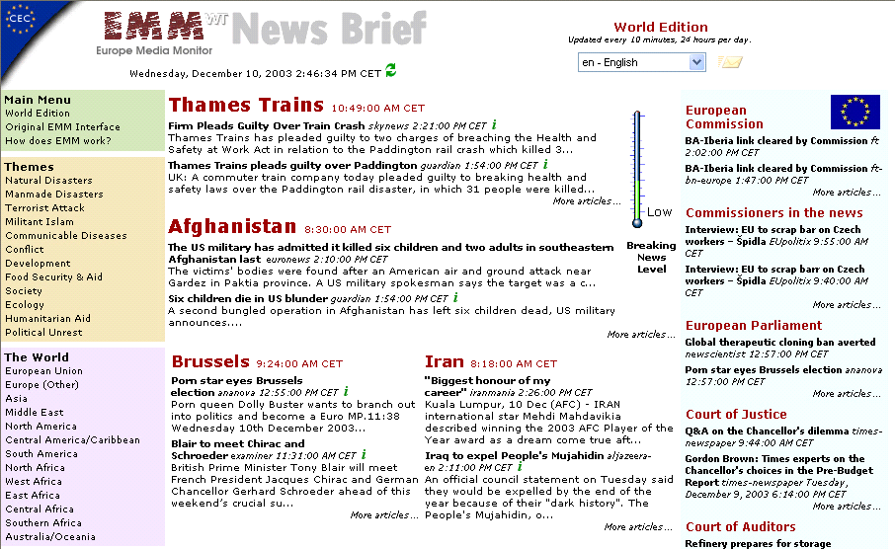
Figure 9: Europe Media Monitor

Project Name: German Environmental Information Network (GEIN)
Semantic Application: Knowledge Management

The German Environmental Information Network (GEIN) is a semantically enhanced portal of environmental information. Users of the network can search content using a “retrieval assistant” that uses ontologies implemented as topic maps to extend, enrich or focus search queries. Search strings are parsed to find and suggest to the user-related topics. In addition to a broad range of topics, the content is matched against location and time dimensions of ontology as demonstrated in the screen shot below.

Specific capabilities provided by semantic technologies include:
- Intelligent concept-aware search
- Expertise location
- Next generation social networking and collaboration

GEIN encourages the practice of a common domain language among different communities that use its information by aggregating and publishing the environmental terminology. Terminology is accessible by both people and computers. People use GEIN system by browsing and searching its portal. Other systems can access GEIN ontology and content through Web Services as it offers a “semantic network service”.

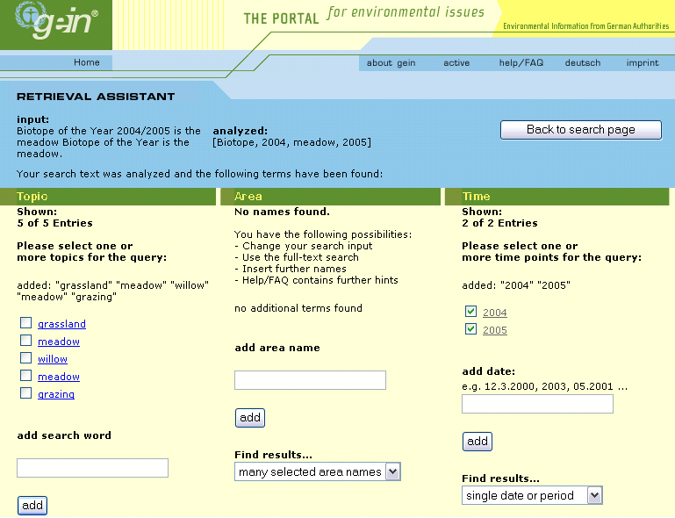

Figure 10: German Environmental Information Network Portal

GEIN architecture is shown in the figure below.

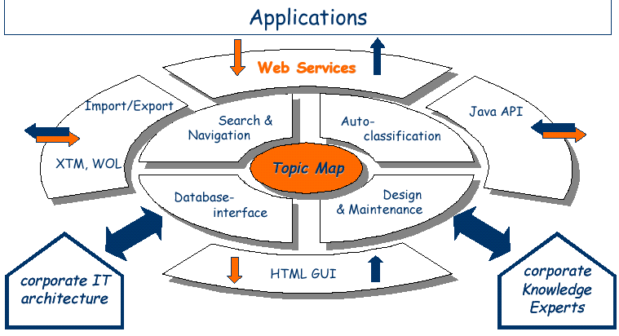
Figure 11: GEIN Architecture
Project Name: Federal Aviation Administration (FAA) [insert project name]
Semantic Application: Data and Application Interoperability

The Federal Aviation Administration (FAA) has been using semantic technology to allow security personnel to assess passenger threats while maintaining a high rate of passenger flow. Data for passenger threat analysis comes from a wide range of heterogeneous sources of structured and unstructured data, including the FBI most wanted list, flight details, news, public records, and biometrics. FAA built a solution built using Semagix Freedom platform that interfaces with diverse information sources, extracts relevant information in near real-time, and then organizes and normalizes them based upon the ontology. The system co-relates the information from different sources to determine possible threats by discovering hidden relationships between seemingly unrelated pieces of information.

Specific capabilities provided by semantic technologies include:
- Integration of disparate data sources
- Web Services discovery and intelligent directories
- Web Services composition

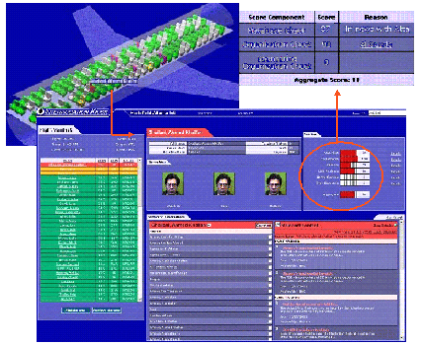
Figure 12: Aviation Security – Passenger Threat Analysis
Project Name: Automobile Design Assistant
Semantic Application: Smart Knowledge-aware Applications

A major car manufacturer has implemented ontology-driven “design assistant” to help engineers design, build and test new prototypes. A key objective for the solution was a speed up of the innovation process. The faster design-build-test cycle can be completed, the greater the number of innovations that can be brought to market. As shown in the figure below ontologies are used to represent complex design knowledge in electronic form.

The solution uses Ontobroker from Ontoprise to bring together knowledge from many different sources, and draws logical conclusions from the combined information. The car manufacturer uses this capability to provide a computational representation of complex dependencies between components of research test vehicles. These dependencies play a key role in the configuration and development of new vehicles. For example, in order for testing to proceed smoothly, the engineer must know if a selected engine can be built into the chosen chassis, if the brakes are sufficient for the engine performance, or that correct electronics is present in the vehicle. The company expects a shortening of the development cycle, while at the same time improvement in development quality. The electronic advisor expected to take care of routine tasks, allowing engineers to concentrate on creative efforts.

Specific capabilities provided by semantic technologies include:
- Advisors and Recommenders
- Reasoning over disparate sources of information
- Contextualized just-in-time retrieval of information

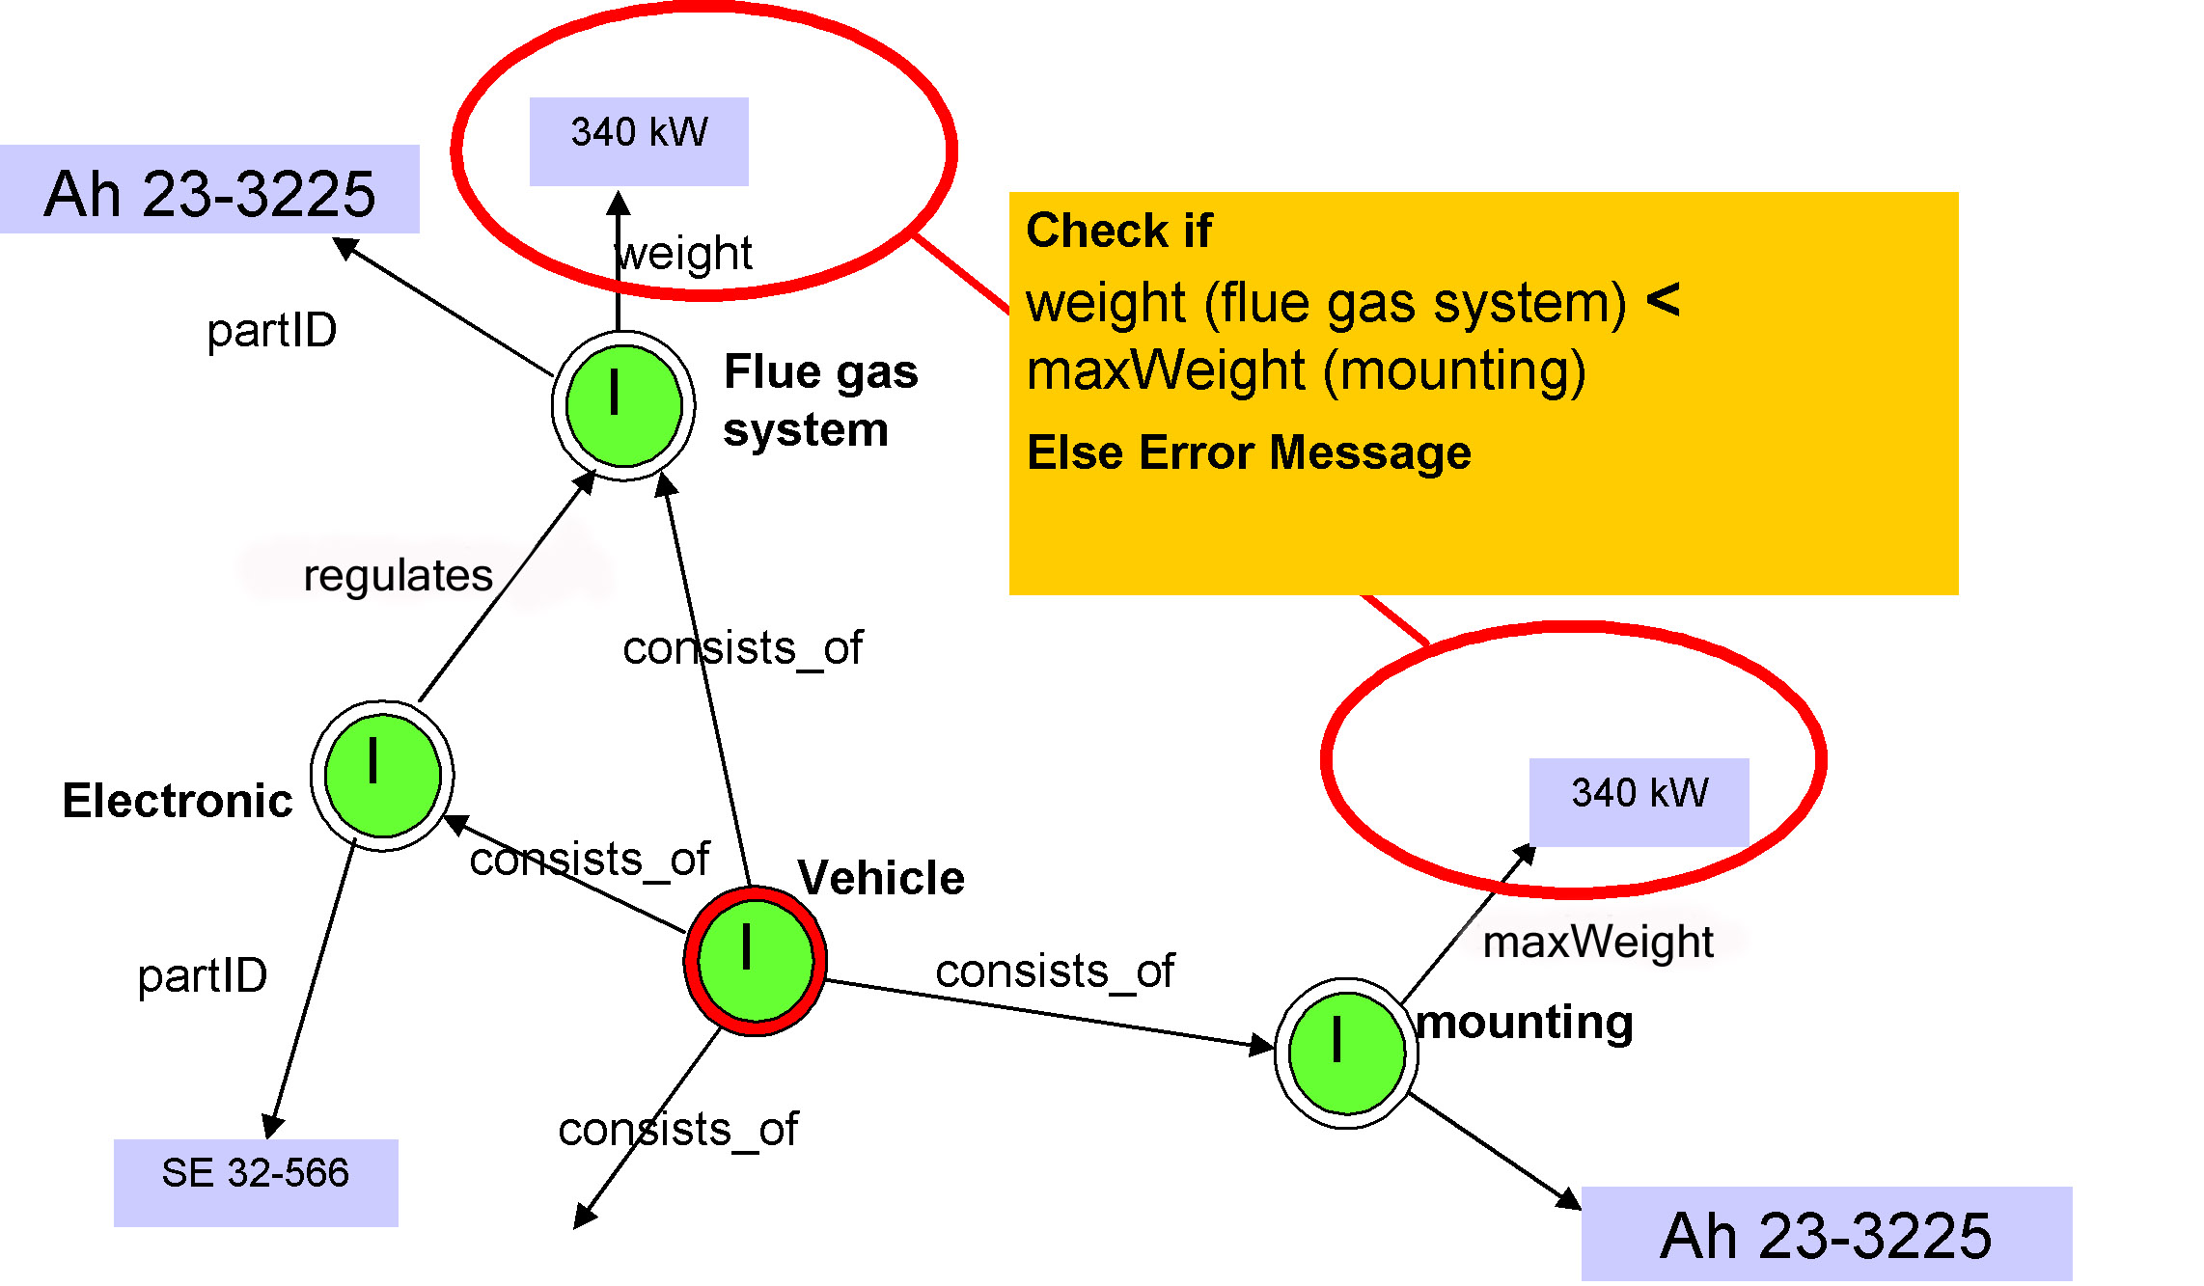
Figure 13: Semantic Design Assistant

Project Name: Clinical Patient Trial Smart Questionnaire
Semantic Application: Dynamic User Interfaces

Unlike other examples in this section, next application still exists only as an idea. The idea of how ontology-driven dynamic forms can improve the data collection process. A flexible and controlled model is envisioned to be used to intelligently guide the user through data capture. The results can be automatically classified and analyzed according to the model. One industry areas where such capability can be useful is clinical trials which represent one of the most costly and time-consuming elements of the drug development process. On-line trial data capture (either remotely or at the point of care) provides an opportunity to improve the trial process significantly. As shown in the next figure ontology model can be used to dynamically generate the clinical trial form according to the profile of the required candidate population. If a candidate is female, she is asked questions about her reproductive status. If a candidate has a history of cancer, she is offered a list of cancer types to select from.

Specific capabilities provided by semantic technologies can include:
- Dynamically generated forms
- Smart context-aware portals

The correct information can then be captured in a controlled format, and inferences made automatically on candidate suitability. Inferences can be straightforward (for example to validate age or make sure that gestational diabetes is not an option for male respondents) or more complex, for example inferring medical conditions based upon the types of medicine being taken, and checking medical conditions against trial exclusion criteria.

During the trial, an ontology can be used to describe the concepts and relationships relevant to the trial, including data to be captured (including defaults, constraints and ranges). The ontology further defines dependencies between the data and the data capture process, such that forms can be dynamically generated according to previous responses, or even the profile of the trial subject, the stage in the process, or dosage. Results can be automatically classified and validated according to rules and categories defined in the ontology.

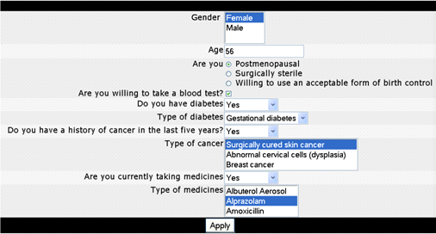
Figure 14: Dynamically generated Form for collecting clinical trial data
Project Name: Citizen Request for Environmental Health Information
Semantic Application: Information Accessibility

A Federal agency has constructed an ontology-based Information Access Portal for residents concerned with measuring health hazards in specific geographic areas. Individuals considering moving to a new location as well as those curious about their local environmental hazards require a single point of access bringing together both environmental and health information. A key objective for the solution was to bring disparate data together into a single location for perusal without forcing changes to workflow, the location of physical data, and disruption. The more easily a resident can search for such information, the easier it will be for them to make educated decisions.

By mapping disparate data assets of various formats to a single ontology model, semantic inconsistencies, redundancies, and gaps in information can be more easily identified. Moreover, publication of this information into a Portal can be achieved quickly and modifications introduced as they emerge without disrupting ongoing information access through the Portal (web interface).

The solution uses the Unicorn System from Unicorn Solutions to semantically map physical data assets to a single ontology model from many different sources. Once each asset was mapped in this project, the redundant terminologies, overlapping concepts/vocabularies, and inconsistencies were easily spotted. In this case, the assets included Excel spreadsheets, structured files, and Microsoft Access files. In addition, the process of comparing different information and their commonalities can also be achieved to the benefit of the portal users. Finally, these sources could be queried, much as a business intelligence tool works, with complex questions capable of being solved within the context of the requisite data sources.

For example, a resident (and also a parent of two children) considers moving to a new location. The individual wishes to verify the accuracy of the health information provided by the real estate agent before committing to the purchase of a new home. The individual can access a catalog of EPA Federal, state, and local data on individual locations, checking for and comparing the number of children affected in recent years by lead in water, new concentration of various pollutants, reports on health statistics in those areas, the number of waste sites within a 50 mile radius, and the amount of pollution measured in recent months in local water sources. By reviewing all of this data, the individual can easily compare the various towns or cities and make an educated decision for the benefit of his or her entire family.

Specific capabilities provided by semantic technologies include:
- Integration of disparate data sources
- Consistency checking of terminologies
- Bringing data assets in assorted locations into one simple location for web access
- Intelligent query

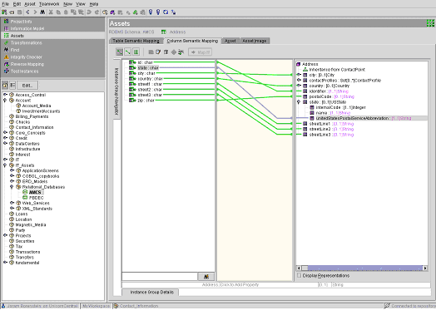
Figure 15: Semantic ontology model and semantic mappings

One-Day Conference on "Semantic Technologies for eGov", September 8th, 2003
The World Wide Web Consortium’s Semantic Web Activity Statement: http://www.w3.org/2001/sw/Activity#intro
The World Wide Web Consortium’s Semantic Web Activity page: http://www.w3.org/2001/sw/
“Semantic Computing’s Building Blocks”, Enterprise Architect Insight, Ken Fromm and Jeff Pollock, Vol. 2. No. 8, April 15, 2004.
Adapted by Rick Murphy.
The Princess Bride, 1987.
Fromm and Pollock.
“Adaptive Information: Improving Business Through Semantic Interoperability, Grid Computing, and Enterprise Integration” by Jeff Pollock and Ralph Hodgson, Wiley Publishing 2004.
Adapted by Rick Murphy.
Pollock and Hodgson.
"The Semantic Web" by Tim Berners-Lee, James Hendler and Ora Lassila Scientific American May 2001 http://www.scientificamerican.com/article.cfm?articleID=00048144-10D2-1C70-84A9809EC588EF21&catID=2
“The Semantic Web: A Guide to the Future of XML, Web Services, and Knowledge Management” by Michael C. Daconta, Leo J. Obrst and Kevin T. Smith. Wiley Publishing 2003, pp. 4.
Ralph Hodgson, “Semantic Web in the Enterprise” panel, Enterprise Architect Summit, June 2004.
"What the Semantic Web can Represent" Tim Berners-Lee September 1998. http://www.w3.org/DesignIssues/RDFnot.html
Berners-Lee, Handler, and Lassila.
“Adaptive Information: Improving Business Through Semantic Interoperability, Grid Computing, and Enterprise Integration” by Jeff Pollock and Ralph Hodgson, Wiley Publishing 2004
From Tim Berners-Lee, ISWC 2003
Pollock and Hodgson.
Pollock and Hodgson
http://www.dublincore.org/about/
Michael Daconta, “Semantic Web in the Enterprise” panel, Enterprise Architect Summit, June 2004.
From Daconta et al (2003), p. 157.
From Daconta et al (2003), p. 157.
Sometimes this hierarchical structure is called a “tree”, with the root at the top and branching downward. This is a simpler structure than we will find in an ontology in general, which will be a “graph”, i.e., a network with branches across nodes (representing other relationships) and with some child nodes having links from multiple parents.
Sometimes this hierarchical structure is called a “tree”, with the root at the top and branching downward. This is a simpler structure than we will find in an ontology in general, which will be a “graph”, i.e., a network with branches across nodes (representing other relationships) and with some child nodes having links from multiple parents.
Berners-Lee, Handler, and Lassila.
www.topquadrant.com
http://www.omg.org/technology/documents/formal/mof.htm
http://www.omg.org/cwm/
http://www.w3.org/People/Berners-Lee/
XML 2000 talk: http://www.w3c.org/2000/Talks/1206-xml2k-tbl/slide10-0.html
Harold Boley, Benjamin Grosof, Michael Sintek, Said Tabet, Gerd Wagner. 2003. RuleML Design, 2002-09-03: Version 0.8. http://www.ruleml.org/indesign.html.
http://www.w3.org/Submission/2004/SUBM-SWRL-20040521/. See also: Horrocks, I; Peter Patel-Schneider; Harold Boley; Said Tabet; Benjamin Grosof; Mike Dean. 2004. SWRL: A Semantic Web Rule Language Combining OWL and RuleML, Draft Version 0.7 of 30 April 2004. http://www.daml.org/rules/proposal/.
Daconta, Obrst and Smith.
Berners-Lee, Handler and Lassila.
Daconta (2004)
Berners-Lee, Handler and Lassila.
Berners-Lee, Handler and Lassila.
Jeffrey Pollock, ManTech EII Workshop, July 2004, www.meiim.com/files/Jeffrey_Pollock.ppt
Harold Boley, Benjamin Grosof, Michael Sintek, Said Tabet, Gerd Wagner. 2003. RuleML Design, 2002-09-03: Version 0.8. http://www.ruleml.org/indesign.html.
http://www.w3.org/Submission/2004/SUBM-SWRL-20040521/. See also: Horrocks, I; Peter Patel-Schneider; Harold Boley; Said Tabet; Benjamin Grosof; Mike Dean. 2004. SWRL: A Semantic Web Rule Language Combining OWL and RuleML, Draft Version 0.7 of 30 April 2004. http://www.daml.org/rules/proposal/.
Hassan Masum and Yi-Cheng Zhang, “Manifesto for the Reputation Society”, FirstMonday, www.firstmonday.dk, June 15, 2004.
James Hendler, Closing Keynote, Semantic Technologies for E-Government, September 2003.
http://www.w3.org/2001/sw/Europe/reports/scalable_rdbms_mapping_report/
http://www.w3.org/2001/sw/Europe/reports/scalable_rdbms_mapping_report/
Pollock, EII Workshop.
From a presentation: "10 Practical Reasons why you need an Ontology" by Michael C. Daconta, Chief Architect, Virtual Knowledge Base. http://www.daconta.net/briefs/why-ontology-general.pdf
Don Hall, Program Director, Logistics Enterprise Support Program, Office of the Assistant Deputy Under Secretary of Defense
From W3C Working Note on Web Services Architecture: http://www.w3.org/TR/ws-arch/#whatis
For additional background, see “Semantic Discovery for Web Services” in “Web Services Journal,” April 2003, http://www.sys-con.com/webservices/article.cfm?id=507.
Fromm and Pollock.
Pollock and Hodgson.
Pollock and Hodgson.
Extracted from NASA presentations and reports.
Pollock and Hodgson.
TopQuadrant, "Harnessing the Value of Semantic Integration For Your Business”.
http://press.jrc.it

