
U.S. EPA Region 4
EPA Knowledge Management

Division Weekly Reporting Tool v1.0
Final Project Report

January 25, 2006


1.0 Introduction
The purpose of this effort is to develop Version 1.0 of a document and content management tool, called the Division Weekly Reporting Tool (DWRT) for the United States Environmental Protection Agency (USEPA), Region 4 (R4), Waste Management Division (WMD). Over the past several years, the WMD Federal Facilities Branch (FFB) Electronic Knowledge Management (EKM) Team has had some meaningful successes, including incorporation of web conferencing, development of several databases for tracking a variety of FFB metrics, and development of a variety of web based services for the FFB and the WMD. In the past year, this team has collaborated with GeoDecisions to develop several proofs of concept tools using families of advanced non-proprietary application development tool kits and languages to overcome various challenges currently facing the USEPA.
One of the biggest challenges within a large government organization like the USEPA is to connect islands of information. There are two major impediments that block effective connections amongst these data islands. The first impediment is the lack of common elements between these islands of information. The second impediment occurs because these information islands are not in compatible “machine” formats. These two issues actually represent two somewhat distinct problems. Linking fields in separate data islands tend to fall in the “semantic” arena – do two different words used in two different databases mean the same thing? Disparate format problems tend to fall in the mechanical arena of moving data through a system.
Our approach addresses issue one by taking advantage of the idea that that 80% of all information has a spatial component. A significant effort frequently goes into attempting to get several entities (federal, state, local, tribal, etc.) to agree on the meaning of words. However, using the commonly shared feature of spatial knowledge allows selection of “all” data within a given, user-defined area, regardless of what it is called by different databases. This is an appropriate use of the computer’s strengths, sorting lots of data into packages that allow humans to make better subjective decisions.
To effectively deal with issue two, mechanical movement of the data through the system, we have incorporated the use of extensible markup language (xml), a common “tagging” meta-language that allows virtually any softwares/hardwares to intermingle readily. XML is a widely accepted and utilized meta-language, heavily promoted by the federal government as well as private industry.
The resulting tool leverages the data normalization capabilities of XML, simple end user search capabilities based on location using a simple graphic user interface and the ability to visualize the spatial and attribute content of events through the use of another open source language called scalable vector graphics (SVG). SVG provides an ability to visualize inherently spatial data on a map to provide context to decision makers. This approach provides both of the issues, semantic and mechanical, to be managed and manipulated with less effort and more effectiveness on all parties sharing data.
2.0 Background
Figure 2.1 provides a view of data, from “traditional” structured data such as data that is stored and analyzed within relational databases to completely unstructured data such as phone calls and emails. Generally, tools are “downwardly compatible”. If one can manage semi-structured data such as that found in remedial investigation documents, then managing structured data is a given. Truly managing unstructured data is still in the prototype phase at an industry level.
Figure 2.1 Structures of Inputs
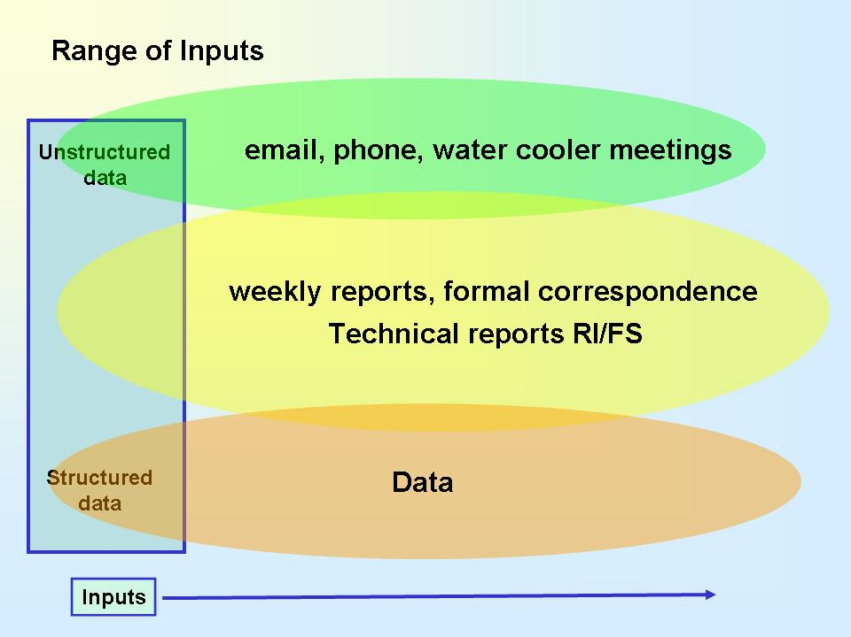
Figure 2.2 provides a map of data flow through the system. The filters and Business Rules that lie between Inputs and Outputs are the value added processes. It is important to recognize that the inputs are compiled once and then reused for many different output products. As well, through no specific effort, institutional memory is dramatically enhanced. In particular, although difficult to describe in this short paper, not only is data stored but much more importantly, the thought processes of how the inputs were combined to create the outputs are preserved.
Figure 2.2 General Business Model
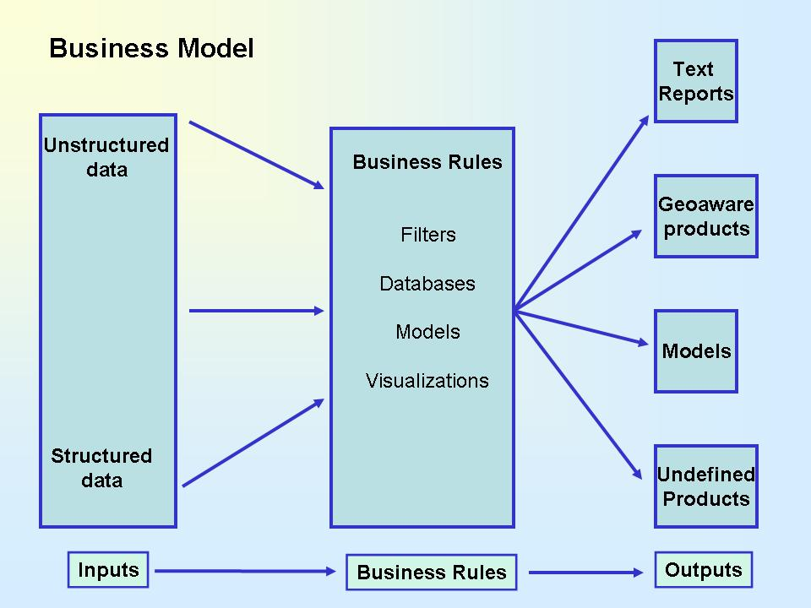
3.0 Developing the Division Weekly Reporting Tool (DWRT)
Figure 3.1a provides the basic logic of the DWRT application. The DWRT application logic mainly consists of three distinct components. Step1) Inputs; Step2) Business Rules and Step3) Outputs. The process involves collecting the input data in a semi-structured format, apply pre-defined business rules and create multiple outputs. It is important to notice that the “mechanics” of moving data through the system must be combined with the expertise of topic experts in order to develop useful and useable tools for the end user. In this case, understanding what types of questions the senior managers need to ask about the weekly report is critical.
Figure 3.1a Division Weekly Report Tool Flow Diagram (Basic)
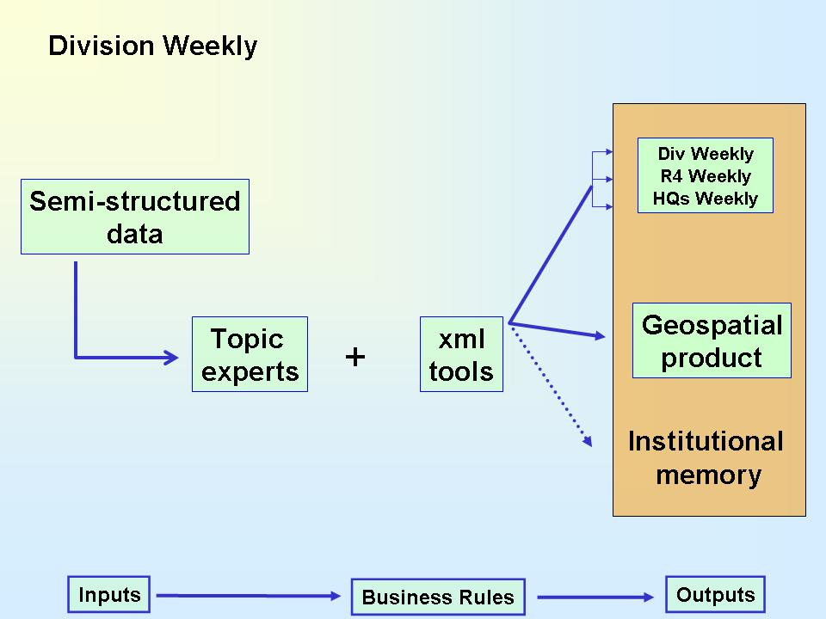

Figure 3.1b Division Weekly Report Tool Flow Diagram (Detailed)
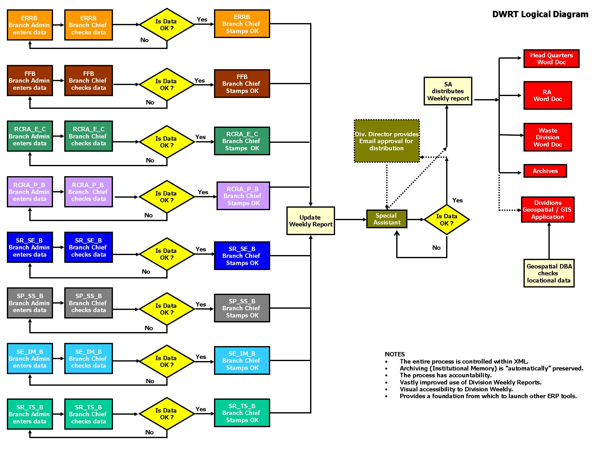
Figure 3.1b provides the detailed logic of the DWRT application. The Step1 includes the process of collecting the weekly reports submitted by Branch Chiefs for their respective branches using a customized GUI. The customized GUI applies the pre-defined business rules and formats the inputted data into a unique file in an ‘XML’ format. The ‘Special Assistant (SA)’ then reviews the submitted information and updates the information if required. The SA creates a ‘Business-as-usual’ MS Word report and sends it to the Division Chief for review. Once the Division Chief clears the report for distribution, the SA creates multiple reports like ‘Division Weekly’, ‘RA weekly’ and ‘HQ weekly’ reports in ‘MS Word’ format for actual distribution. In addition, a copy of the weekly report is also saved in the ‘Archive’ folder for future references.
3.1 Creating Searchable Reports
Figure 3.2a is the Graphical User Interface (GUI) that provides the Branch Chief and/or their assistant entering data the opportunity to “tag” that data with semantic values (for example, tagging the date of the report for later retrieval). The GUI collects the data entered, formats the data in a pre-defined structure and saves it to an ‘xml’ report. The design tried to limit changes to the established business processes already in place in the Waste Division. By creating weekly report in this form instead of “free form”, the creator is not overly burdened by a process that will be difficult to enforce and the value that is added via both short term understanding by the end user as well as longer term institutional memory is perceived to be strongly cost beneficial. It is possible to easily deploy similar interfaces on all computers in the division, providing everyone with a common interface for weekly report creation.
Figure 3.2a Graphical User Interface to create ‘xml’ structured reports (Branch Chief)
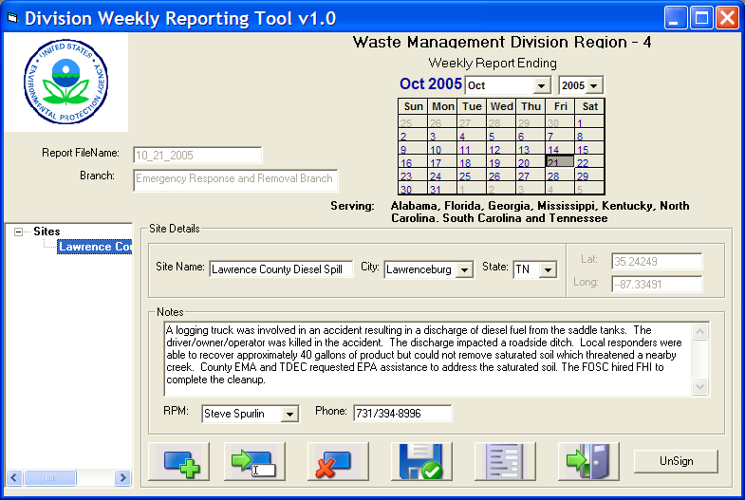
Figure 3.2b is the Graphical User Interface (GUI) for the Division Chief’s Special Assistant (SA). The GUI is similar to that of the Branch Chief’s but the main difference is that the SA’s interface has access to the data of all branches, whereas the each Branch Chief’s interface has access to the respective branch’s data. Also, the SA’s interface has additional tools for ‘locking’, ‘signing off’, ‘exporting Division, RA and HQ weekly’ and a link to the map interface.
This ‘xml’ report thus created, can then be made available and used by most other softwares since XML is an ‘open’ standard and can also be imported into a ‘database’ (e.g. MS Access, Oracle etc) for institutional memory purposes. In the case of the DWRT, the XML document drives both the creation of the ‘Work’ document and the ‘geospatial’ product.
Figure 3.2b Graphical User Interface to create ‘xml’ structured reports (Special Assistant)
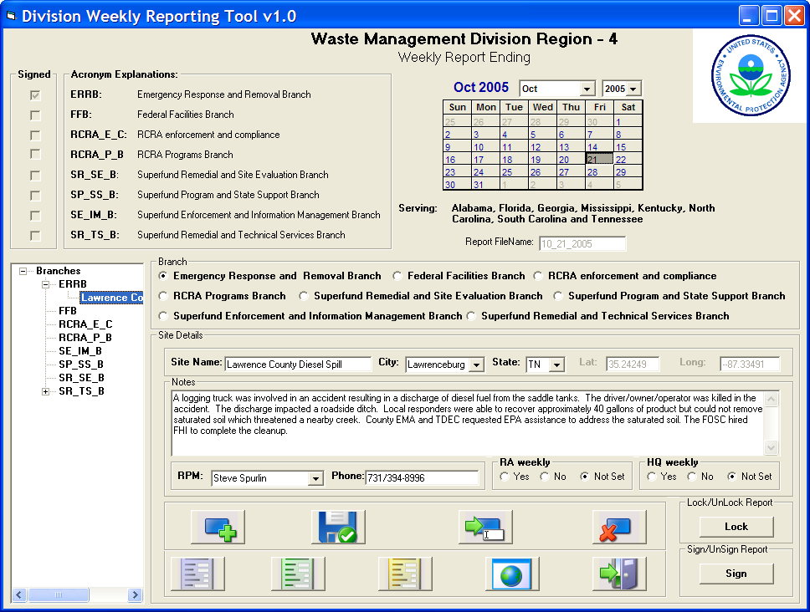
3.3 Division Weekly Reporting Tool (DWRT) - Data Architecture:
The ‘xml’ reports created by the above mentioned interfaces are housed in a ‘Central Repository’ as shown in Figure 3.3. There are three main components in the central repository: 1) XML reports 2) Non-spatial database and 3) Geospatial database. The ‘XML reports’ section contains an archive of XML reports for the previous reporting periods. The ‘Word’ versions of these reports are located separately in an ‘archive’ folder for retrieval through the Map Interface. The ‘Non-spatial database’ section consists of auxiliary information like ‘lat-long’ of site locations, RPM phone numbers etc. The ‘Geospatial database’ sections consists of maps stored in a W3C recommended XML specification – Scalable Vector Graphics (SVG).
Figure 3.3 DWRT Architecture Diagram

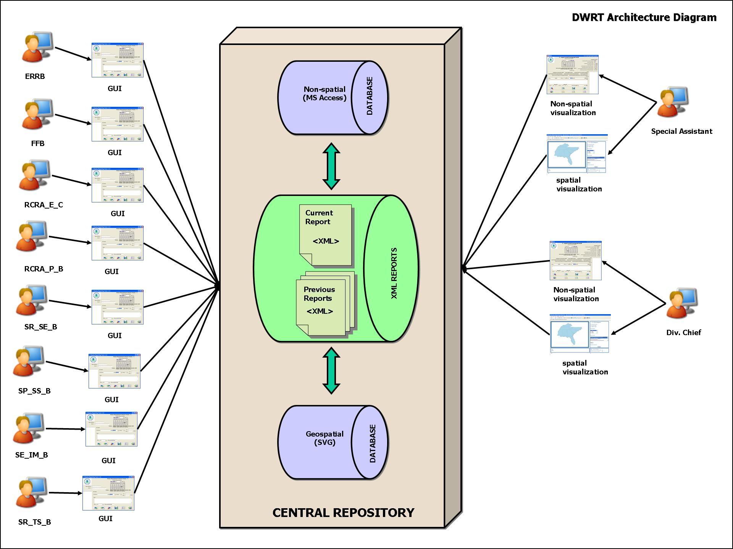
3.4 Division Weekly Reporting Tool – Map Interface:
The weekly report (Figure 3.4a) that is created as described above is immediately available for ‘searching’ through the Map Interface. The user can select one or more reports and branches of interest as the ‘search criteria’. The application searches through the selected report(s) and branch(es) and displays a pop-up window with a summary report of all the site locations and their details. The application also displays ‘dots’ on the map for all the corresponding site locations found in the ‘search results’. The user can position the mouse cursor on top of any ‘dot’ (location) and get the ‘city’ and ‘state’ information immediately displayed in the information bar below the map section.
Figure 3.4a Summary Report Output (Fig refers to results for 2 reports and 1 branch)
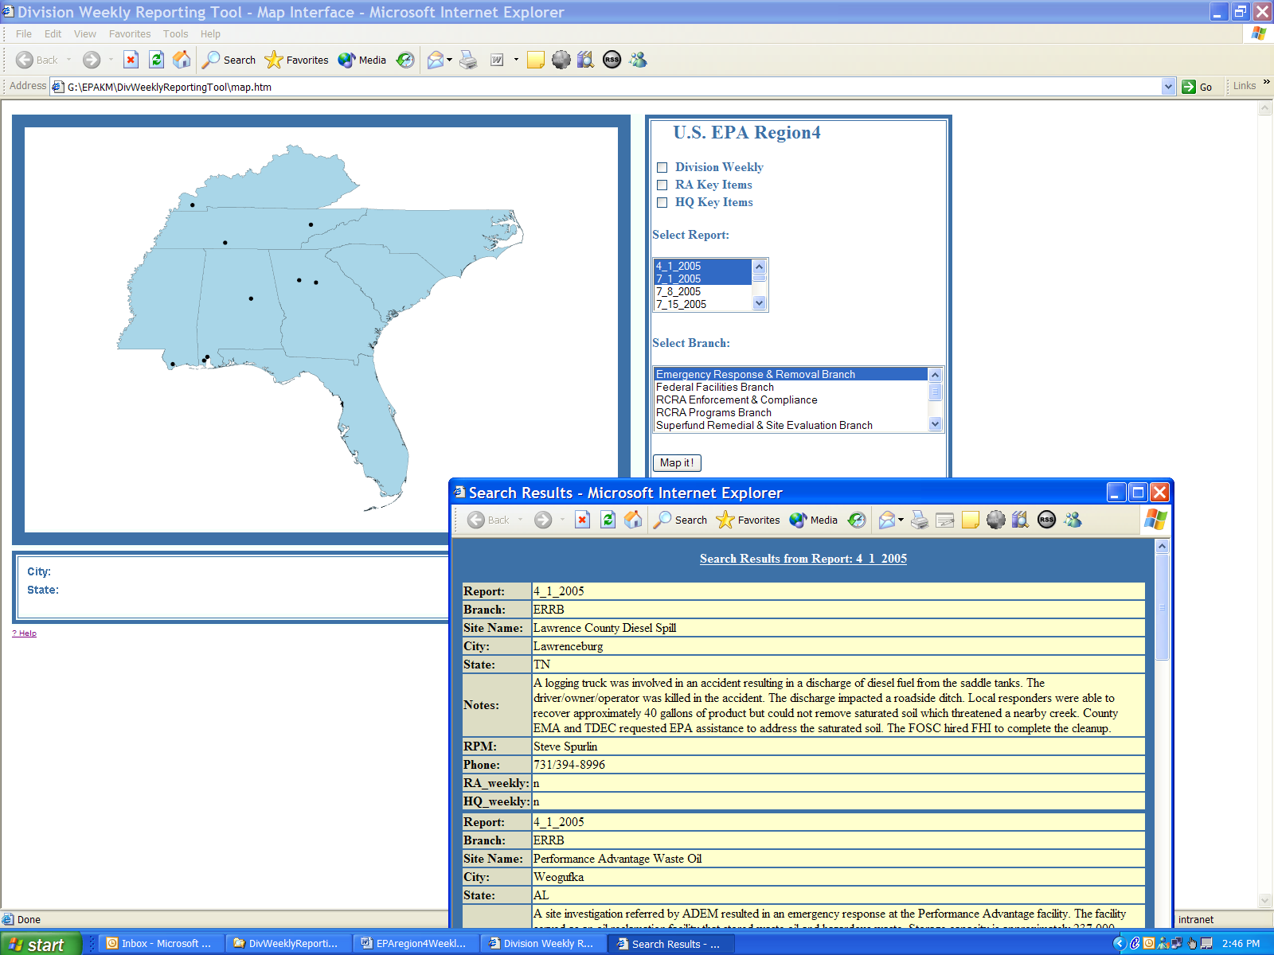
In addition, the user can also select one or more reports and branches of interest and click on a ‘dot’ (location) to extract information for that particular location within the selected report(s) and branch(es) (Figure 3.4b). Clicking on a site location not only creates a synthetic document with location specific information but also contains a ‘hotlink’ to the corresponding ‘Word’ report.
Figure 3.4b Report Output for Specific Site Selections (Fig refers to results for 2 reports and 1 branch for ‘Atlanta’)
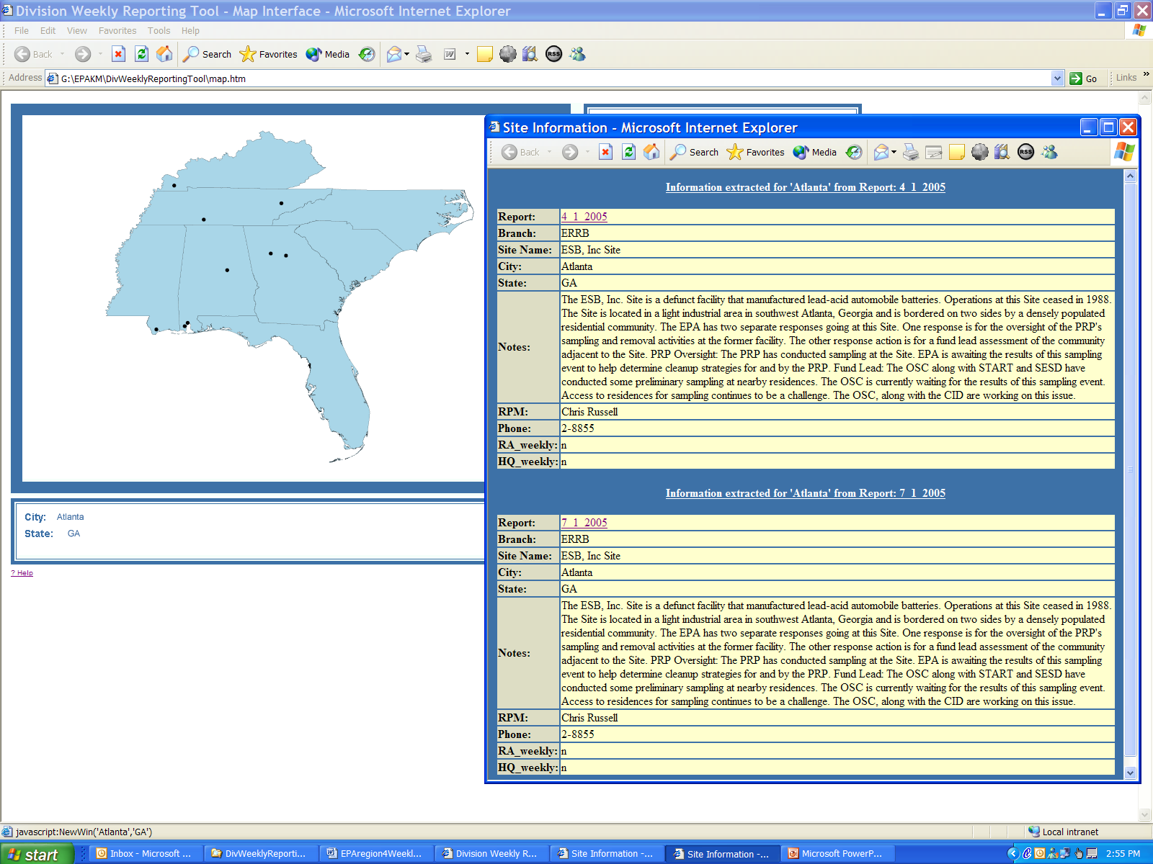

“ The essence of this tool is that it achieves multiple objectives of a simple business process in the U.S. EPA. It configures the content into an easily shared ‘interoperable’ format (xml) and the popular document format (‘Word’) which is also immediately searchable and viewable as a ‘map’. “
4.0 System Requirements:
- Operating System – Windows NT, 2000, XP
- RAM – Atleast 256 mb recommended
- Software – Adobe SVG Viewer 3.x (free), Internet Browser(IE 6.x or higher recommended), MS Word, MS Access.

5.0 Results and Conclusions
The DWRT is currently loaded onto 10 locations. 8 of these locations are the Branch Administrator’s workstations. 1 of these locations is the Division Director’s Special Assistant’s workstation and the final location is the Division Director’s workstation. These applications have been fully accepted and are being utilized on a weekly basis, fulfilling a primary objective of the project. The DWRT has proven useful and simple enough to replace an existing, onerous business process with one that is much more efficient, while capturing a greater quantity of institutional knowledge within a central repository. The USEPA R4 staff that has access to this application continues to provide meaningful feedback to the EKM Team regarding its usefulness.
One thing to note regarding the installation process, however, is the limitations presented by approaching this solution as a client-side rather than server-side solution. Because the bulk of the DWRT resides locally on individual workstations any change to the base system requirements can affect the installation and proper functioning of the application. In at least one situation an install resulted in a minor functional error within that particular application that could not be replicated on any other installation nor resolved. While the remainder of the installations proceeded smoothly, this unexplained phenomenon can be anticipated from similar future efforts that develop complex, client-side solutions. A conclusion drawn from this experience is that any long-term plans for further distribution of this or similar tools should be developed from an enterprise architectural approach using server-side components available to any end user through a web browser.

The site locations are generalized to the city they are located in.

